EEASCNA Minutes July 2026

East end area is part of a worldwide Fellowship.

Elaine J. opened ASC Meeting with moment of silence followed by the Serenity Prayer

Reading of Twelve Traditions – Frederick

Reading of Twelve Concepts – Kristy

Reading of Article III – Ica

Article III: A. Definition and Function of the Area: The Area Service Conference (ASC) is the communicative channel for a unified Fellowship, a tie that binds us together. The ASC serves as a link in the flow of communication from the member to the worldwide Fellowship, establishes a structure in which services and education are provided, and functions as a vehicle through which our Area Fellowship and society can relate. The EEASC is a committee made up of Group Service Representatives (GSRs), special purpose Task panels and an Administrative Body from Member Groups of the East End Area.

Administration Roll Call (2025-2026)

Key: 0= Not Present, 1= Present, (-) = Vacant, R= Report submitted only
ROLE | NAME | D | J | F | M | A | M | J | J | A | S | O | N | D
Facilitator | Elaine J. | L | 1 | 1 | 1 | 1 | 1 | 1 | 0
Co-Facilitator | Valorie W. | - | - | - | - | - | - | - | 1
Secretary | Ica B. | 1 | 1 | 1 | 1 | 1 | 1 | 1 | 1
Alt-Secretary | VACANT | - | - | - | - | - | - | - | -
Treasurer | Paul B. | 1 | 1 | 0 | 1 | 1 | 0 | 1 | 1
Alt-Treasurer | Kaleb B. | 1 | 1 | 1 | 1 | - | 1 | 1 | 1
H&I Chair | Alveta J. | 1 | 0 | 0 | 1 | 1 | 1 | 0 | 1
H&I Vice | Steven L. | - | 1 | 1 | 1 | 1 | 1 | 1 | 1
PR Chair | Simone J. | - | - | - | 1 | 1 | 0 | 1 | 0
PR Vice | Pete | - | - | - | - | - | - | - | 0
Activities Chair | Russell M. | 0 | 0 | 1 | 1 | 1 | 1 | 0 | 1
Activities Vice | VACANT | 0 | 0 | 0 | 0 | - | - | - | -
RCM | Toby B | 1 | 1 | 1 | 1 | 1 | 1 | 1 | 1
RCMA | VACANT | 1 | 0 | 1 | 1 | 1 | 0 | 1 | -

Group Voting Policy:

- To reach quorum, 50% + 1 of groups present must be in good standing.

- A quorum must be reached by fifteen (15) minutes after roll call is completed and before any business can be conducted.

- In order for a topic to be enacted, 80% of the groups present must be in good standing.

- New groups must attend 3 consecutive Area Meetings to gain voting rights at the 3rd Area.
- If a group misses 2 consecutive Area Meetings to regain voting rights at the 2nd.

East End Area Groups Roll Call

Key: 0= Not Present, 1= Present, L= Late, R= Represented (to keep in Good Standing), RO= Report only Blacked Out= Not G.S.
2025-2026 | D | J | F | M | A | M | J | J | A | S | O | N | D
Changing in Grayson | 1 | 1 | 1 | R | 1 | 1 | 1 | 1
Clean & Free | R | R | R | R | R | R | 1 | 0
Covington Miracles |  |  |  | 1 | 1 | 0 | 1 | 0
Fahrfromusin | R | R | R | R | R | R | R | 0
Far Out | R | R | R | R | R | R | R | R
Freedom on Friday |  | 1 | L | 1 | 1 | 0 | R | 0
Harvest Group |  |  |  |  |  |  | R | 0
How It Works | 1 | 1 | 1 | 1 | 1 | 1 | 0 | R
It Works How and Why |  |  |  |  |  |  | 0 | 0
It’s Only a Season | 0 | 1 | 0 | 0 |  | 1 | 0 | 1
Just for Today | R | R | R | R | R | R | R | R
Let the Truth Be Told | L | 1 | 1 | 1 | 1 | 1 | 1 | 1
Let the Truth Be Told-Virtual |  |  |  |  |  |  |  | 1
Let the Truth Be Told-New Generations |  |  |  |  |  |  |  | 1
NA Vaders | 1 | 1 | 1 | 1 | 1 | 1 | 0 | 1
Out of the Cold – Book Study | 0 | 1 | 0 | 0 |  |  |  | 0
Recovery at the Rock | 1 | 1 | 1 | 1 | 1 | 1 | R | 1
Restore Group | - | - | - | - | 1 | 1 | 0 | 0
Serenity Is Common Knowledge | 1 | 1 | 1 | 1 | 1 | 1 | 1 | 1
Sisters In Unity | 0 | 1 | 1 | L | 1 | 0 | 1 | 0
Spiritual Awakening |  |  |  | 1 |  |  | 1 | 0
The Journey Continues | 1 | 1 | 1 | 1 | 1 | R | R | 0
Unlimited Hope | 0 | R | 0 | 0 |  |  |  | 1
We Stick and Stay |  |  |  |  |  |  |  | 0
Total of Groups in Area | 22 | 20 | 21 | 23 | 24 | 24 | 23 | 23 |  |  |  | 21
Total Groups Present | 9 | 16 | 13 | 15 | 14 | 12 | 16 | 11 |  |  |  | 13
Groups in Good Standing | 12 | 14 | 15 | 15 | 14 | 14 | 12 | 14 |  |  |  | 12
Groups Present & G.S. | 9 | 14 | 12 | 13 | 14 | 13 | 12 | 8 |  |  |  | 12
Number for Quorum (50% + 1)?  Is Quorum reached? | Y | Y | Y | Y | Y | Y | Y | Y |  |  |  | Y
Number for Consensus  (80% present in G.S)? | 8 | 12 | 8 | 11 | 10 | 11 | 10 | 7 |  |  |  | 10
**Opened meeting at 3:00 p.m. – Roll Call ended at 3:13 p.m. At that time Quorum was met

Subcommittee Reports

Treasurer’s Report

RCM Report
RCM REPORT Toby Barwick
Georgia Region met on 06/13/26 and 06/14/26 in Macon Georgia
- New Officers were elected
- NEW BUSINESS
Topic
2026-007
Reimburse H&I Secretary for hotel stay @
PR Learning Day in Jesup
CONSENSUS REACHED

Topic
2026-009
Georgia Region to host Band of Brothers
Convention in Atlanta ~ October 2027
CONSENSUS REACHED

- OLD BUSINESS

Topic
2026-001
ASC submission of over-calculated donation r
CONSENSUS REACHED

Topic
2026-004
Region to Plan/Host 2-day GSR Assembly January 16-17,
2027 held @ Windgate by Wyndham Hotel
RCMs had decided to send back to Areas for input
CONSENSUS REACHED

- OPEN FORUM

Outgoing PR Chair stated that this task panel continues to not be
supported by the areas & groups and that this has been happening for
the past several years. Stated areas & groups need to realize the
importance of Public Relations to the worldwide NA fellowship. It is an intricate part of trending Fellowship Development. Asked that Areas request Learning Days/Service Workshops from Region’s PR and H&I

RD & RDA stated the importance of familiarizing with World Services
and the many Fellowship surveys provided via NA.org . This is the best way to have your voices heard as individual NA members, homegroup members & members of the fellowship’s evolving service structure! RCMs expressed concerns regarding continuity of service and lack of many members’ willingness to serve. How can we help them

H&I Report

NOT RECEIVED

PR Report

NOT PRESENT

Activities Report

NOT RECEIVED

Old Business

NONE

Nominations/Elections

- TOBY B. for RCM
  - Nomination from Recovery at the Rock
  - Passed!
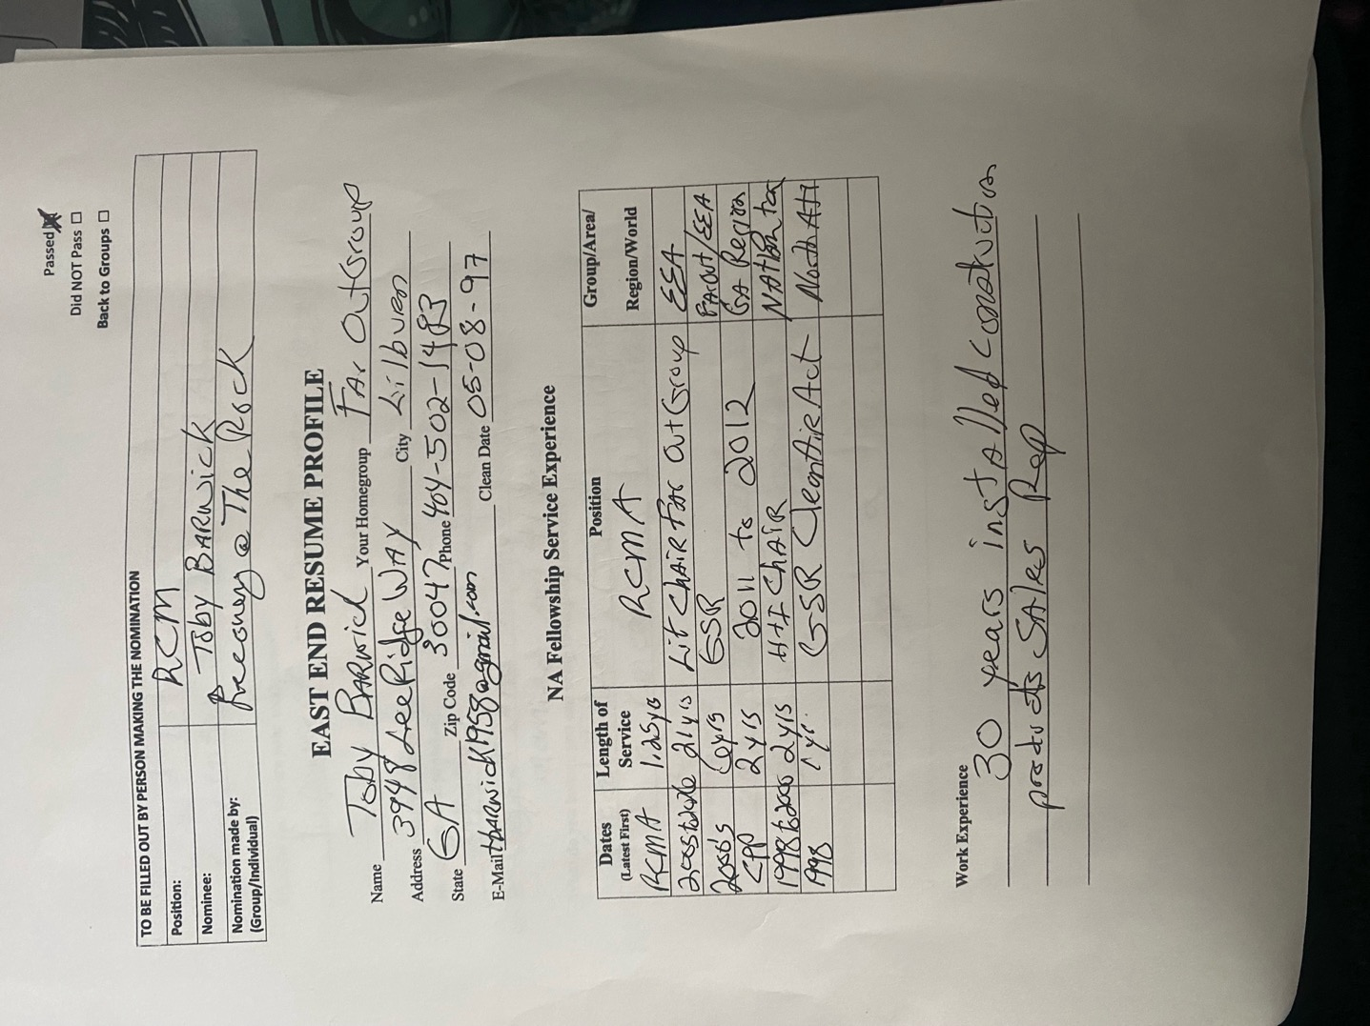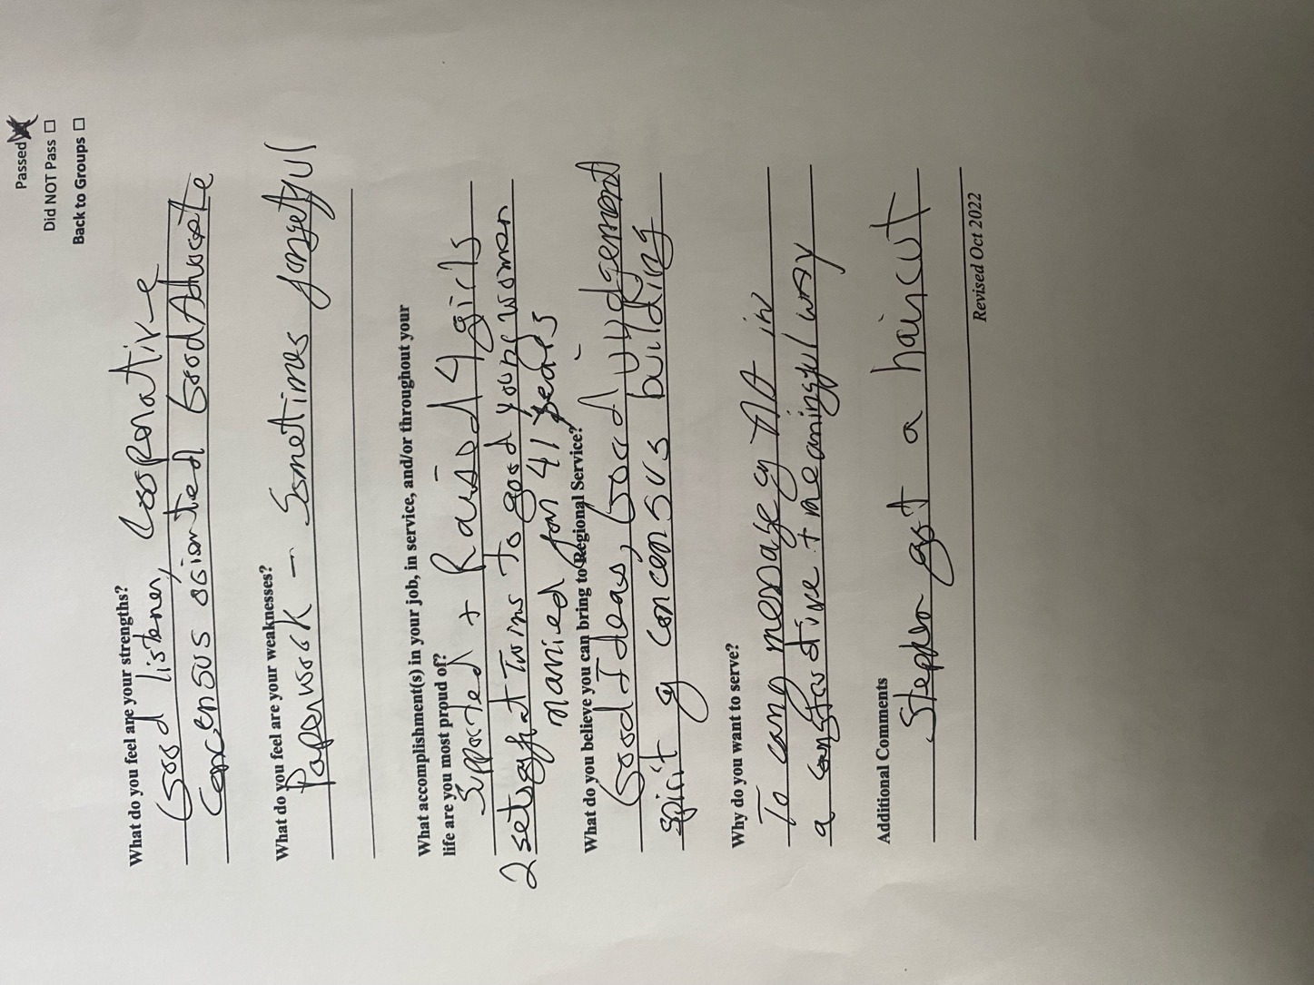
- Valorie W. for Co-Facilitator
  - Nomination from Alveta J.
  - Passed

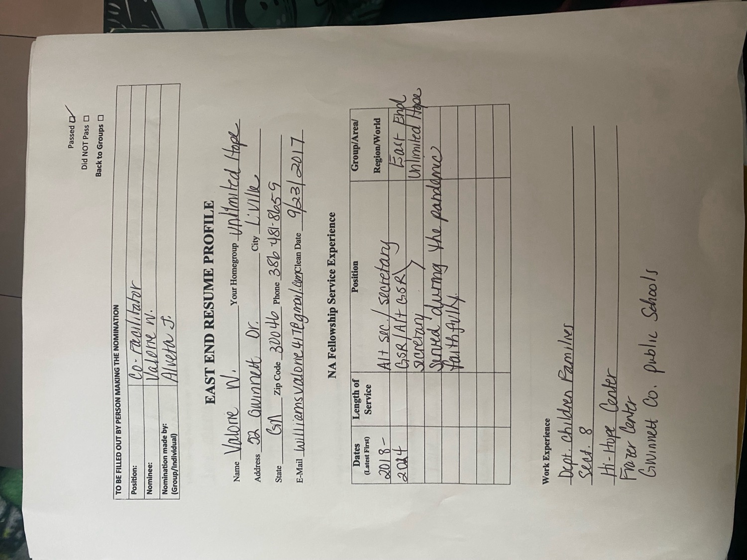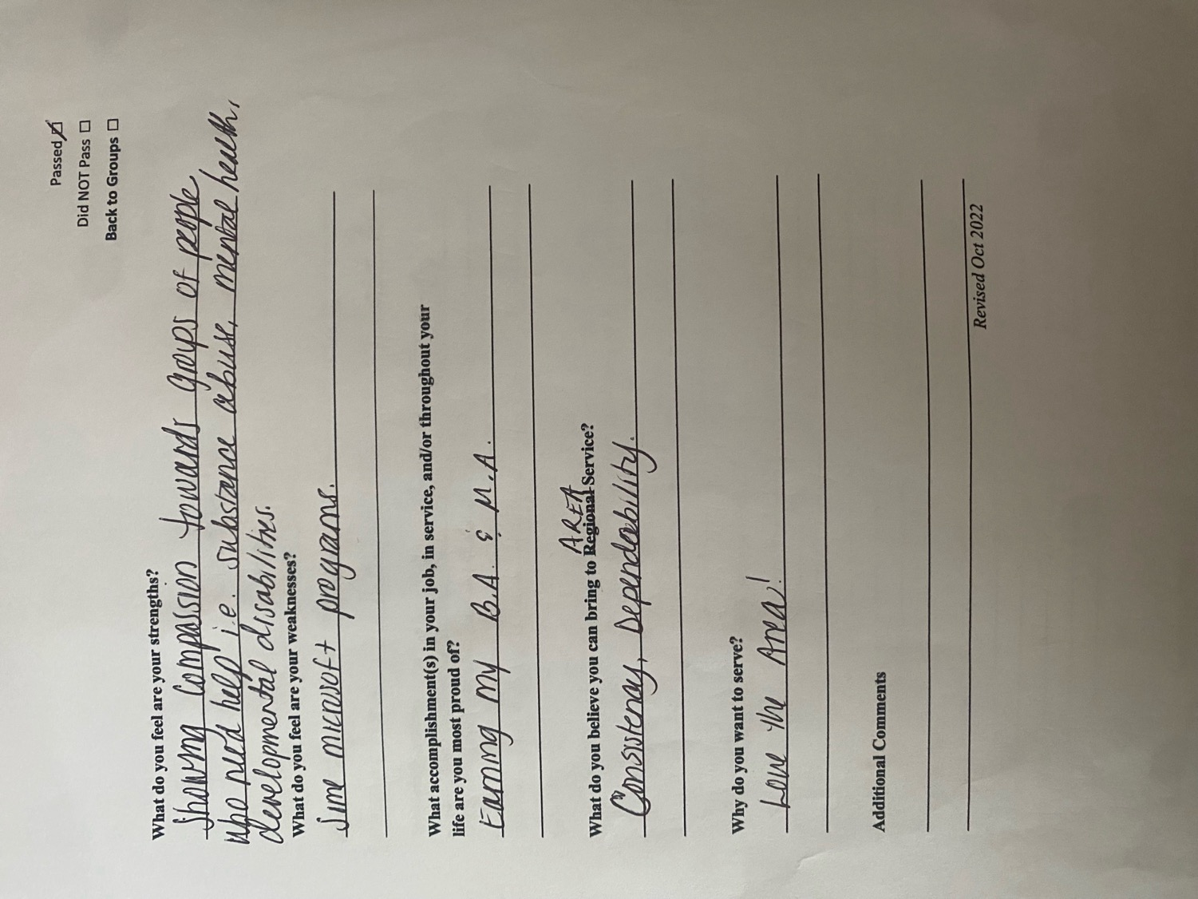
OPEN FORUM

NONE

New Business

NONE

GSR Reports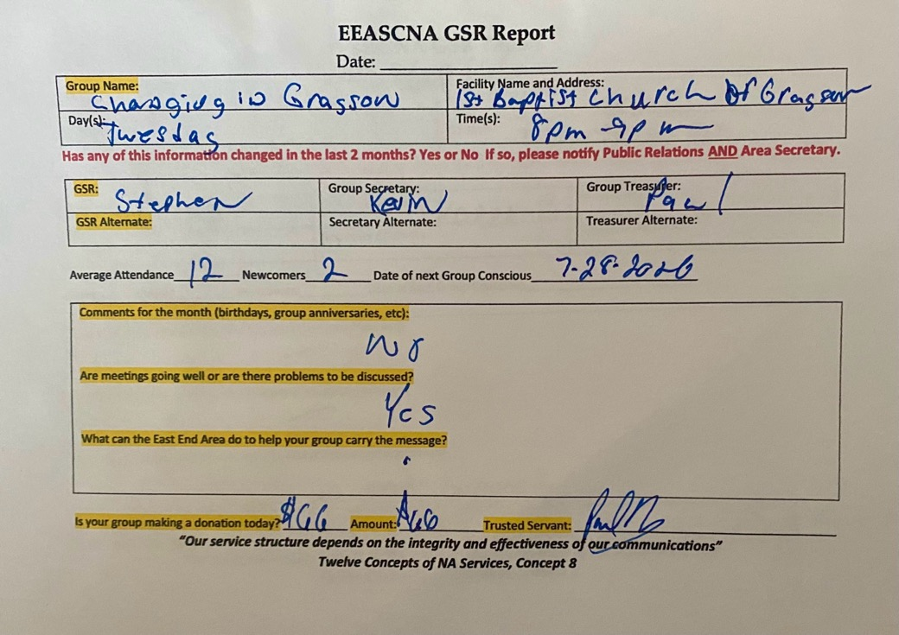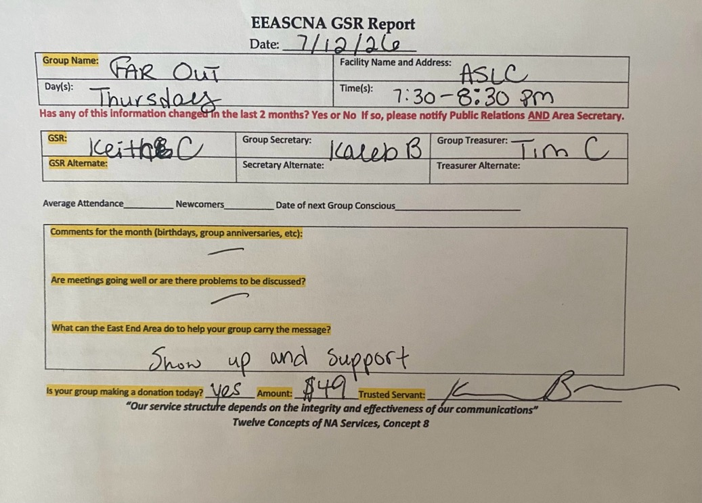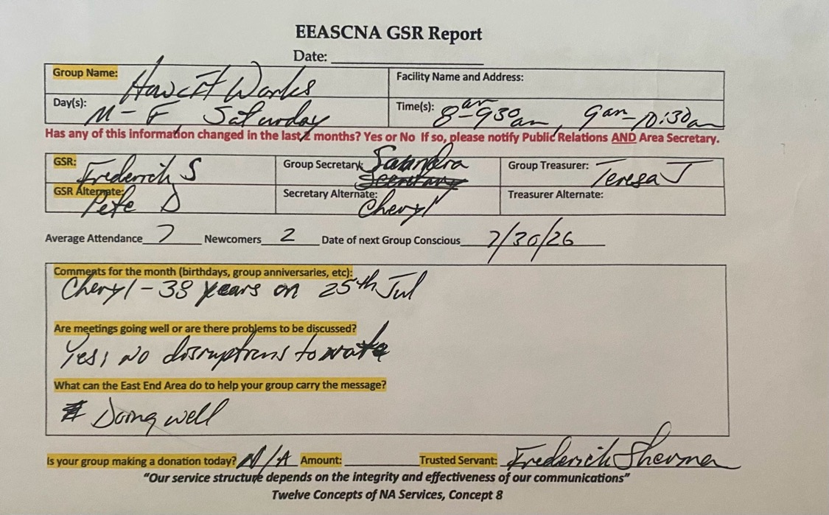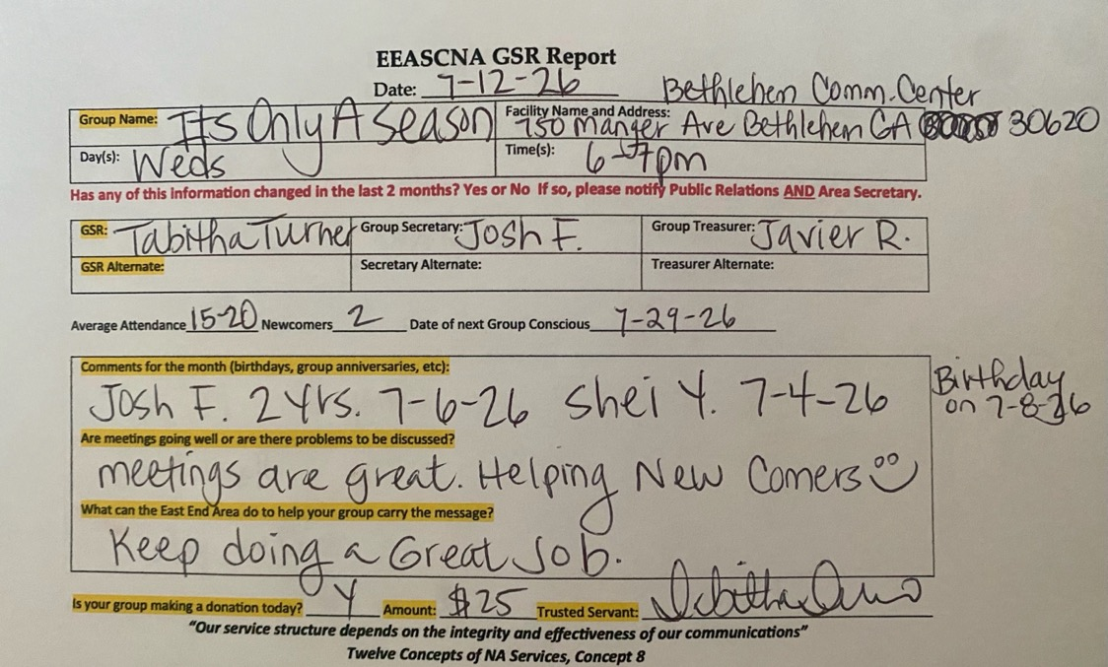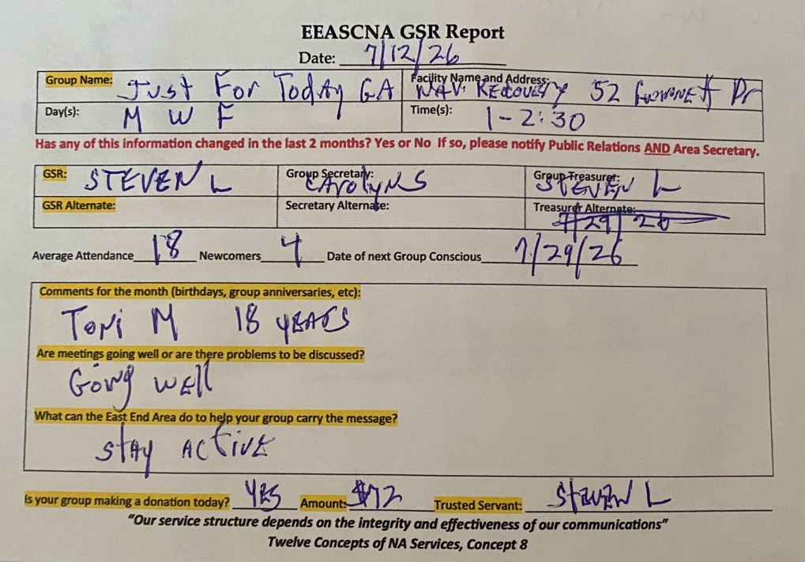

Let The Truth Be Told
Lawrenceville Presbyterian Church
800 Lawrenceville Hwy, Lawrenceville, GA 30046
Saturday 11 am – 12:30 pm
GSR: Jeff S
Secretary: Thom H
Treasurer: B.J. K
15 average attendance with average of 5 newcomers
Next group conscious is 8-1-2026
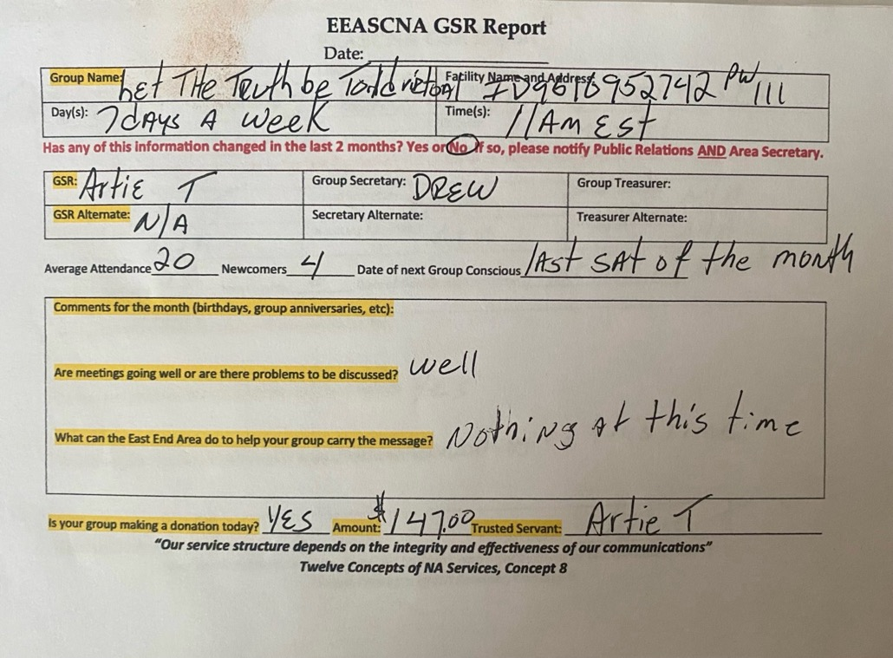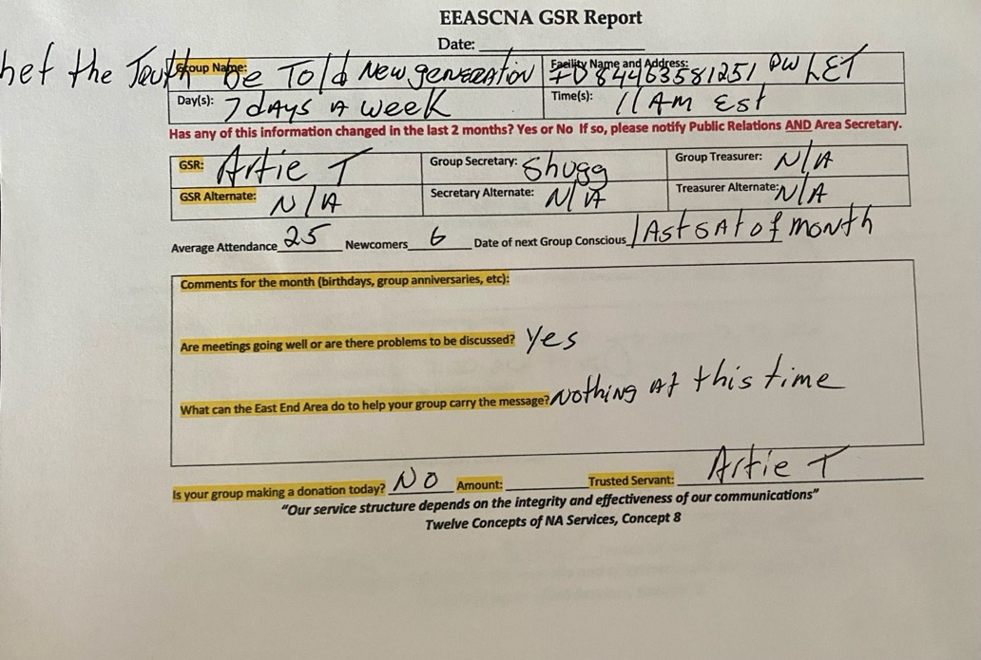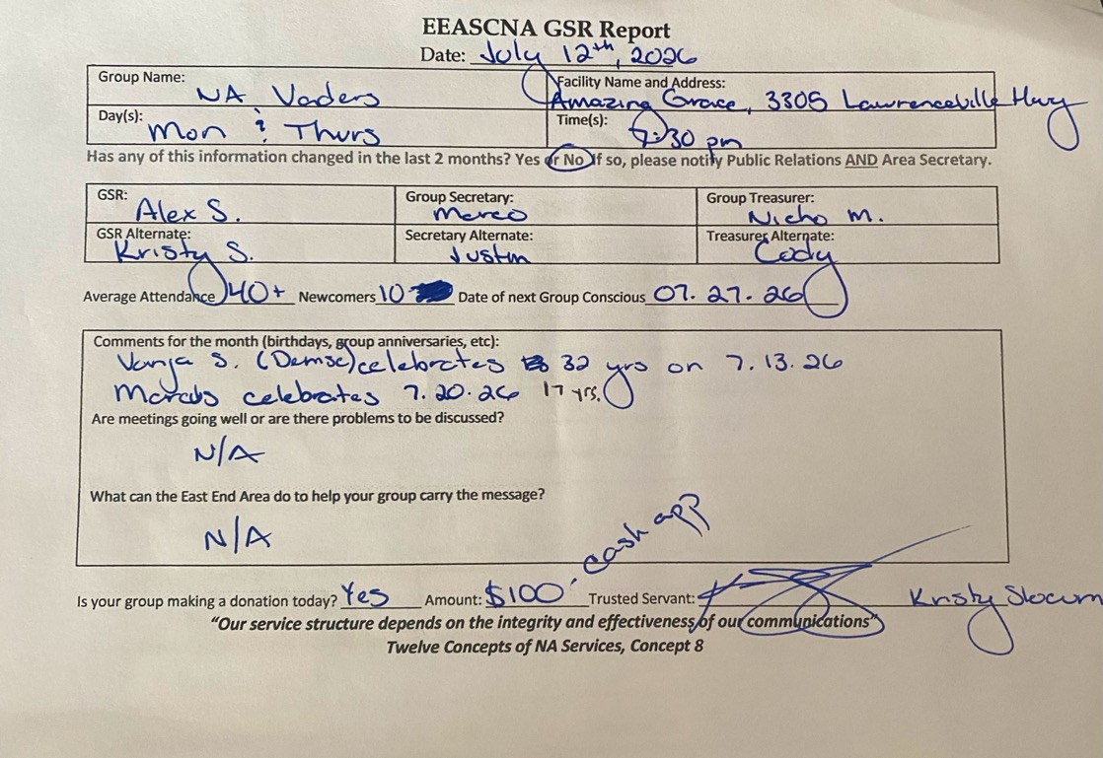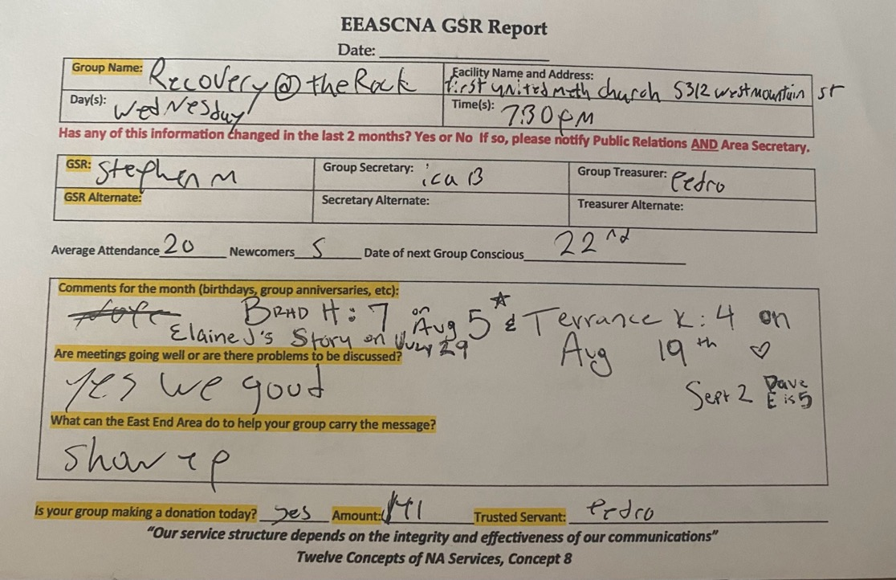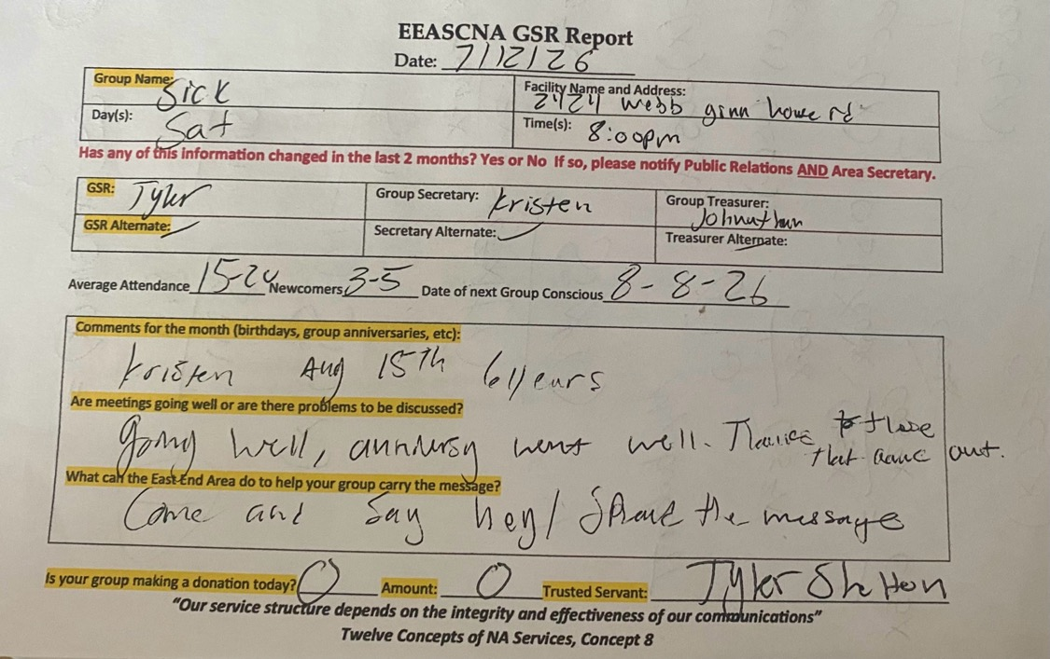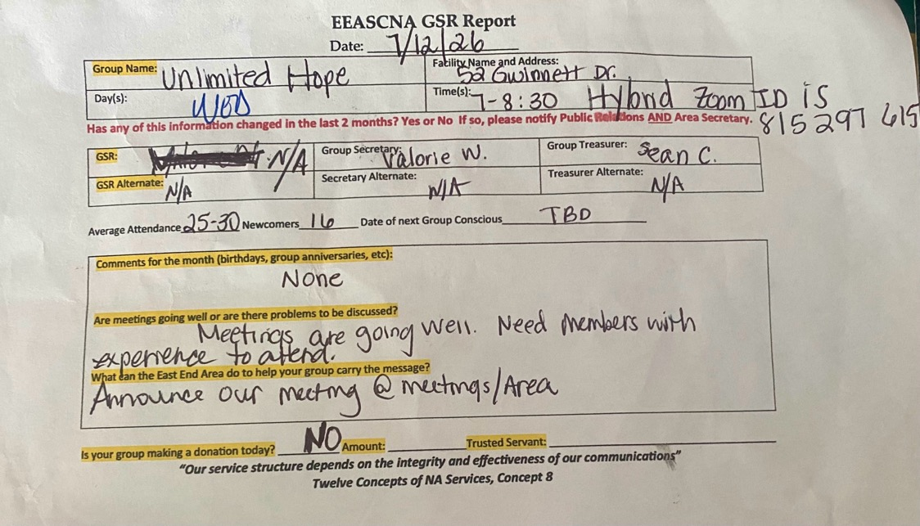

Flyers


Take back to Home groups:

Vacant positions:
RCMA
Alternate Secretary (◕‿◕)♡

Plans for the next meeting:

August 2nd @ Grit & Grace RCO
2800 Georgia Hwy. 138
Conyers, GA 30094

Admin meeting begins at 2:30 pm
Area meeting begins at 3:00 pm

