EEASCNA Minutes April 2026

East end area is part of a worldwide Fellowship.

Elaine J. opened ASC Meeting with moment of silence followed by the Serenity Prayer

Reading of Twelve Traditions – Steven M.

Reading of Twelve Concepts – Alveta J.

Reading of Article III – Jon C.

Article III: A. Definition and Function of the Area: The Area Service Conference (ASC) is the communicative channel for a unified Fellowship, a tie that binds us together. The ASC serves as a link in the flow of communication from the member to the worldwide Fellowship, establishes a structure in which services and education are provided, and functions as a vehicle through which our Area Fellowship and society can relate. The EEASC is a committee made up of Group Service Representatives (GSRs), special purpose Task panels and an Administrative Body from Member Groups of the East End Area.

Administration Roll Call (2025-2026)

Key: 0= Not Present, 1= Present, (-) = Vacant, R= Report submitted only
ROLE | NAME | D | J | F | M | A | M | J | J | A | S | O | N | D
Facilitator | Elaine J. | L | 1 | 1 | 1 | 1
Co-Facilitator | VACANT | - | - | - | - | -
Secretary | Ica B. | 1 | 1 | 1 | 1 | 1
Alt-Secretary | VACANT | - | - | - | - | -
Treasurer | Paul B. | 1 | 1 | 0 | 1 | 1
Alt-Treasurer | Kaleb B. | 1 | 1 | 1 | 1 | -
H&I Chair | Alveta J. | 1 | 0 | 0 | 1 | 1
H&I Vice | Steven L. | - | 1 | 1 | 1 | 1
PR Chair | Simone J. | - | - | - | 1 | 1
PR Vice | VACANT | - | - | - | - | -
Activities Chair | Russell M. | 0 | 0 | 1 | 1 | 1
Activities Vice | VACANT | 0 | 0 | 0 | 0 | -
RCM | Jon C. | 1 | 1 | 1 | 1 | 1
RCMA | Toby B. | 1 | 0 | 1 | 1 | 1

Group Voting Policy:

- To reach quorum, 50% + 1 of groups present must be in good standing.

- A quorum must be reached by fifteen (15) minutes after roll call is completed and before any business can be conducted.

- In order for a topic to be enacted, 80% of the groups present must be in good standing.

- New groups must attend 3 consecutive Area Meetings to gain voting rights at the 3rd Area.
- If a group misses 2 consecutive Area Meetings to regain voting rights at the 2nd.

East End Area Groups Roll Call

Key: 0= Not Present, 1= Present, L= Late, R= Represented (to keep in Good Standing), RO= Report only Blacked Out= Not G.S.
2025-2026 | D | J | F | M | A | M | J | J | A | S | O | N | D
Changing in Grayson | 1 | 1 | 1 | R | 1
Clean & Free | R | R | R | R | R
Covington Miracles |  |  |  | 1 | 1
Fahrfromusin | R | R | R | R | R
Far Out | R | R | R | R | R
Freedom on Friday |  | 1 | L | 1 | 1
Harvest Group
How It Works | 1 | 1 | 1 | 1 | 1
It Works How and Why
It’s Only a Season | 0 | 1 | 0 | 0
Just for Today | R | R | R | R | R
Let the Truth Be Told | L | 1 | 1 | 1 | 1
Let the Truth Be Told-Virtual
Madison Group
NA Vaders | 1 | 1 | 1 | 1 | 1
Out of the Cold – Book Study | 0 | 1 | 0 | 0
Progress not Perfection
Recovery at the Rock | 1 | 1 | 1 | 1 | 1
Serenity Is Common Knowledge | 1 | 1 | 1 | 1 | 1
Sisters In Unity | 0 | 1 | 1 | L | 1
Spiritual Awakening |  |  |  | 1
The Journey Continues | 1 | 1 | 1 | 1 | 1
Unlimited Hope | 0 | R | 0 | 0
We Stick and Stay
Total of Groups in Area | 22 | 20 | 21 | 23 | 24 |  |  |  |  |  |  | 21
Total Groups Present | 9 | 16 | 13 | 15 | 14 |  |  |  |  |  |  | 13
Groups in Good Standing | 12 | 14 | 15 | 15 | 14 |  |  |  |  |  |  | 12
Groups Present & G.S. | 9 | 14 | 12 | 13 | 14 |  |  |  |  |  |  | 12
Number for Quorum (50% + 1)?  Is Quorum reached? | Y | Y | Y | Y | Y |  |  |  |  |  |  | Y
Number for Consensus  (80% present in G.S)? | 8 | 12 | 8 | 11 | 10 |  |  |  |  |  |  | 10
**Opened meeting at 3:00 p.m. – Roll Call ended at 3:06 p.m. At that time Quorum was met

Subcommittee Reports

Treasurer’s Report
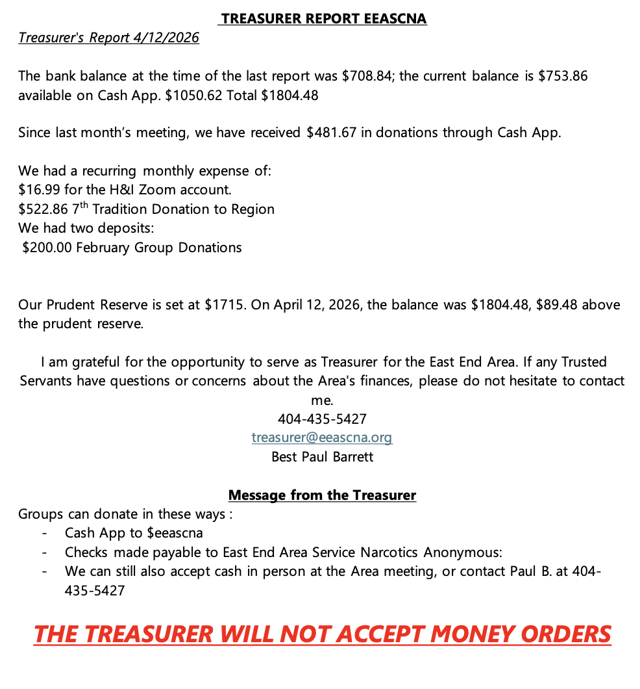

RCM Report
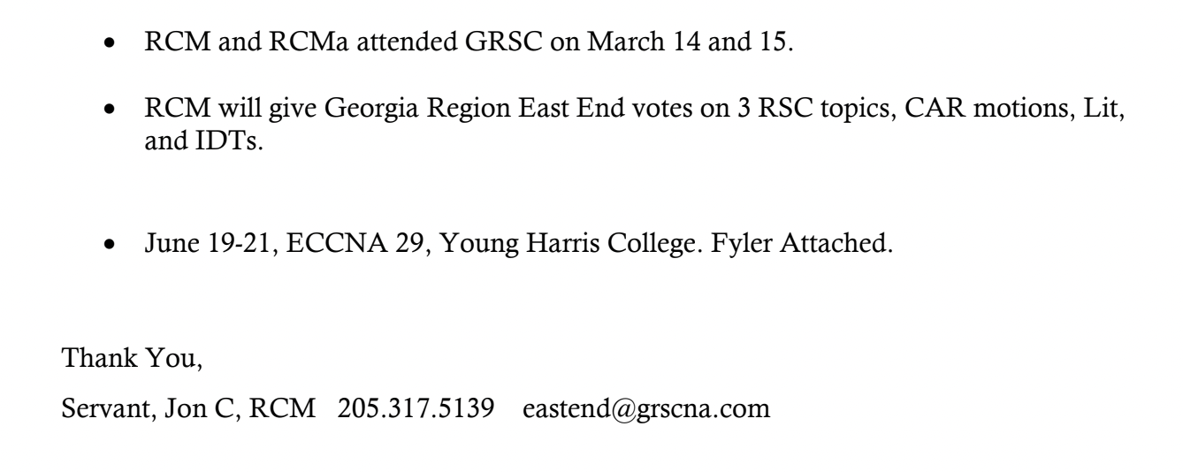
Topic 2025-15 (bod pool) reached consensus
Elimination reached consensus
All three passed
15 nominations ~ all resumes [note from secretary: when RCM sends resumes to me, I will forward them along to GSRs and trusted servants]

2026-001: ASC submission overcalculated donations
- An area donated more money than they meant to the region, and there is nothing in policy about how to do this. Area has to request refund within two weeks
2026-004: GSR Assembly a two-day event instead of one-day event
- Being nice to GSRs asking
- Jan 16-17 if 2 days, 16 if one

H&I Report

H and I is going well, we did carry the message to the jail during March, except the Thursday before Easter. We picked up the following week with meetings. I took literature to the jail on 25 March in the following quantities:
Literature Distribution
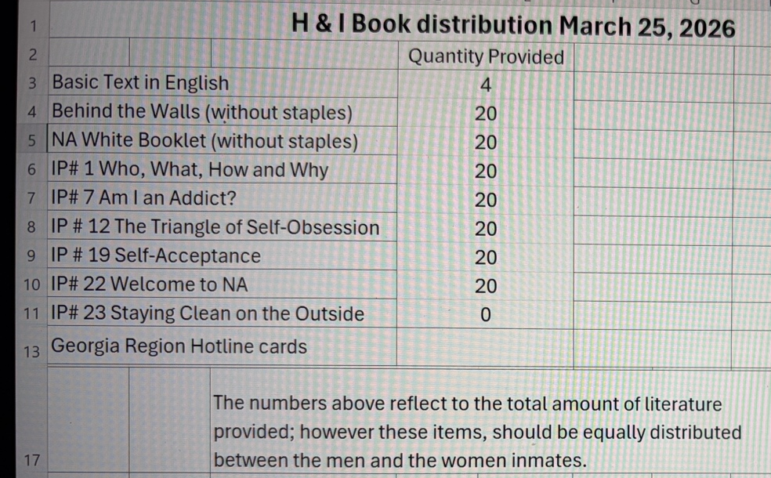
New Order placed 10 April
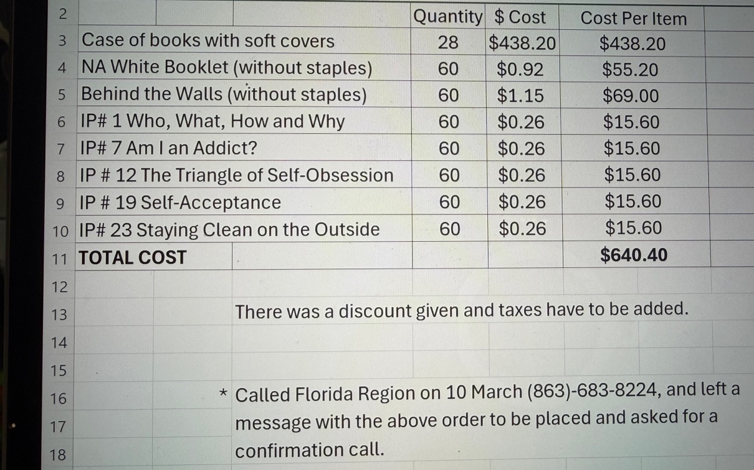

PR and H & I are planning to do a presentation to the possible new location in Norcross, more to follow as we make arrangements, we also plan to take the remaining literature that I currently have on hand. The literature is a mirror of the quantities that are listed above in the last distribution to the Gwinnett County Jail.
I was able to attend for the Georgia Region for a second time and I requested and received reimbursement for both trips, as well as printing of flyers for H & I Volunteers. We were blessed to receive 8 Basic Text which greatly helped us to fulfill our commitment to provide literature to the jail and to the new treatment facility. I chose a learning day but I need to rethink the date because I chose the weekend of Memorial Weekend. More to follow on that. Please don’t hesitate to contact me with any questions or if you know someone that is interested in giving back what was so freely given to them. Thank you for allowing me to be of service and to serve.

Alveta J. H&I Chair

PR Report

Simone J, we are so grateful to have you joining our Admin as PR Chair
[Upon 22 April 2026, secretary has not received report. If/when report is given, secretary will update minutes documentation on East End website]

Activities Report
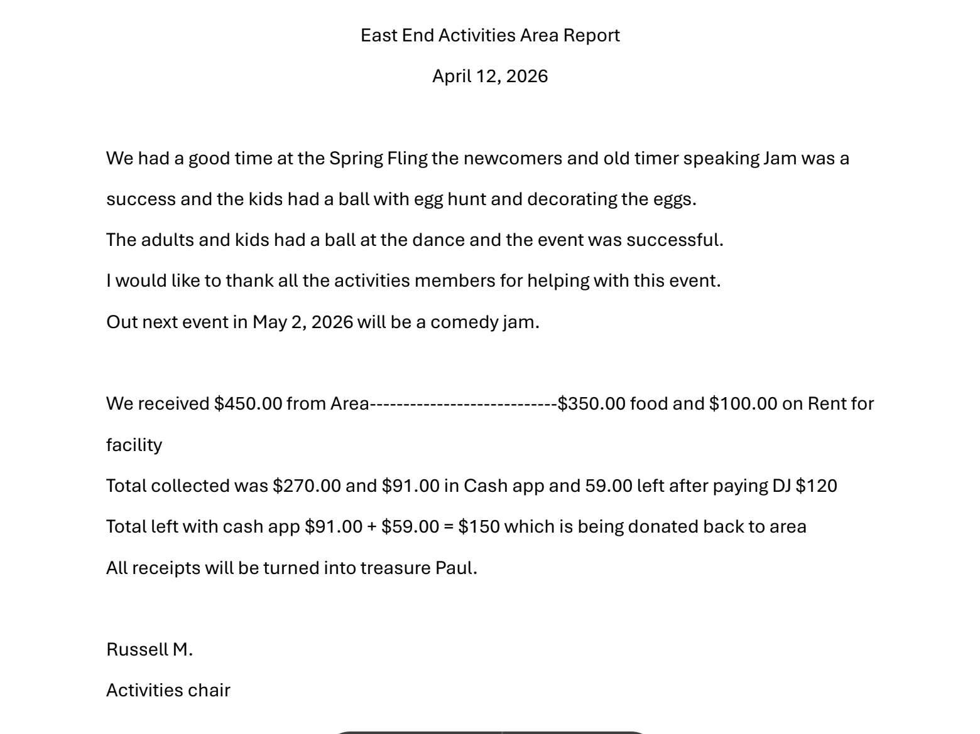

Old Business

NONE

Nominations/Elections

NONE

OPEN FORUM

NONE

New Business

NONE

GSR Reports

Changing in Grayson: First Baptist Church Grayson on Tuesdays at 8:00 pm
GSR: Steven M (trusted servant)
Group Secretary: Kevin
Group Treasurer: Paul B
Average attendance of 20-25 with 2-4 newcomers
4-28-2026 is next group conscious

How It Works: Zoar Church on Mondays-Fridays 8 am to 9:30 am, Saturdays 9:00am-10:30 am
GSR: Frederick S & GSR Alt: Sandra J
Secretary: Saundra
Treasurer: Teresa J
Average attendance 8 with 3 newcomers
Next group conscious: 4-30-2026

Let The Truth Be Told: Lawrenceville Presbyterian Church on Saturday from 11:00 AM – 12:30 PM
GSR: Jeff S (trusted servant)
Secretary: Thom H.
Treasurer: B.J. K.
Average attendance of 10 with 5 newcomers
Next group conscious: 5-2-2026

Recovery at the Rock: Stone Mountain First United Methodist Church from 7:30 – 8:30 pm on Wednesdays
GSR: Stephen M
Secretary: Ica B
Treasurer: Pedro M
Average attendance: 20-25 with 5 newcomers
Date of next group conscious: 4-15-2026
DAVE T CELEBRATES 10 YEARS ON 4-15-2026

Restore Group: Sugar Hill Church @ 5091 Nelson Brodgon Blvd. Sugar Hill, GA 30518 on Sundays from 7:00pm-8:00pm
GSR is Brandon L
Group Secretary is Kirk W
Please come support this brand-new group!

Serenity is Common Knowledge: 2424 Webb Ginn House Rd on Saturdays at 8:00 pm
GSR: Tyler S (trusted servant)
Secretary: Kristen
Treasurer: Jonathan
Average attendance 15-20 with 5 newcomers
Date of next GC is 5-2-2026
BRAD IS CELEBRATING ON 4-18-2026

Sisters in Unity: Lawrenceville Presbyterian on Tuesdays at 7 pm
GSR: Molly P (trusted servant) & GSR Alt: Blair J.
Secretary: Melissa
Group Treasurer: Cheryl B.
Average attendance of 25 with 10 newcomers
Next group conscious 4-14-2026
NA Vaders @ Amazing Grace Lutheran Church on Mondays && Thursdays from 7:30-8:45 pm
GSR is Alex (trusted servant)
Secretary is Marco
Treasurer is Nicho
Average attendance is 40 with 10 newcomers
Date of next group conscious: 4-27-2026

The Journey Continues: Zoar Church on Tuesdays from 7:00pm to 8:30 pm
GSR: Thomas W (trusted servant)
Group Secretary: June A
Group Treasurer: Elaine J
Average Attendance: 12 – 22 with 7 newcomers
Date of next GC: 4/28/2026

Flyers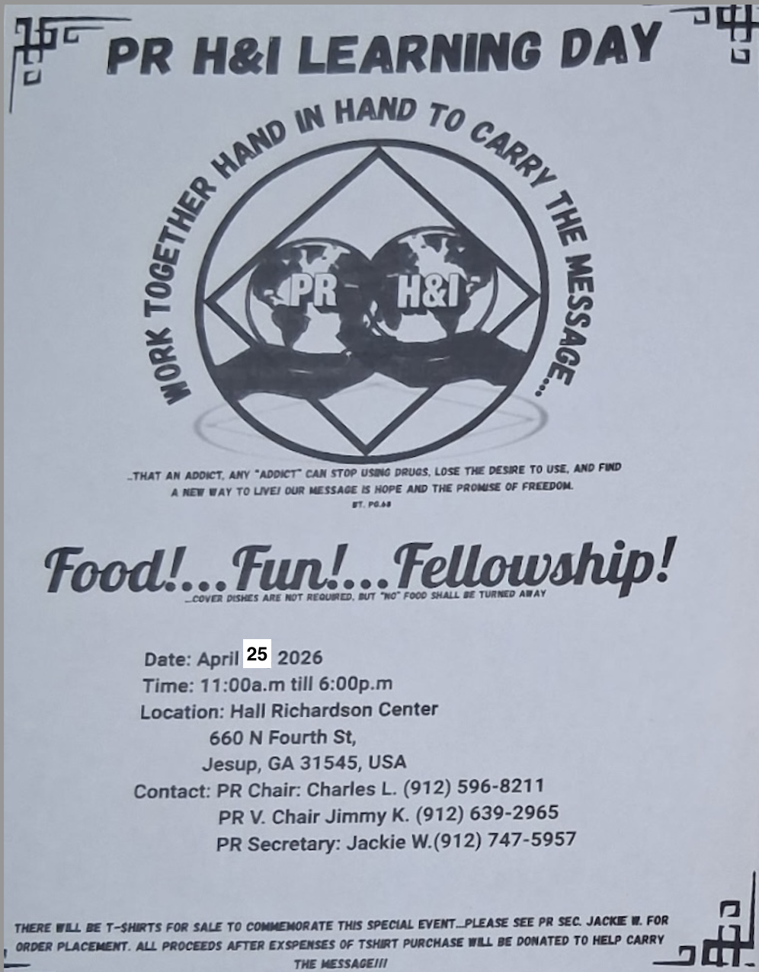
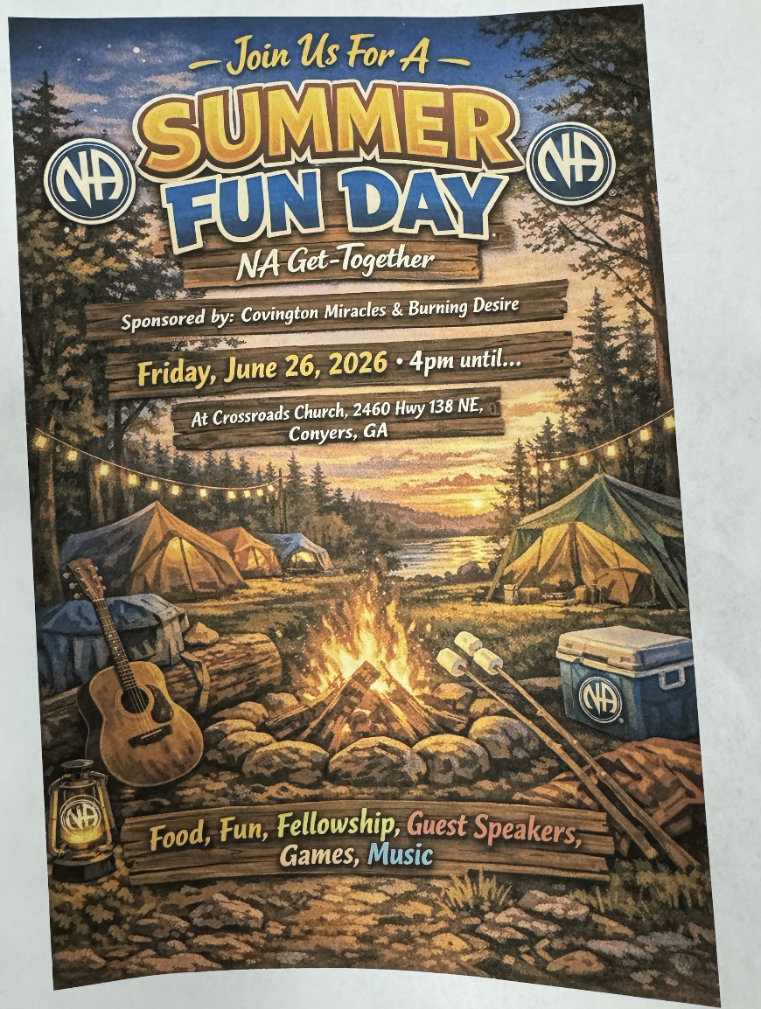


Take back to Home groups:

2026-001: “ASC submission [regarding] overcalculated donations”
- An area donated more money than they meant to the region, and there is nothing in policy about how to remedy this. Policy change would state an area has to request refund from region within two weeks
2026-004: GSR Assembly becoming a two-day event instead of one-day event
- In the past, the GSR Assembly has been one day. This topic proposes to make the GSR Assembly two days. [if it is to be one day in 2027, the date will be January 16. If it is two-days, they will be January 16-17]

Vacant positions:
Co-Facilitator
Alternate Secretary

Plans for the next meeting:

May 3rd @ Zoar United Methodist Church
3895 Zoar Church Road SW
Snellville, GA, 30039

Admin meeting begins at 2:30 pm
Area meeting begins at 3:00 pm

