**EEASCNA Minutes - October 2018**

* Area began at 3:00 pm
* Simone opened ASC Meeting with moment of silence followed by the Serenity Prayer
* Reading of Twelve Traditions - Yvonne J.
* Reading of Twelve Concepts - Autumn R.
* Reading of Article II & III: Purpose of EEASCNA - Simone

**Article II:** Purpose The purpose of the East End Area Service Committee of Narcotics Anonymous (EEASCNA) shall be to respond to the needs and collective conscience of its member groups. EEASCNA supports and encourages the unity, welfare and growth of the East End Area as part of a worldwide Fellowship.

**Article III:** A. Definition and Function of the Area: The Area Service Conference (ASC) is the communicative channel for a unified Fellowship, a tie that binds us together. The ASC serves as a link in the flow of communication from the member to the worldwide Fellowship, establishes a structure in which services and education are provided, and functions as a vehicle through which our Area Fellowship and society can relate. The EEASC is a Committee made up of Group Service Representatives (GSRs), special purpose Task panels and an Administrative Body from Member Groups of the East End Area.

**Administration Roll-Call**

**Key: 0= Not Present, 1= Present, (-) = Vacant, R= Report submitted only**

|  |  |  |  |  |  |  |  |  |  |  |  |  |  |  |
| --- | --- | --- | --- | --- | --- | --- | --- | --- | --- | --- | --- | --- | --- | --- |
| **ROLE** | **NAME** | **D** | **J** | **F** | **M** | **A** | **M** | **J** | **J** | **A** | **S** | **O** | **N** | **D** |
| **Facilitator** | **Simone J.** | **1** | **1** | **1** | **1** | **1** | **1** | **1** | **1** | **1** | **0** | **1** |  |  |
| **Co-Facilitator** | **Willie A.** | **-** | **1** | **1** | **1** | **1** | **1** | **0** | **1** | **1** | **1** | **0** |  |  |
| **Secretary** | **Kristin F.** | **1** | **1** | **1** | **1** | **1** | **1** | **1** | **1** | **1** | **1** | **1** |  |  |
| **Alt-Secretary** | **VACANT** | **-** | **-** | **-** | **-** | **-** | **-** | **-** | **-** | **-** | **-** | **-** |  |  |
| **Treasurer** | **Fred G.** | **1** | **1** | **1** | **1** | **1** | **1** | **1** | **1** | **1** | **1** | **1** |  |  |
| **Alt-Treasurer** | **Geraldine G.** | **-** | **-** | **-** | **-** | **-** | **-** | **-** | **-** | **1** | **0** | **1** |  |  |
| **H&I Chair** | **Jon C.** | **1** | **1** | **1** | **1** | **1** | **1** | **1** | **1** | **1** | **0** | **0** |  |  |
| **H&I Vice** | **Nicole A.** | **-** | **-** | **0** | **0** | **0** | **0** | **0** | **0** | **0** | **0** | **0** |  |  |
| **PR Chair** | **Linda Z.** | **1** | **1** | **1** | **1** | **1** | **1** | **1** | **1** | **1** | **1** | **1** |  |  |
| **PR Vice** | **VACANT** | **-** | **-** | **-** | **-** | **-** | **-** | **-** | **-** | **-** | **-** | **-** |  |  |
| **Activities** | **Tracy S.** | **-** | **1** | **0** | **1** | **1** | **1** | **1** | **1** | **0** | **1** | **0** |  |  |
| **Activities Vice** | **VACANT** | **-** | **-** | **-** | **-** | **-** | **1** | **1** | **1** | **0** | **-** | **-** |  |  |
| **RCM** | **Jackson J.** | **1** | **1** | **1** | **1** | **1** | **1** | **-** | **-** | **-** | **1** | **1** |  |  |
| **RCMA** | **David C.** | **1** | **1** | **1** | **1** | **0** | **1** | **1** | **1** | **1** | **1** | **1** |  |  |

**Group Voting Policy:**

1. To reach quorum, 50% + 1 of groups present must be in good-standing.
2. A quorum must be reached by fifteen (15) minutes after roll call is completed and before any business can be conducted.
3. In order for a topic to be enacted, 80% of the groups present must be in good standing.
4. New groups must attend 3 consecutive Area Meetings to gain voting rights at the 3rd Area.
5. If a group misses 2 consecutive Area Meetings to re-gain voting rights at the 2nd.

**East End Area Groups Roll Call**

**Key: 0= Not Present, 1= Present, R= Report Submitted only, Blacked Out= Not G.S.**

|  |  |  |  |  |  |  |  |  |  |  |  |  |  |
| --- | --- | --- | --- | --- | --- | --- | --- | --- | --- | --- | --- | --- | --- |
| **2017-2018** | **D** | **J** | **F** | **M** | **A** | **M** | **J** | **J** | **A** | **S** | **O** | **N** | **D** |
| **By NA Means Necessary** | **0** | **0** | **0** | **0** | **0** | **0** | **0** | **0** | **0** | **0** | **0** |  |  |
| **Changing in Grayson** | **1** | **1** | **1** | **0** | **1** | **0** | **R** | **R** | **R** | **R** | **R** |  |  |
| **Clean & Free** | **1** | **1** | **1** | **1** | **1** | **1** | **1** | **1** | **1** | **1** | **0** |  |  |
| **Covington Miracles** | **1** | **1** | **1** | **1** | **1** | **1** | **1** | **1** | **1** | **1** | **0** |  |  |
| **Fahrfromusin** | **1** | **1** | **1** | **1** | **1** | **1** | **1** | **1** | **1** | **0** | **1** |  |  |
| **Far Out** | **0** | **0** | **0** | **0** | **0** | **0** | **0** | **0** | **1** | **0** | **0** |  |  |
| **Freedom on Friday** | **-** | **-** | **-** | **-** | **1** | **1** | **1** | **1** | **1** | **R** | **R** |  |  |
| **Get Real** | **1** | **0** | **1** | **0** | **1** | **0** | **0** | **0** | **0** | **0** | **0** |  |  |
| **Harvest** | **1** | **1** | **1** | **1** | **1** | **1** | **1** | **1** | **0** | **0** | **1** |  |  |
| **How It Works** | **1** | **1** | **1** | **1** | **1** | **1** | **1** | **1** | **1** | **1** | **1** |  |  |
| **Just for Today** | **1** | **1** | **1** | **1** | **1** | **R** | **1** | **1** | **1** | **1** | **0** |  |  |
| **Let the Truth Be Told** | **0** | **1** | **1** | **0** | **1** | **0** | **1** | **0** | **1** | **0** | **0** |  |  |
| **Monroe New Miracles** | **1** | **1** | **1** | **1** | **1** | **1** | **1** | **1** | **0** | **1** | **1** |  |  |
| **NA Vaders** | **1** | **1** | **1** | **1** | **0** | **1** | **1** | **1** | **1** | **1** | **1** |  |  |
| **NA Way** | **1** | **1** | **1** | **1** | **R** | **R** | **1** | **1** | **1** | **1** | **1** |  |  |
| **Recovery at the Rock** | **1** | **1** | **0** | **1** | **1** | **R** | **1** | **0** | **0** | **0** | **0** |  |  |
| **Restoration at work** | **1** | **1** | **1** | **1** | **1** | **1** | **1** | **1** | **1** | **1** | **1** |  |  |
| **Sisters in Unity** | **1** | **1** | **1** | **1** | **1** | **1** | **1** | **R** | **1** | **1** | **1** |  |  |
| **Spiritual Principles** | **0** | **1** | **1** | **1** | **1** | **1** | **1** | **1** | **1** | **0** | **1** |  |  |
| **Touch of Hope** | **-** | **-** | **-** | **-** | **-** | **-** | **-** | **1** | **1** | **1** | **0** |  |  |
| **The Journey Continues** | **1** | **1** | **1** | **1** | **1** | **1** | **1** | **1** | **1** | **1** | **1** |  |  |
| **Unlimited Hope** | **1** | **0** | **1** | **1** | **1** | **1** | **0** | **1** | **1** | **1** | **1** |  |  |
| **Total of Groups in Area** | **23** | **22** | **22** | **22** | **23** | **23** | **23** | **23** | **24** | **24** | **24** |  |  |
| **Total Groups Present** | **16** | **16** | **17** | **15** | **18** | **14** | **17** | **16** | **16** | **13** | **13** |  |  |
| **Groups in Good Standing** | **17** | **17** | **17** | **17** | **17** | **17** | **18** | **18** | **18** | **19** | **18** |  |  |
| **Groups Present & G.S.** | **15** | **16** | **16** | **15** | **15** | **13** | **17** | **16** | **15** | **11** | **13** |  |  |
| **Number for Quorum (50% + 1)?**  **Is Quorum reached?** | **10 Yes** | **10 Yes** | **10 Yes** | **10 Yes** | **10 Yes** | **10 Yes** | **10 Yes** | **10 Yes** | **10 Yes** | **10 Yes** | **10 Yes** |  |  |
| **Number for Consensus (80% present in G.S)?**  **# needed to Assent on Topics** | **12** | **13** | **13** | **12** | **12** | **11** | **14** | **13** | **11** | **9** | **9** |  |  |
| **Roll call ended at 3:09 pm**  **At this moment, quorum was met** |  |  |  |  |  |  |  |  |  |  |  |  |  |
|  |  |  |  |  |  |  |  |  |  |  |  |  |  |

**Subcommittee Reports**

**Treasurer Report**

Full report below:

To East End Area Trusted Servants,

Since last month’s meeting we have received $490.98 in group donations. $420.98 was deposited into the EEASCNA checking account, and $70 cash was given to Activities for storage containers and New Comers Lunch Tip.

We had monthly expenses incurred in the amount of $1168.76. The checks that have cleared and online/debit card payments are listed on the attached spreadsheet. The beginning balance for September statement was $2813.86 and the ending balance is $1645.10. This is less than our Prudent Reserve, $1715, by $69.90

Please note that the August column of the balance sheet had to be updated since we moved September Area to August 26th. Although somewhat confusing, it had to be done to make the bank statements and our records match.

I am grateful for the opportunity to serve the East End Area as Treasurer. If any Trusted Servants have questions or concerns about the Area finance’s, please feel free to contact me at 678-325-8827 or email at fgiordiano@gmail.com.

Kind Regards,

Fred Giordiano

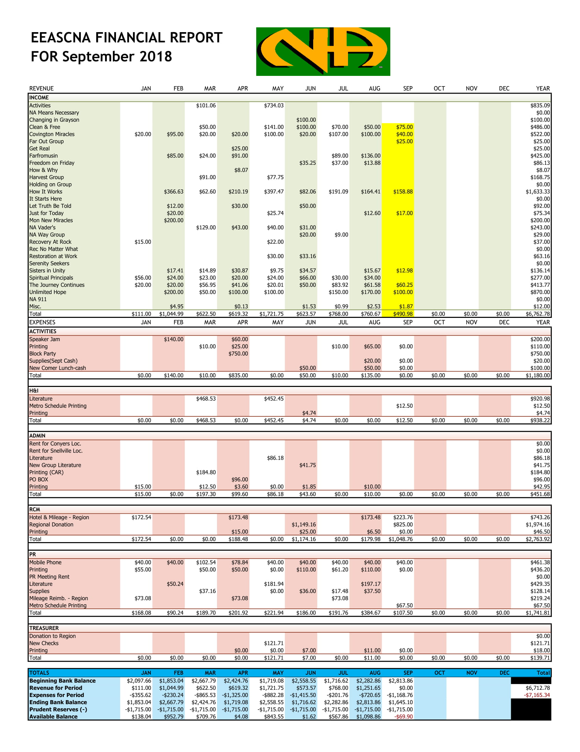

**RCM Report**

Next RSC will be December 8th & 9th

* Announce Georgia Regional Convention
* ***Topics from Region to be voted on are below the RCM Report***





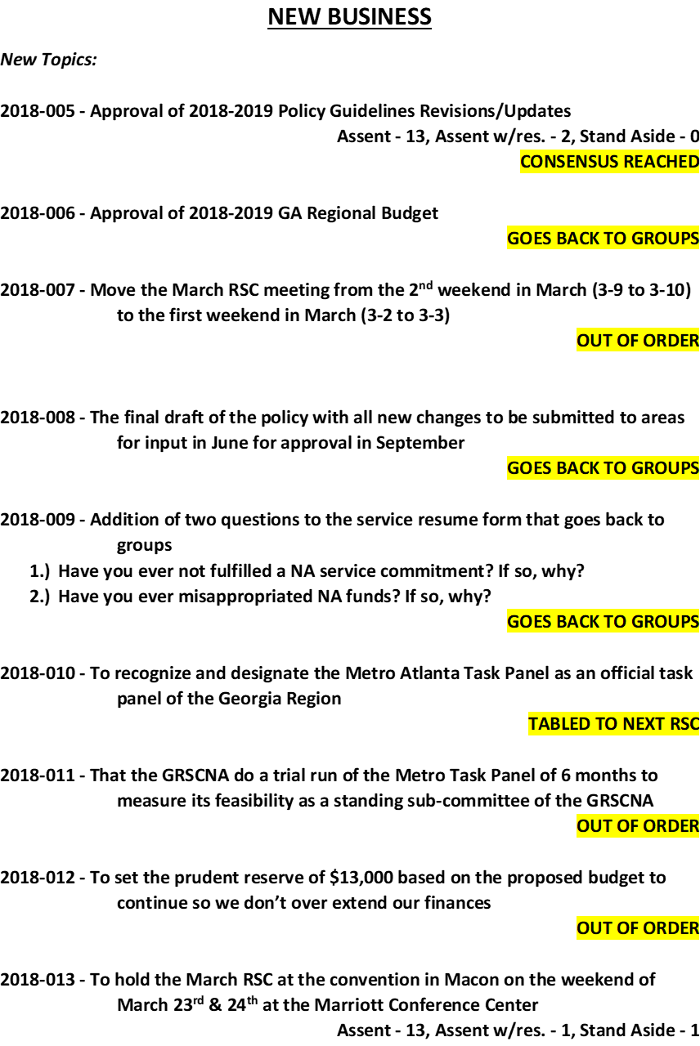



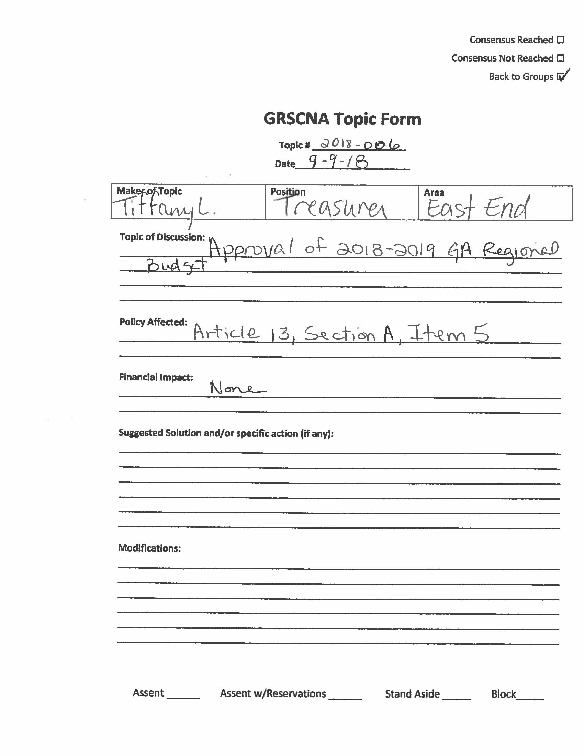

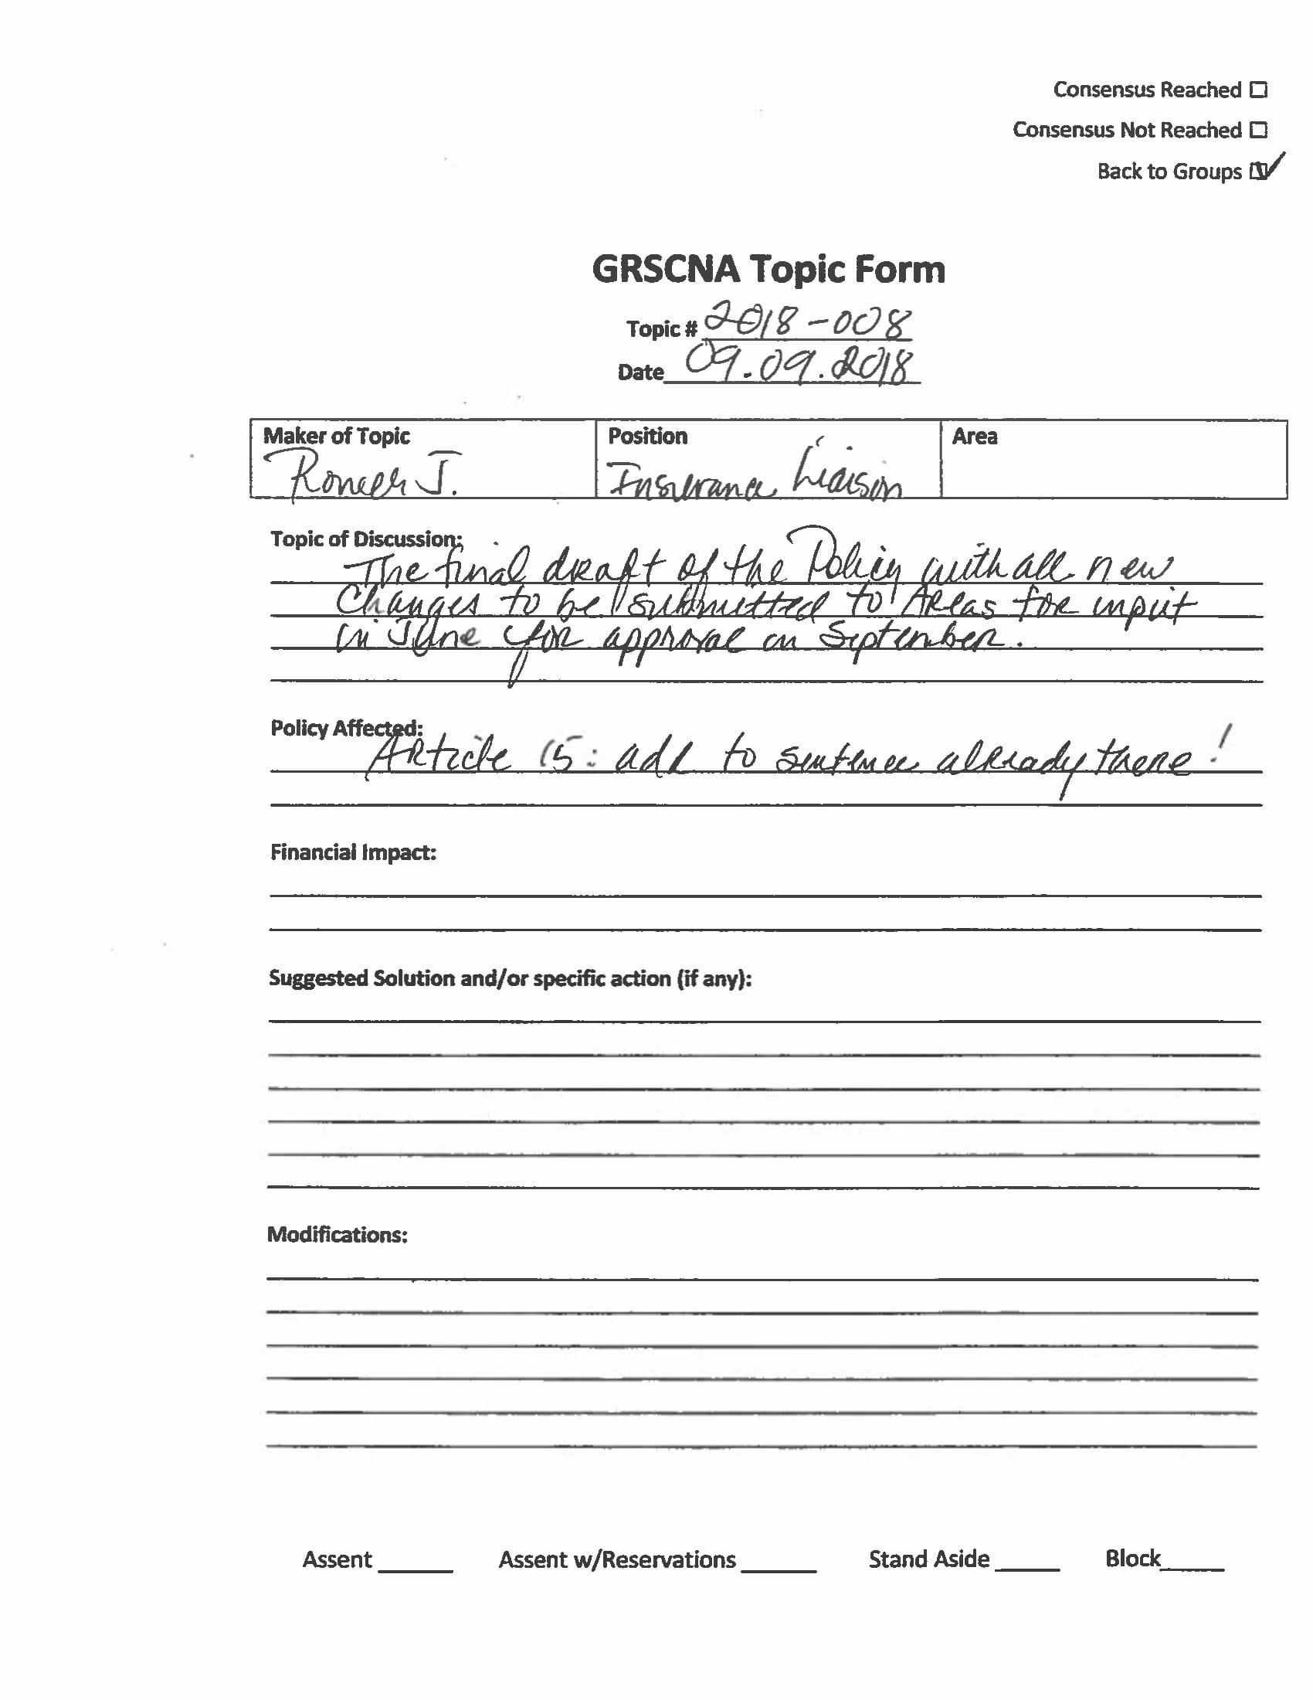

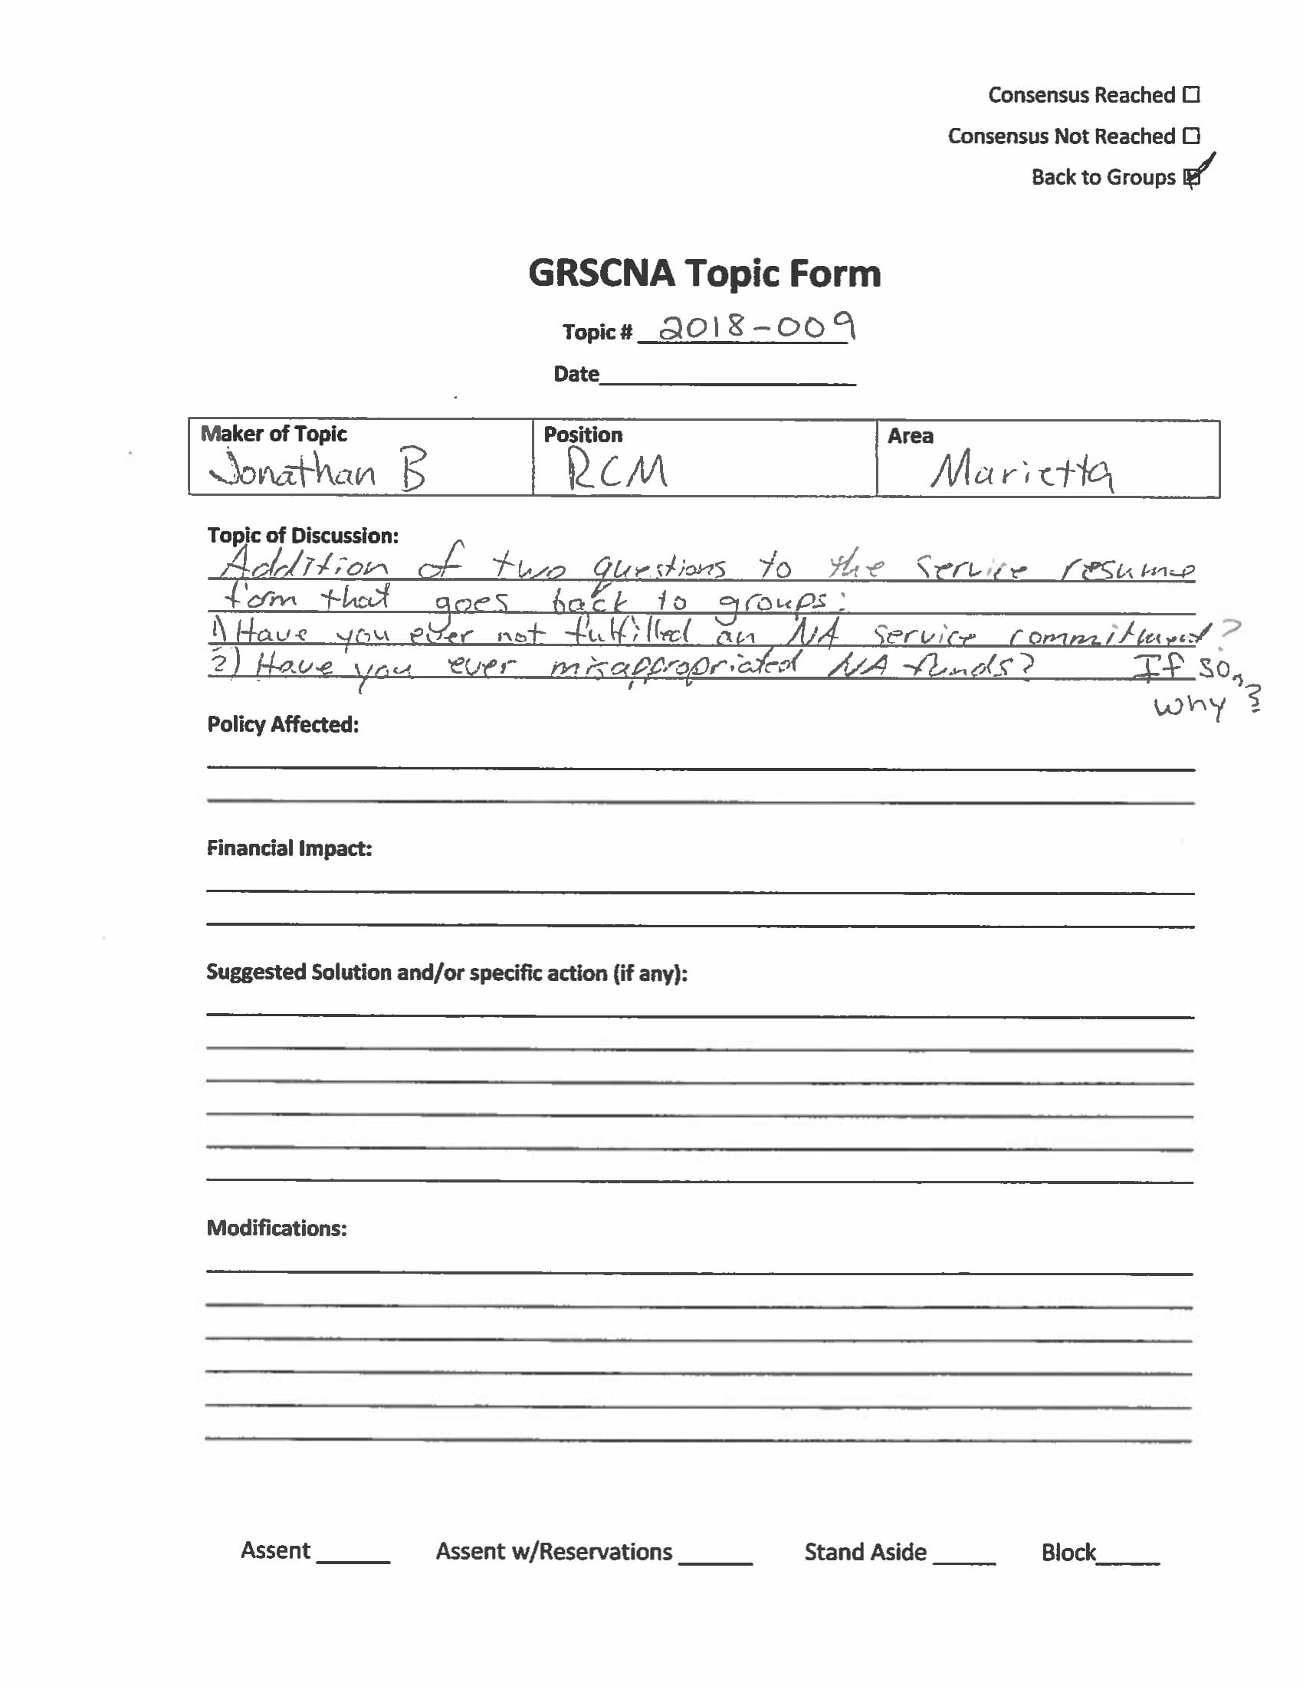

**H & I Report**

**H&I Chair not present at ASC meeting**

* Contact Jon C. to volunteer - (205) 317-5139
* 90-day clean time requirement
* Please announce H&I needs in meetings, don’t wait until group conscious!!

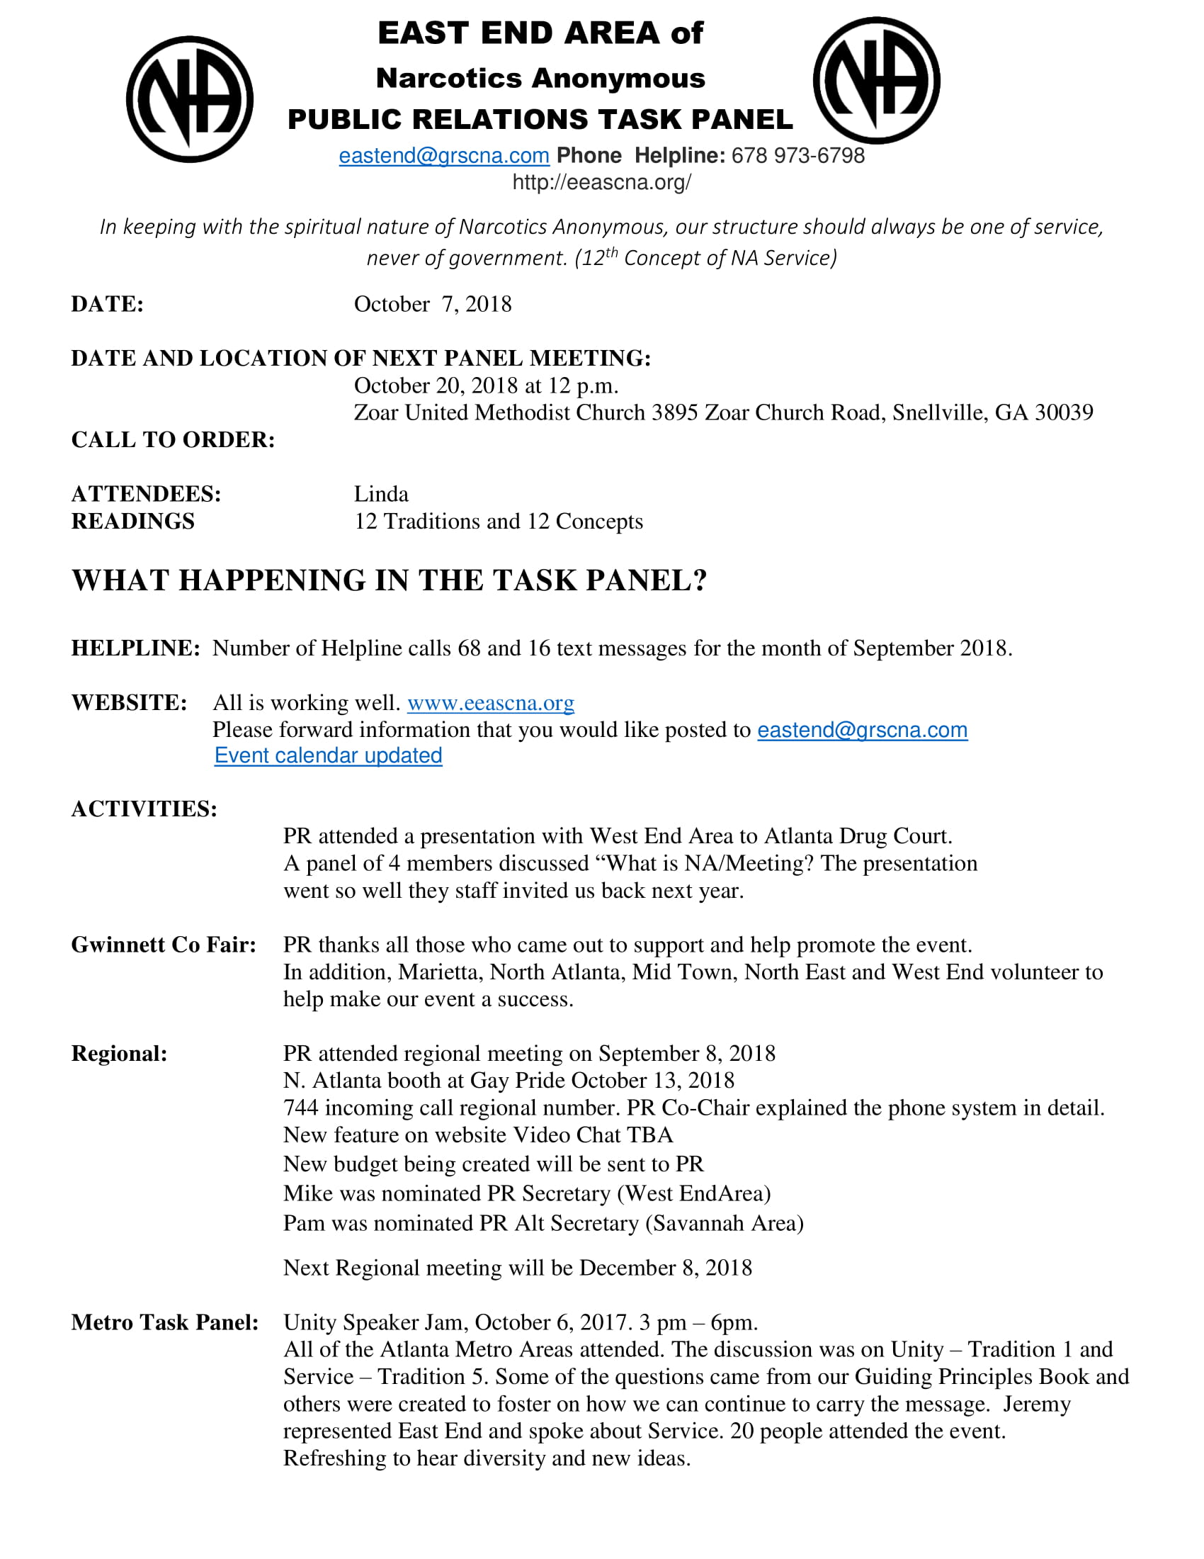**Public Relations Report**

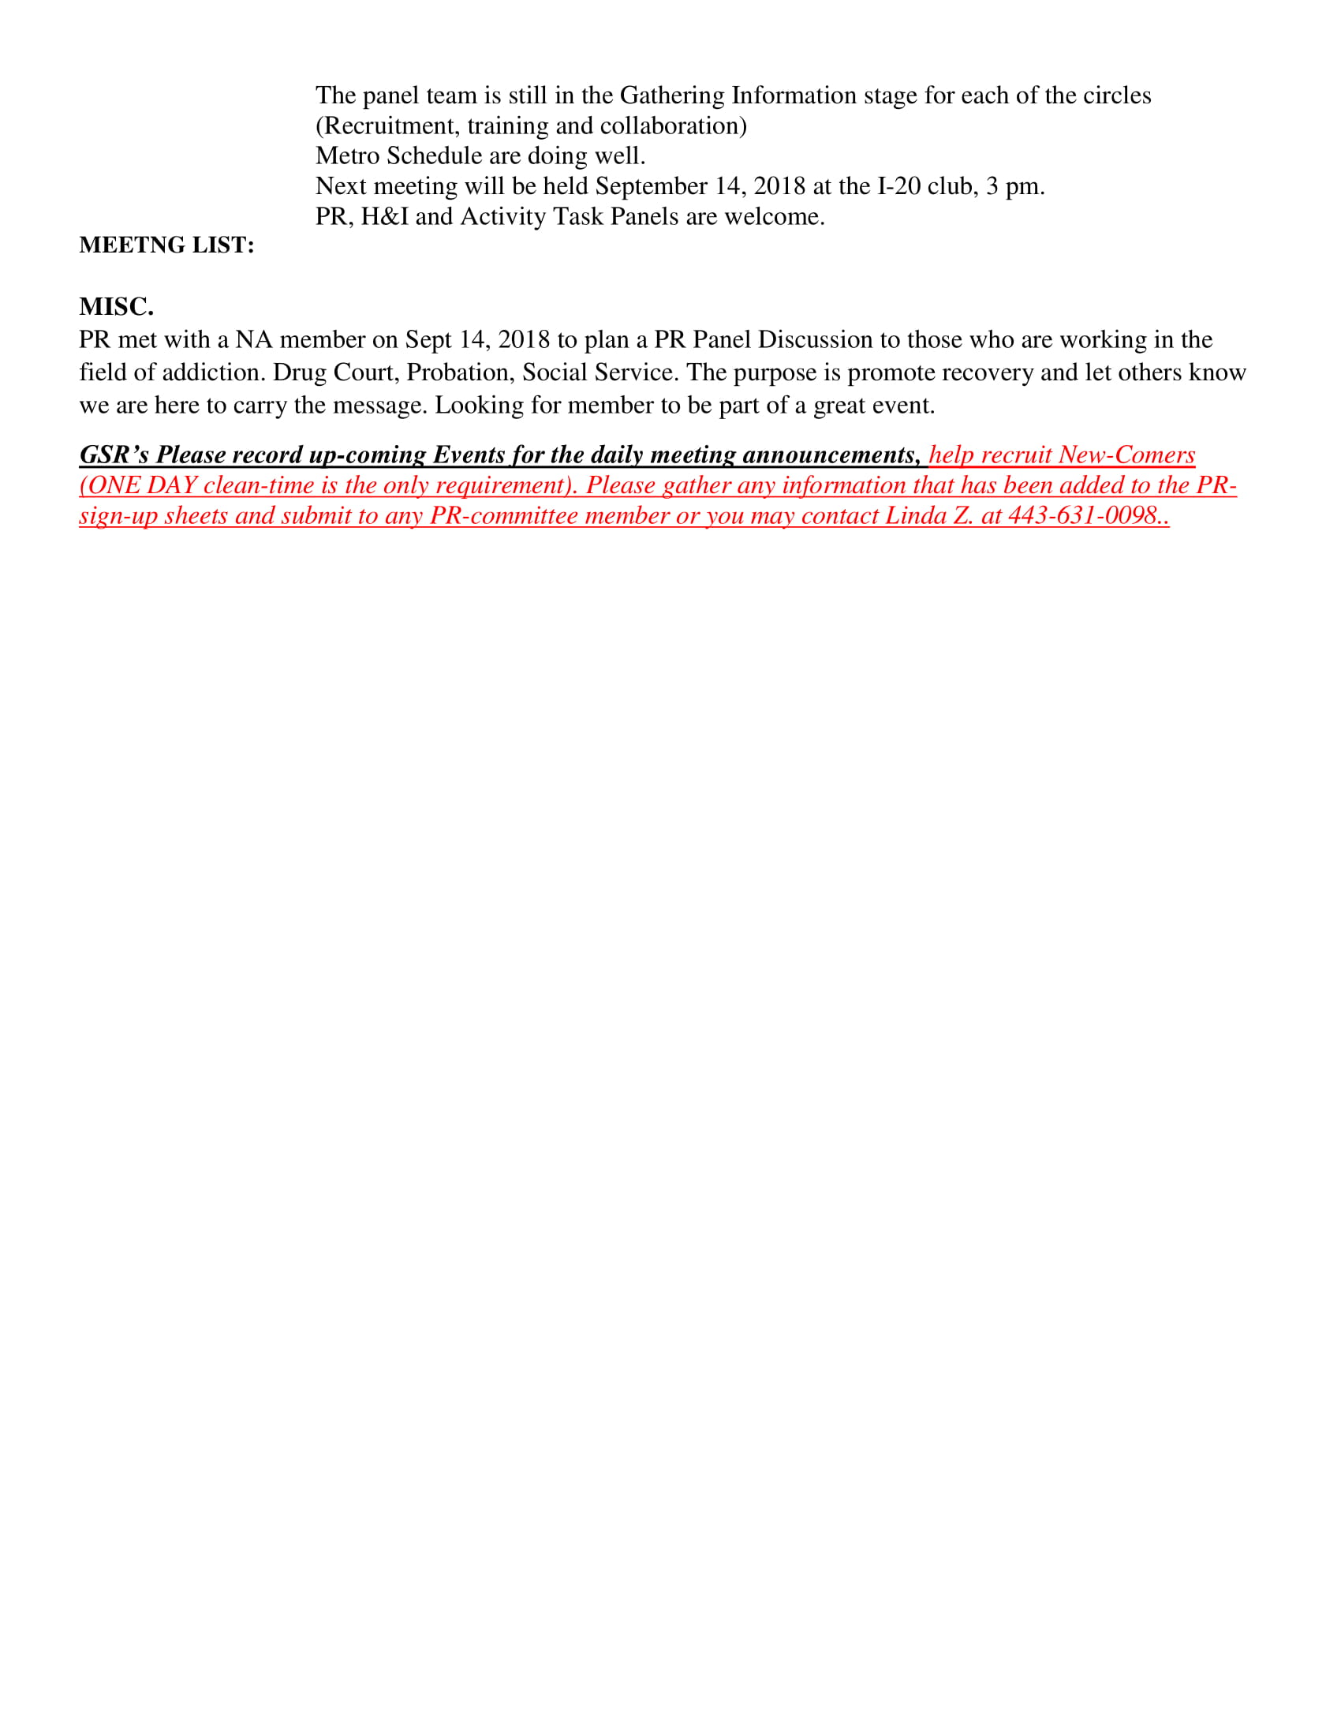

**Activities Report**

* Upcoming events -
  + November - Thanksgiving marathon
    - Flyer and sign-up sheet below***
* Will sell soda and water at ASC from now on
* Make sure GSRs are spreading word about events! Hand out flyers! Announce at meetings!!
* Activities sub-committee meeting meets the 3rd Saturday of every month at 11 am at Zoar church

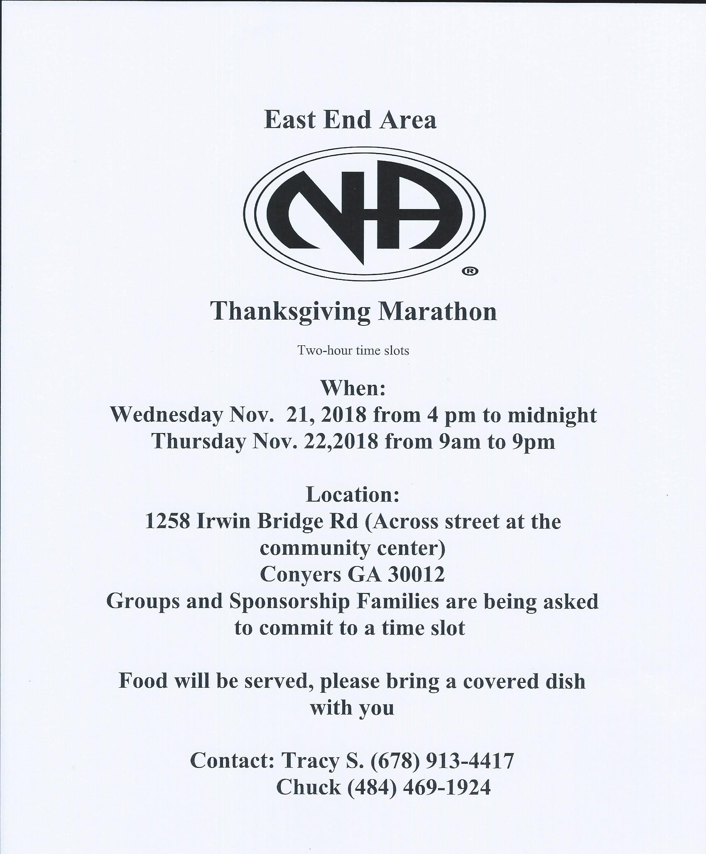

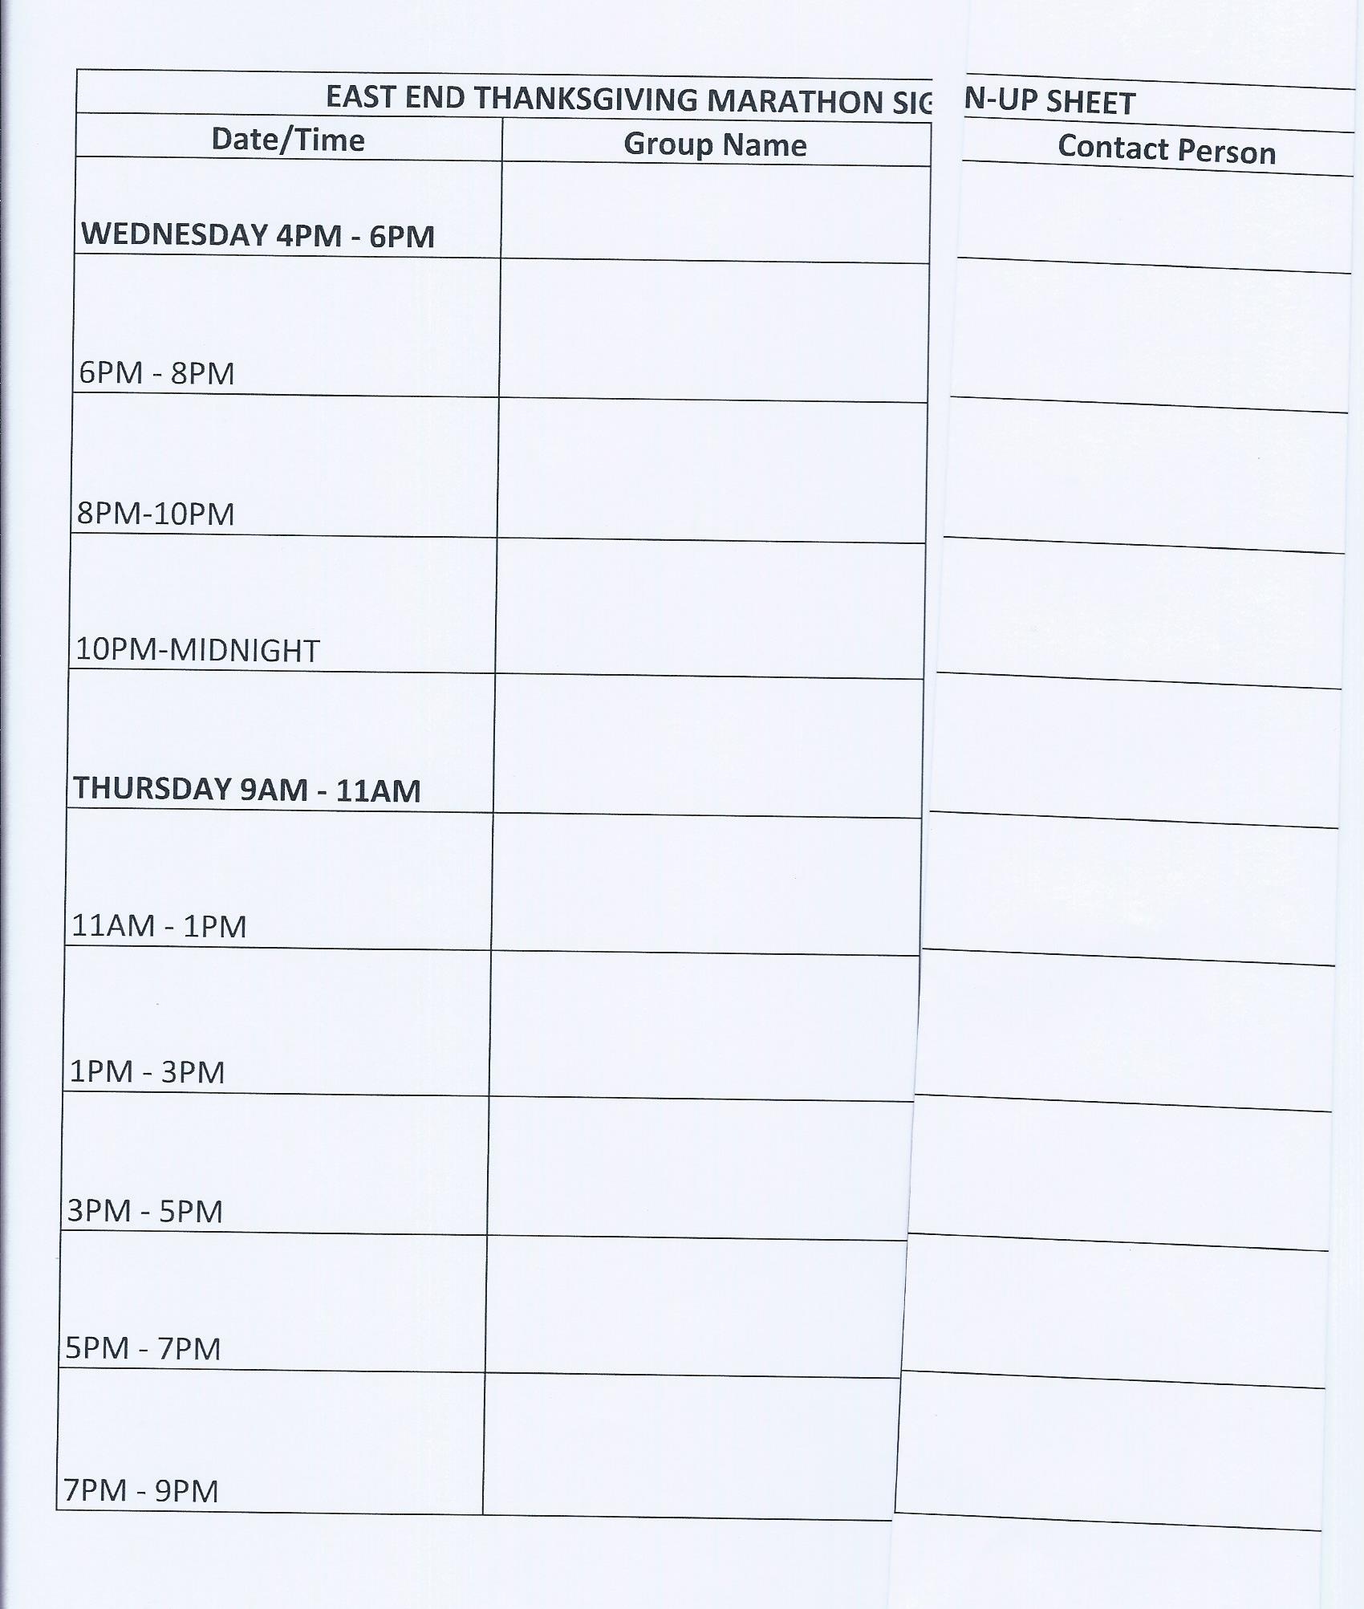

**Group Reports**

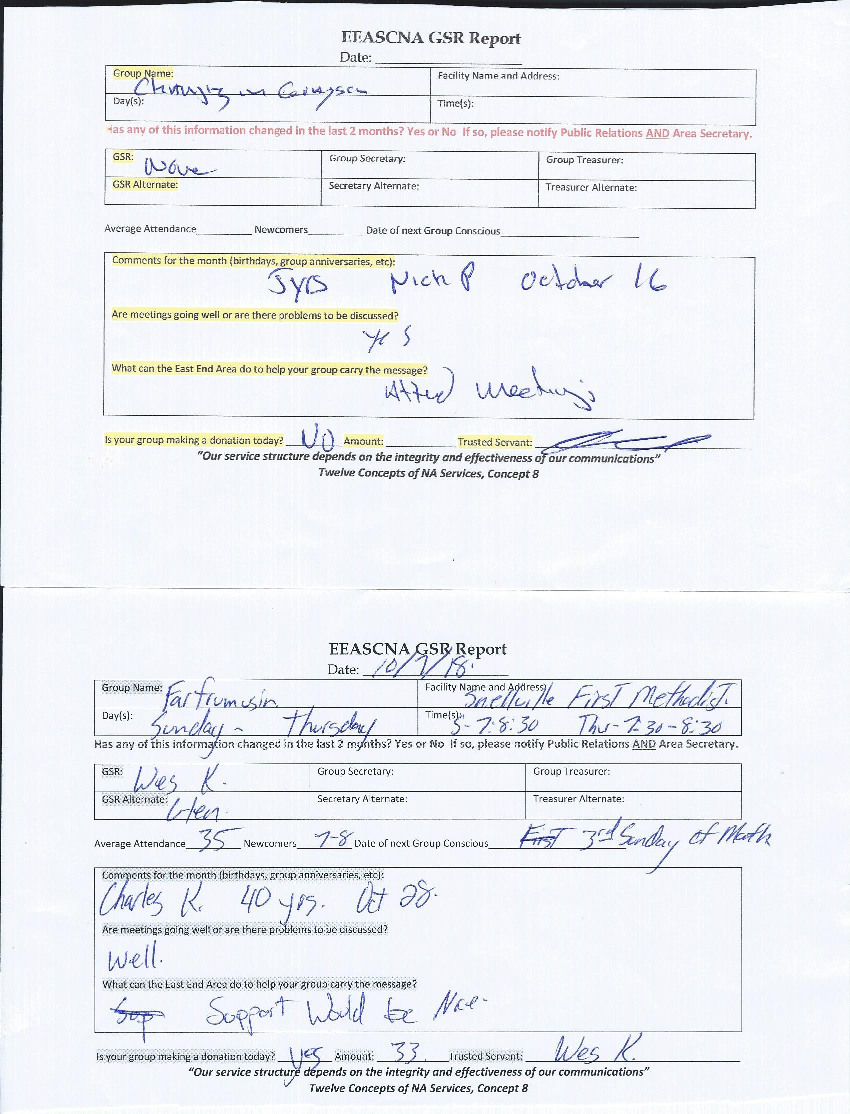**SCANNED AND ATTACHED BELOW**

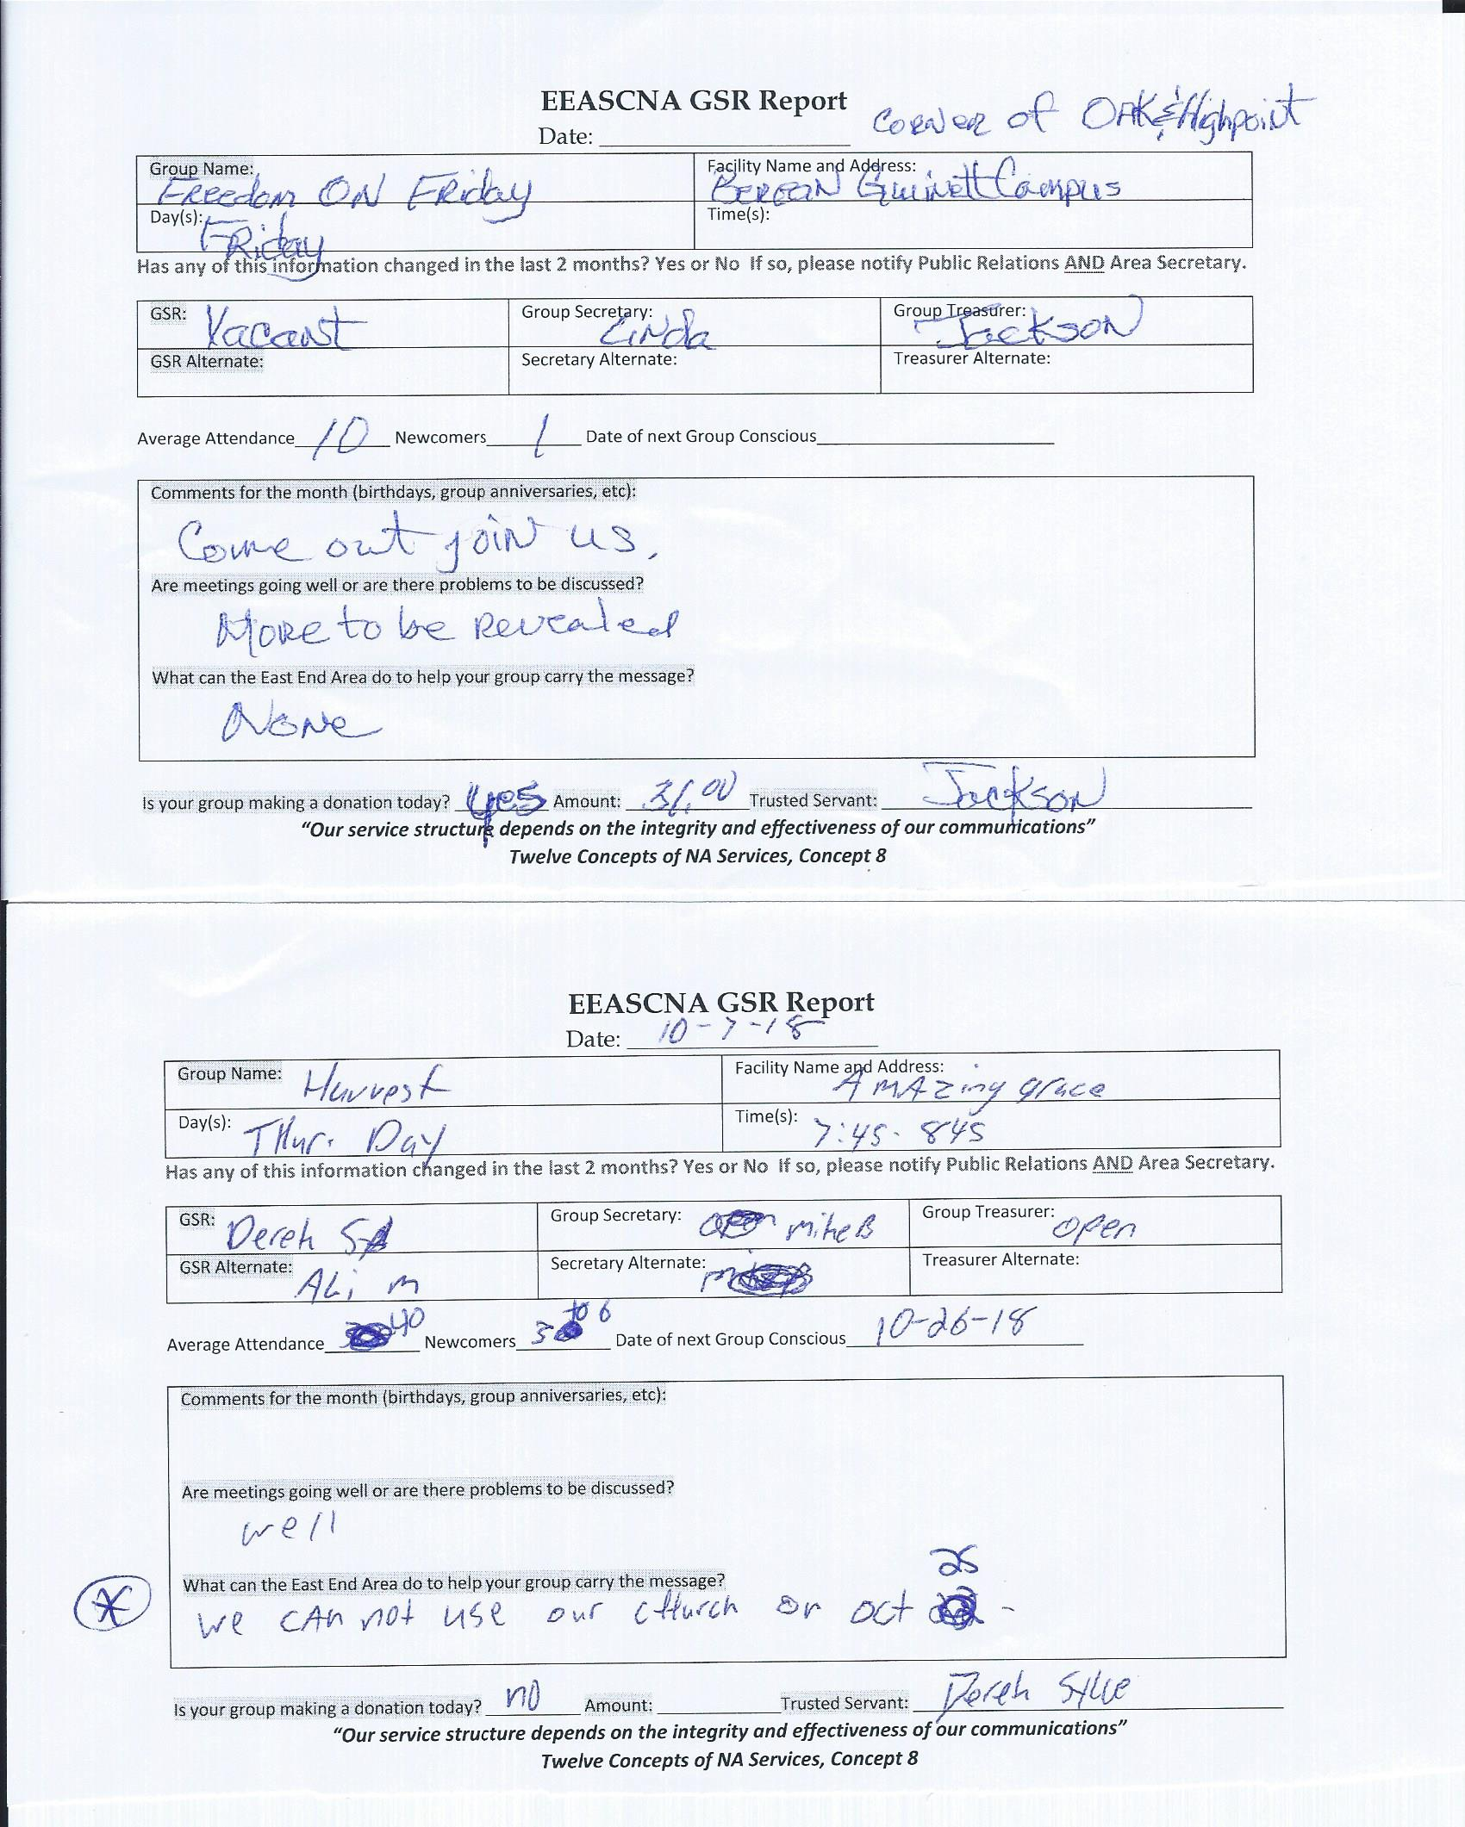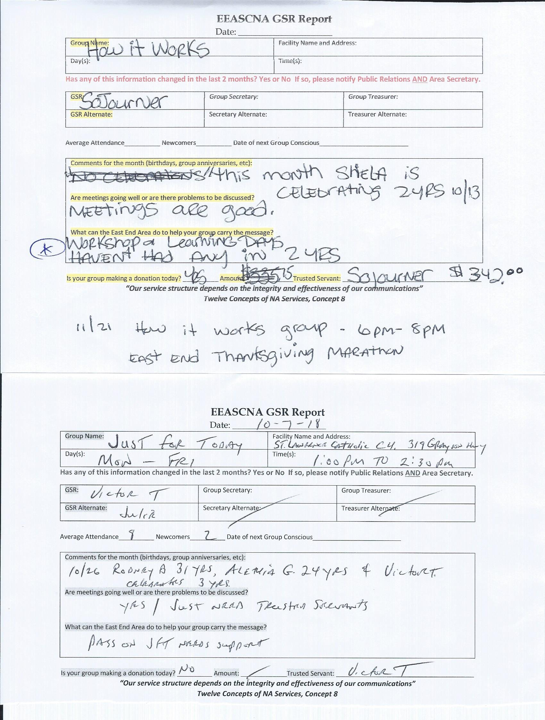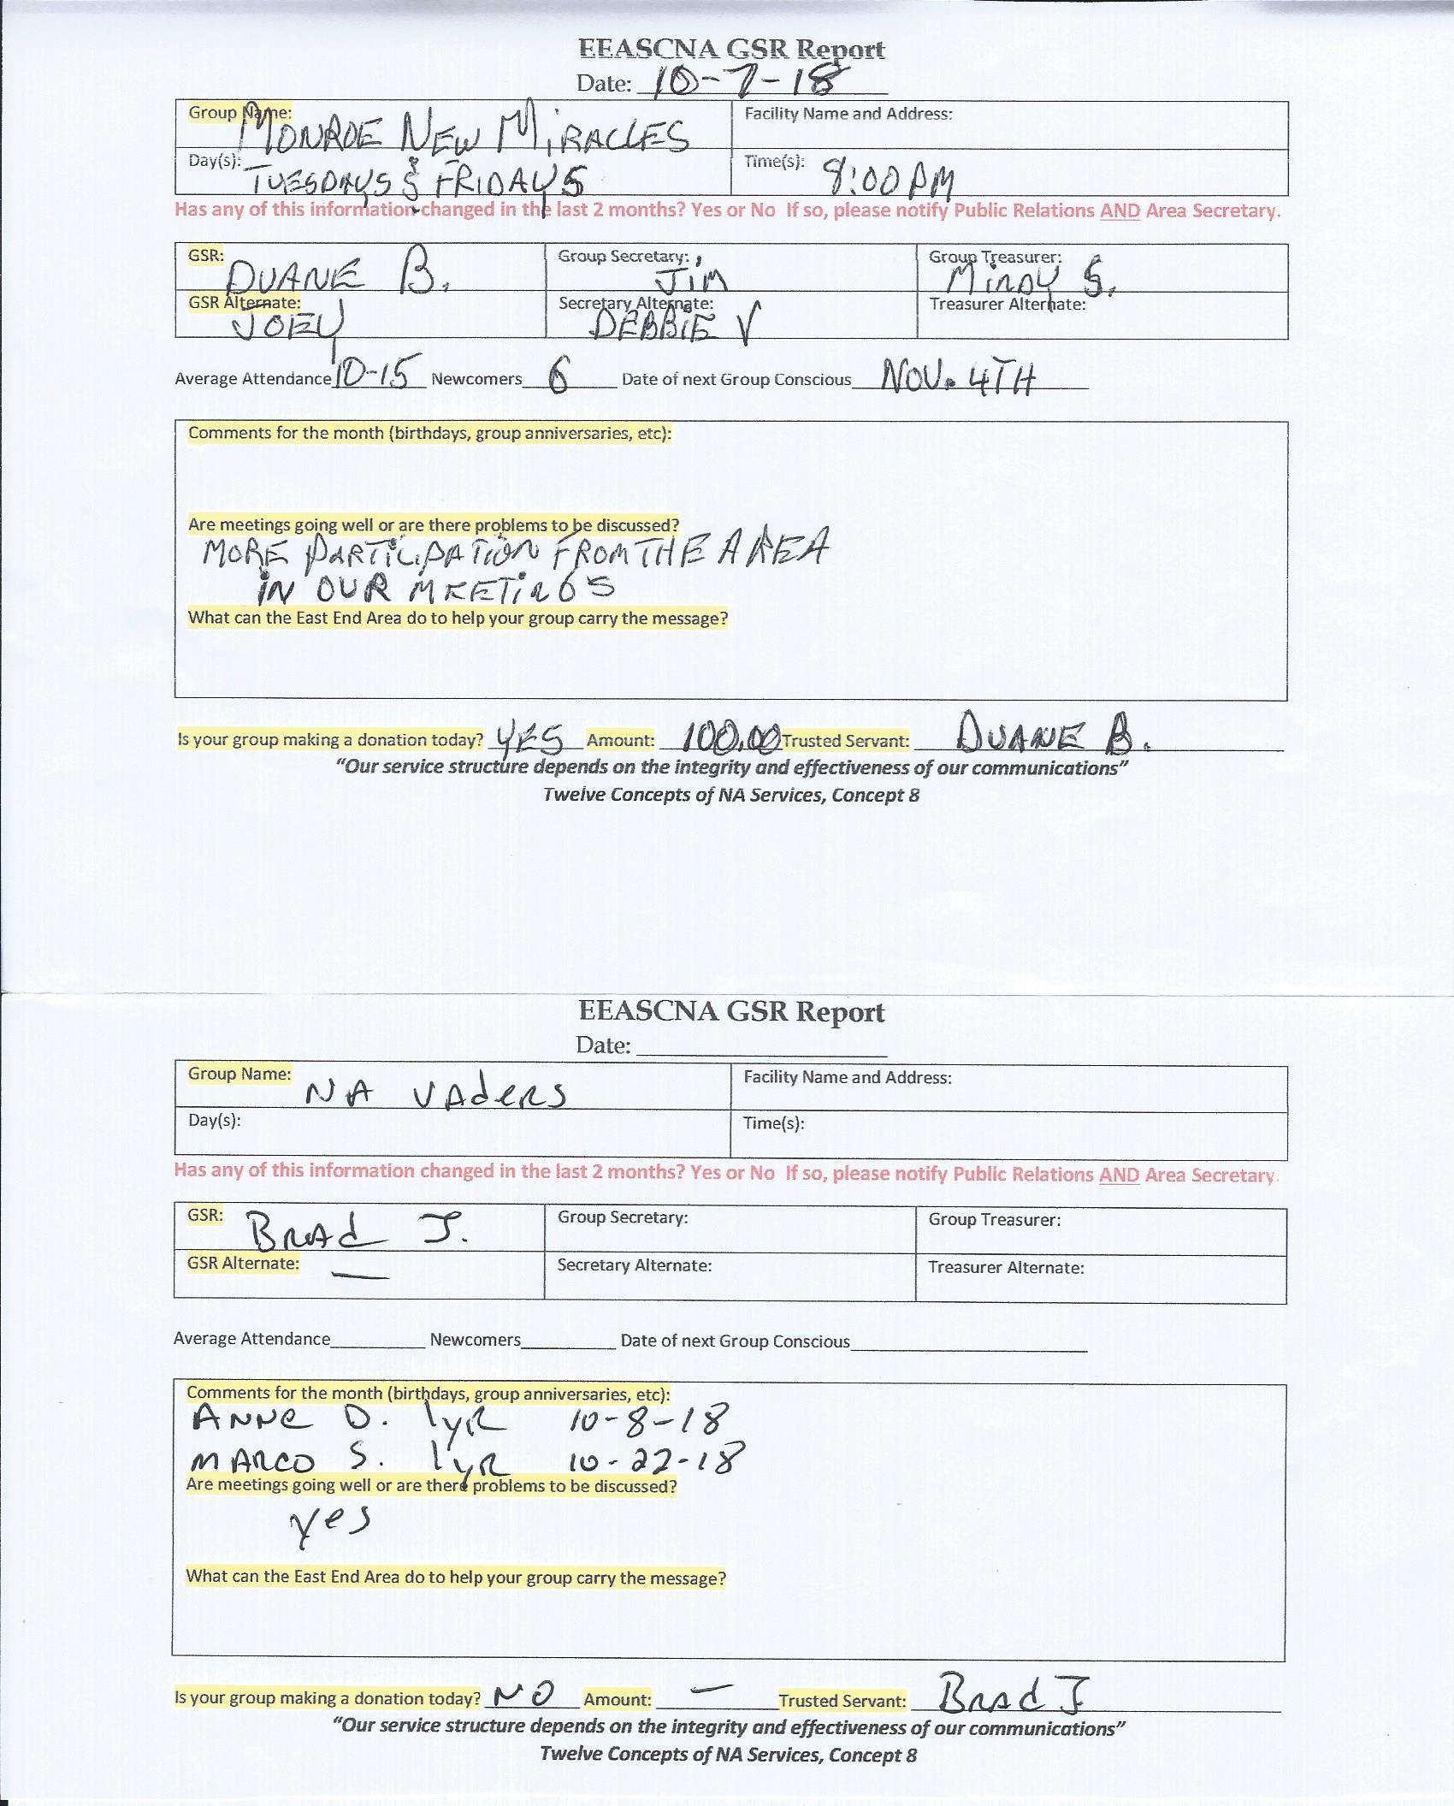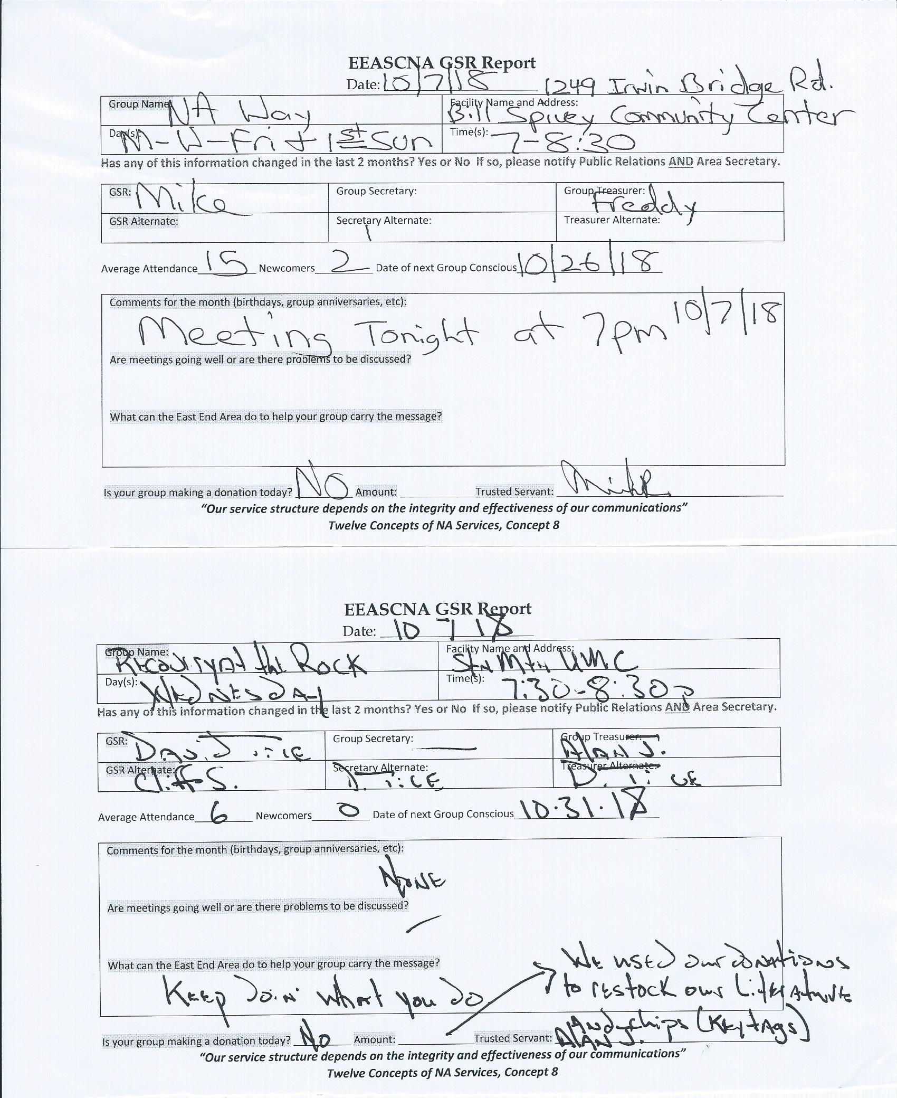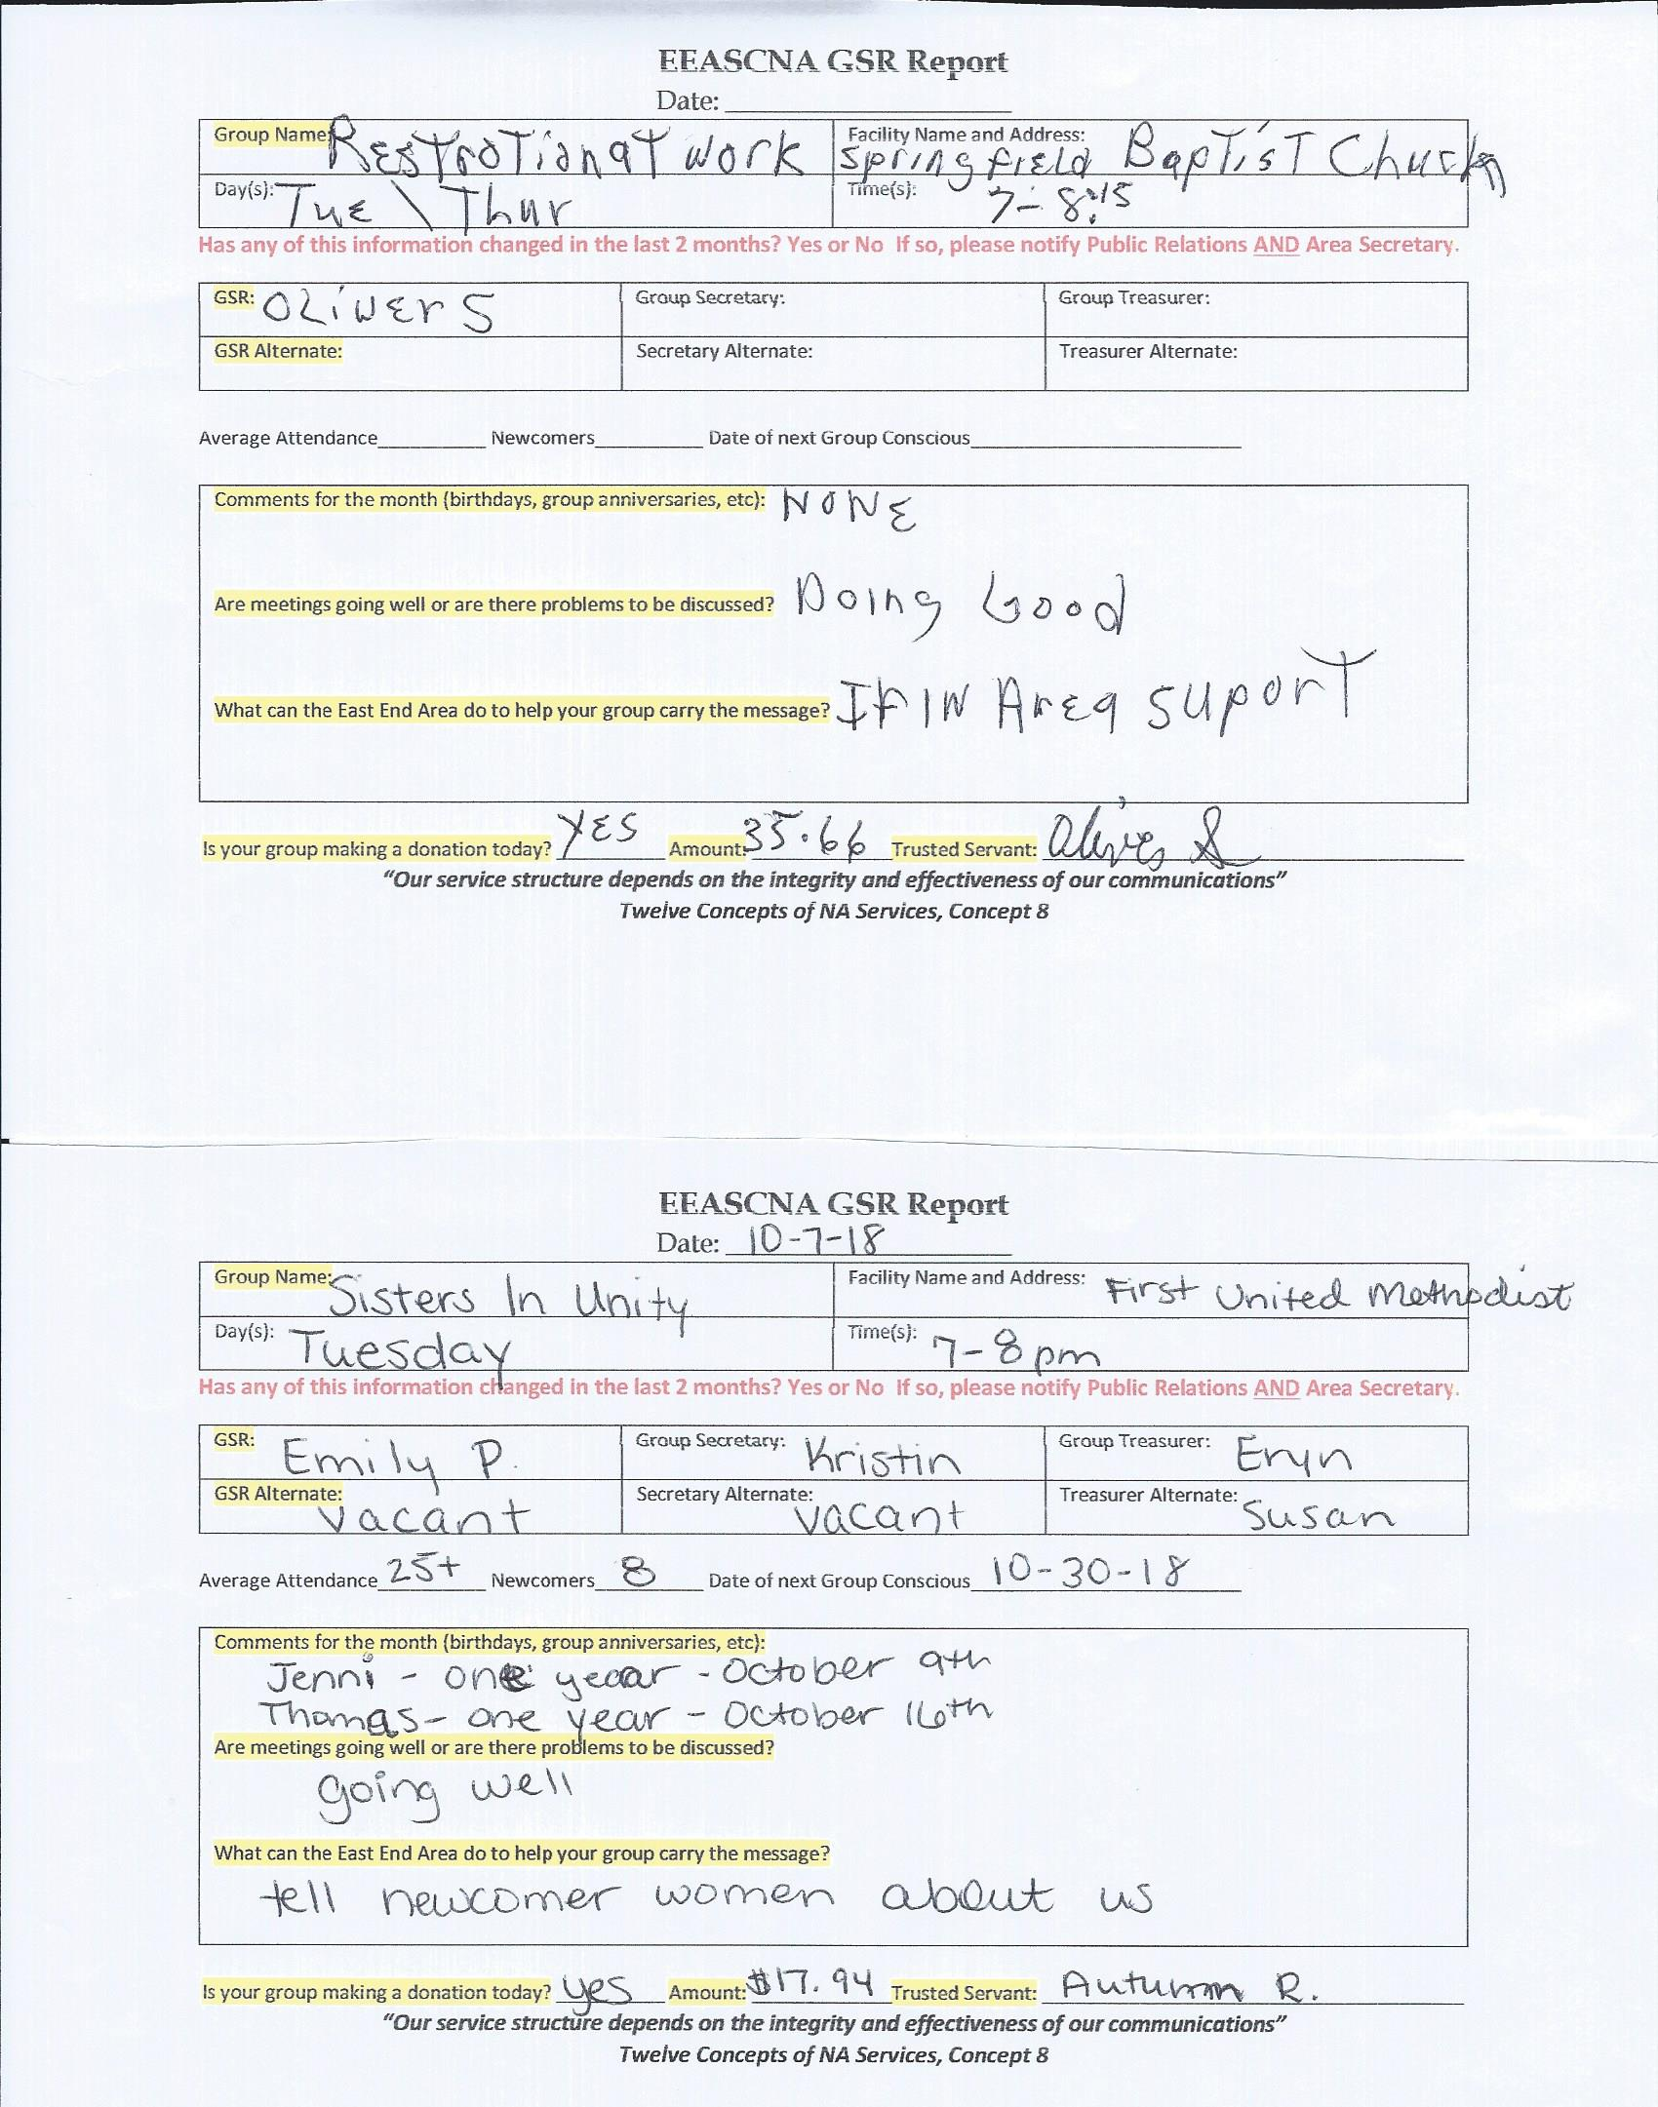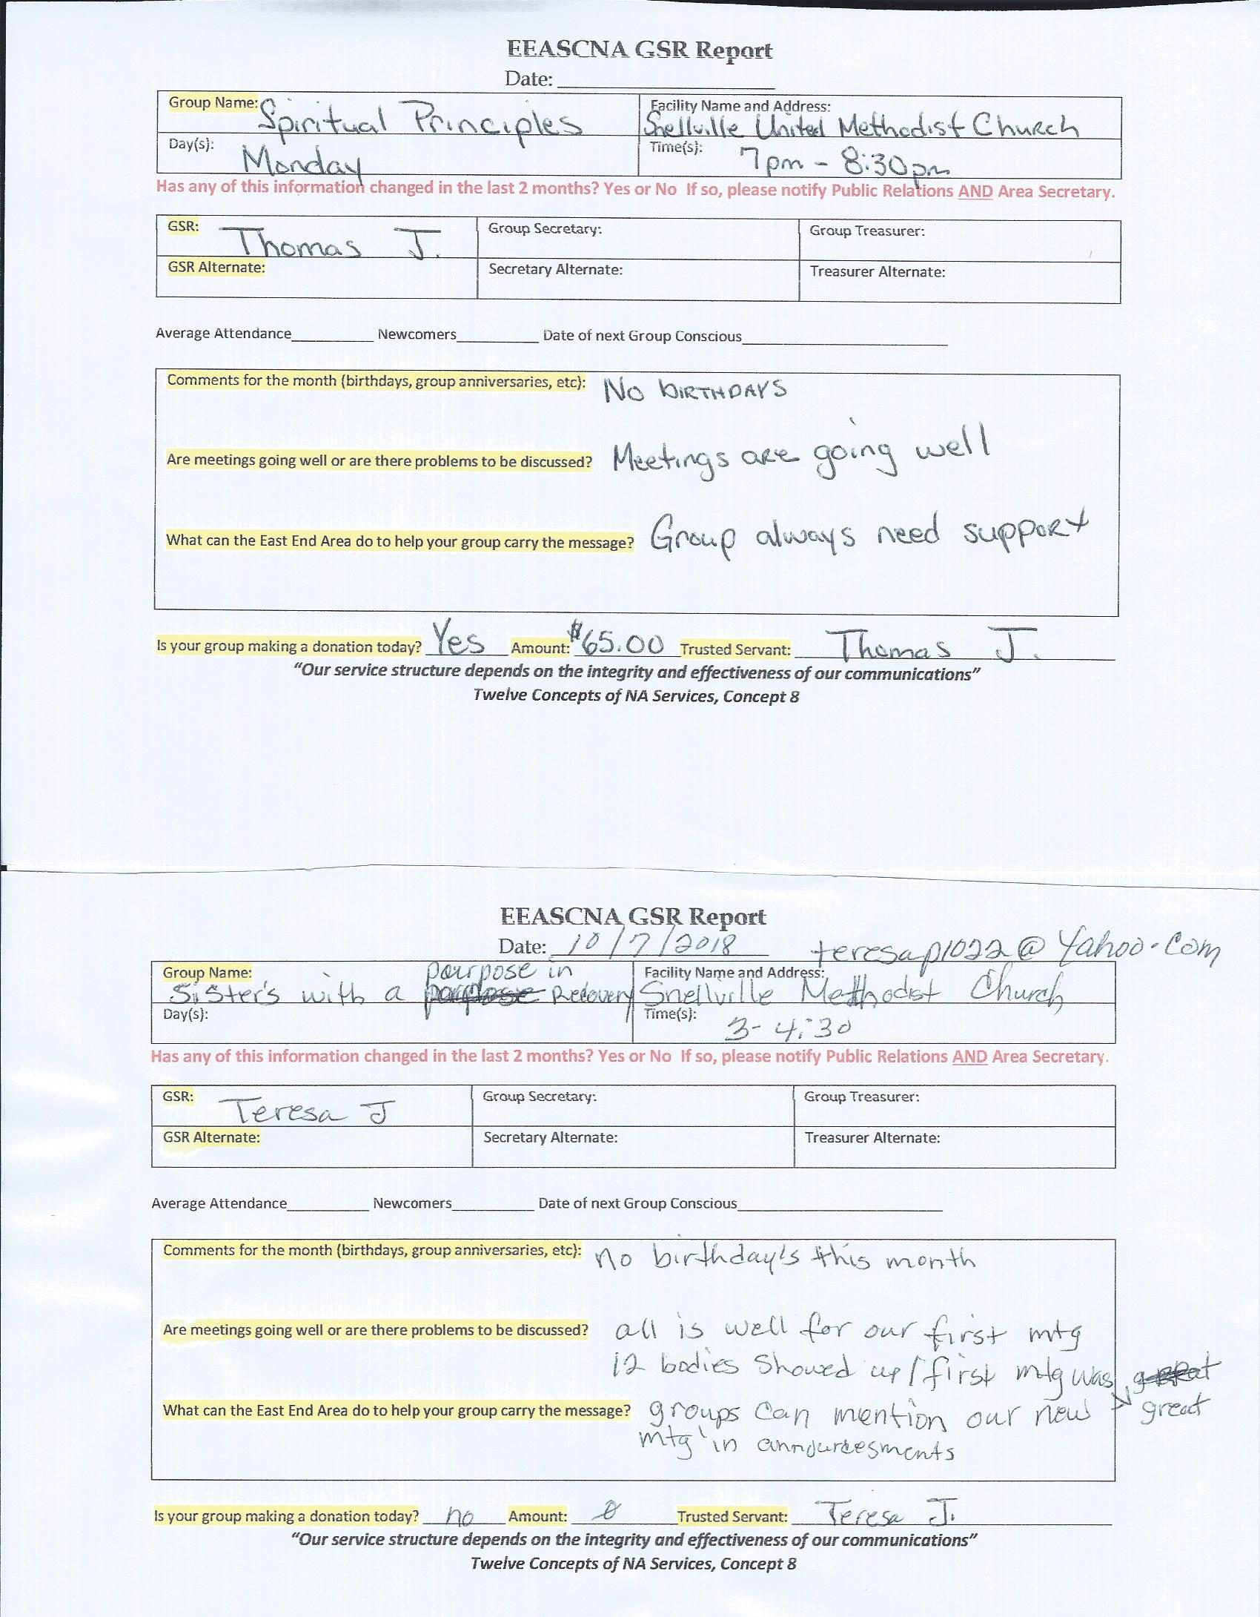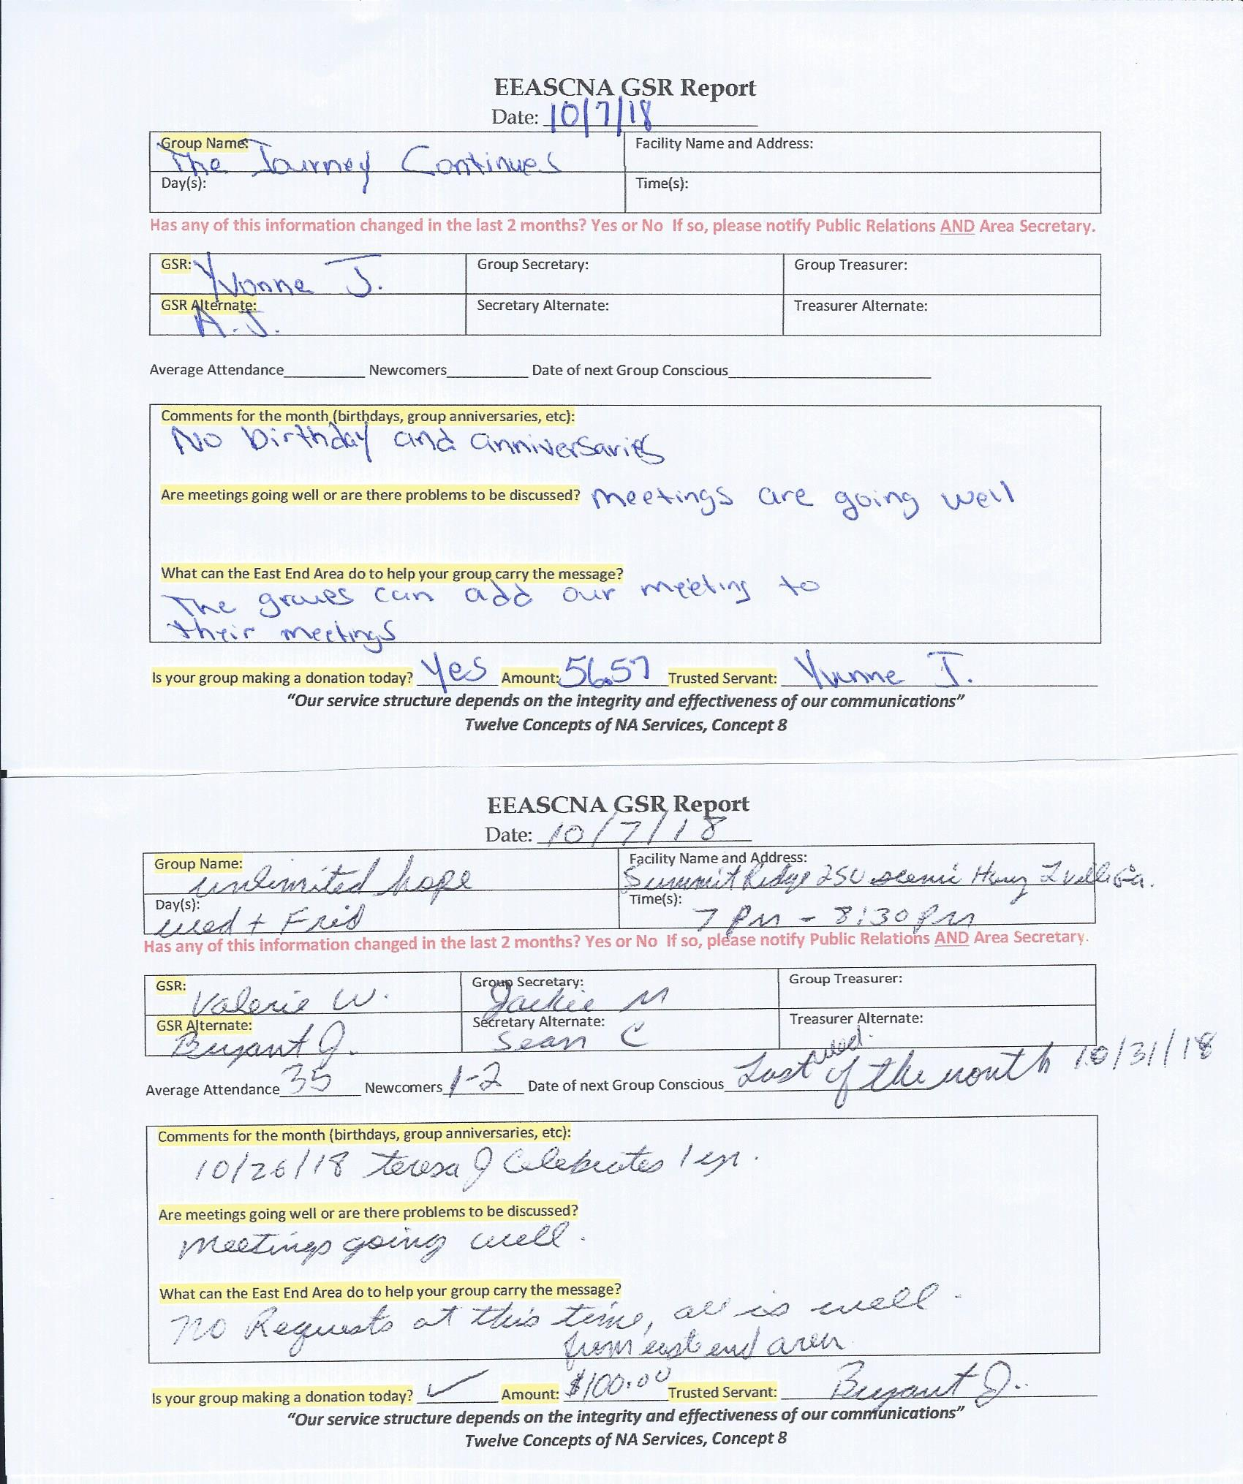

**Old Business**

Topic 2018-003 - Changing Article VII Section F to read: All positions can be held at a maximum of two terms. After serving as primary for two terms, the trusted servant cannot be nominated for the primary or secondary position for six months.

**Assent -11 Assent w/res. - 0 Stand Aside - 0**

**CONSENSUS REACHED**

**Nominations/Elections**

None

**Positions Still Open**

Alternate Secretary

Public Relations Vice Chair

**Open Forum**

* H&I and treatment centers - packet for events, want to let them know we have things going on
* By NA Means Necessary might close soon, 2 homegroup members holding it together, needs support!

**New Business**

**New meeting**

Sisters with a Purpose in Recovery

Women’s Rap Group

Every Saturday 3:00-4:30 pm

2428 E. Main St. Bldg. H

Snellville, GA 30078

**Take back to groups**

* Please look through Group Reports and see what the group’s needs are! Let’s help each other out!
* GRCNA flyer below for next March
* New meeting in Area on Saturday afternoon
* Nominations and elections are in November - **all positions open** (except RCM/RCMA)
* Vote on Topics from Region:
  + 2018-006
  + 2018-008
  + 2018-009
  + Topic forms are above with RCM Report

**Plans for the next meeting**

**Next Area Service will be**

**Held at 3pm on November 4th in Conyers**

**\*\*ADMIN MEETS AT 2:00 PM\*\***

**(Other forms and flyers below)**

