EEASCNA Minutes - September 2018
- Area began at 3:01 pm
- Simone opened ASC Meeting with moment of silence followed by the Serenity Prayer
- Reading of Twelve Traditions - Brian J.
- Reading of Twelve Concepts - Justin
- Reading of Article II & III: Purpose of EEASCNA - Willie

Article II: Purpose The purpose of the East End Area Service Committee of Narcotics Anonymous (EEASCNA) shall be to respond to the needs and collective conscience of its member groups. EEASCNA supports and encourages the unity, welfare and growth of the East End Area as part of a worldwide Fellowship.
Article III: A. Definition and Function of the Area: The Area Service Conference (ASC) is the communicative channel for a unified Fellowship, a tie that binds us together. The ASC serves as a link in the flow of communication from the member to the worldwide Fellowship, establishes a structure in which services and education are provided, and functions as a vehicle through which our Area Fellowship and society can relate. The EEASC is a Committee made up of Group Service Representatives (GSRs), special purpose Task panels and an Administrative Body from Member Groups of the East End Area.
Administration Roll-Call
Key: 0= Not Present, 1= Present, (-) = Vacant, R= Report submitted only
ROLE | NAME | D | J | F | M | A | M | J | J | A | S | O | N | D
Facilitator | Simone J. | 1 | 1 | 1 | 1 | 1 | 1 | 1 | 1 | 1 | 0
Co-Facilitator | Willie A. | - | 1 | 1 | 1 | 1 | 1 | 0 | 1 | 1 | 1
Secretary | Kristin F. | 1 | 1 | 1 | 1 | 1 | 1 | 1 | 1 | 1 | 1
Alt-Secretary | VACANT | - | - | - | - | - | - | - | - | - | -
Treasurer | Fred G. | 1 | 1 | 1 | 1 | 1 | 1 | 1 | 1 | 1 | 1
Alt-Treasurer | Geraldine G. | - | - | - | - | - | - | - | - | 1 | 0
H&I Chair | Jon C. | 1 | 1 | 1 | 1 | 1 | 1 | 1 | 1 | 1 | 0
H&I Vice | Nicole A. | - | - | 0 | 0 | 0 | 0 | 0 | 0 | 0 | 0
PR Chair | Linda Z. | 1 | 1 | 1 | 1 | 1 | 1 | 1 | 1 | 1 | 1
PR Vice | VACANT | - | - | - | - | - | - | - | - | - | -
Activities | Tracy S. | - | 1 | 0 | 1 | 1 | 1 | 1 | 1 | 0 | 1
Activities Vice | VACANT | - | - | - | - | - | 1 | 1 | 1 | 0 | -
RCM | Jackson J. | 1 | 1 | 1 | 1 | 1 | 1 | - | - | - | 1
RCMA | David C. | 1 | 1 | 1 | 1 | 0 | 1 | 1 | 1 | 1 | 1
Group Voting Policy:
- To reach quorum, 50% + 1 of groups present must be in good-standing.
- A quorum must be reached by fifteen (15) minutes after roll call is completed and before any business can be conducted.
- In order for a topic to be enacted, 80% of the groups present must be in good standing.
- New groups must attend 3 consecutive Area Meetings to gain voting rights at the 3rd Area.
- If a group misses 2 consecutive Area Meetings to re-gain voting rights at the 2nd.
East End Area Groups Roll Call
Key: 0= Not Present, 1= Present, R= Report Submitted only, Blacked Out= Not G.S.
2016-2017 | D | J | F | M | A | M | J | J | A | S | O | N | D
By NA Means Necessary | 0 | 0 | 0 | 0 | 0 | 0 | 0 | 0 | 0 | 0
Changing in Grayson | 1 | 1 | 1 | 0 | 1 | 0 | R | R | R | R
Clean & Free | 1 | 1 | 1 | 1 | 1 | 1 | 1 | 1 | 1 | 1
Covington Miracles | 1 | 1 | 1 | 1 | 1 | 1 | 1 | 1 | 1 | 1
Fahrfromusin | 1 | 1 | 1 | 1 | 1 | 1 | 1 | 1 | 1 | 0
Far Out | 0 | 0 | 0 | 0 | 0 | 0 | 0 | 0 | 1 | 0
Freedom on Friday | - | - | - | - | 1 | 1 | 1 | 1 | 1 | R
Get Real | 1 | 0 | 1 | 0 | 1 | 0 | 0 | 0 | 0 | 0
Harvest | 1 | 1 | 1 | 1 | 1 | 1 | 1 | 1 | 0 | 0
How It Works | 1 | 1 | 1 | 1 | 1 | 1 | 1 | 1 | 1 | 1
Just for Today | 1 | 1 | 1 | 1 | 1 | R | 1 | 1 | 1 | 1
Let the Truth Be Told | 0 | 1 | 1 | 0 | 1 | 0 | 1 | 0 | 1 | 0
Monroe New Miracles | 1 | 1 | 1 | 1 | 1 | 1 | 1 | 1 | 0 | 1
NA Vaders | 1 | 1 | 1 | 1 | 0 | 1 | 1 | 1 | 1 | 1
NA Way | 1 | 1 | 1 | 1 | R | R | 1 | 1 | 1 | 1
No Name Group | 0 | 0 | 0 | 0 | 0 | 0 | 0 | 0 | 0 | 0
Recovery at the Rock | 1 | 1 | 0 | 1 | 1 | R | 1 | 0 | 0 | 0
Restoration at work | 1 | 1 | 1 | 1 | 1 | 1 | 1 | 1 | 1 | 1
Sisters in Unity | 1 | 1 | 1 | 1 | 1 | 1 | 1 | R | 1 | 1
Spiritual Principles | 0 | 1 | 1 | 1 | 1 | 1 | 1 | 1 | 1 | 0
Step to Mercy | 0 | 0 | 0 | 0 | 0 | 0 | 0 | 0 | 0 | 0
Touch of Hope | - | - | - | - | - | - | - | 1 | 1 | 1
The Journey Continues | 1 | 1 | 1 | 1 | 1 | 1 | 1 | 1 | 1 | 1
Unlimited Hope | 1 | 0 | 1 | 1 | 1 | 1 | 0 | 1 | 1 | 1
Total of Groups in Area | 23 | 22 | 22 | 22 | 23 | 23 | 23 | 23 | 24 | 24
Total Groups Present | 16 | 16 | 17 | 15 | 18 | 14 | 17 | 16 | 16 | 13
Groups in Good Standing | 17 | 17 | 17 | 17 | 17 | 17 | 18 | 18 | 18 | 19
Groups Present & G.S. | 15 | 16 | 16 | 15 | 15 | 13 | 17 | 16 | 15 | 11
Number for Quorum (50% + 1)?  Is Quorum reached? | 10 Yes | 10 Yes | 10 Yes | 10 Yes | 10 Yes | 10 Yes | 10 Yes | 10 Yes | 10 Yes | 10 Yes
Number for Consensus (80% present in G.S)?  # needed to Assent on Topics | 12 | 13 | 13 | 12 | 12 | 11 | 14 | 13 | 11 | 9
Roll call ended at 3:08 pm
At this moment, quorum was met
Subcommittee Reports

Treasurer Report
- Giving money to Treasure for tip for Lunch and money to purchase a bin to use for Activities’ supplies

Full report below:
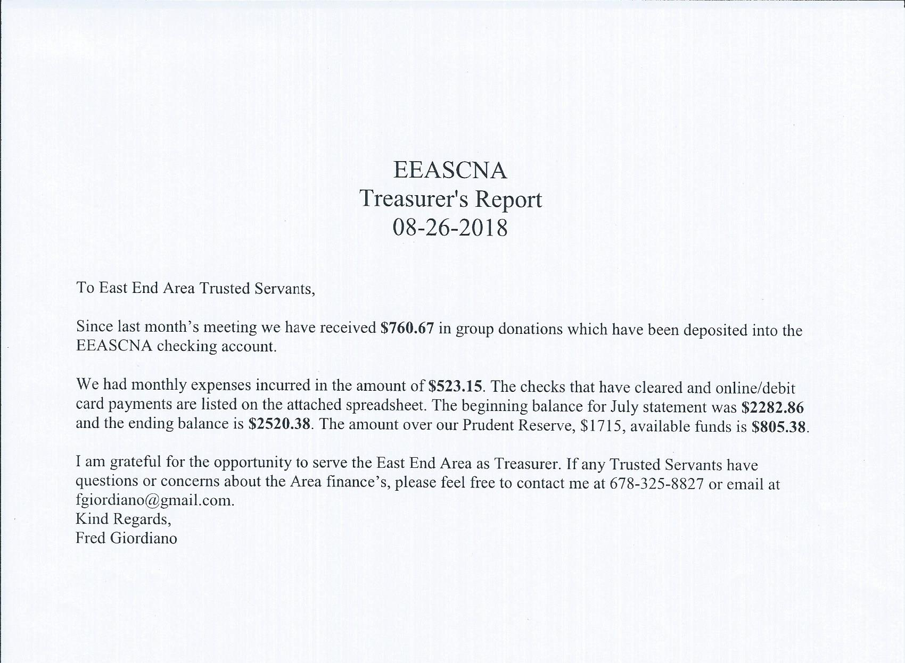
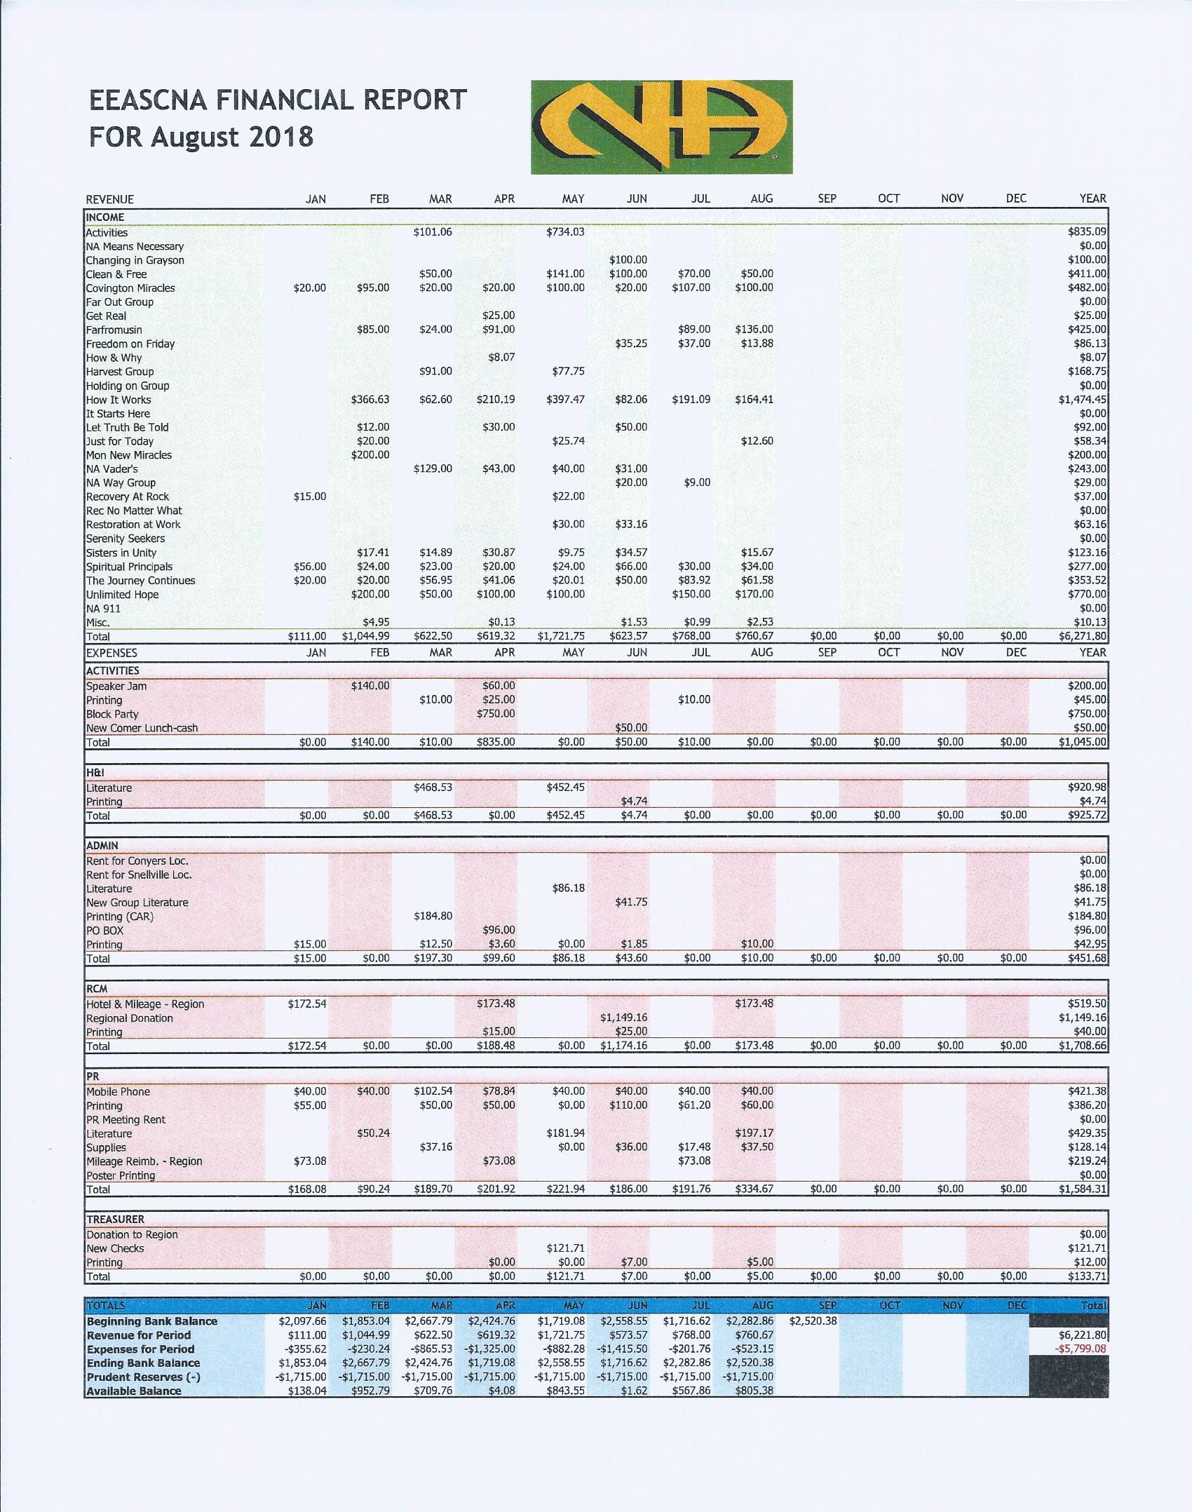

RCM Report
Next RSC will be September 8th & 9th
- CPP Policy changes need to be voted on
  - All changes passed
- Consensus Based Decision Making (CBDM)

Full report below:

RCM Report
to the
East-End ASC
Date: August 26, 2018

Next RSC will be September 8th and 9th 2018

Regional Service Committee minutes can be found @
https://www.dropbox.com/s/rj15qqlhwvwf25f/GRSCNA%20Minutes%20-%20.June%202018.docx?dl=0

Full report below:
Old Business

- 2018-005 - To approve updated CPP Policy
- Review the results of the Conference Agenda Report (CAR)
- Discuss the Hand-out on Consciences Based Decision Making (CBDM)
How to literature.
New Business

- Vote on the revision of the Convention Planning Panel Policy
Changes and updates to CPP policies 6\10 \2018

- Page 1 under Purpose 2nd para. Added 12 Concepts Now reads: it should always conform to the 12 traditions and 12 concepts of N.A. and reflect our primary purpose.
- Page 1 under Convention Planning Panel Meetings.2nd para. Removed; is required to purchase a banquet ticket for the current year convention. Paragraph now reads: Each CPP member is required to stay on site during the entire convention, when a host hotel is secured by GRC Inc. each member will be required to secure their reservation on the master account. Payment for the hotel expense must be paid no later than the first day of the convention.
- Under Attendance 1st sentence added or 3 for the year. Now reads: Any CPP committee officer, either administrative officer of Subcommittee Chair or Vice-Chair who is absent at two (2) Consecutive or any three (3) for the year regular scheduled meeting, …
- Page 3, #8 is Virtual meetings will follow all policies that are in place already and #9 is now the Agenda.
- Page 7 under; Travel Policy changed $00.46\mile to Region Allotment
- Page 10. 3rd para. changed cash to funds 4th para from once a week to daily 5th CFO to BOD also removed mail in registration sentence.
- Page 11. Changed handle money to; operate point of sale device and CFO to BOD
- Page 12. changed taped and taping to; record and recording.
Page 13. Under Hospitality added; Approved raffle instead of just raffle under Arts & graphics added; continued and future. Now reads; This subcommittee will be responsible for continued solicitation of the fellowship for artwork that will go along with the current and future convention themes.

New Topics
- Georgia Regional History Book Project
Vacant Admin Positions:
- Alternate Secretary
Treasurers Report
April 2018 - June 2018

1. Bank Statements and Reconciliation Summary Reports
2. Profit & Loss and Budget vs. Actual
3. Check Register
4. Income & Expenses
5. 2018-2019 Proposed Budget

Thanks for allowing us to be of service

RCM/RCMA

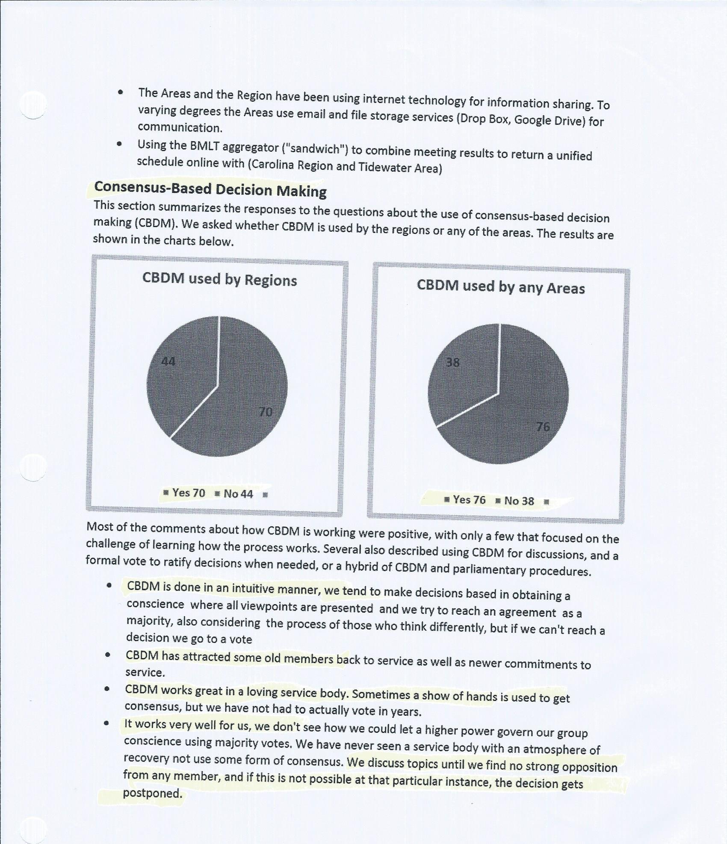

H & I Report

- Contact Jon C. to volunteer - (205) 317-5139
- 90-day clean time requirement
- Please announce H&I needs in meetings, don’t wait until group conscious!!

Public Relations Report
- Touch of Hope - starts August 26th
- Unity Speaker Jam on October 6th - flyer below***
Full report below:
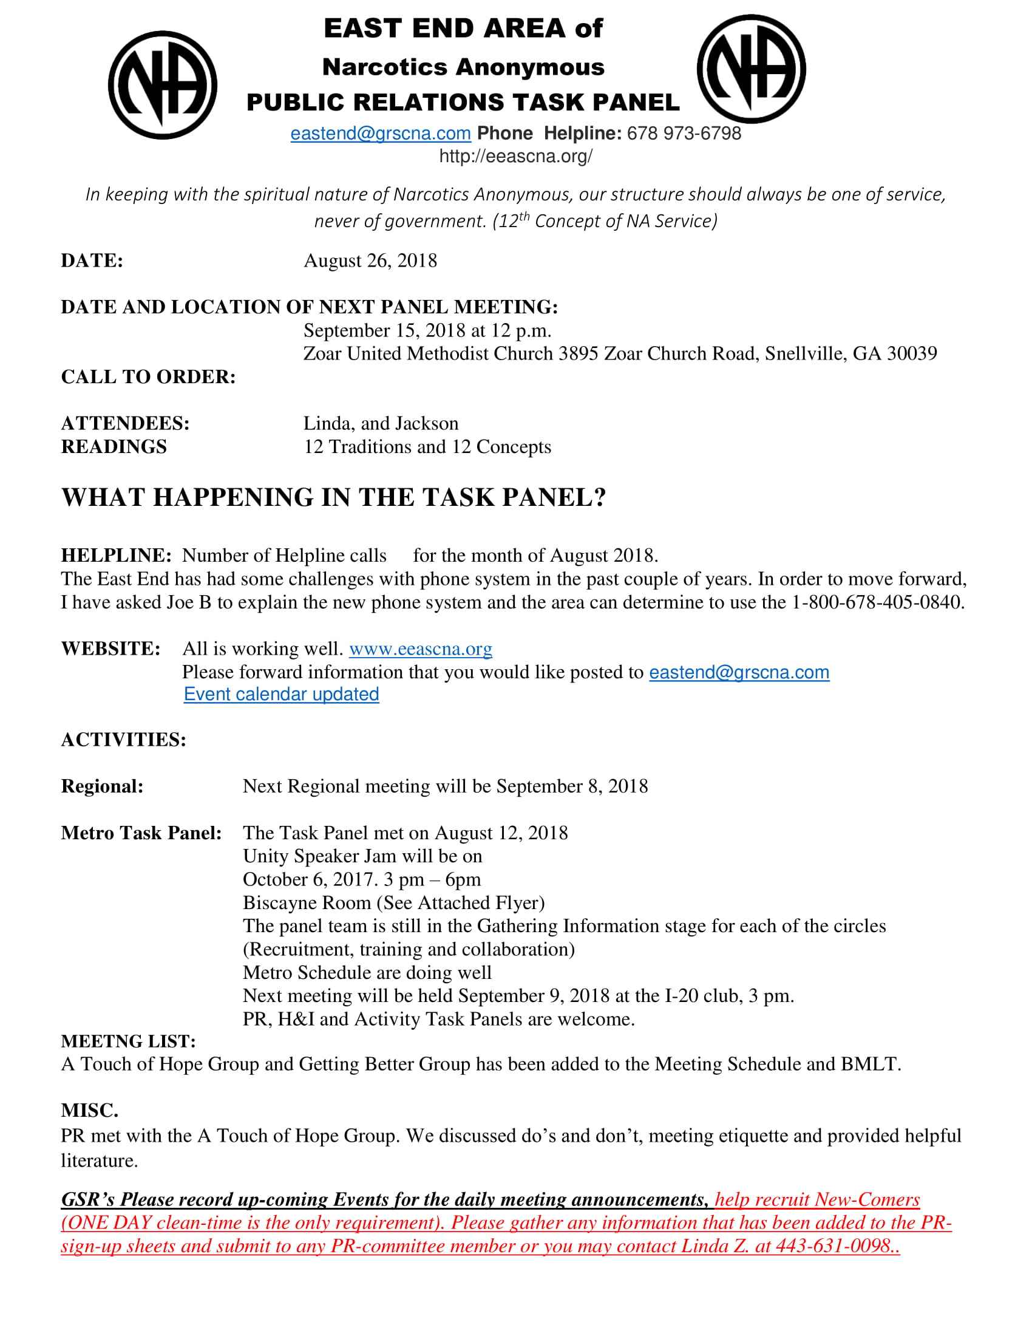
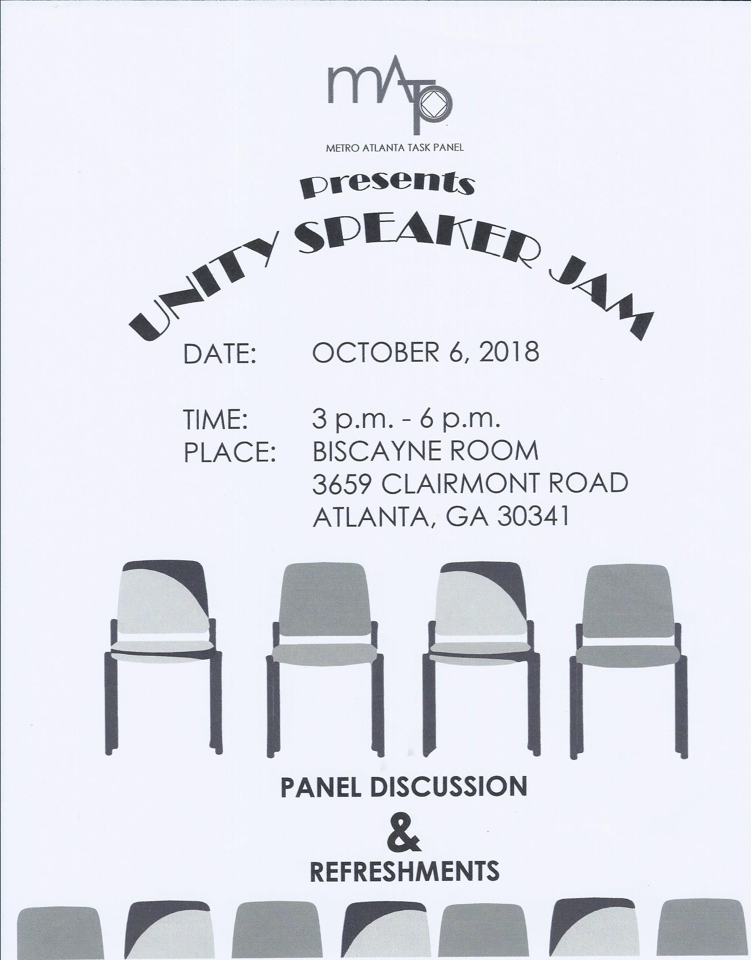
Activities Report
- Upcoming events -
  - October - Let’s Have Lunch!!
    - Flyer below***
  - November - Thanksgiving marathon
    - Flyer and sign-up sheet below***
- Will sell soda and water at ASC from now on
- Make sure GSRs are spreading word about events! Hand out flyers! Announce at meetings!!
- Activities sub-committee meeting meets the 3rd Saturday of every month at 11 am at Zoar church

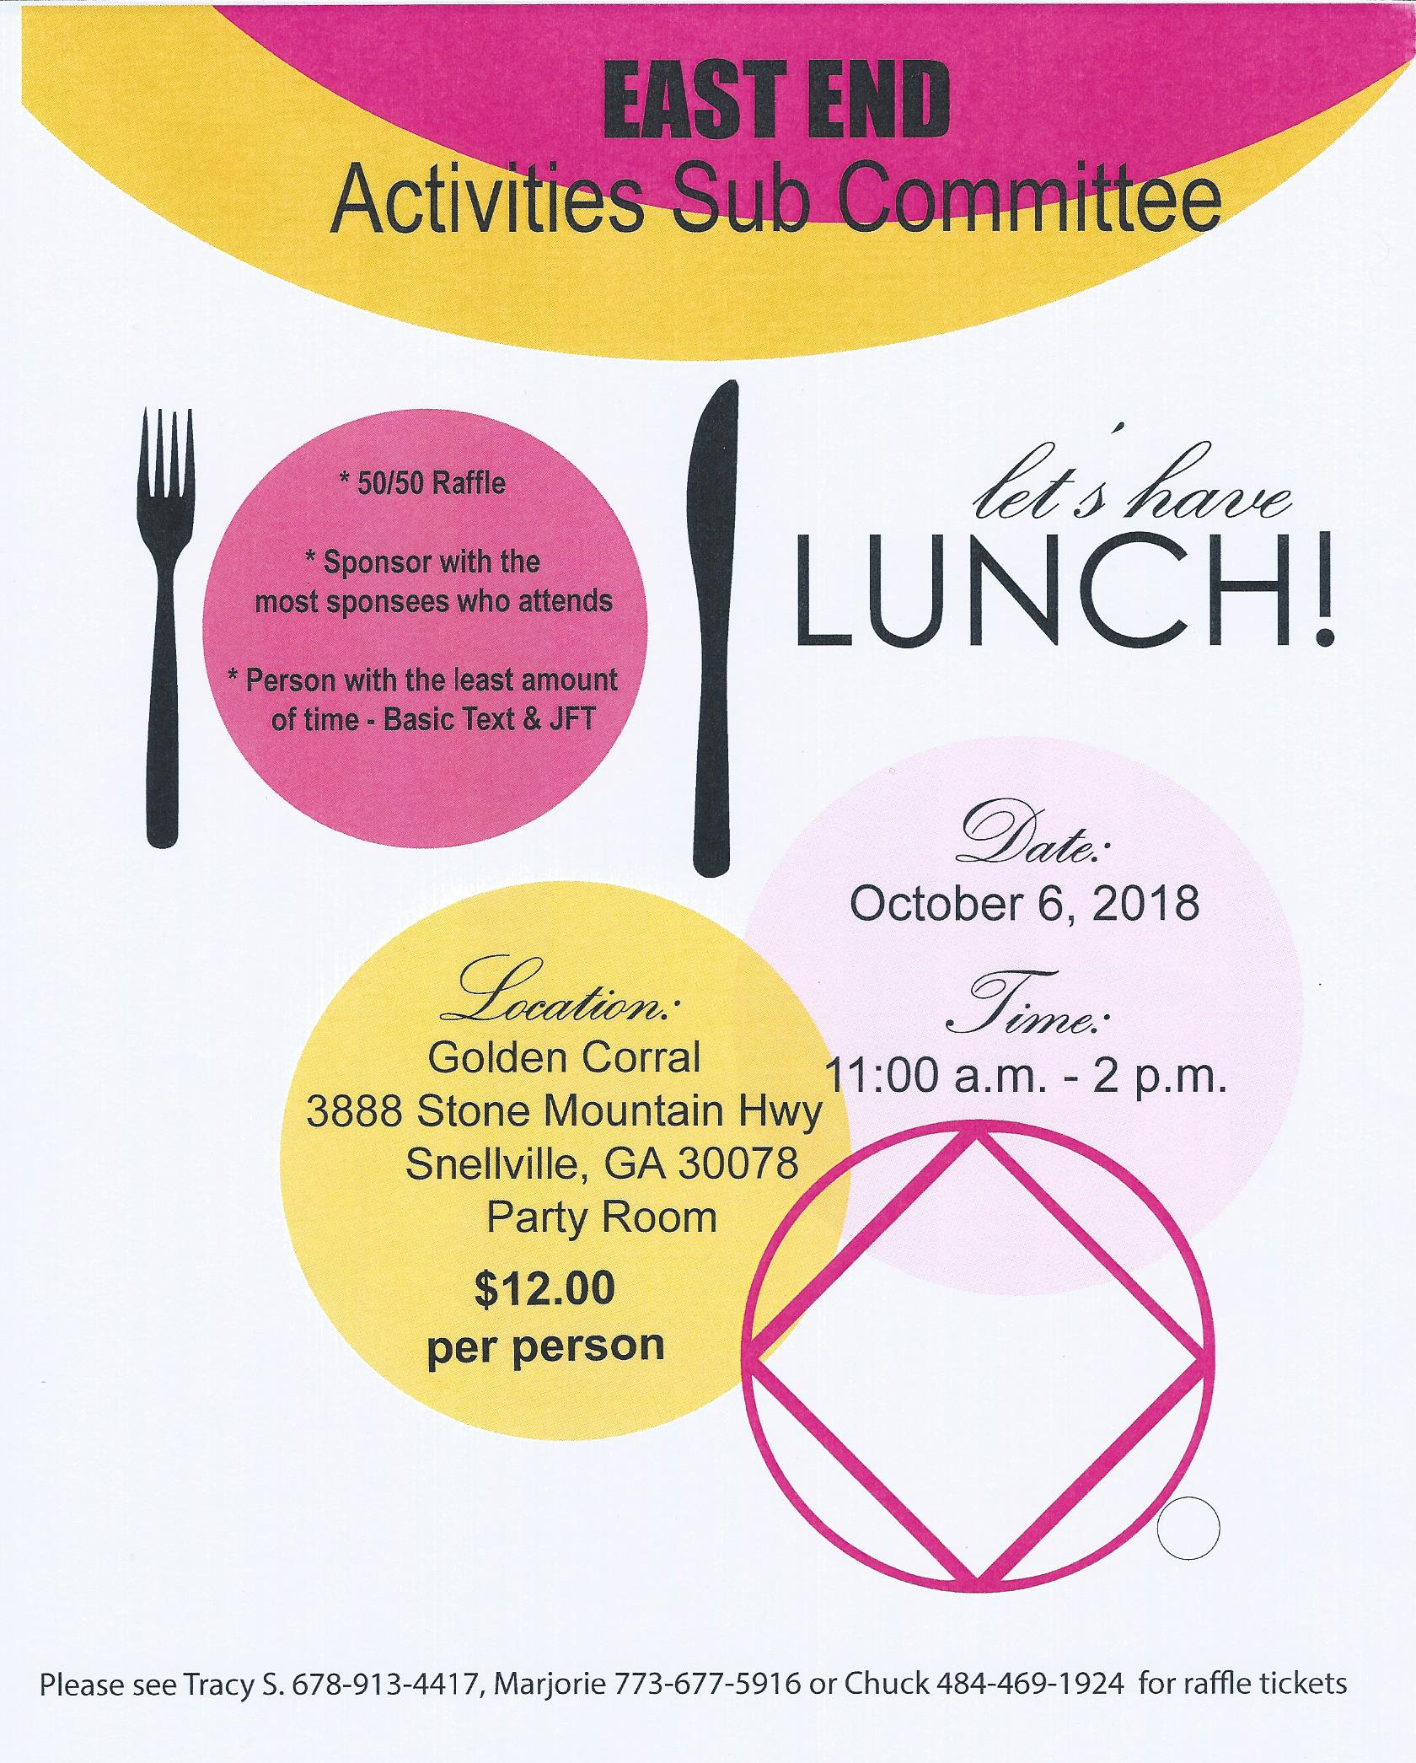
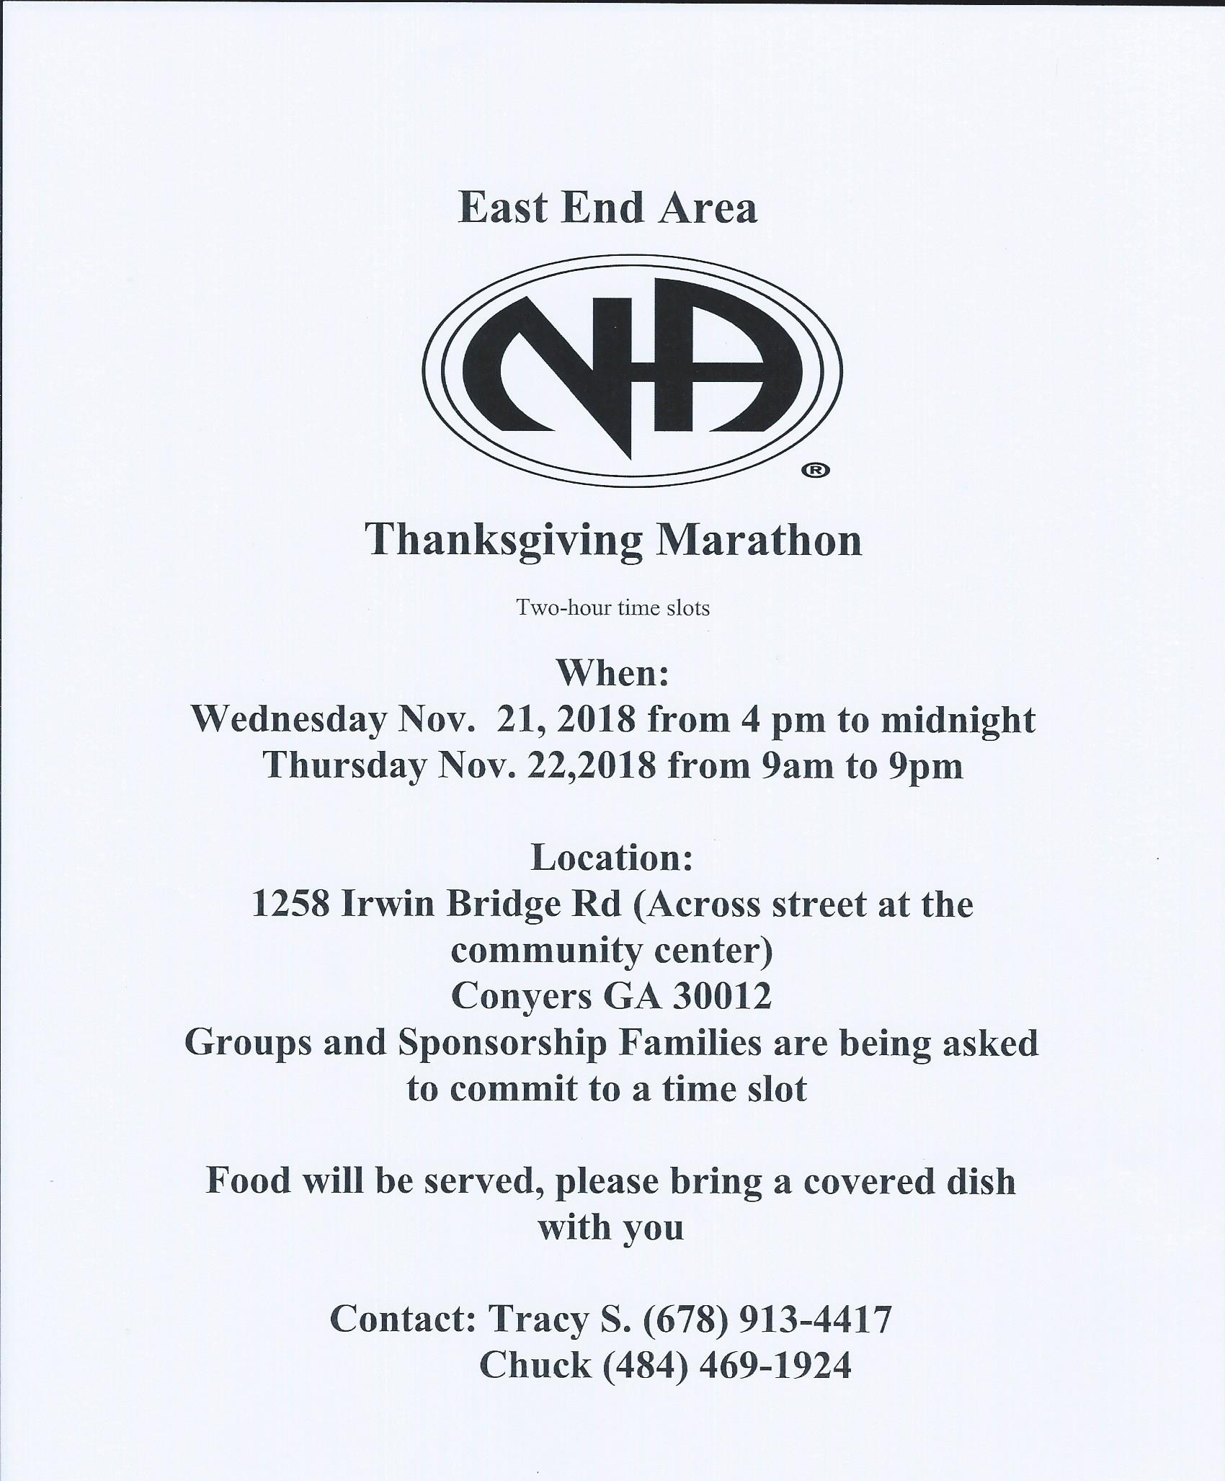
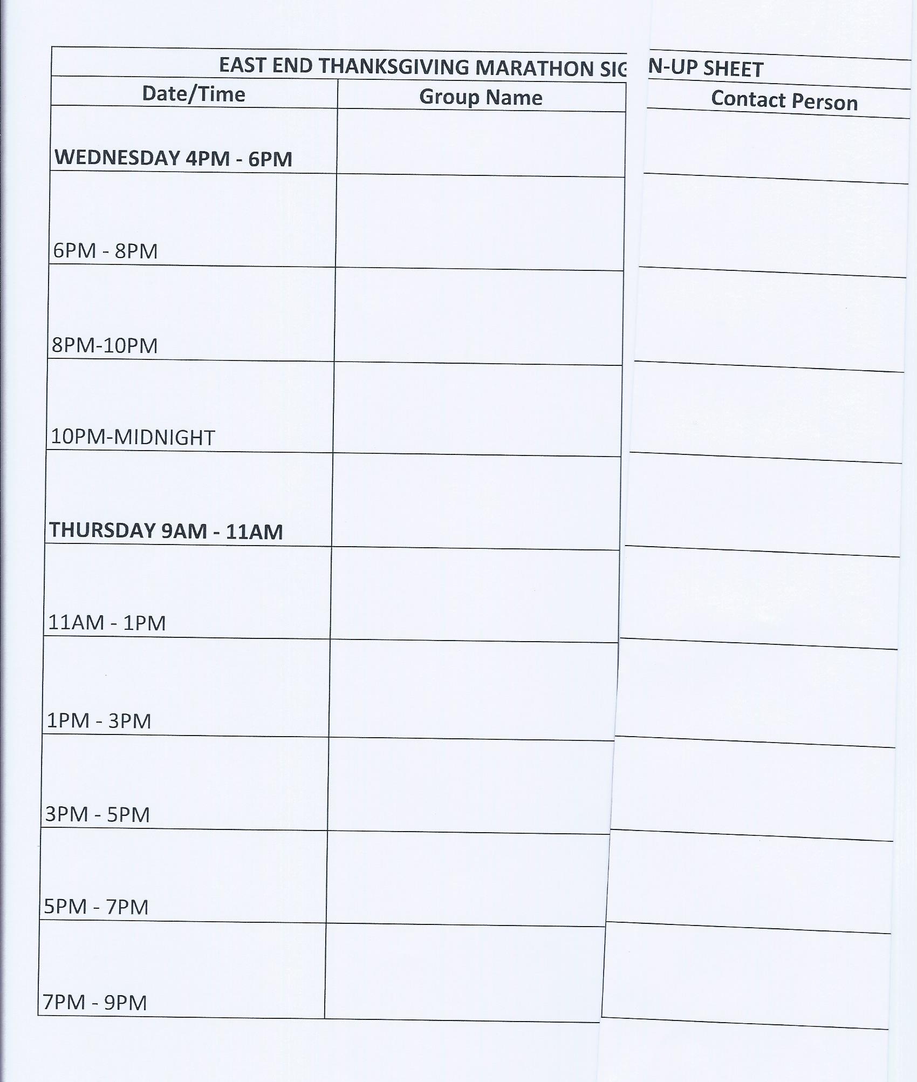

Inventory Ad-hoc committee
- Area Inventory collected - data will be discussed at next ASC meeting in October

Group Reports
SCANNED AND ATTACHED BELOW
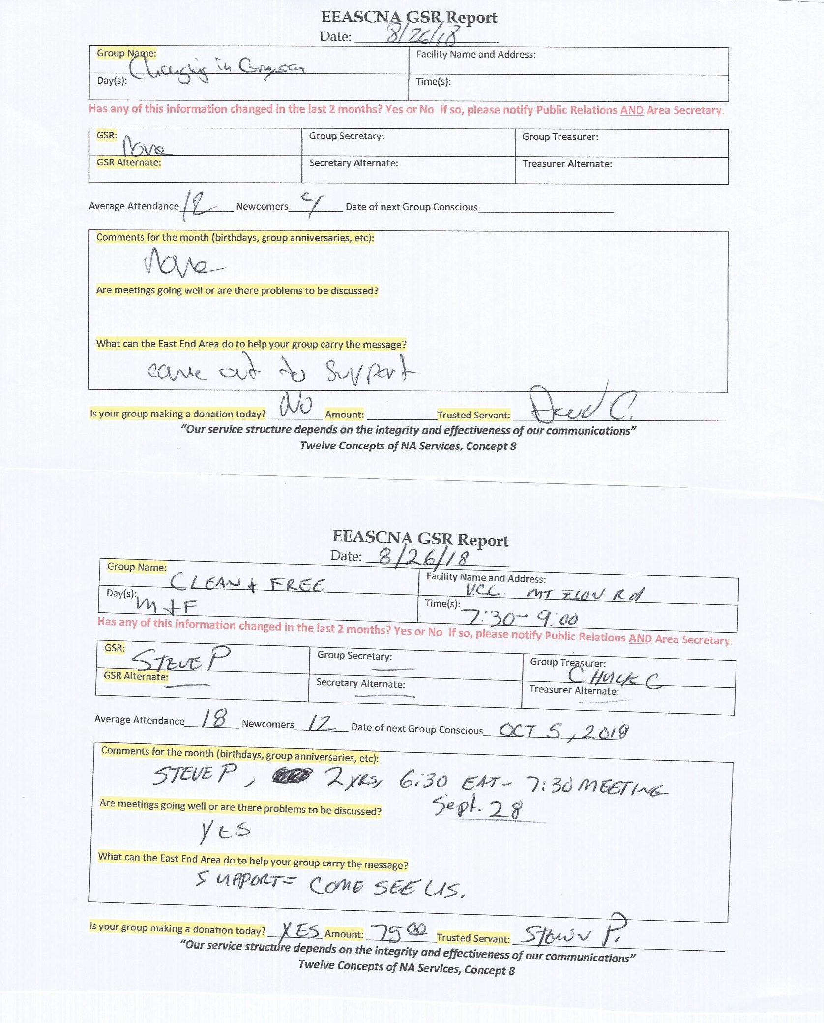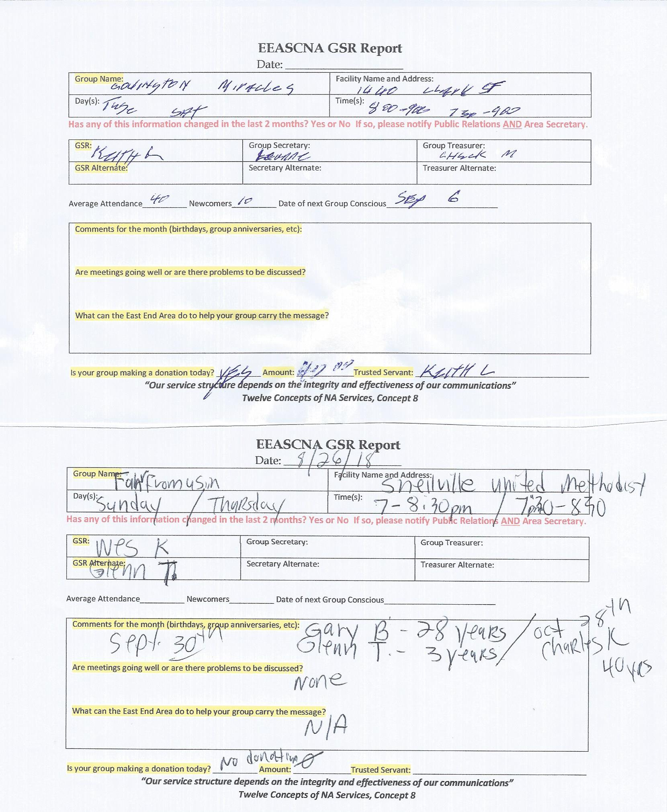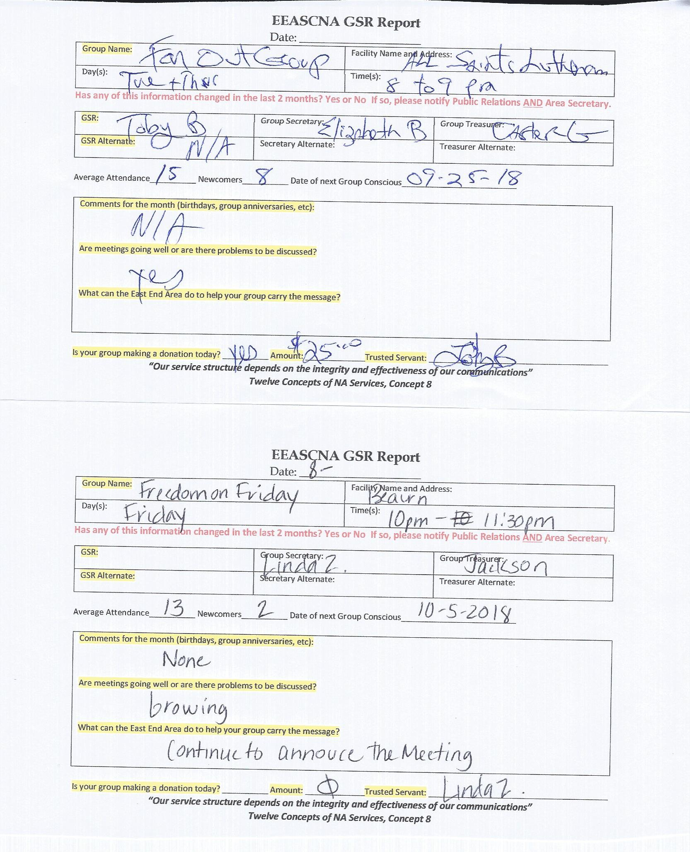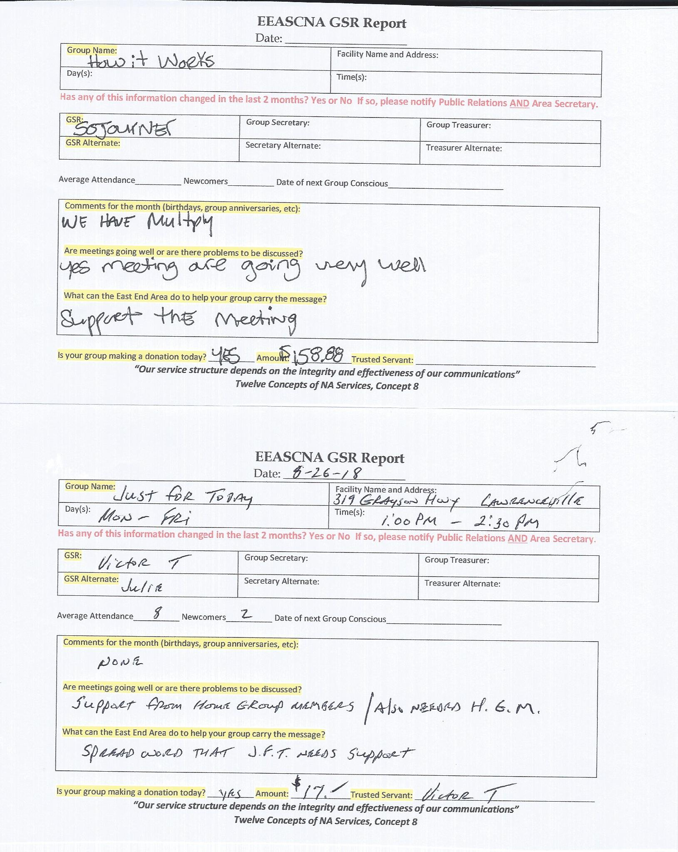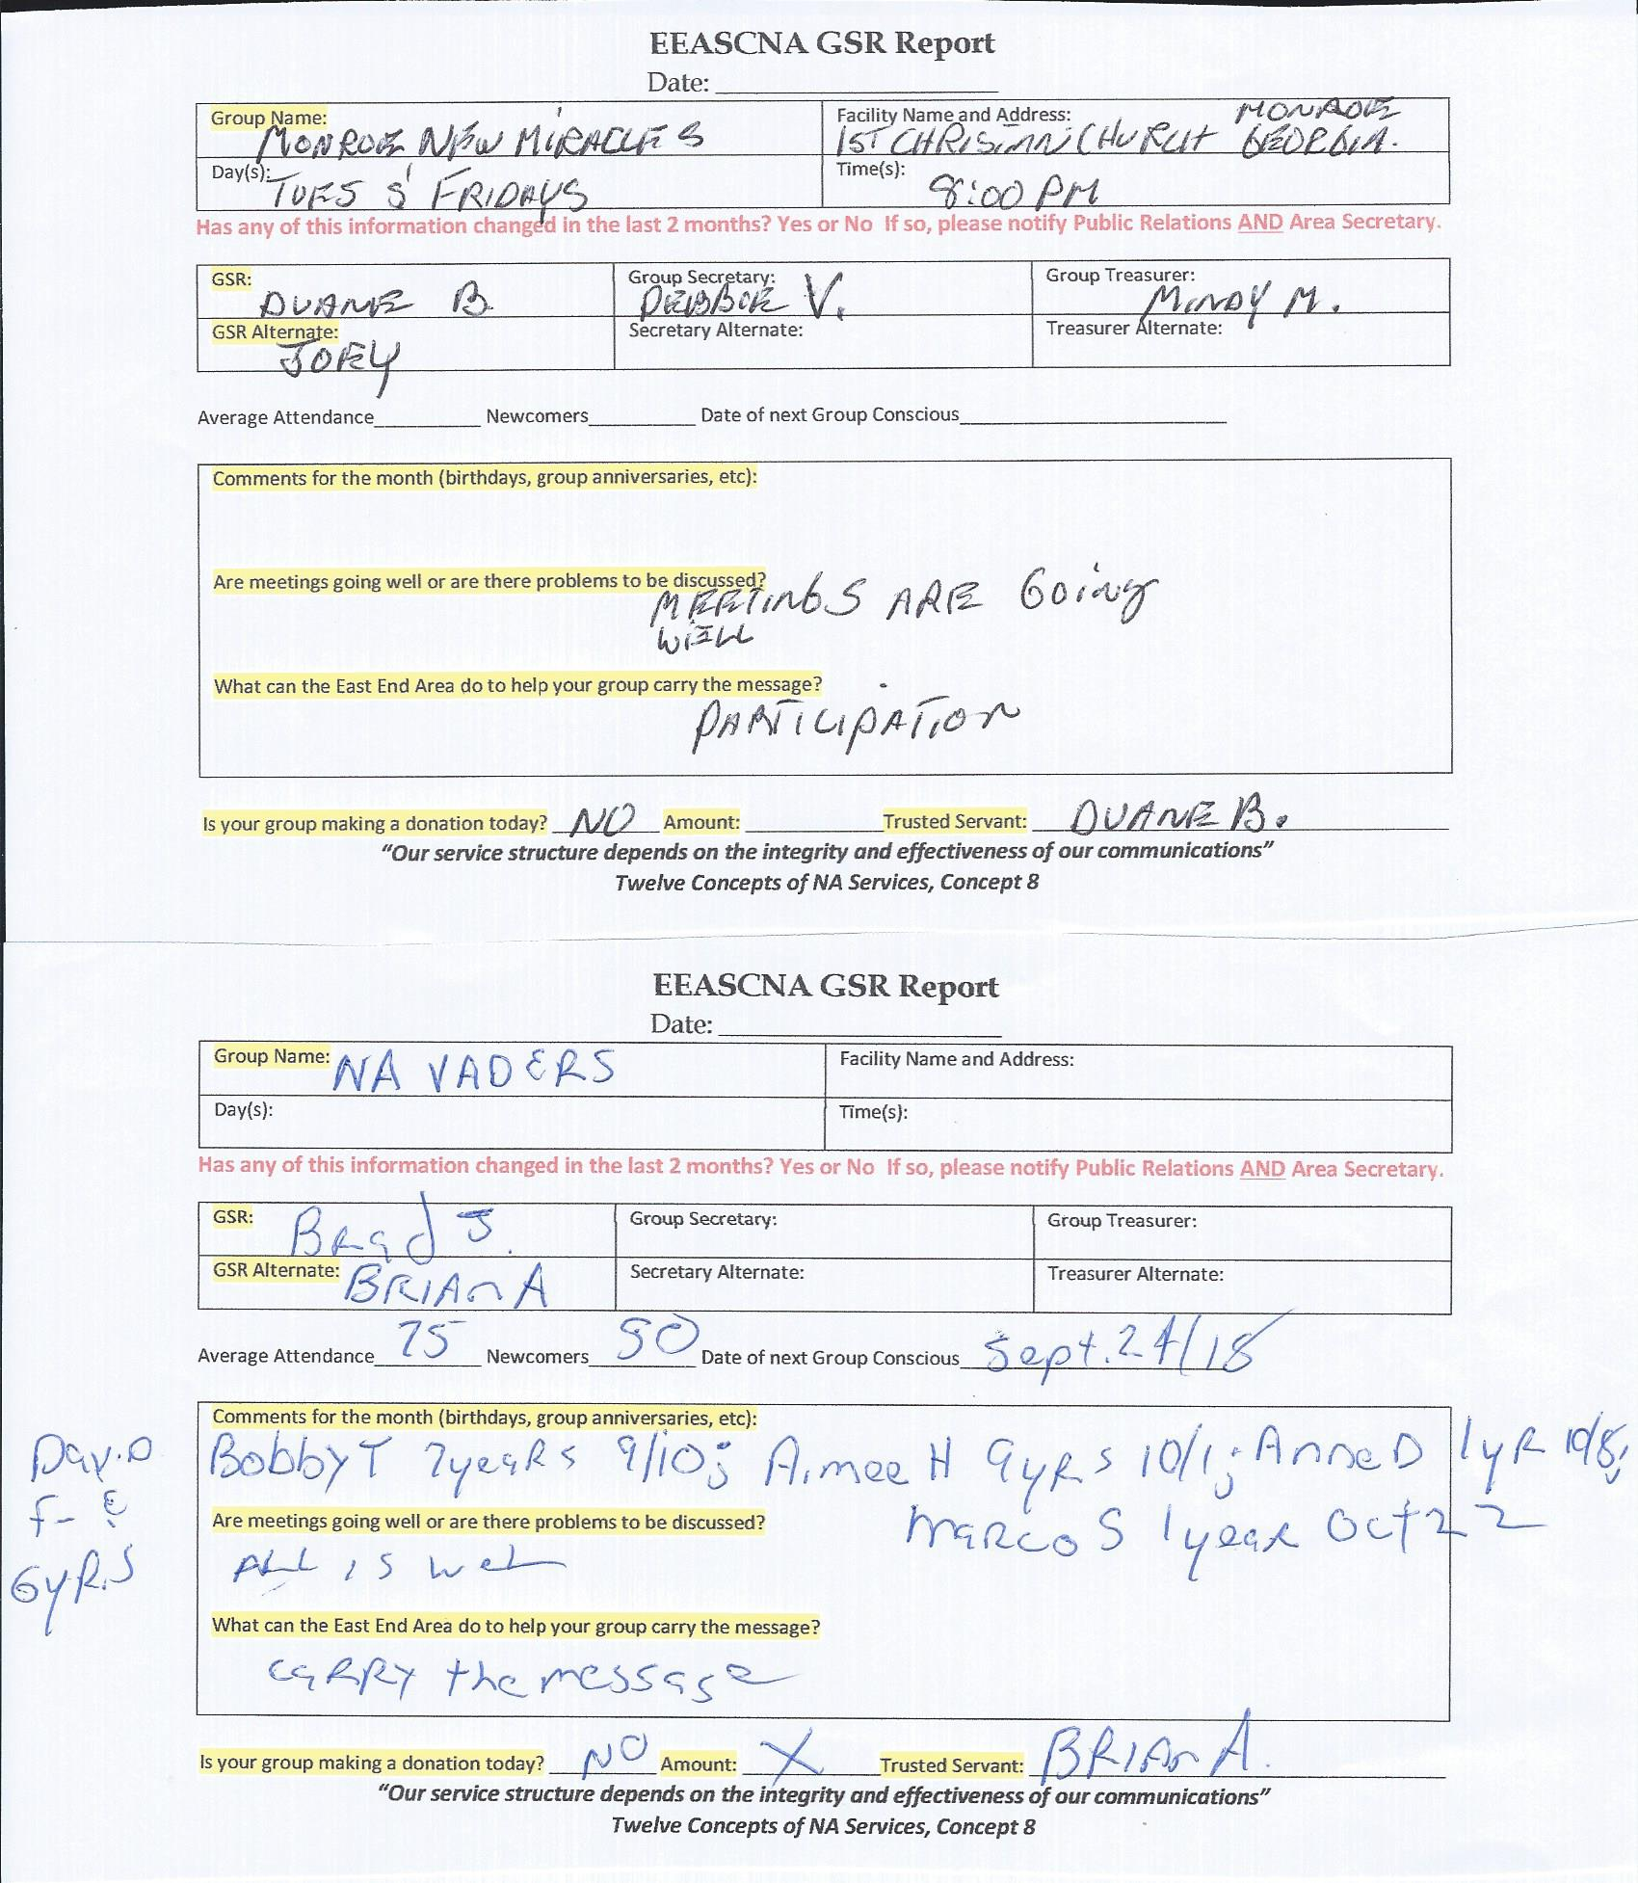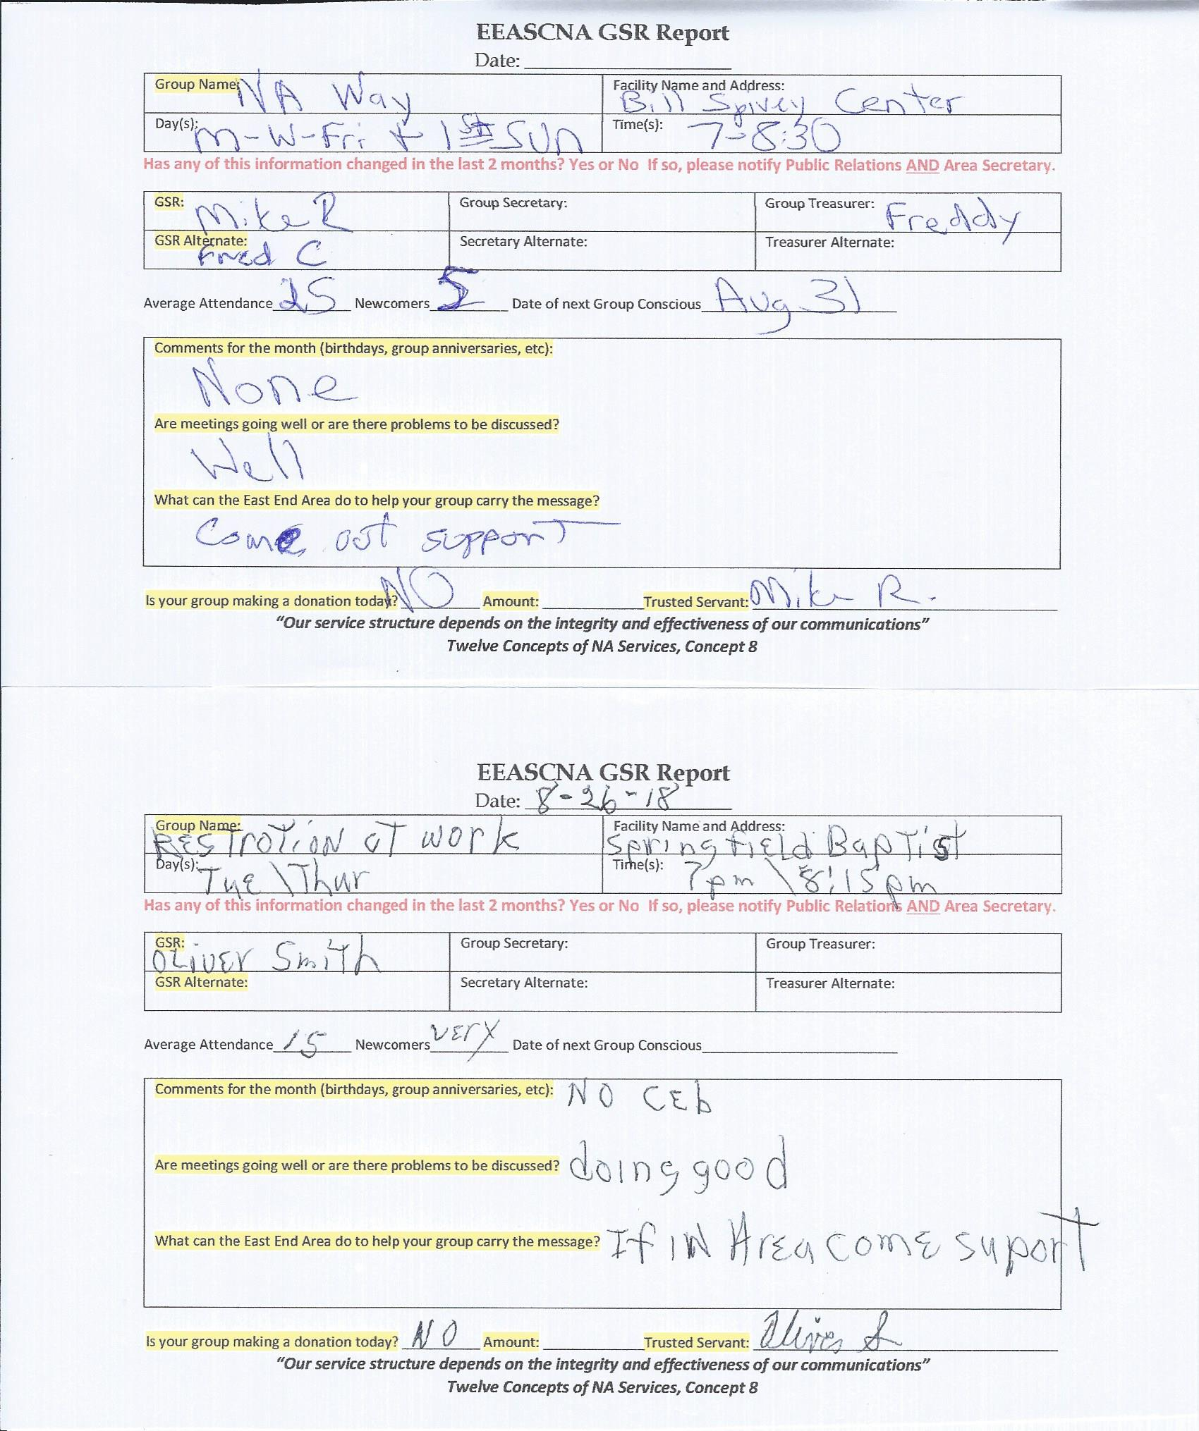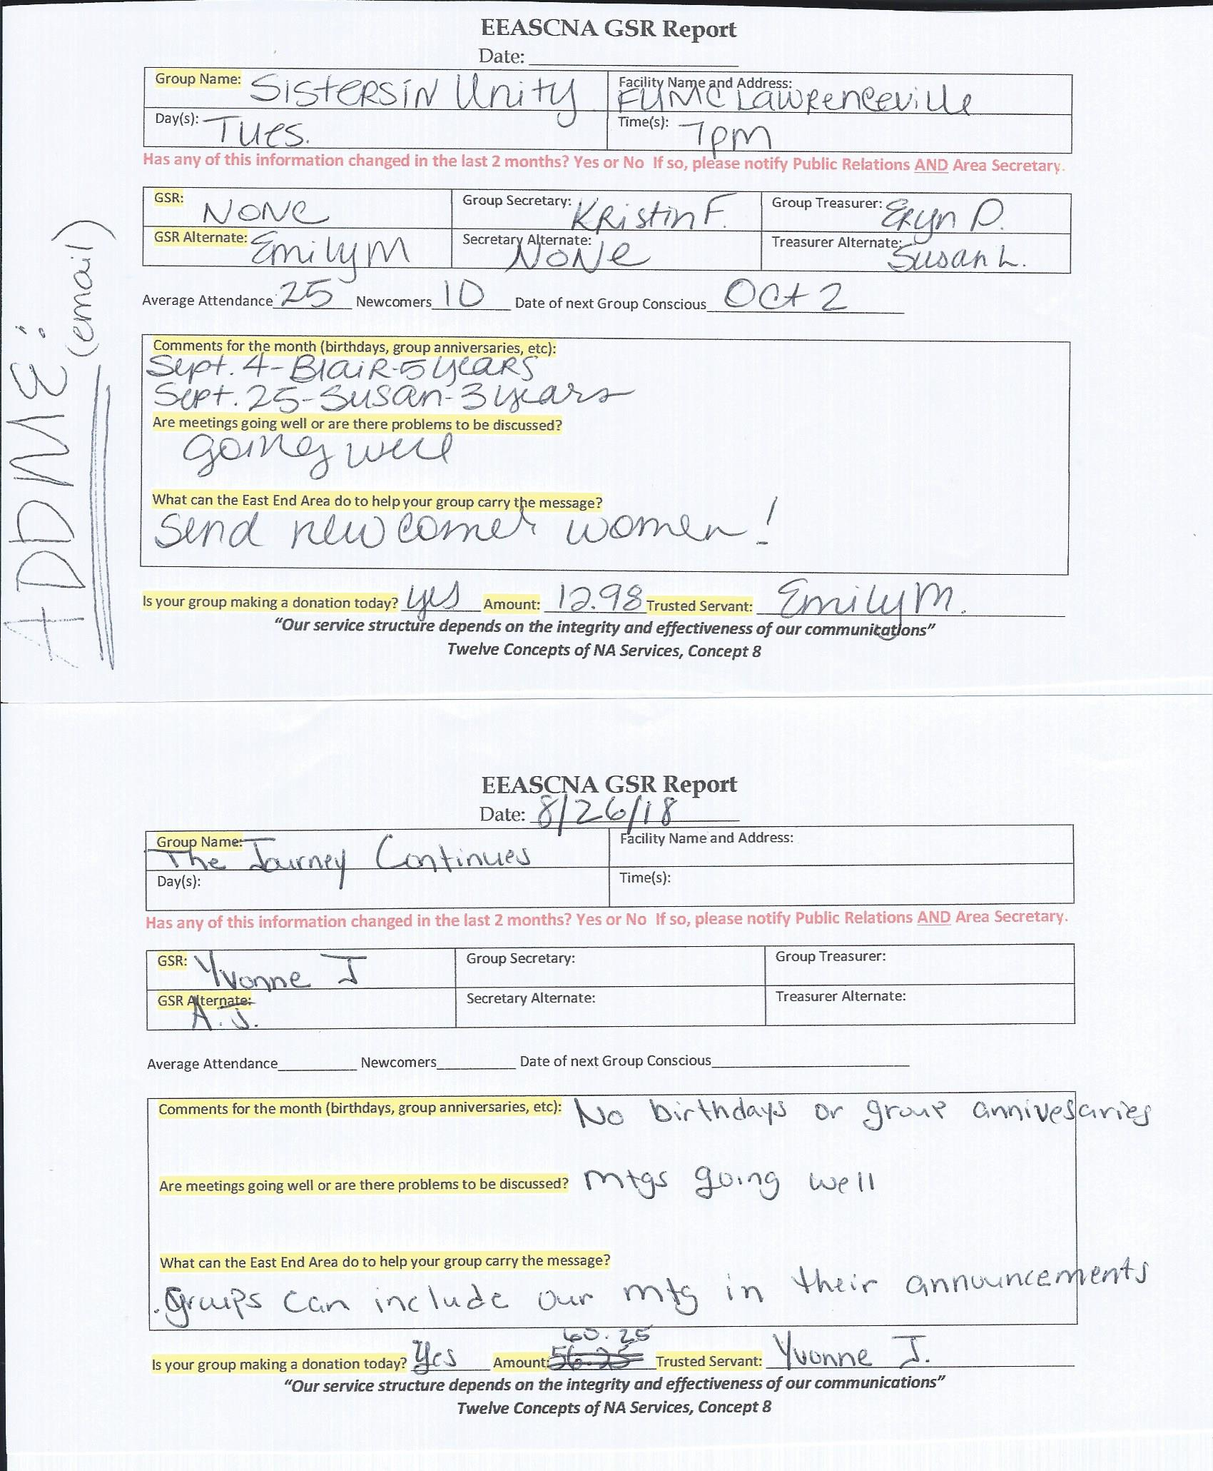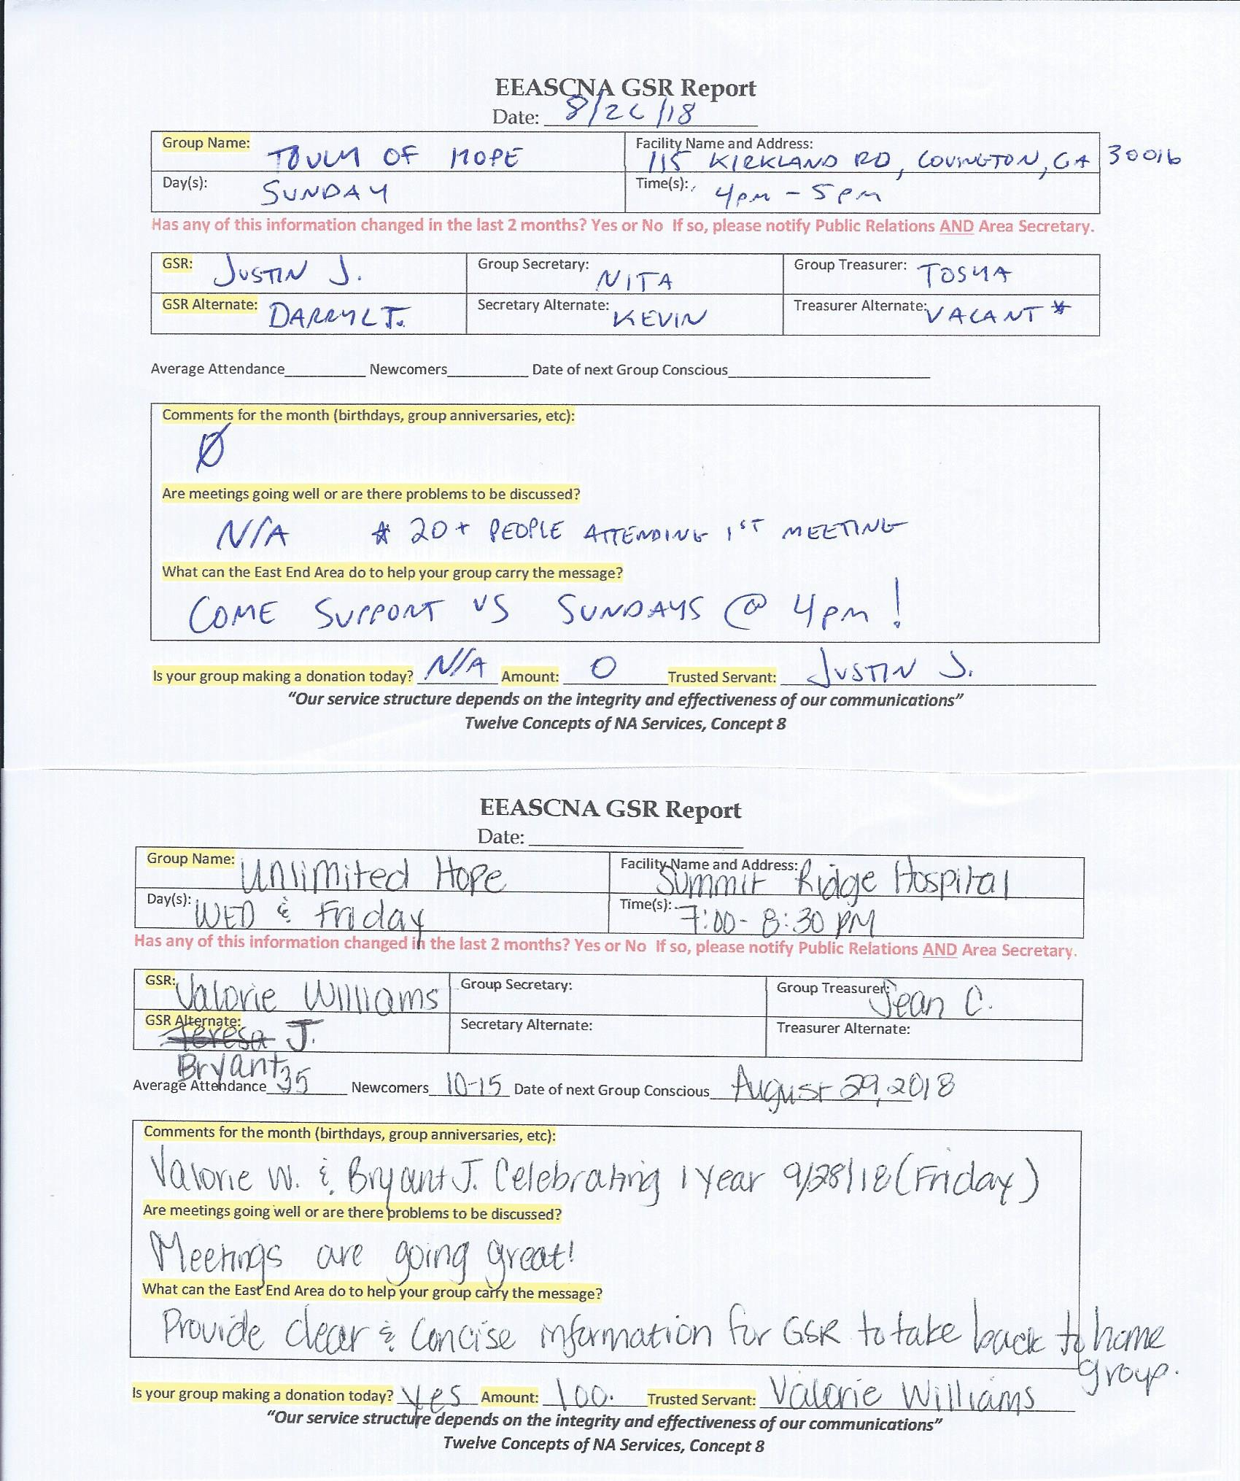

Old Business
- Serve two terms in a position, have to sit out of that same or related position for two terms - 2
- Serve your term, can come back to position after 6 months of being away - 7
- Serve as alternate then move to position, can serve max amount of terms, must take one term off before rotating back into related position - 2

Nominations/Elections

None

Positions Still Open
Alternate Secretary
Public Relations Vice Chair

Open Forum
- Discussion about topic

New Business
Topic 2018-003 - Changing Article VII Section F to read: All positions can be held at a maximum of two terms. After serving as primary for two terms, the trusted servant cannot be nominated for the primary or secondary position for six months.
(Topic form below)
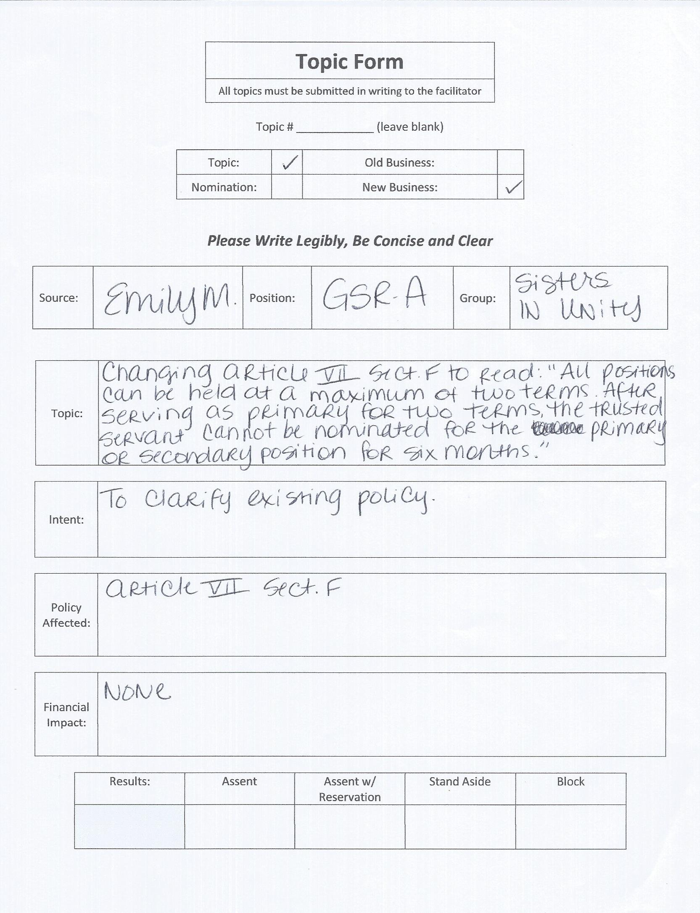

Take back to groups
- Voting on Topic 2018-003
- GRCNA flyer below for next March

Plans for the next meeting
Next Area Service will be
Held at 3pm on October 7th in Snellville
**ADMIN MEETS AT 2:00 PM**

(Other forms and flyers below)

