**Notice: Meeting format has changed**
EEASCNA Minutes- December 2016
Sojourner opened ASC Meeting with moment of silence followed by the Serenity Prayer
Reading of Twelve Traditions - Brian
Reading of Twelve Concepts - Rick
Reading of Article II & III: Purpose of EEASCNA - Simone
Article II: Purpose The purpose of the East End Area Service Committee of Narcotics Anonymous (EEASCNA) shall be to respond to the needs and collective conscience of its member groups. EEASCNA supports and encourages the unity, welfare and growth of the East End Area as part of a worldwide Fellowship.
Article III: A. Definition and Function of the Area: The Area Service Conference (ASC) is the communicative channel for a unified Fellowship, a tie that binds us together. The ASC serves as a link in the flow of communication from the member to the worldwide Fellowship, establishes a structure in which services and education are provided, and functions as a vehicle through which our Area Fellowship and society can relate. The EEASC is a Committee made up of Group Service Representatives (GSRs), special purpose Task panels and an Administrative Body from Member Groups of the East End Area.
Administration Roll-Call
Key: 0= Not Present, 1= Present, (-) = Vacant, R= Report submitted only
ROLE | NAME | D | J | F | M | A | M | J | J | A | S | O | N | D
Facilitator | Sojourner B. | i | i | i | i | i | 1 | 1 | 1 | 1 | 1 | 1 | 1 | 1
Co-Facilitator | Simone J. | - | - | - | 1 | 1 | - | - | - | - | 0 | 1 | 1 | 1
Secretary | Sara Y. | 1 | 1 | 1 | 1 | 1 | 1 | 1 | 0 | 1 | 1 | 0 | 1 | 1
Alt-Secretary | Kristin F. | - | - | - | - | - | - | - | 1 | 1 | 1 | 1 | 1 | 1
Treasurer | Susan W. | i | i | i | 1 | 1 | 1 | 1 | 1 | 1 | 1 | 1 | 1 | 1
Alt-Treasurer | Cheri H. | - | - | - | 0 | 0 | 1 | 1 | 1 | 1 | 1 | 1 | 0 | 0
H&I Chair | Tim F. | 1 | 1 | 1 | 1 | 1 | 1 | 1 | 1 | 1 | 1 | 1 | 1 | 0
H&I Vice |  | - | - | - | - | - | - | - | - | - | - | - | - | -
PR Chair | Jackson J. | - | - | - | - | - | 1 | 0 | - | - | - | - | 1 | 1
PR Vice |  | - | - | - | - | - | - | - | - | - | 1 | 1 | 1 | -
Activities | Elaine J. | 1 | 1 | i | 1 | 1 | 0 | 1 | 1 | 1 | 1 | 1 | 0 | 1
Activities Vice |  | - | - | 1 | - | 1 | 1 | 1 | 0 | 1 | 0 | 1 | 0 | 0
RCM | Fred C. | 1 | 1 | 1 | 1 | 1 | 1 | 1 | 1 | 1 | 1 | 1 | 1 | 1
RCMA | Mike R. | - | 1 | 1 | 1 | 1 | 1 | 0 | 1 | 1 | 1 | 1 | 1 | 1
Group Voting Policy:
- To reach quorum, 50% + 1 of groups present must be in good-standing.
- A quorum must be reached by fifteen (15) minutes after roll call is completed and before any business can be conducted.
- In order for a topic to be enacted, 80% of the groups present must be in good standing.
- New groups must attend 3 consecutive Area Meetings to gain voting rights at the 3rd Area.
- If a group misses 2 consecutive Area Meetings to re-gain voting rights at the 2nd.

East End Area Groups Roll Call
Key: 0= Not Present, 1= Present, R= Report Submitted only, Blacked Out= Not G.S.
2015- 2016 | D | J | F | M | A | M | J | J | A | S | O | N | D
By NA Means Necessary | 1 | 1 | 0 | 1 | 0 | 0 | 1 | 0 | 0 | 0 | 0 | 0 | 0
Changing in Grayson | R | R | 1 | 1 | 1 | 1 | 1 | R | 1 | R | 1 | 1 | 1
Clean & Free | 1 | 1 | 1 | 1 | 1 | 1 | 1 | 1 | 1 | 0 | 1 | 1 | 1
Covington Miracles | 1 | 1 | 1 | 1 | R | 1 | 1 | 1 | 1 | 1 | 1 | 1 | 1
Fahrfromusin | 1 | 1 | 1 | R | 1 | 1 | 1 | R | 1 | 1 | 1 | 1 | 1
Far Out | 1 | 1 | 1 | 1 | 1 | 1 | 0 | 1 | 0 | 0 | 0 | 0 | 1
Get Real | 1 | 0 | 0 | 0 | 0 | 0 | 0 | 0 | 0 | 0 | 0 | 0 | 0
Harvest | 1 | 1 | 1 | 1 | 1 | 1 | 1 | 1 | 1 | 1 | 1 | 1 | 0
How It Works | 1 | 0 | 1 | 1 | 1 | 1 | 1 | 1 | 1 | 1 | 1 | 1 | 1
Just for Today | 1 | 1 | R | 0 | 1 | 1 | 1 | 1 | 1 | 1 | 1 | 1 | 1
Let the Truth Be Told | 0 | 1 | 1 | 0 | 1 | 0 | 1 | 1 | 1 | 1 | 1 | 1 | R
Monroe New Miracles | 1 | 1 | 1 | 1 | 1 | 1 | 0 | 0 | 1 | 0 | 1 | 1 | 1
NA Vaders | 1 | 1 | 1 | 1 | 1 | 1 | 1 | 1 | 1 | 1 | 1 | 1 | 1
NA Way | 1 | 1 | 1 | 1 | 1 | 1 | 1 | 1 | 1 | 1 | 1 | R | 1
No Name Group | _ | _ | 1 | 0 | 1 | 1 | 1 | 1 | 1 | 0 | 1 | 0 | 0
Recovery at the Rock | 1 | 1 | 0 | 0 | 0 | 0 | 0 | 0 | 0 | 0 | 0 | 0 | 0
Restoration at work | 0 | 1 | 1 | 1 | 1 | 1 | 1 | 1 | 1 | 1 | 1 | 1 | 1
Set-Free | - | 1 | 1 | 0 | 0 | 0 | 0 | 0 | 0 | 0 | 0 | 0 | 0
Sisters in Unity | 1 | 1 | 1 | 1 | 1 | 1 | 1 | 1 | 1 | 1 | 1 | 1 | 1
Spiritual Principles | - | - | - | - | 1 | 1 | 1 | R | 1 | 0 | 1 | P | P
The Journey Continues | - | - | - | - | - | - | - | - | 1 | 1 | 1 | 1 | 1
Unlimited Hope | 1 | 0 | 1 | R | 1 | 0 | 1 | 1 | 0 | 1 | 0 | 1 | 1
Total of Groups in Area | 19 | 19 | 20 | 20 | 21 | 21 | 21 | 21 | 21 | 22 | 22 | 22 | 22
Total Groups Present | 14 | 17 | 15 | 14 | 17 | 15 | 17 | 16 | 12 | 13 | 16 | 14 | 14
Groups in Good Standing | 16 | 16 | 17 | 17 | 16 | 16 | 17 | 18 | 18 | 17 | 17 | 17 | 17
Groups Present & G.S. | 13 | 16 | 14 | 14 | 15 | 13 | 15 | 16 | 13 | 12 | 16 | 14 | 14
Number for Quorum (50% + 1)?  Is Quorum reached? | 11 Yes | 10 Yes | 11 Yes | 11 Yes | 10 Yes | 12 Yes | 15 Yes | 12 Yes | 12 Yes | 12 Yes | 12 Yes | 12 Yes | 12 Yes
Number for Consensus (80% present in G.S)?  Do we have Consensus? | 14 Yes | 13 Yes | 12 Yes | 11 Yes | 10 Yes | 14 Yes | 10 Yes | 13 Yes | 13 Yes | 12 Yes | 13 Yes | 11 | 11

Subcommittee Reports
Admin- Treasurer discussed paying rent for Snellville location. PR talked about updating website and utilizing Google calendar, and building up subcommittee. Activities scheduled New Year’s dance.

Treasurer Report
Treasurer will come next month to help replacement. Full report below:
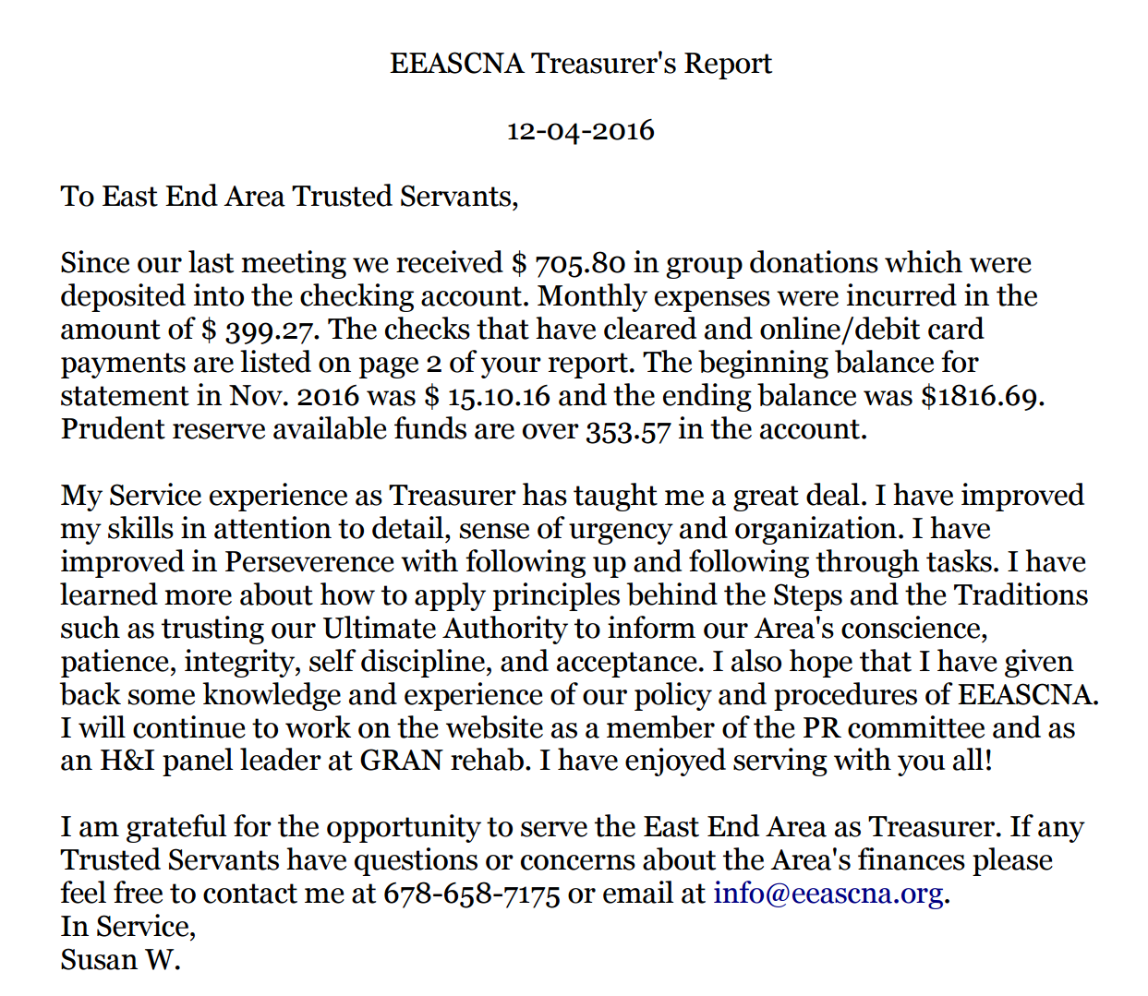
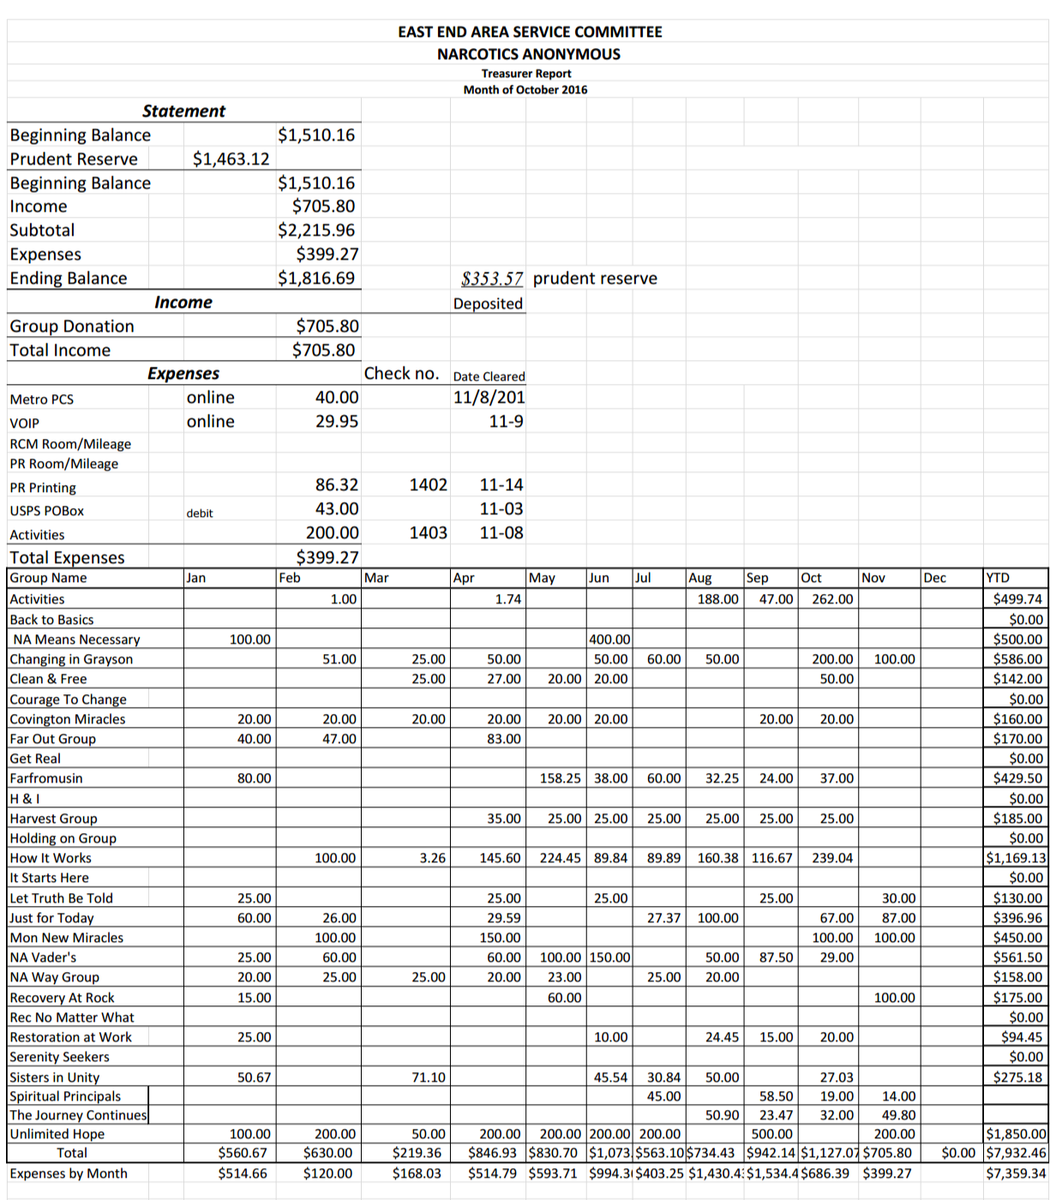

RCM Report
RSC is Dec 10th and 11th in Forsyth. Subcommittees meet at 9 am. Will have a date for the consensus workshop after meeting with the RD in December. RCMA position will be open in March.

H & I Report
Needs new panel leader for men’s meeting. Full report below:
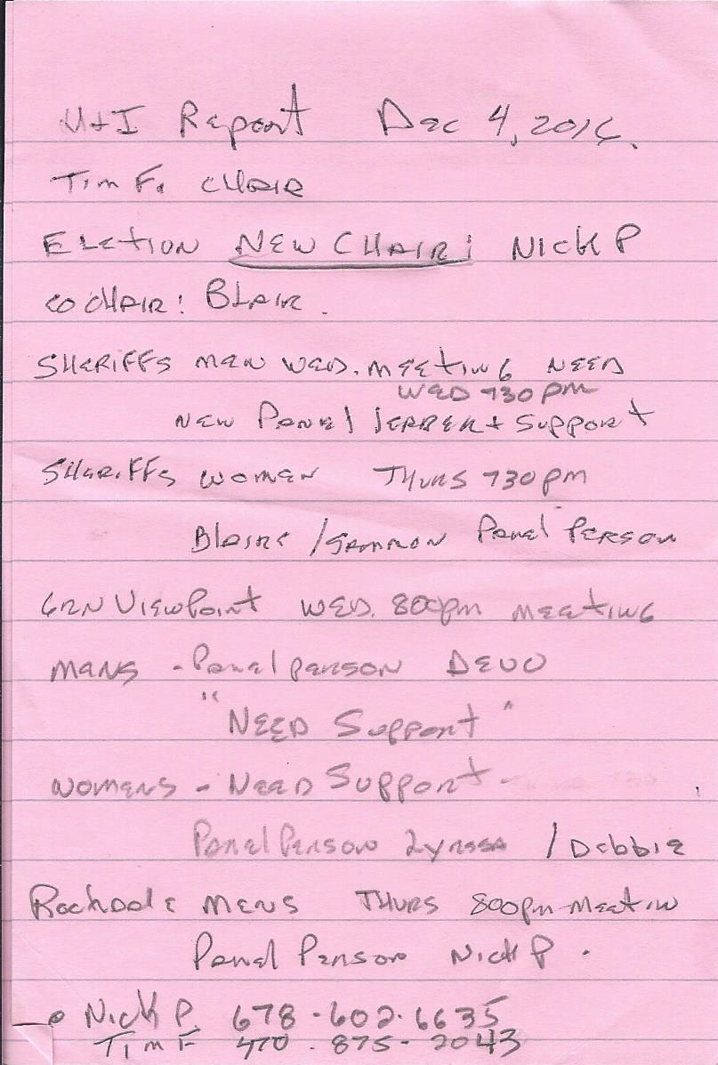

Public Relations Report
Drug court orientation literature needs approval. Walton county jail setting up new meeting there. High school and hospital programs. Announcing GRCNA with full name. Full report below:

PUBLIC RELATIONS
Monthly Subcommittee Meeting
November, 2016 4:00pm- 6:00pm
Attendees: Jackson
Joe B.
The first order of business is to get the committee members information in order and assembled. Print out East End Area Policy.

Chair: Jackson J. Jackson jacksonjamesE@hotmail.com;
Co-Chair: David F. Rfarthing@yahoo.com;
Web-site Cord: Susan W. spiritualsuze@yahoo.com;
Co- Web site Cord
Phone Coordinator Dinky (Tracey S., Brenda)
Meeting List Fred C. coleman1849@gmail.com;
Comm0ittee Member Joe B. smooth4152003@yahoo.com;

Old BUSINESS
*The web site migration .
*Establish and maintain a 6 to 12-month calendar to balance with other functions
*Secure meeting place at Zoar Church
New BUSINESS FOR NOVEMBER

1. Inventory Currrent Services
a. Set the 2017 calendar to include PR.learning days
2. Where is Narcotics Anonymous Needed Most In The Community
a. Where are our new members coming from
3. Examine and get approval of Drug Court Orientation Literature.

DISCUSSION: For November

Georgia Regional is preparing a Learning Day in late January or early February, the East End Ares (EEA) is urged to participate. There will be workshops from 7:am to 7:pm Ending with a GRACNA fundraiser. MORE TO BE REVEALED
Presentations to take our message to the High school and Middle Schools
Walton County Jail
Better contact with area Hospitals
P R Committee
Activities Report
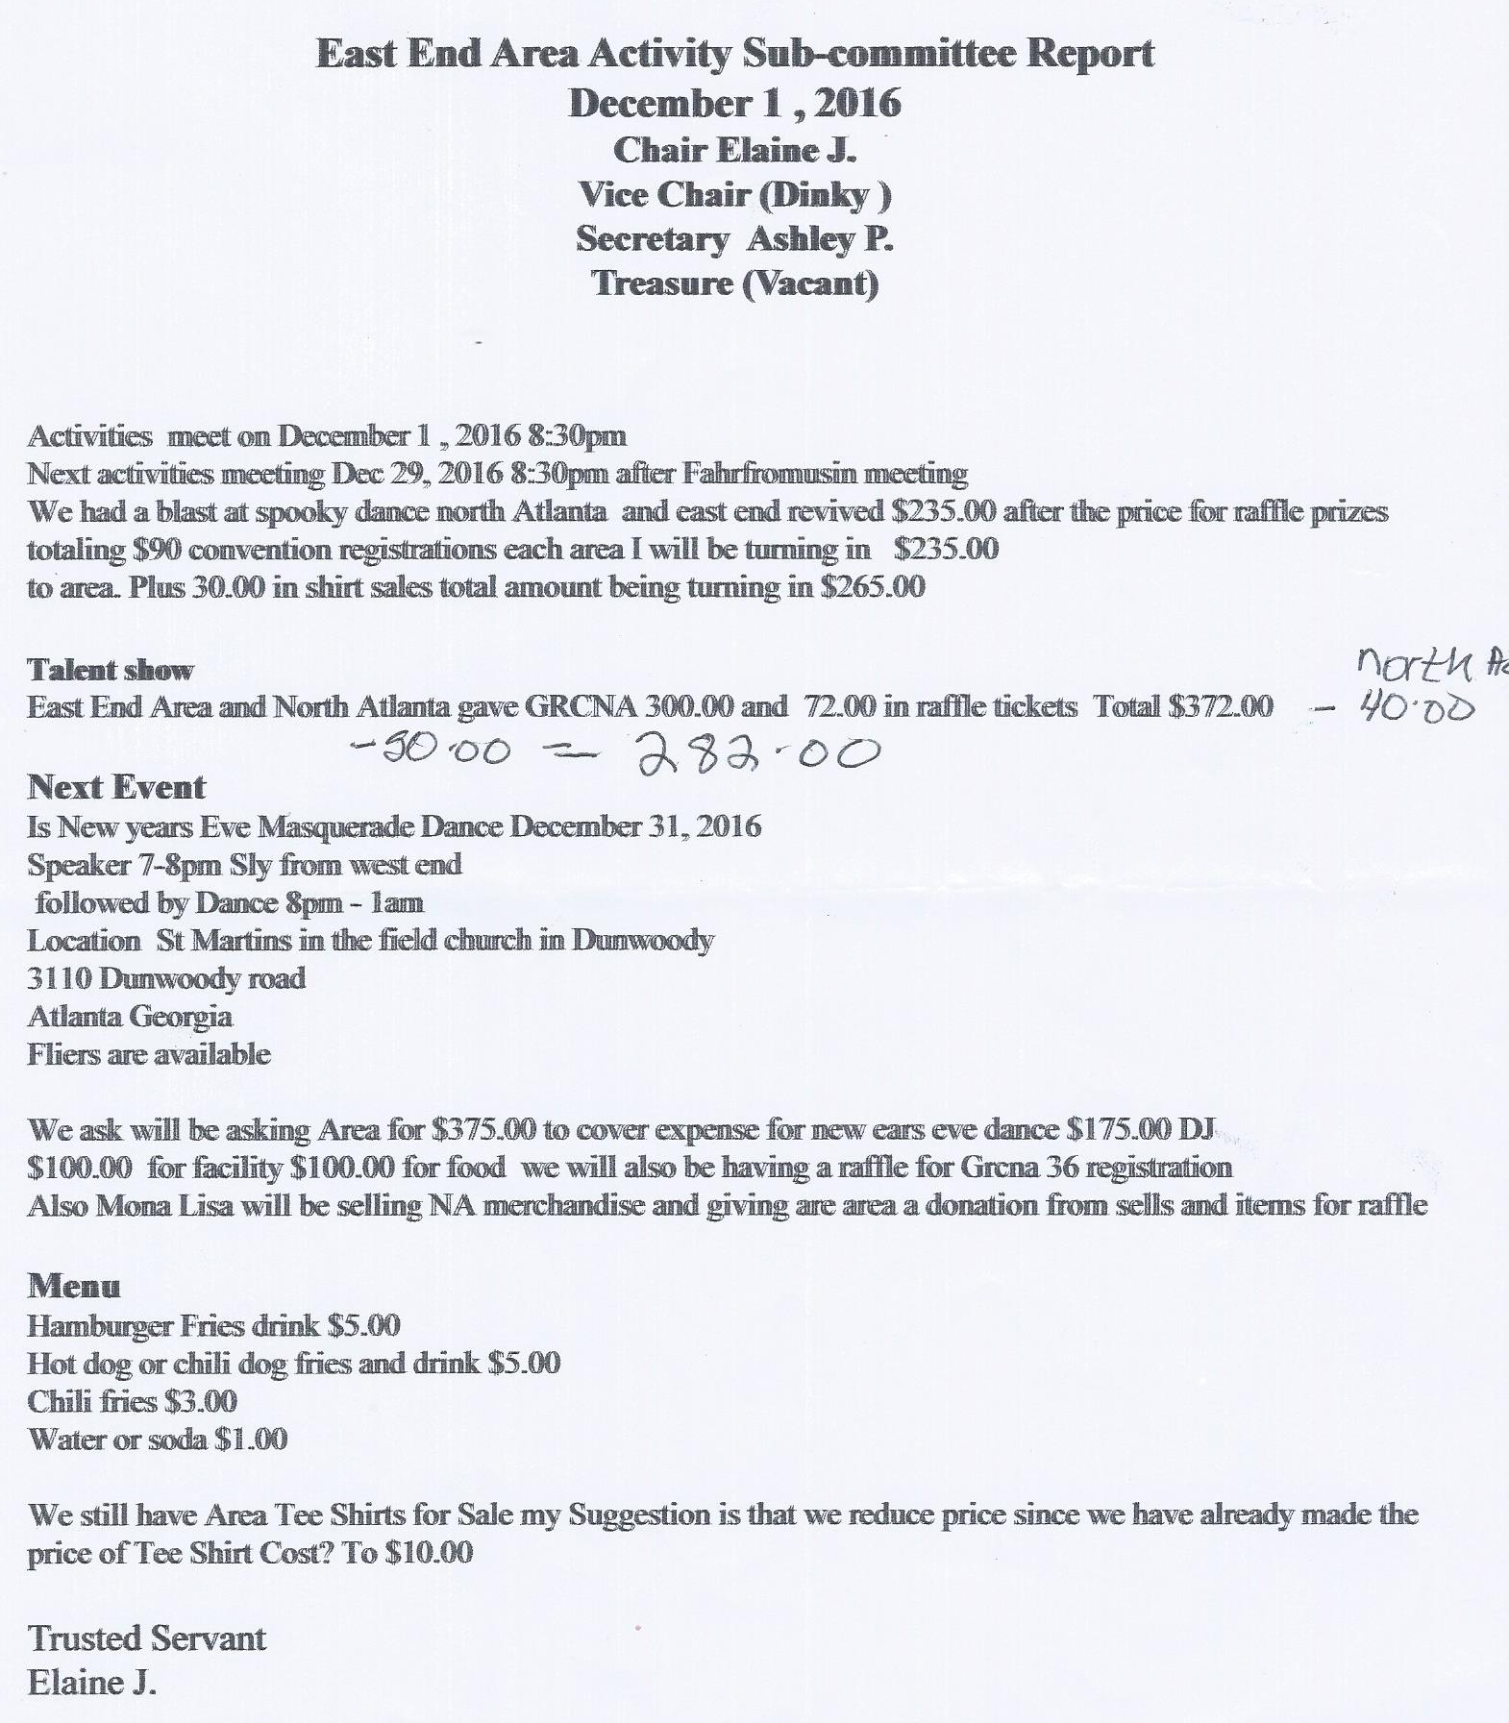
Dec 29th next meeting. 4-5 new activity members. New Year’s dance scheduled, flyer attached, $5 suggested donation. East End area t-shirts still available, should we lower cost to $10? Need someone to step up and take over Activities position.

Group Reports
SCANNED AND ATTACHED BELOW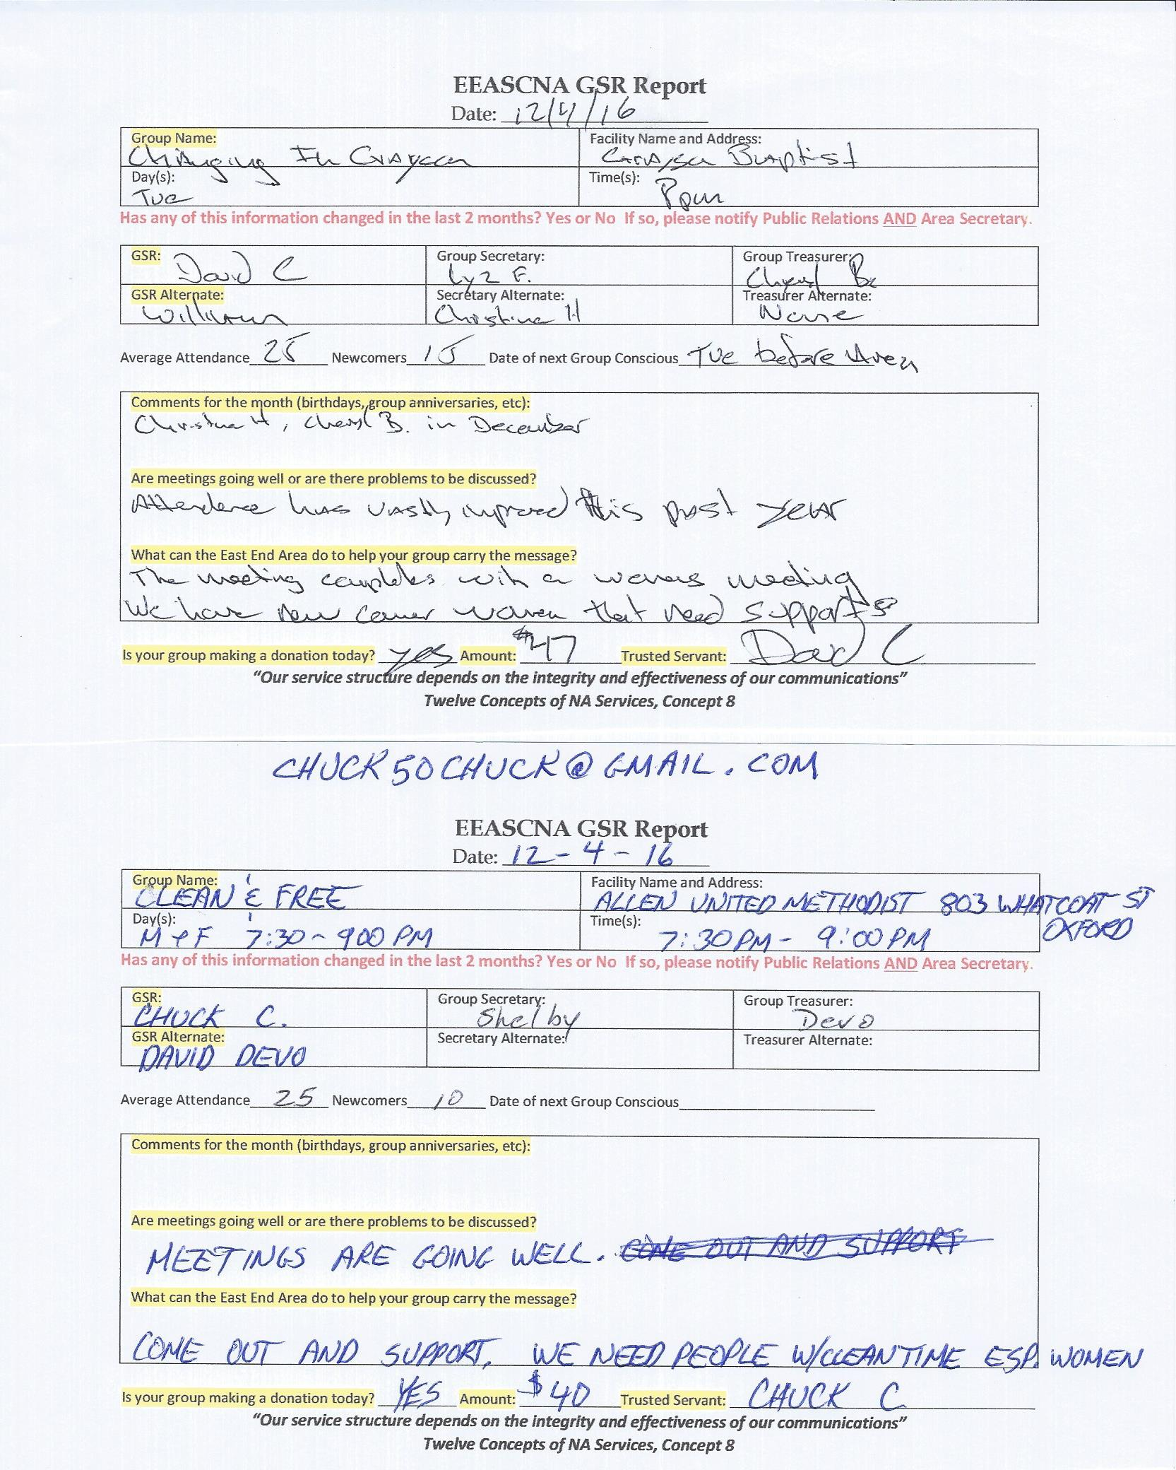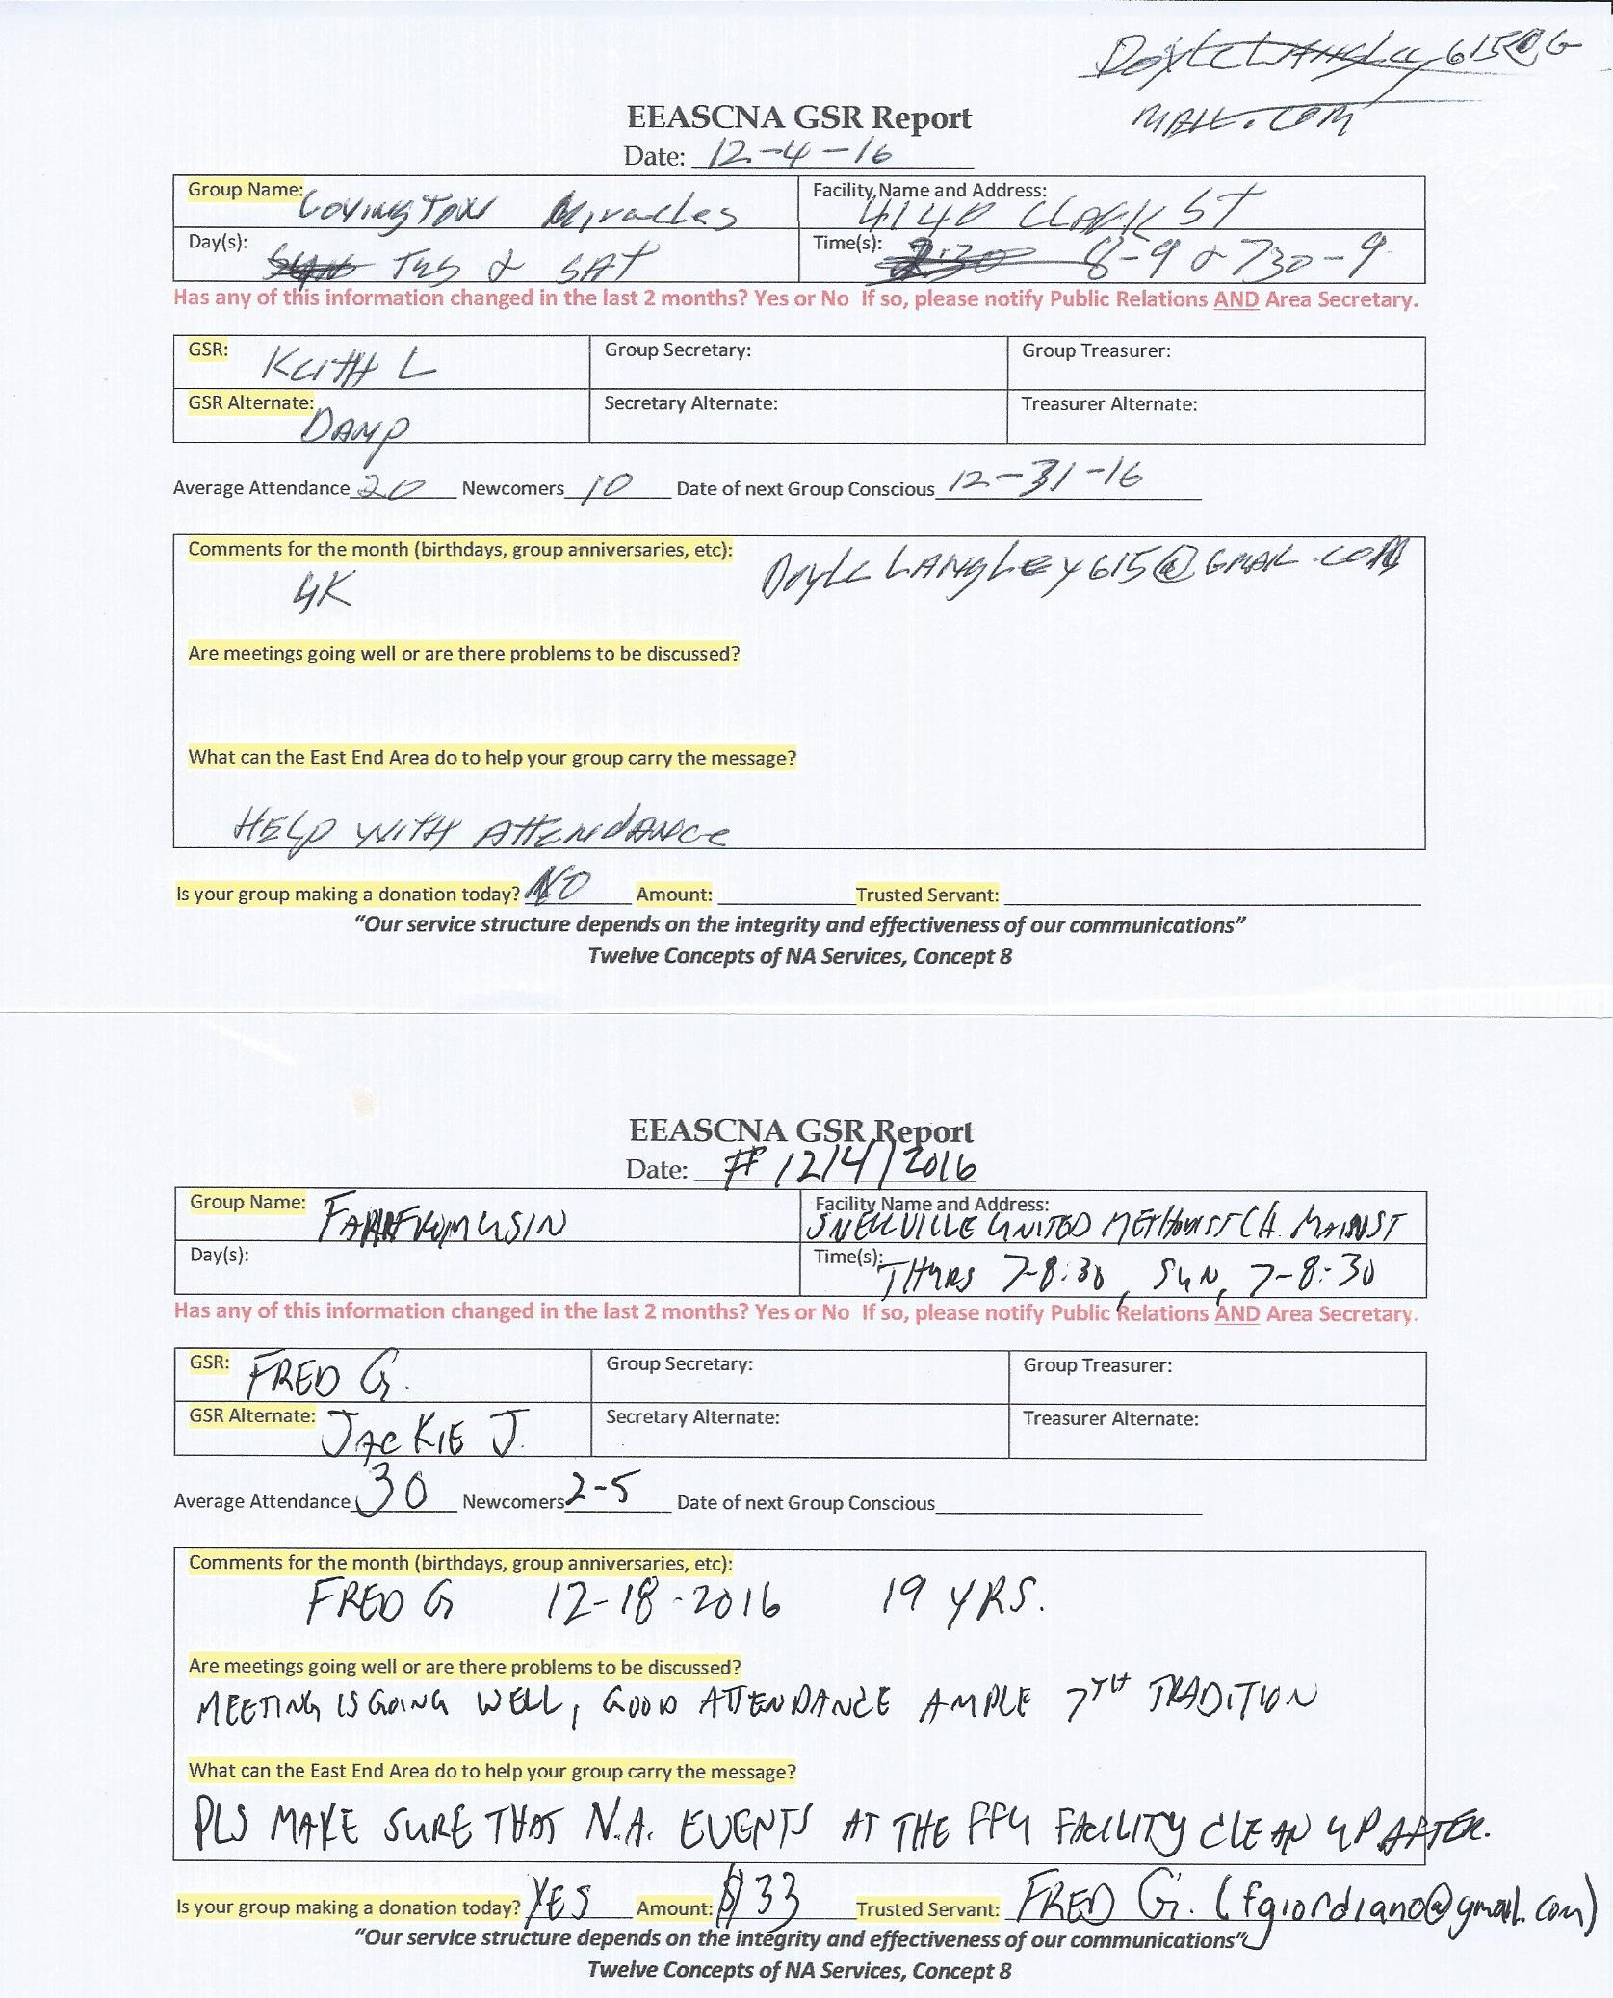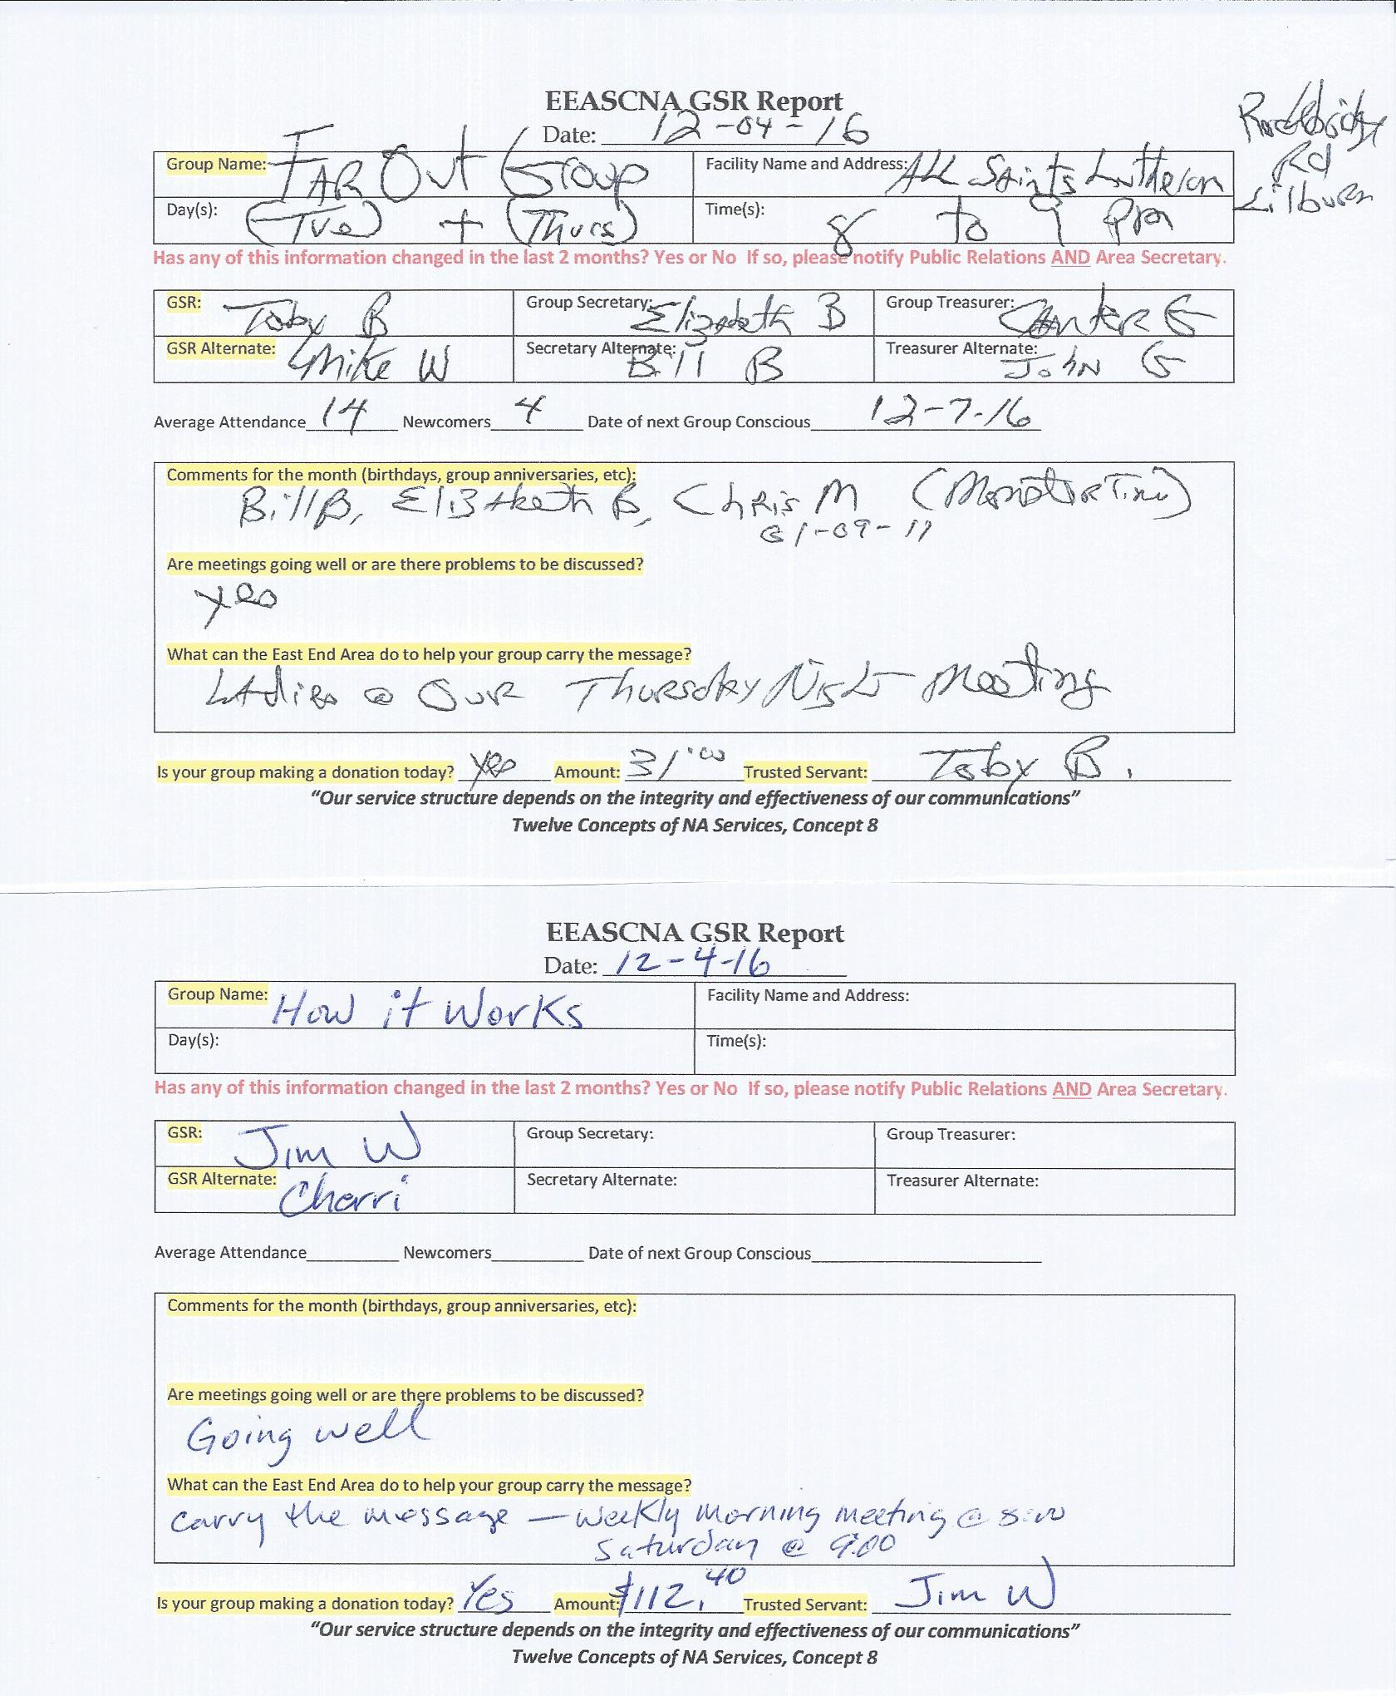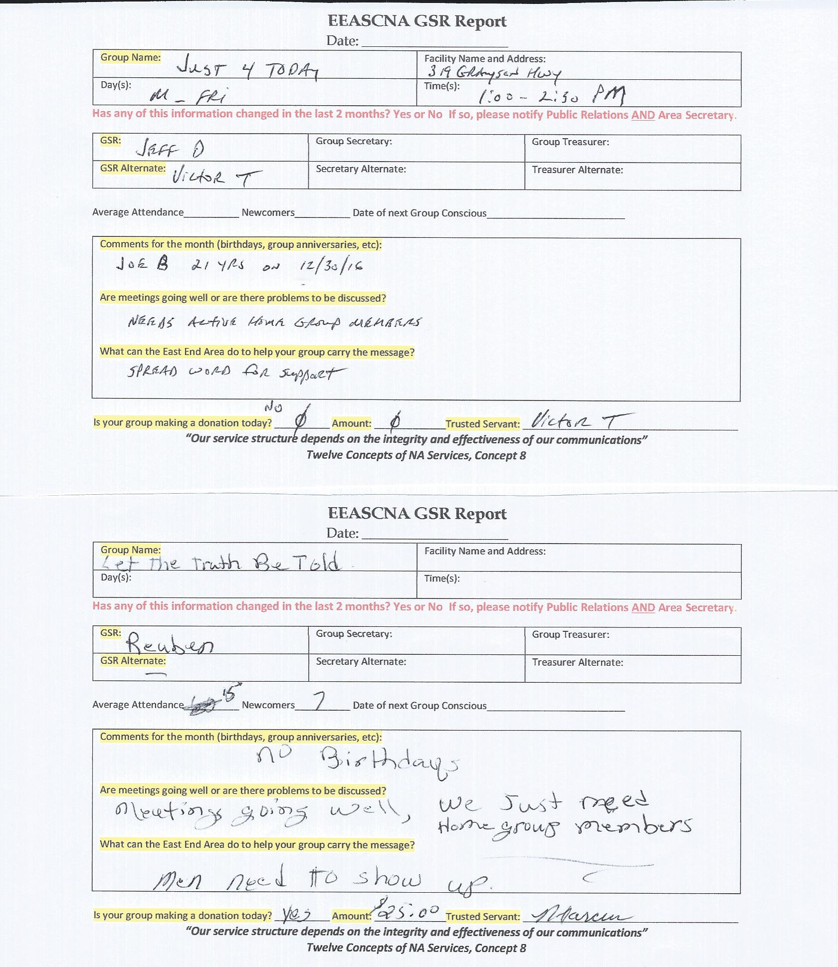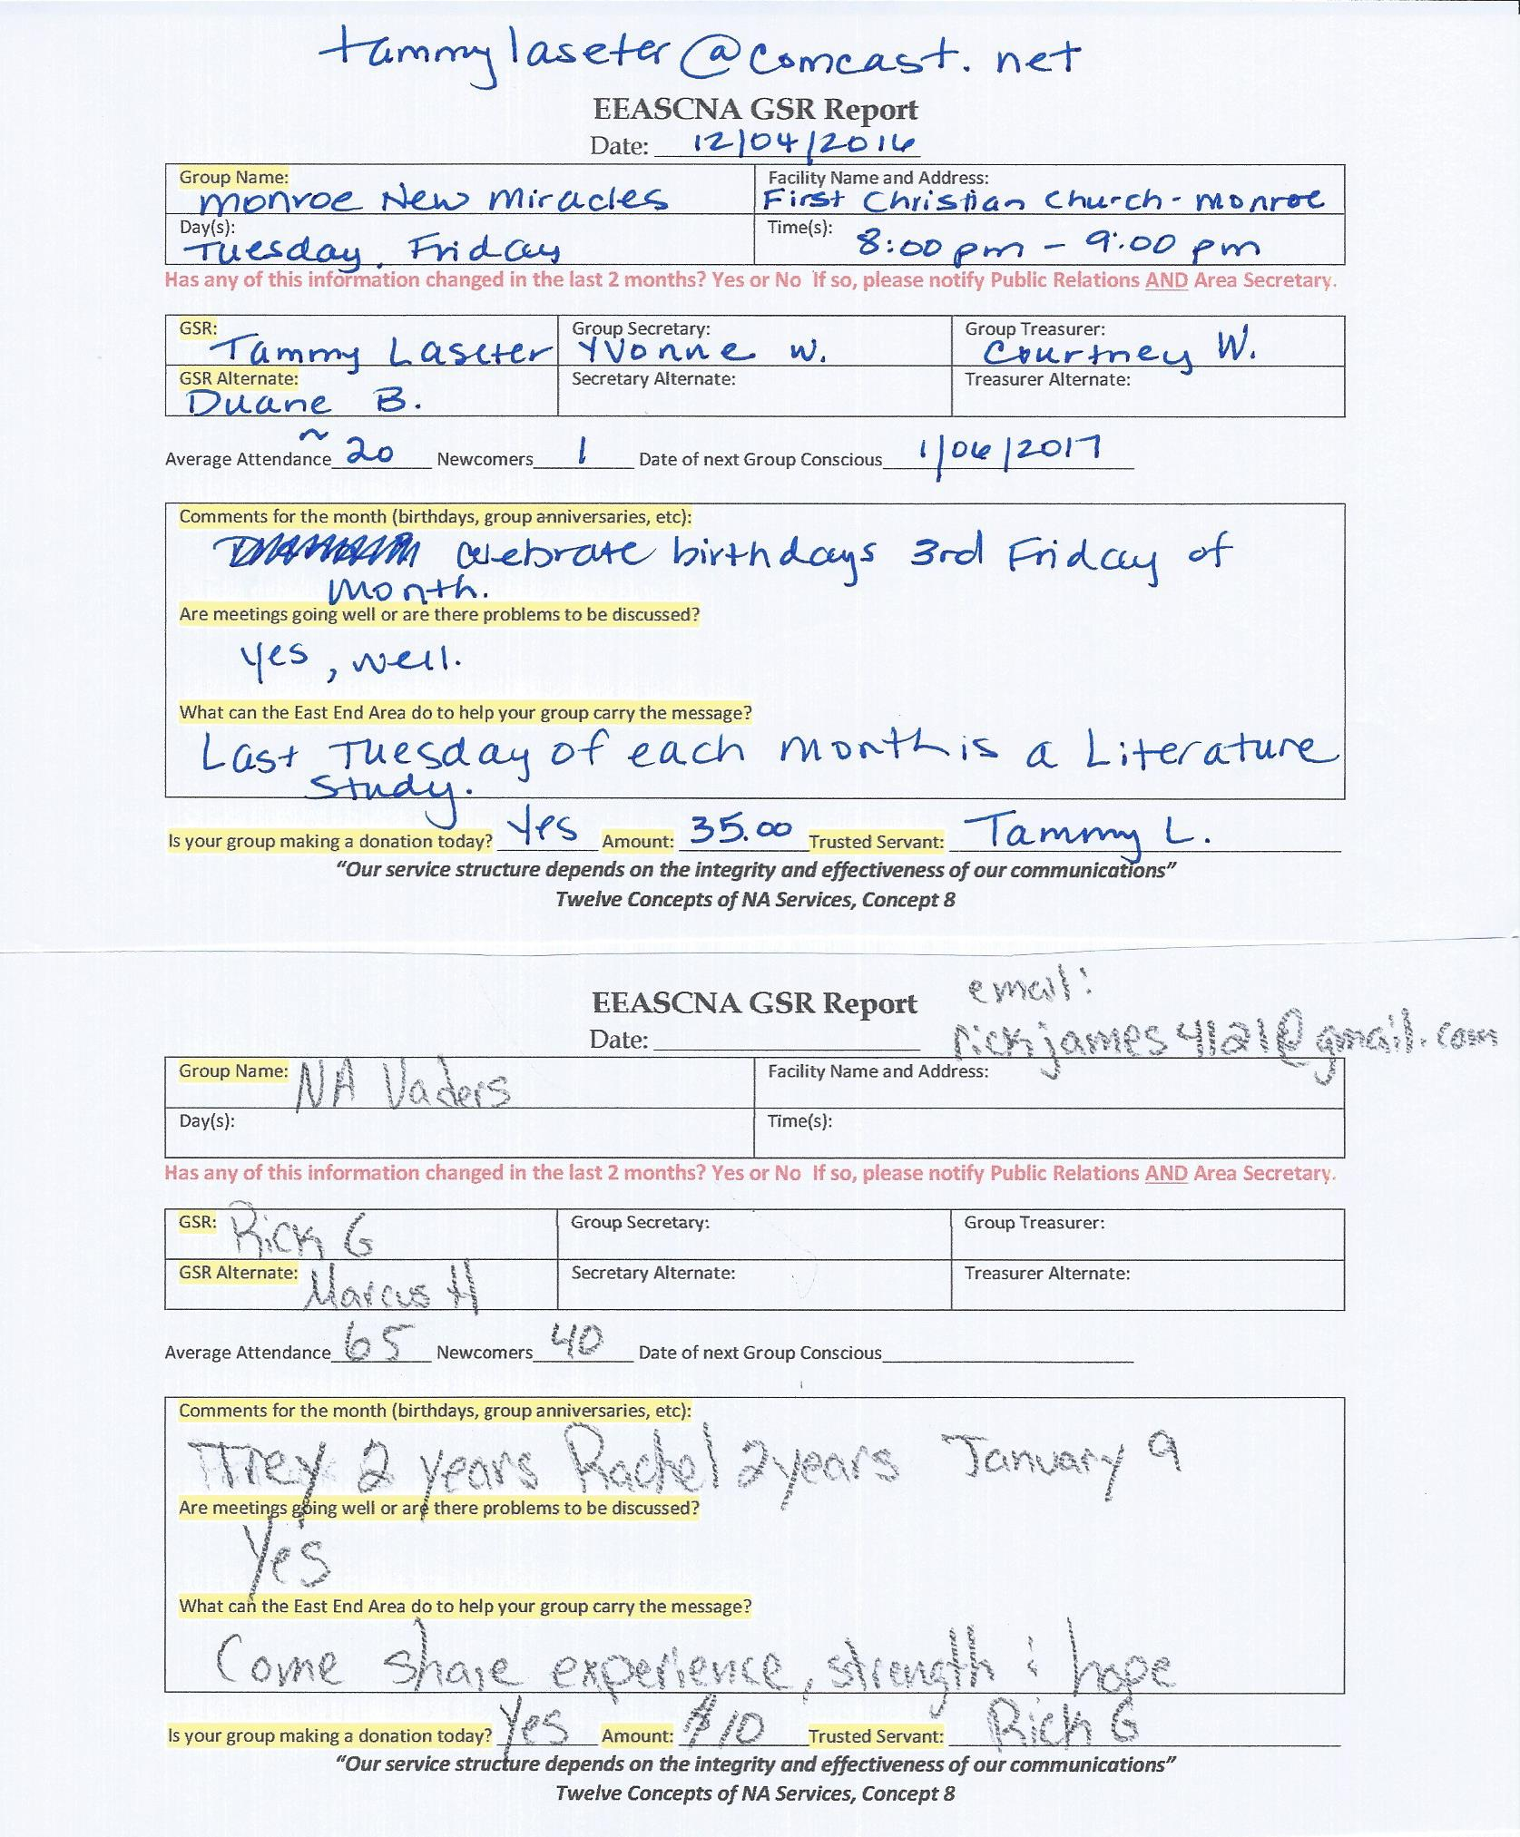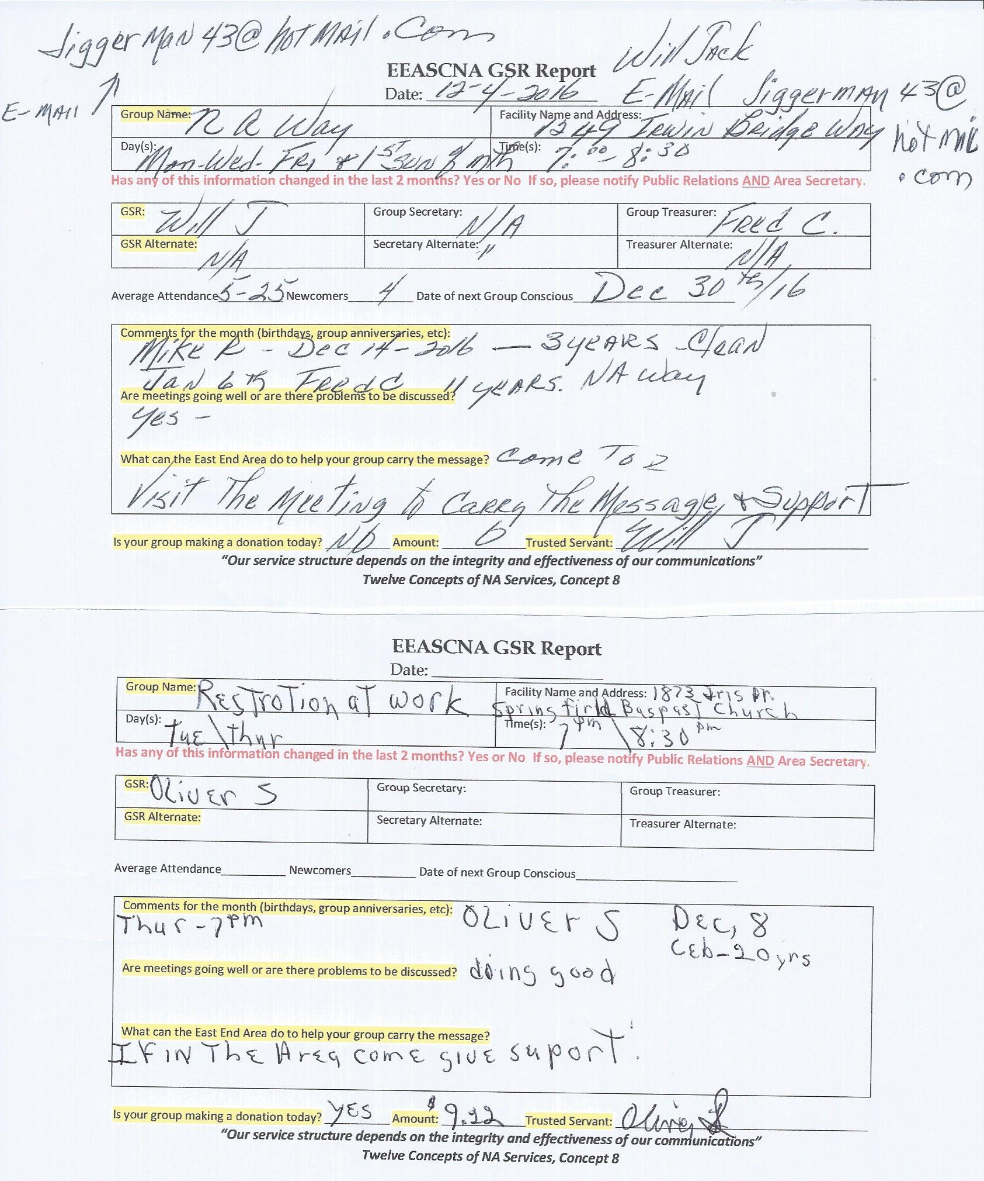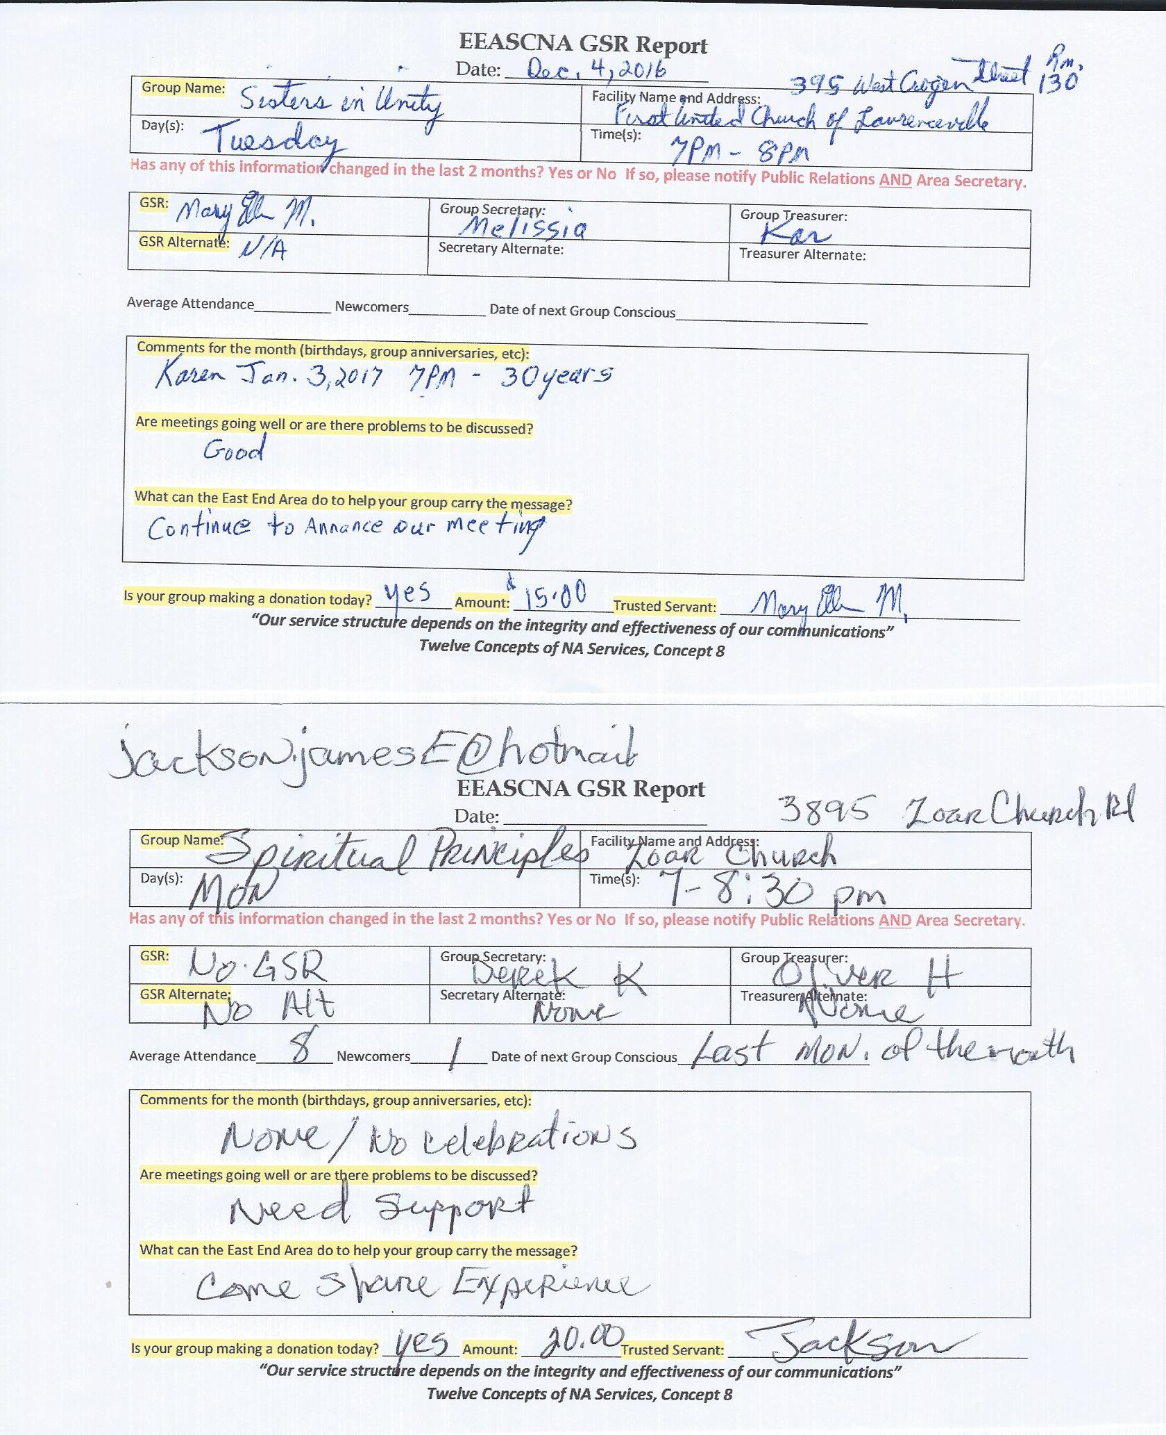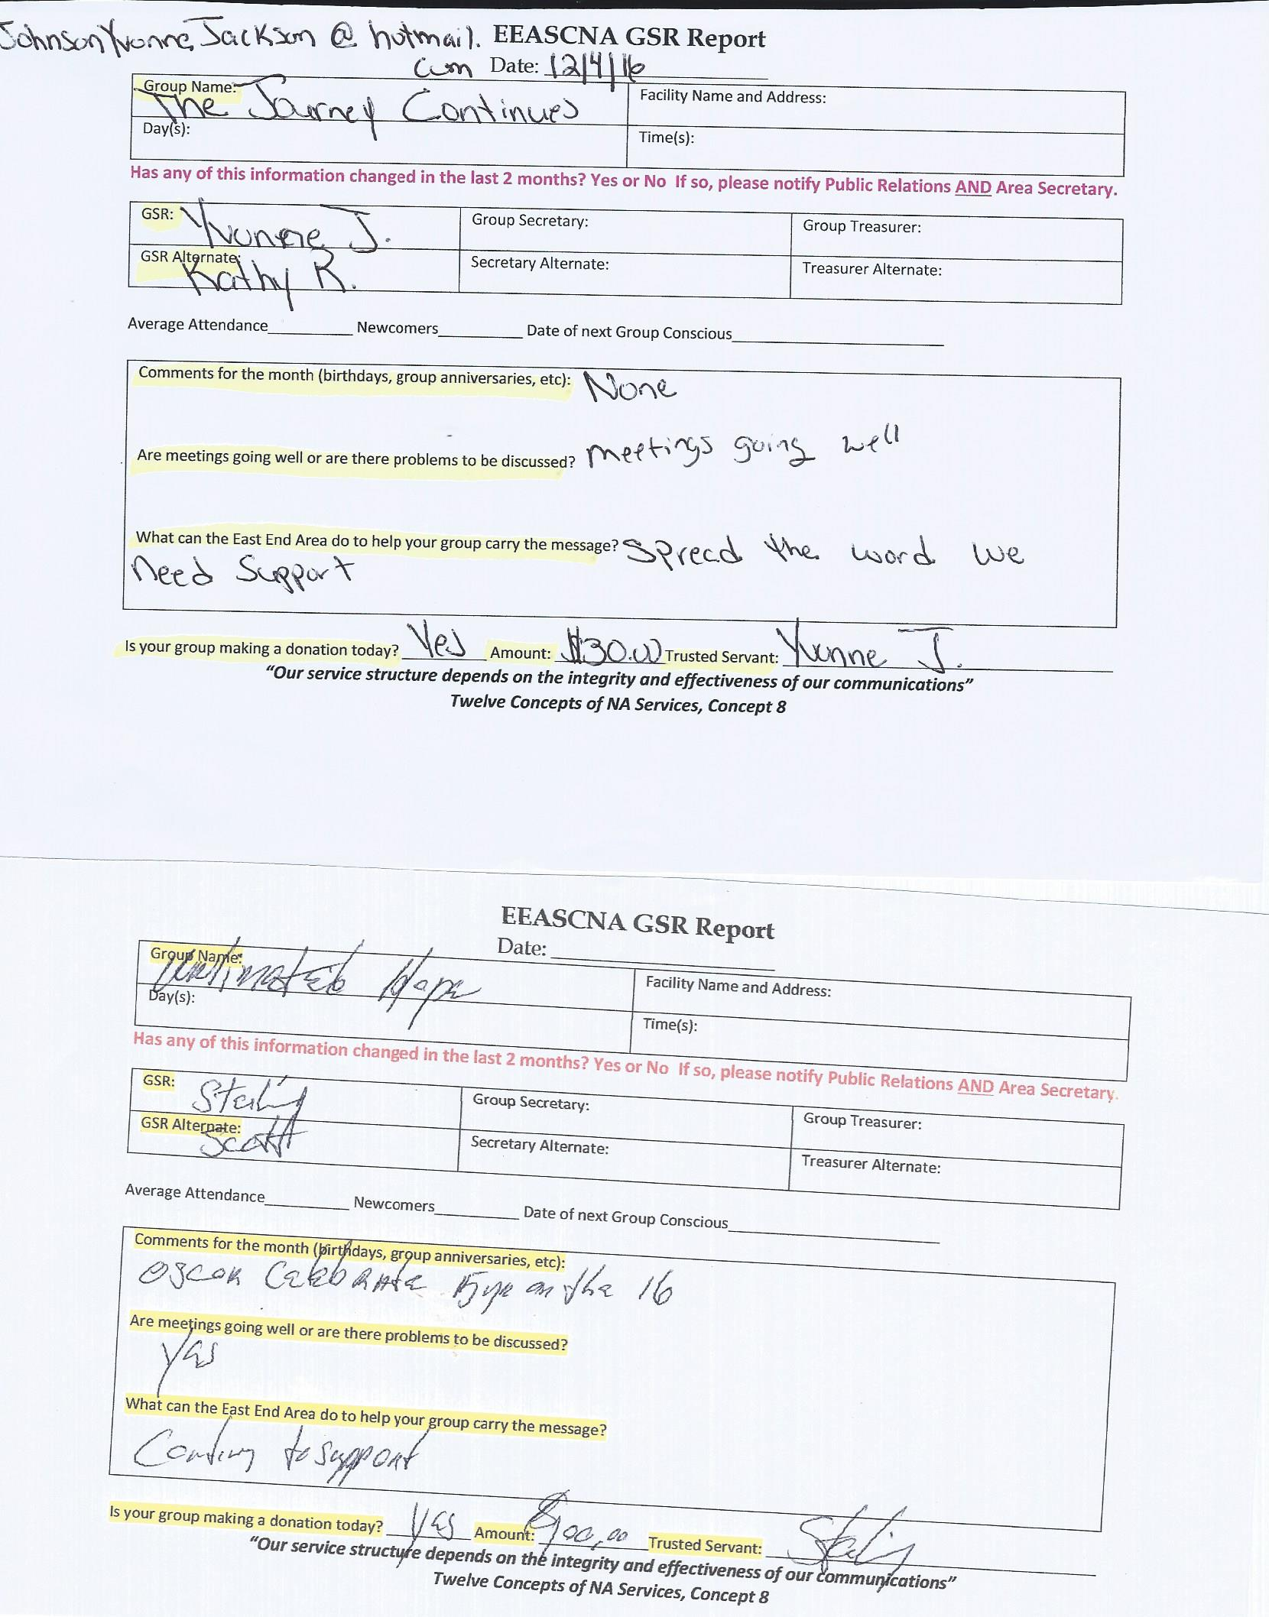

Old Business
Topic # 16-001 - To wave the clean time requirement for the secretary nomination
12 – Assent Stand Aside - 2 PASS

Nominations/Elections
Nick P./H&I - 14 - Assent PASS
Brian A./Treasurer - 14 - Assent PASS
Kristin F./Secretary - 12 - Assent / 2 - Stand aside PASS
Sojourner/ Facilitator - 14 - Assent PASS
Simone J./ Co Facilitator - 14 - Assent PASS

Open Forum
VOTING IS NOT MADE IN OPEN FORUM
- December 24th – January 1st NA meetings around the clock @ 24 Hour Room 261 Marietta Rd Canton GA
- There was talk of newly elected positions making budget for next year

New Business
None

Plans for the next meeting
Next Area Service will be
Held at 3pm January 8th in Conyers
**ADMIN MEETS AT 2:30 PM**

