EEASCNA Minutes - February 2018
- Area began at 3:01 pm
- Simone opened ASC Meeting with moment of silence followed by the Serenity Prayer
- Reading of Twelve Traditions - Mike R.
- Reading of Twelve Concepts - Linda Z.
- Reading of Article II & III: Purpose of EEASCNA - Willie

Article II: Purpose The purpose of the East End Area Service Committee of Narcotics Anonymous (EEASCNA) shall be to respond to the needs and collective conscience of its member groups. EEASCNA supports and encourages the unity, welfare and growth of the East End Area as part of a worldwide Fellowship.
Article III: A. Definition and Function of the Area: The Area Service Conference (ASC) is the communicative channel for a unified Fellowship, a tie that binds us together. The ASC serves as a link in the flow of communication from the member to the worldwide Fellowship, establishes a structure in which services and education are provided, and functions as a vehicle through which our Area Fellowship and society can relate. The EEASC is a Committee made up of Group Service Representatives (GSRs), special purpose Task panels and an Administrative Body from Member Groups of the East End Area.
Administration Roll-Call
Key: 0= Not Present, 1= Present, (-) = Vacant, R= Report submitted only
ROLE | NAME | D | J | F | M | A | M | J | J | A | S | O | N | D
Facilitator | Simone J. | 1 | 1 | 1
Co-Facilitator | Willie A. | - | 1 | 1
Secretary | Kristin F. | 1 | 1 | 1
Alt-Secretary | VACANT | - | - | -
Treasurer | Brian A. | 1 | 1 | 1
Alt-Treasurer | VACANT | - | - | -
H&I Chair | Jon C. | 1 | 1 | 1
H&I Vice | Nicole A. | - | - | 0
PR Chair | Linda Z. | 1 | 1 | 1
PR Vice | VACANT | - | - | -
Activities | Tracy S. | - | 1 | 0
Activities Vice | VACANT | - | - | -
RCM | Mike R. | 1 | 1 | 1
RCMA | Fred C. | 1 | 1 | 1
Group Voting Policy:
- To reach quorum, 50% + 1 of groups present must be in good-standing.
- A quorum must be reached by fifteen (15) minutes after roll call is completed and before any business can be conducted.
- In order for a topic to be enacted, 80% of the groups present must be in good standing.
- New groups must attend 3 consecutive Area Meetings to gain voting rights at the 3rd Area.
- If a group misses 2 consecutive Area Meetings to re-gain voting rights at the 2nd.
East End Area Groups Roll Call
Key: 0= Not Present, 1= Present, R= Report Submitted only, Blacked Out= Not G.S.
2016-2017 | D | J | F | M | A | M | J | J | A | S | O | N | D
By NA Means Necessary | 0 | 0 | 0
Changing in Grayson | 1 | 1 | 1
Clean & Free | 1 | 1 | 1
Covington Miracles | 1 | 1 | 1
Fahrfromusin | 1 | 1 | 1
Far Out | 0 | 0 | 0
Get Real | 1 | 0 | 1
Harvest | 1 | 1 | 1
How It Works | 1 | 1 | 1
Just for Today | 1 | 1 | 1
Let the Truth Be Told | 0 | 1 | 1
Monroe New Miracles | 1 | 1 | 1
NA Vaders | 1 | 1 | 1
NA Way | 1 | 1 | 1
No Name Group | 0 | 0 | 0
Recovery at the Rock | 1 | 1 | 0
Restoration at work | 1 | 1 | 1
Sisters in Unity | 1 | 1 | 1
Spiritual Principles | 0 | 1 | 1
Step to Mercy | 0 | 0 | 0
The Journey Continues | 1 | 1 | 1
Unlimited Hope | 1 | 0 | 1
Total of Groups in Area | 23 | 22 | 22
Total Groups Present | 16 | 16 | 17
Groups in Good Standing | 17 | 17 | 17
Groups Present & G.S. | 15 | 16 | 16
Number for Quorum (50% + 1)?  Is Quorum reached? | 10 Yes | 10 Yes | 10 Yes
Number for Consensus (80% present in G.S)?  # needed to Assent on Topics | 12 | 13 | 13
Roll call ended at 3:09
At this moment, quorum was met

Subcommittee Reports
Admin Report -
- H&I - need budget approved for literature
- PR - new email is being used
- Policy Ad-hoc - 17 policies printed to hand out to groups in good standing

Treasurer Report
- This is last month as Treasurer!
- Need a new Treasurer - term has ended!!
Full report below:
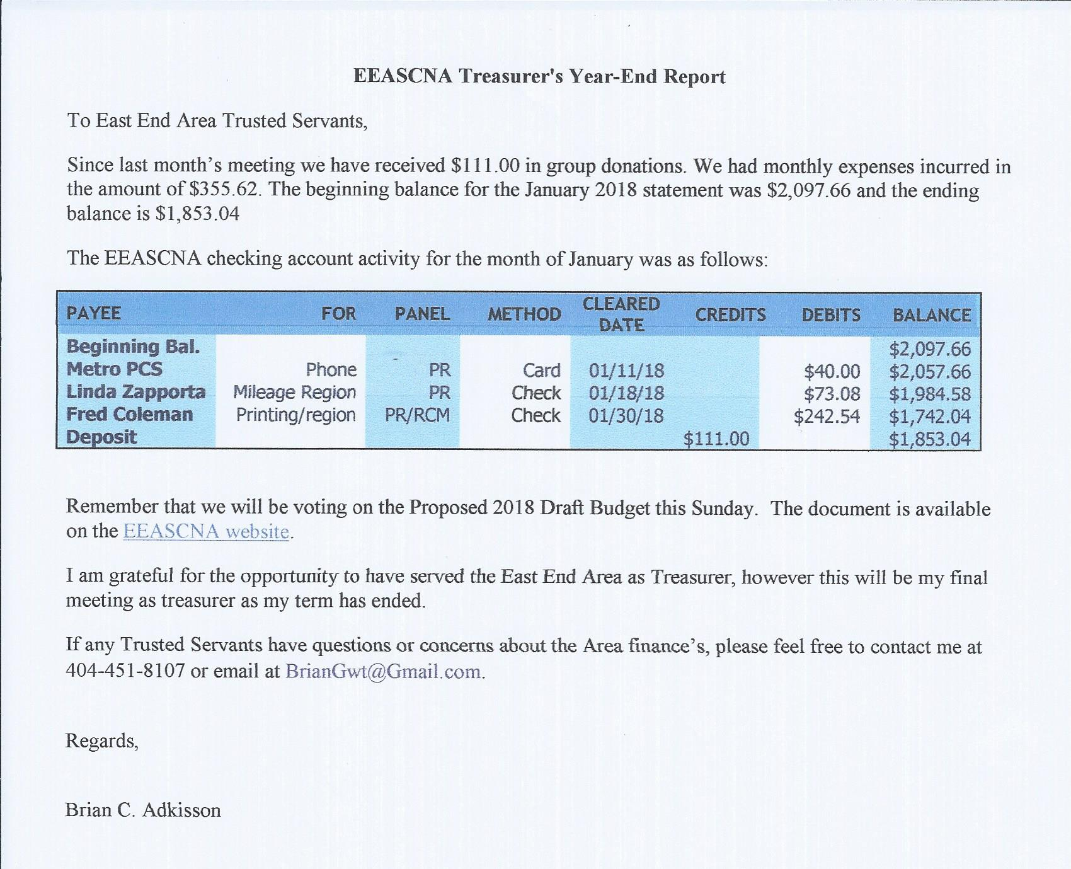
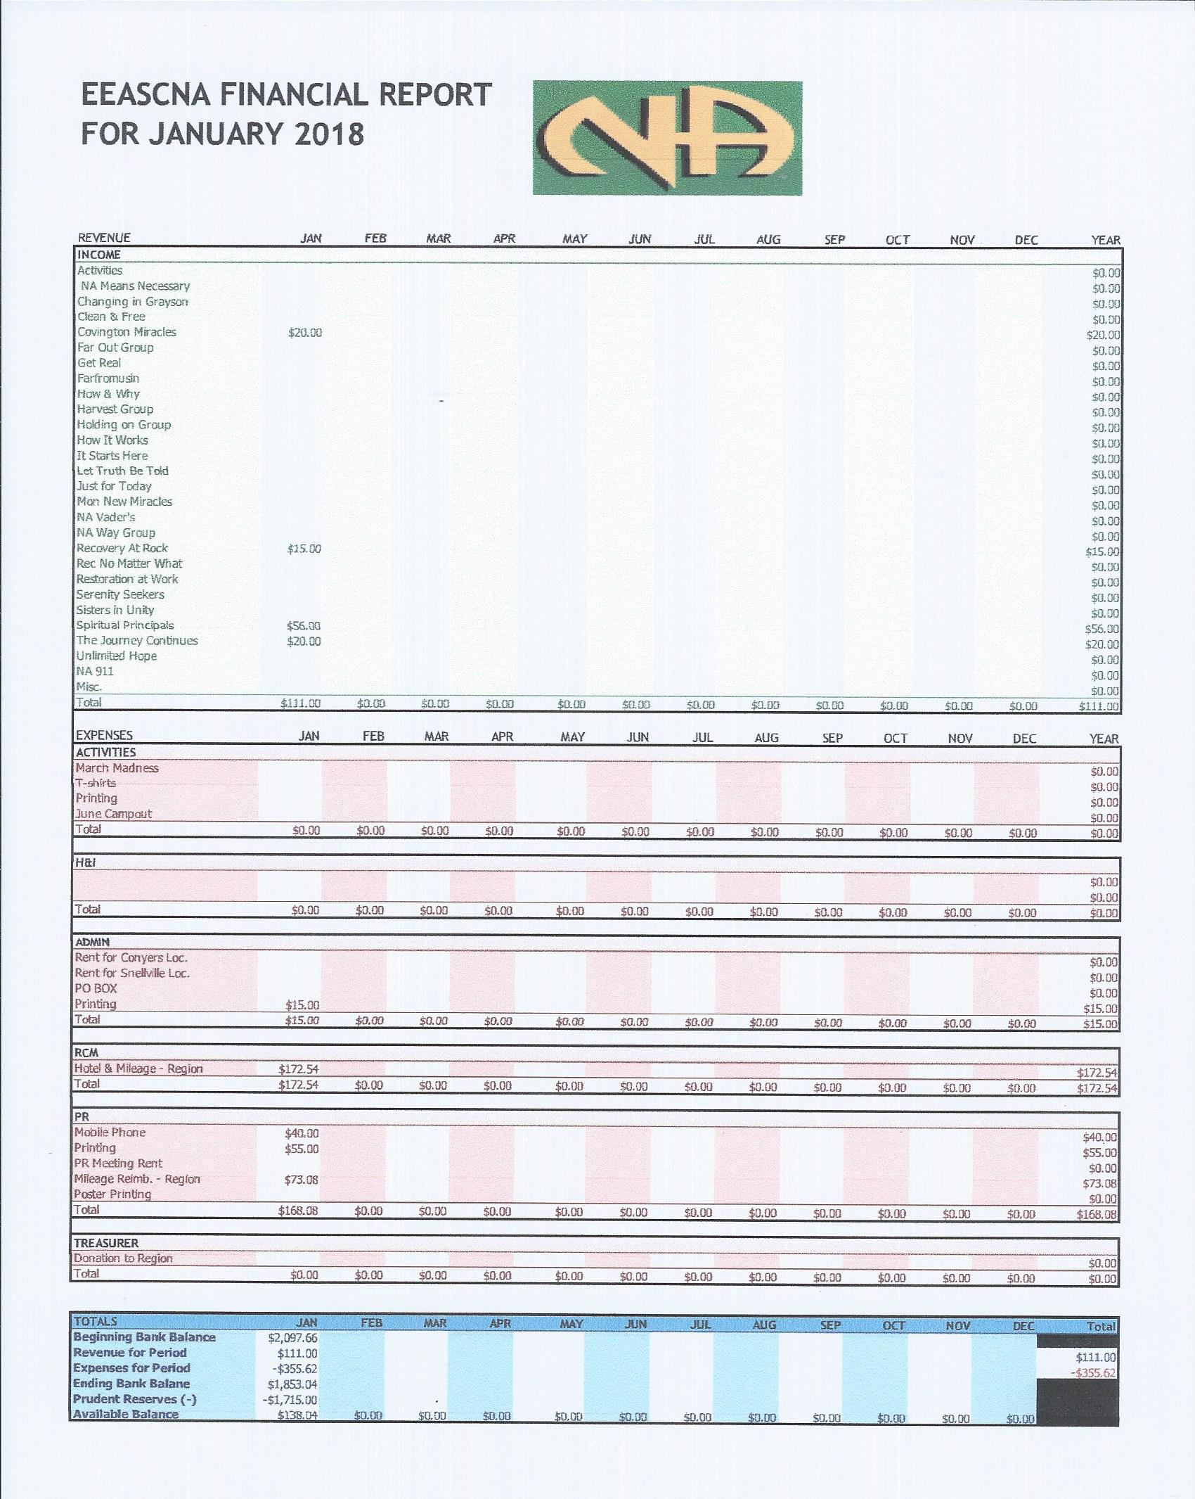
RCM Report
Next RSC will be March 10th & 11th
- CAR Report workshop moved to February 10th, 2018 at 4 pm

Full report below:

2/4/18
The next RSC meeting will be on March 10 thru 11th. I would like to apologized to the groups, I didn’t help with the RCM report the last ASC. I assumed RCM had hand written the report, after several text and emails from secretary. I realized she didn’t have one. I would also like to let the groups know, I spoke with the RD Jeremy L and we decided it would be best to reschedule CAR workshop until Next Saturday at 4 PM. The meeting will be February 10 2018, at 2424 Webb Ginn House Rd. Snellville, GA. Angela House behind the church. I know this a quick notice due to Super Bowl we feel it would affect the attendance. I would also like to emphasize the next RSC will be in march where we will have to go back and carry our areas votes on the CAR report.
Trusted Servant
Fred C

H & I Report
- Going to every meeting in East End in next month to get volunteers to make a commitment schedule
- Twin Lakes in Monroe on Monday nights at 7 pm - will need volunteers! At least 90 days clean time required - Twin Lakes 398 Highway 11, Monroe, GA 30655
- Please announce H&I needs in meetings, don’t wait until group conscious!!
Full report below:
Support is up.
More support would be greatly appreciated.
Waiting for budget to be approved for literature orders!!!
Jon C. - (205) 317-5139

Public Relations Report
- New phone for phone line
- PR will be visiting groups that haven’t been active to see if meeting still there
- Regional calendar to possibly attend other area events/celebrations
- Gwinnett county fair


Full report below:
EAST END AREA of
Narcotics Anonymous
PUBLIC RELATIONS TASK PANEL
eastend@grscna.com
Phone Helpline: 678 973-6798
http://eeascna.org/
In keeping with the spiritual nature of Narcotics Anonymous, our structure should always be one of service, never of government.
(12th Concept of NA Service)
DATE: January 20, 2017

DATE AND LOCATION OF NEXT PANEL MEETING:
 | February 17, 2018
CALL TO ORDER: | Zoar United Methodist Church 3895 Zoar Church Road, Snellville, GA 30039
ATTENDEES: | Joe, Fred and Linda
READINGS | 12 Traditions and 12 Concepts

WHAT HAPPENING IN THE TASK PANEL?

HELPLINE: Number of Helpline calls 31 for the month of January 2018.

WEBSITE: All is working well. www.eeascna.org

ACTIVITIES
Do we want to host the Gwinnett County Fair again this year? The exhibit application need to be turned in by March 15, 2018. The GA Region will be paying the admission fee.

Please forward information that you would like posted to eastend@grscna.com
MEETNG LIST: MISC.
- Poster Drive – Created a database for Facility leads. We determine there are least 23 different types of facility we can contact to grow within the community (Poster distribution and/or new meetings).
- ATL Metro Task Panel – PR attended the ATL Metro Task Panel on January 14, 2018 at I-20 Club. This meeting was a brainstorming and planning meeting on What is Our Metro going to be? For more information see attachments.
- PR Inventory – The task panel complete the first phase of the PR inventory.4. On January 15, 2018, PR and H&I met with the Director of Twins Lake Recovery. We donated some literature, informal presentation and asked if they had any questions. The meeting will be held on Monday at 7 pm.
- On January 11, 2018, PR and group members met with Pastor Kevin Lee and staff member to discuss a new meeting at the Berean Christian Church. The idea meeting would be held Friday 10 pm. To be determine.
- Upcoming meeting with the Director of Ridgeview Institute, Monroe, GA on Feb. 7, 2018 11 am to discuss a new meeting at this facility. Keep you posted.

GSR’s Please record up-coming Events for the daily meeting announcements, help recruit New-Comers (ONE DAY clean-time is the only requirement). Please gather any information that has been added to the PRsign-up sheets and submit to any PR-committee member or you may contact Linda Z. at 443-631-0098.

Activities Report
- Speaker Jam in March (flyer included below)
- Block Party in May at NA Way location
- Activities sub-committee meeting meets the 3rd Saturday of every month at 11 am at Zoar church
Full report below:

Speaker Jam will be held on Saturday March 3, 2018 from 2pm - until 8pm. We have 5 speakers scheduled, along w/H&I and PR will be taking a slot to make presentations of their committees.

Water and soda will be sold.

IN Service
Tracy S
678-913-4417

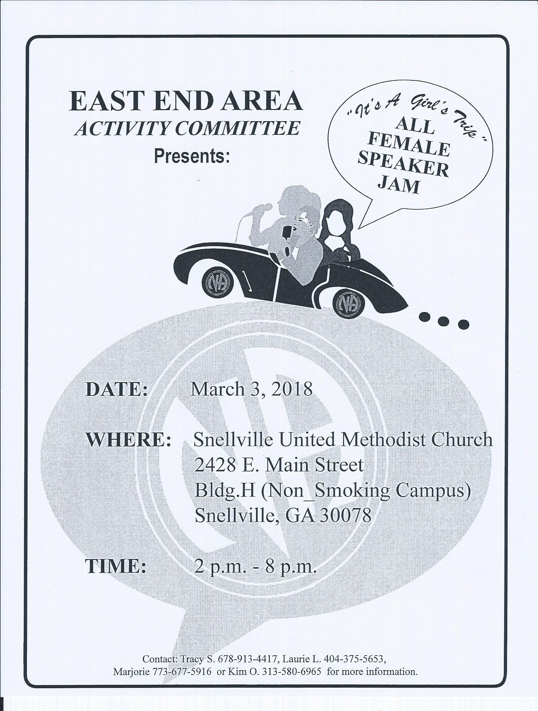

Inventory Ad-hoc committee
- Committee head stepped down, still looking for someone to lead so we can move forward
- To commit, have to be willing to meet face to face
- Passing around list to have anyone sign up
- Contact - Willie (704) 634-2546
Nomatterwhat1948@gmail.com
- No clean time required to serve on committee

Policy Ad-hoc committee
- Policy rough draft handed out today to take back to groups
- Please look over policy and come back next month ready to vote on making it the final copy

Group Reports
SCANNED AND ATTACHED BELOW
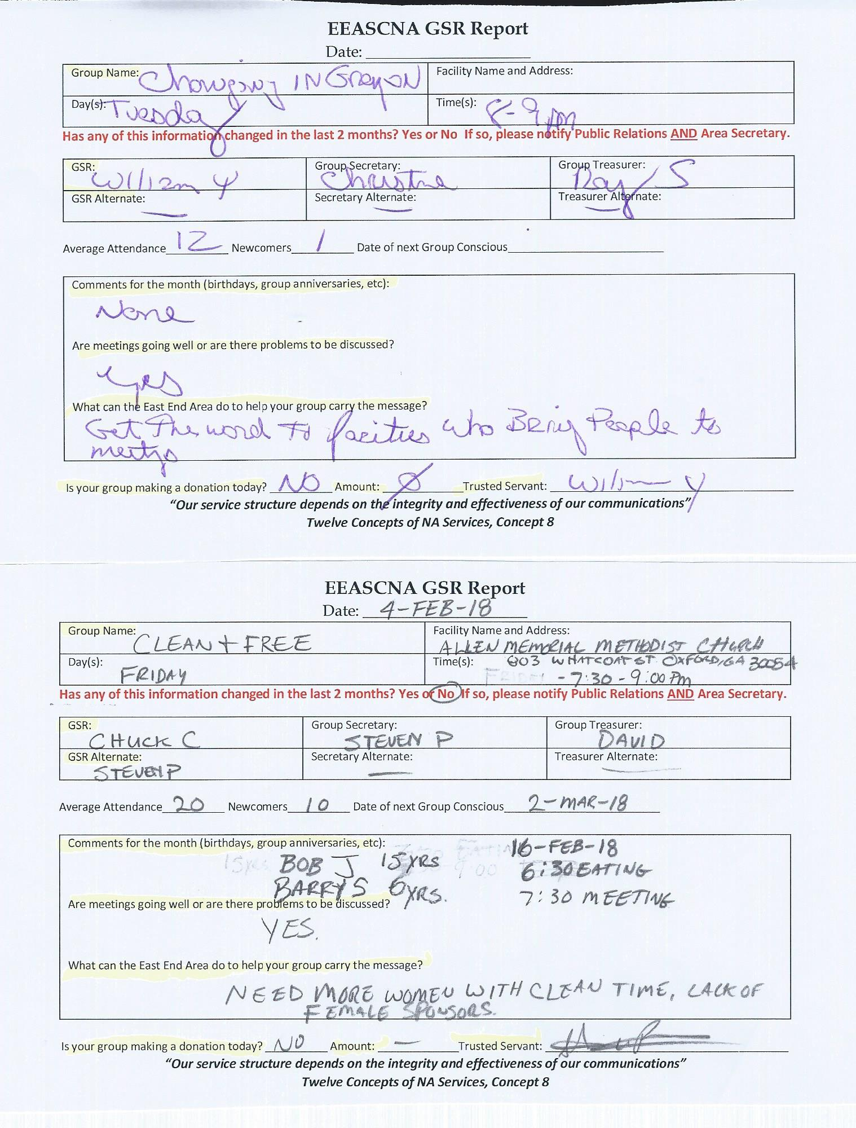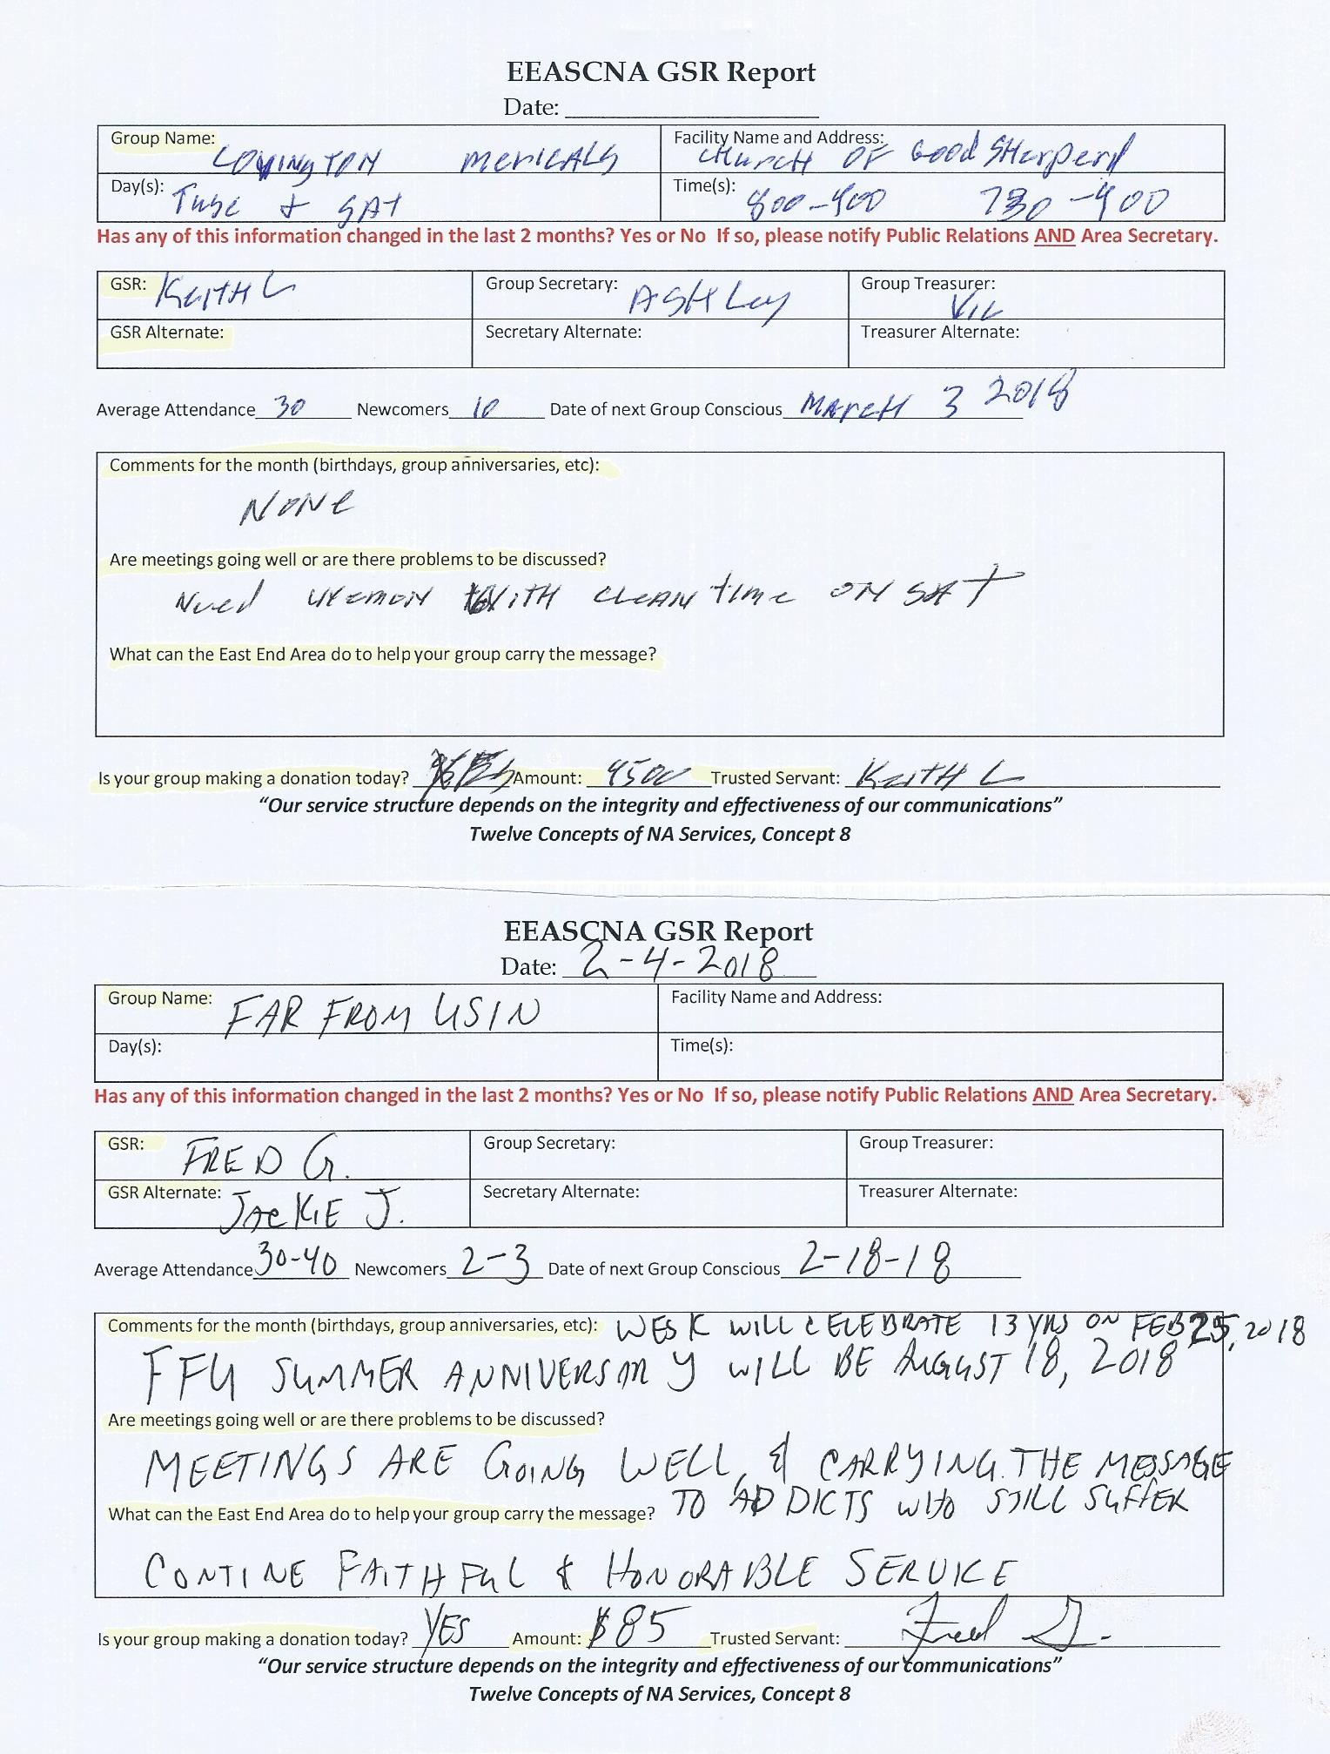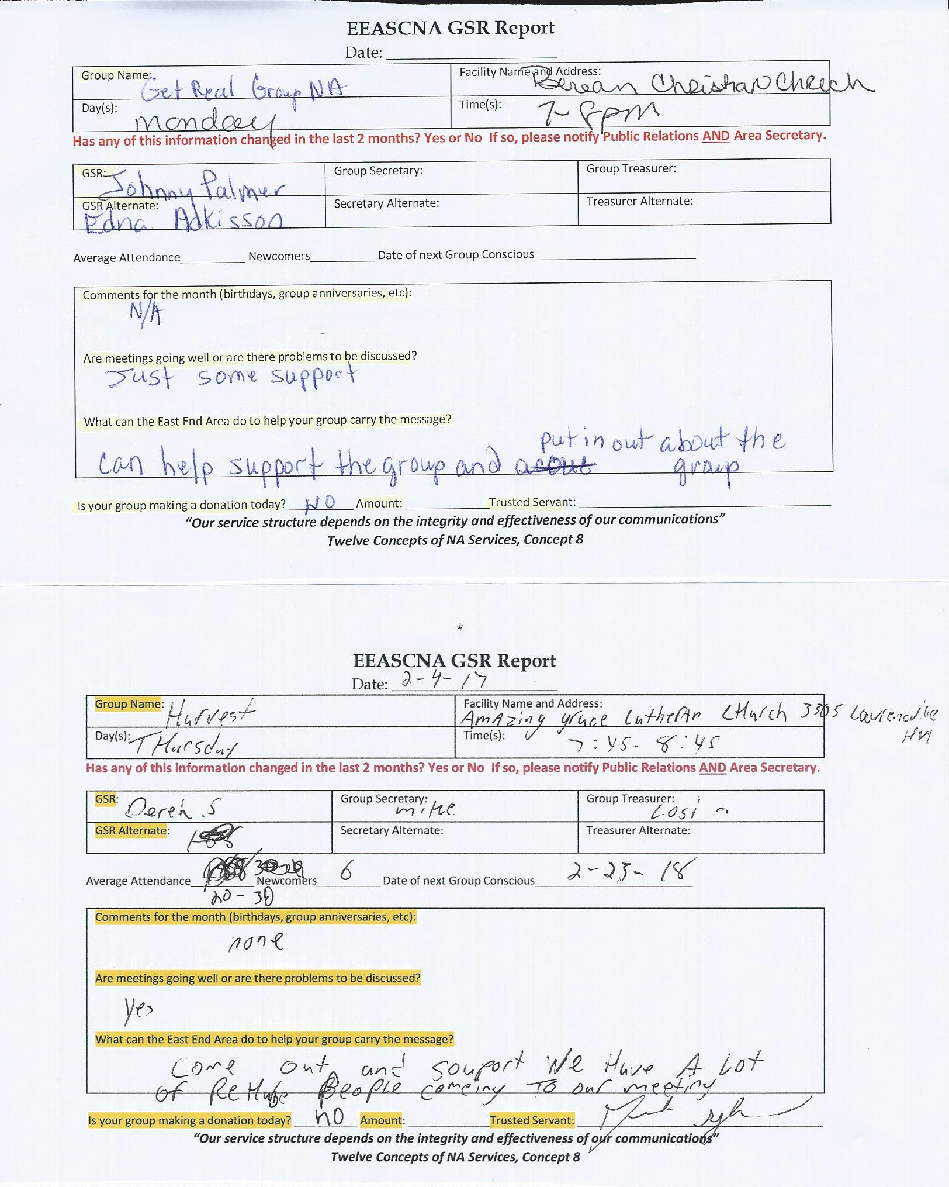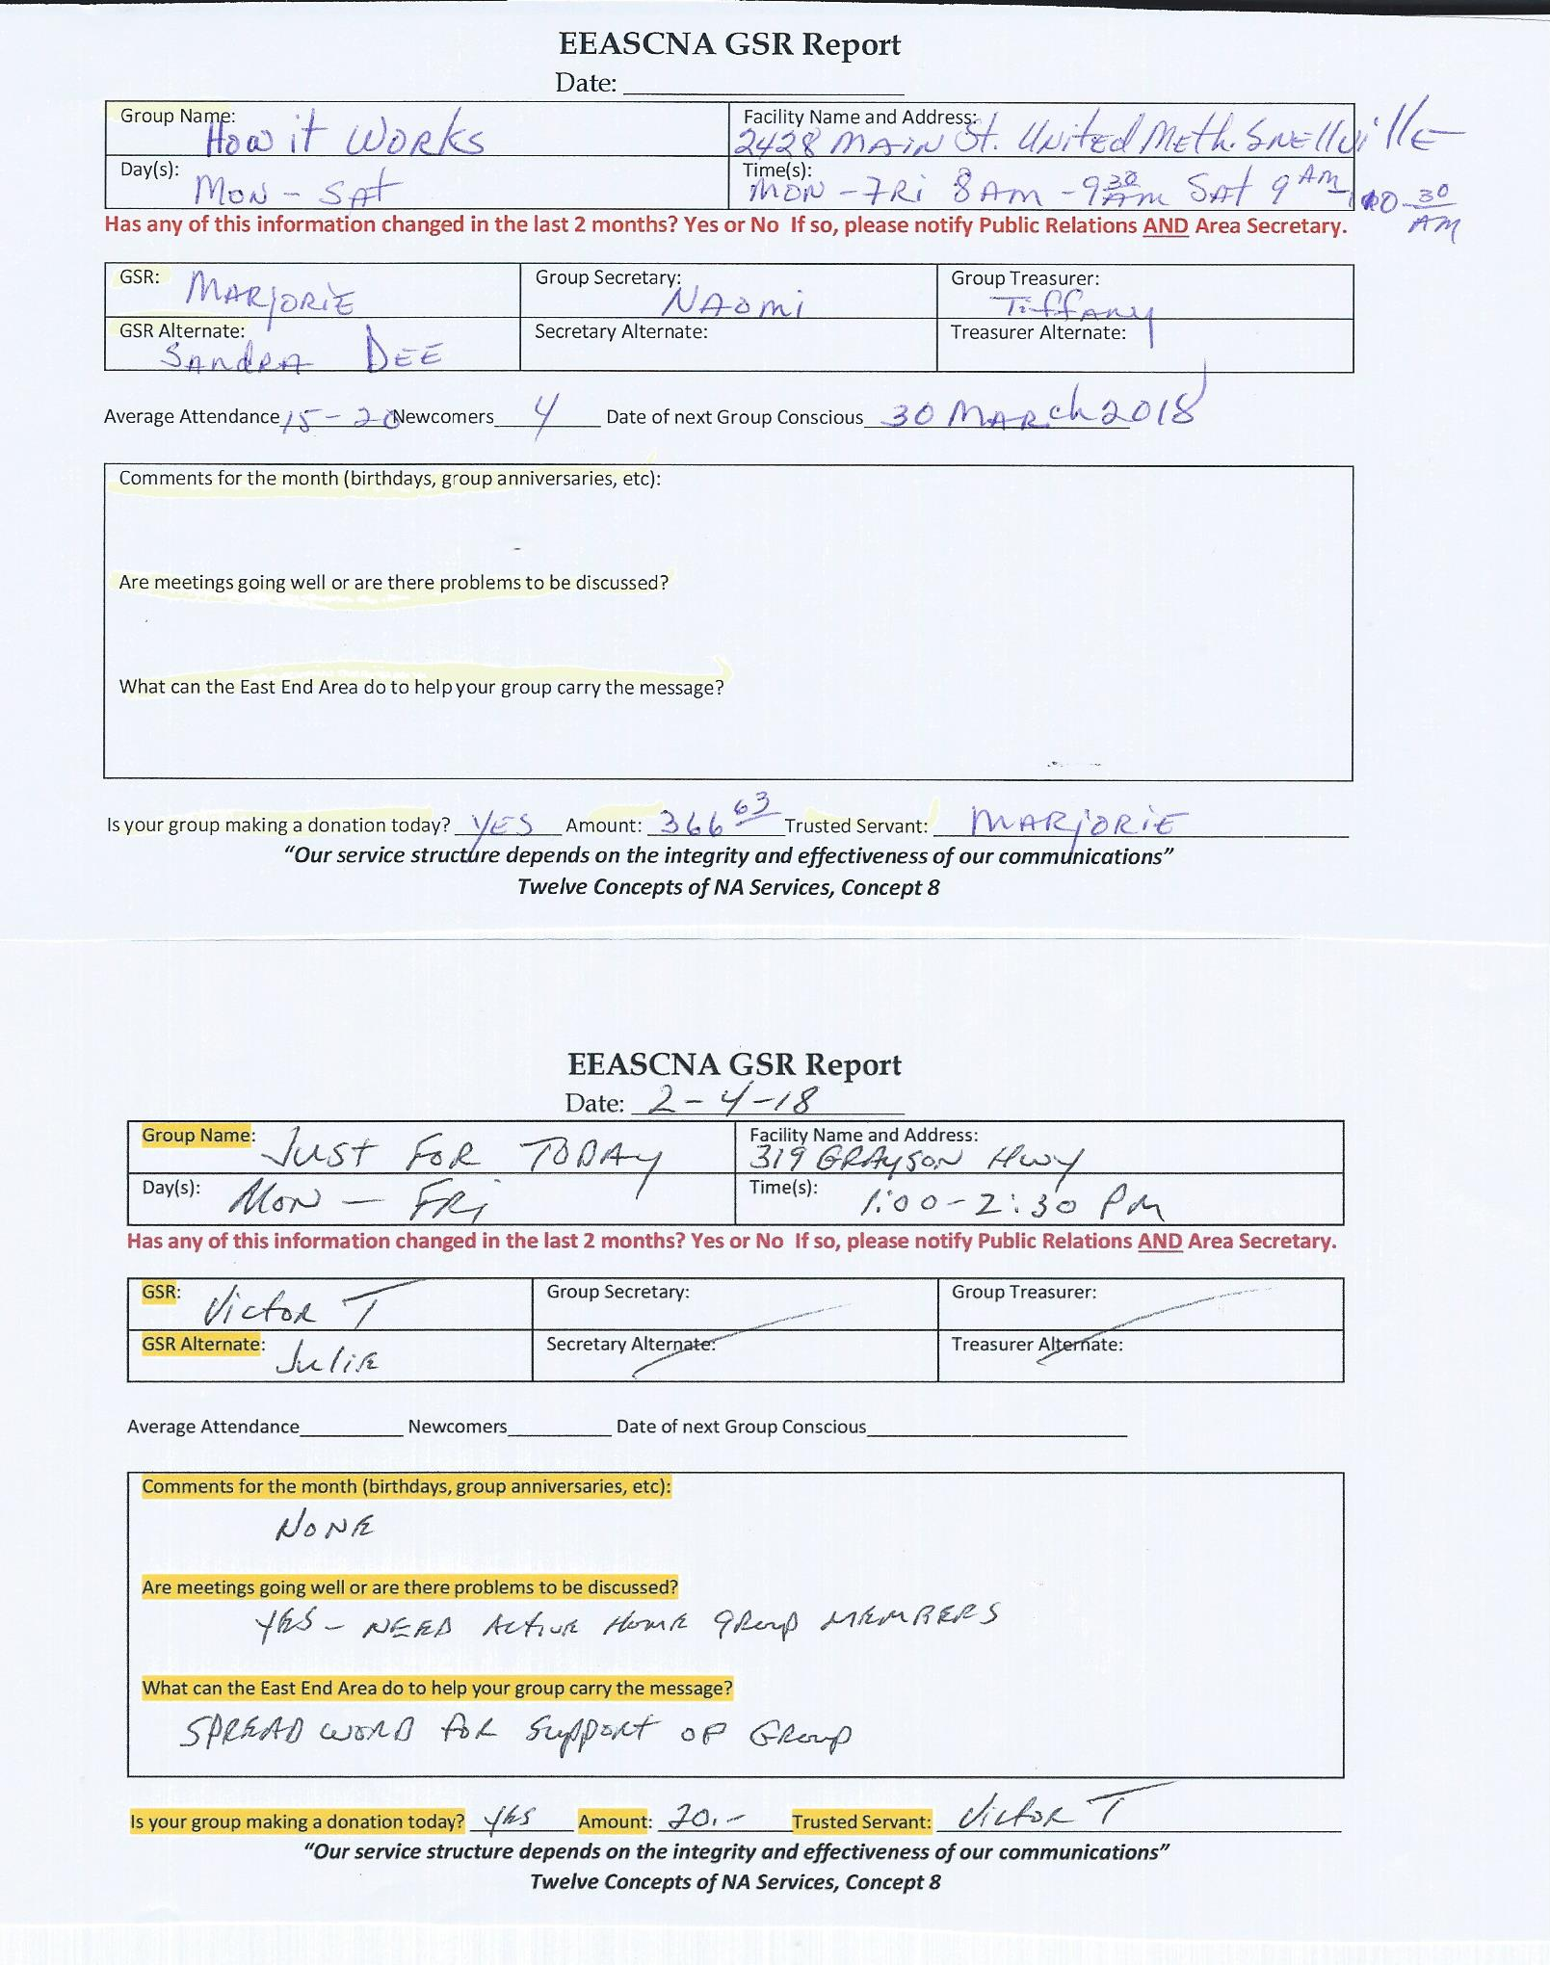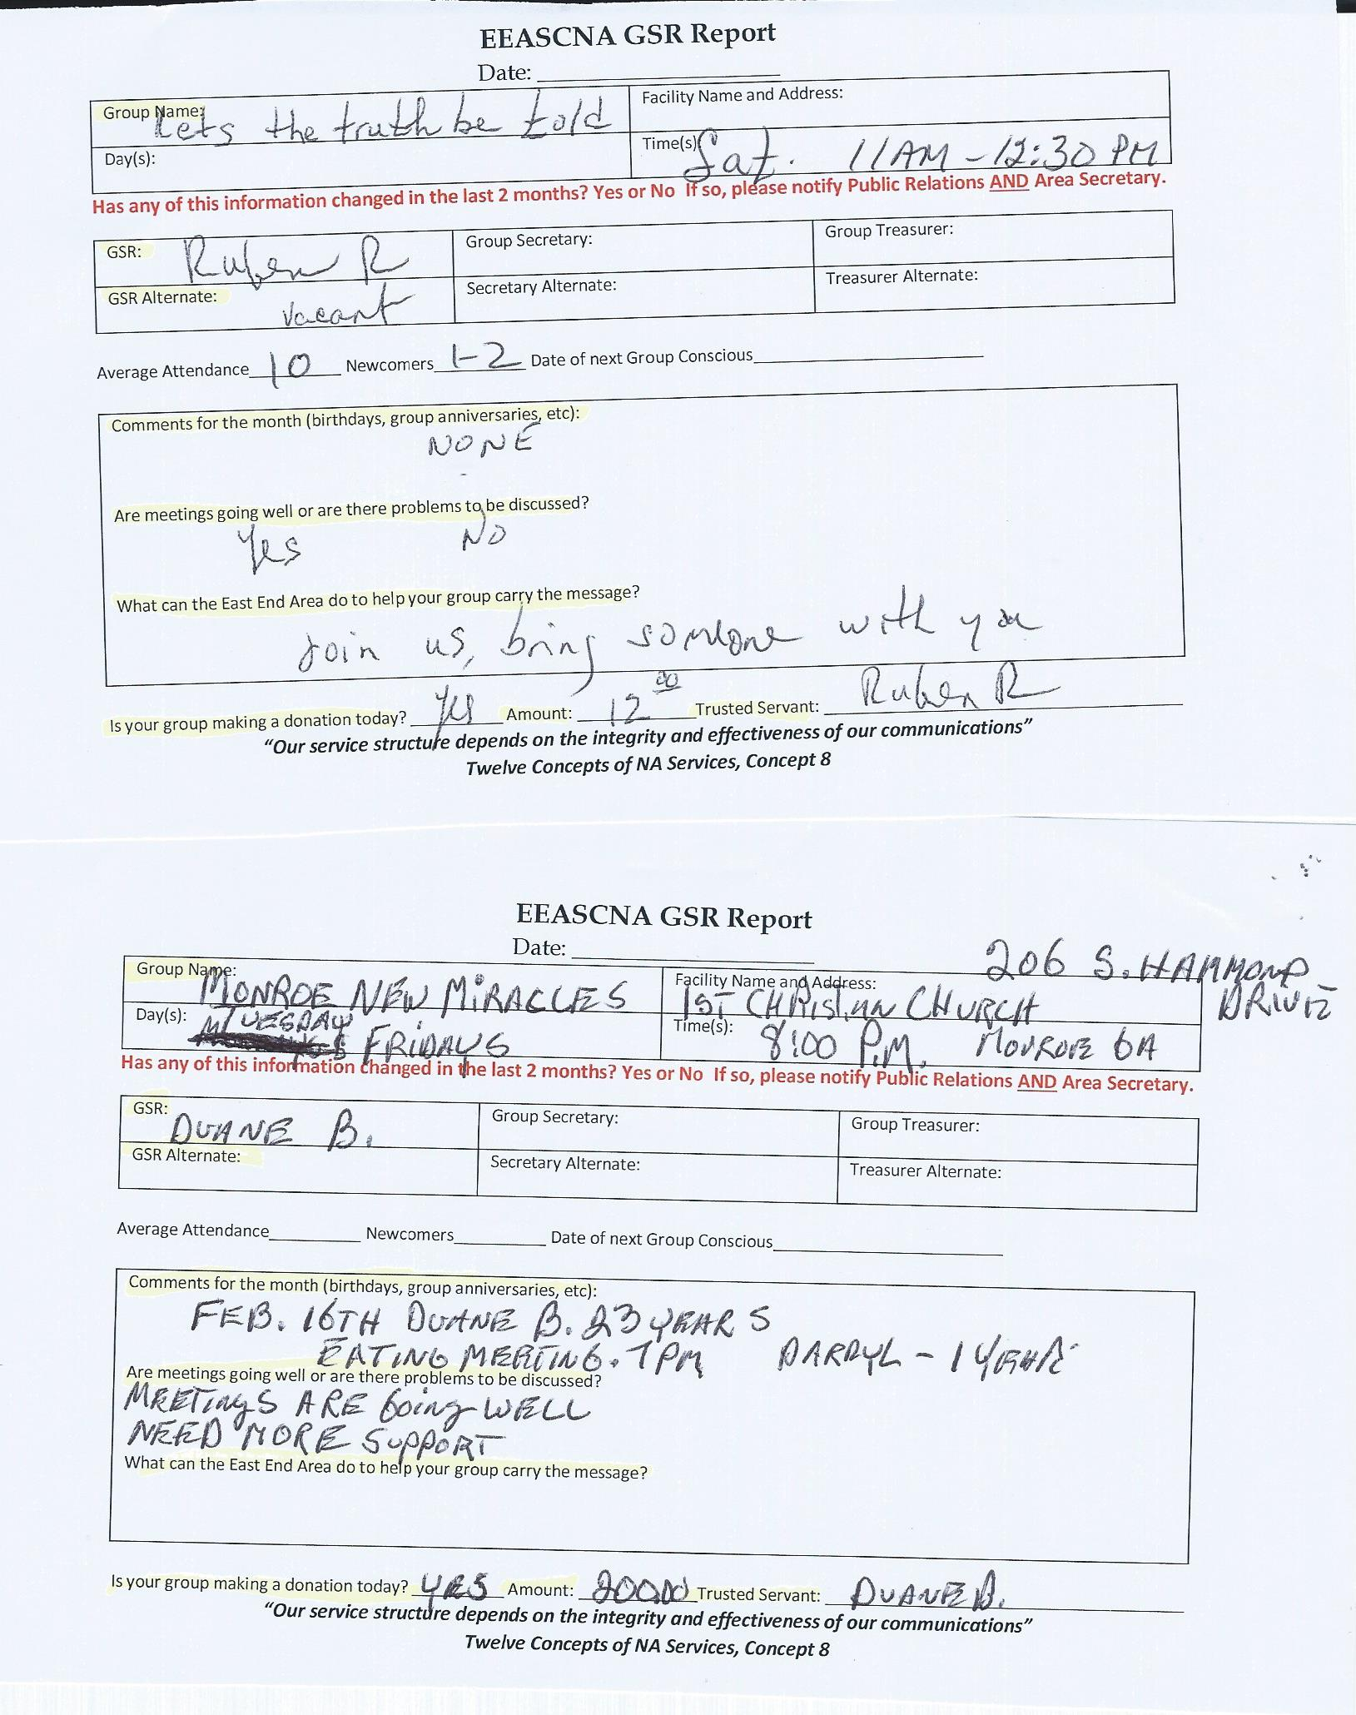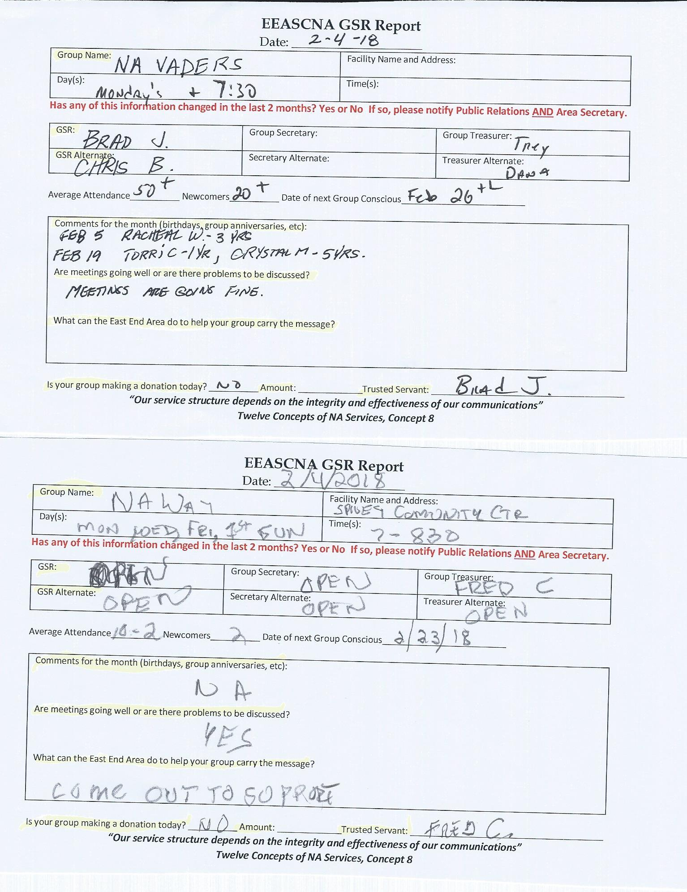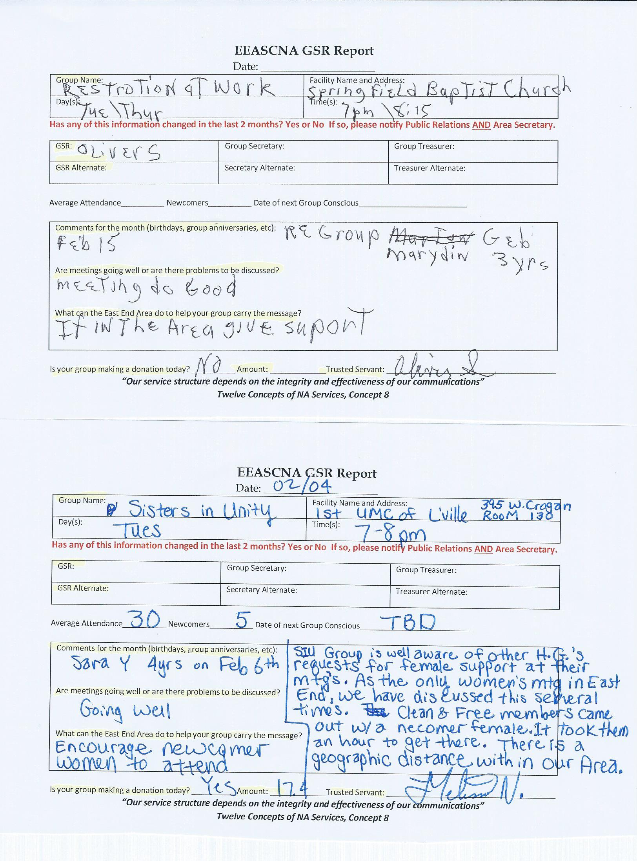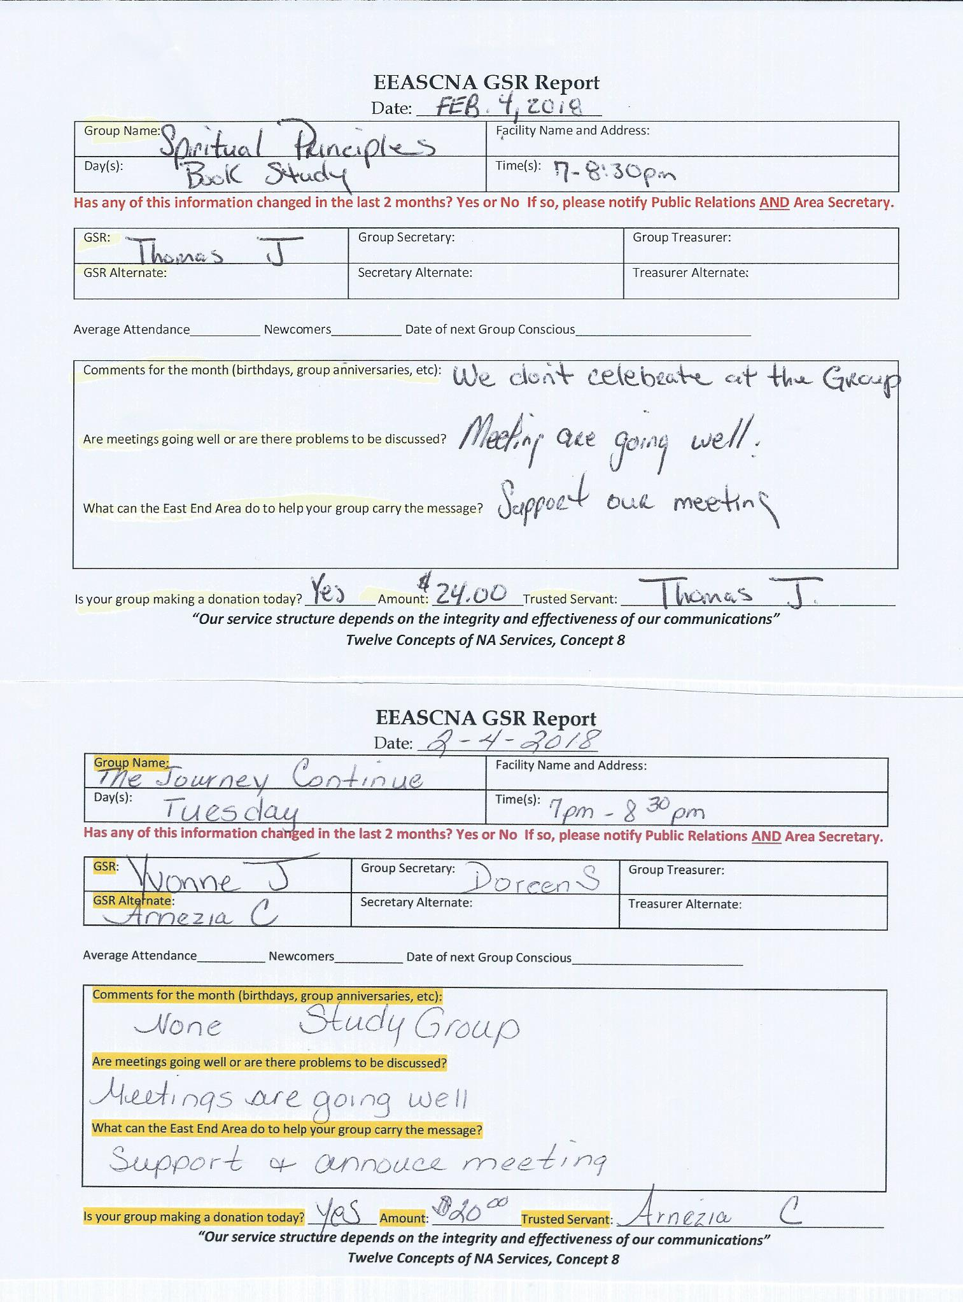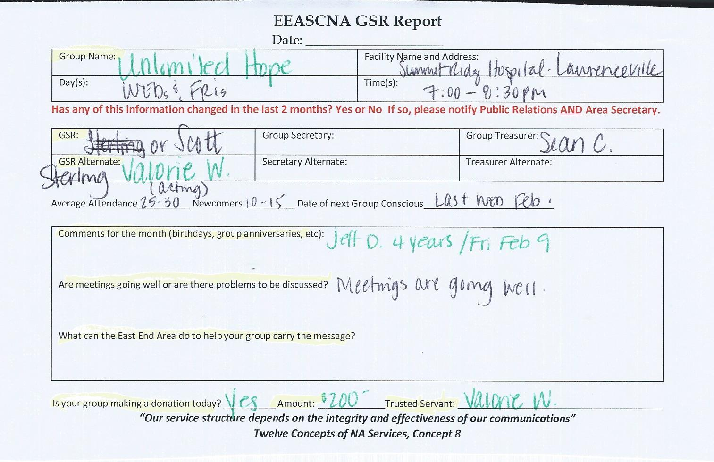

Old Business
Budget approval for 2018
Assent - 14 Assent w/res. - 1 Stand Aside - 0

Nominations/Elections

Treasurer - Fred G.
PASS - CONSENSUS REACHED
(Nomination form below)
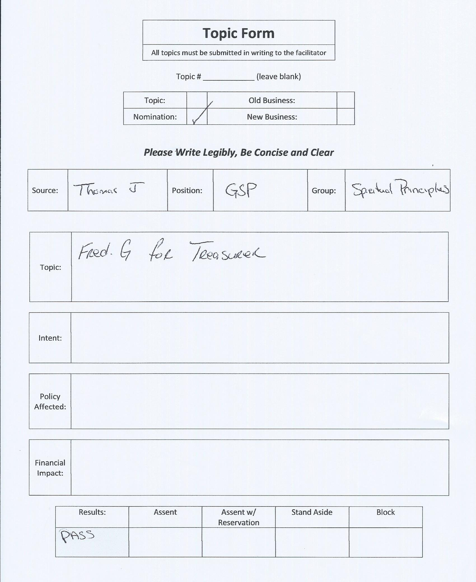

Positions Still Open
Treasurer
Alternate Treasurer
Alternate Secretary
H & I Vice Chair
Activities Vice Chair
Public Relations Vice Chair

Open Forum
- Suggested to purchase the Guide to Local Service book to better understand service work
- NA.org - can print out IPs and booklets from website for more readings about service work

New Business
None

Plans for the next meeting
Next Area Service will be
Held at 3pm March 4th in Conyers
**ADMIN MEETS AT 2:00 PM**

(Other forms and flyers below)


