EEASCNA Minutes - January 2018
- Area began at 3:02 pm
- Simone opened ASC Meeting with moment of silence followed by the Serenity Prayer
- Reading of Twelve Traditions - Derek
- Reading of Twelve Concepts - William
- Reading of Article II & III: Purpose of EEASCNA - Willie

Article II: Purpose The purpose of the East End Area Service Committee of Narcotics Anonymous (EEASCNA) shall be to respond to the needs and collective conscience of its member groups. EEASCNA supports and encourages the unity, welfare and growth of the East End Area as part of a worldwide Fellowship.
Article III: A. Definition and Function of the Area: The Area Service Conference (ASC) is the communicative channel for a unified Fellowship, a tie that binds us together. The ASC serves as a link in the flow of communication from the member to the worldwide Fellowship, establishes a structure in which services and education are provided, and functions as a vehicle through which our Area Fellowship and society can relate. The EEASC is a Committee made up of Group Service Representatives (GSRs), special purpose Task panels and an Administrative Body from Member Groups of the East End Area.
Administration Roll-Call
Key: 0= Not Present, 1= Present, (-) = Vacant, R= Report submitted only
ROLE | NAME | D | J | F | M | A | M | J | J | A | S | O | N | D
Facilitator | Simone J. | 1 | 1
Co-Facilitator | Willie A. | - | 1
Secretary | Kristin F. | 1 | 1
Alt-Secretary | VACANT | - | -
Treasurer | Brian A. | 1 | 1
Alt-Treasurer | VACANT | - | -
H&I Chair | Jon C. | 1 | 1
H&I Vice | Nicole A. | - | -
PR Chair | Linda Z. | 1 | 1
PR Vice | VACANT | - | -
Activities | Tracy S. | - | 1
Activities Vice | VACANT | - | 1
RCM | Mike R. | 1 | 1
RCMA | Fred C. | 1 | 1
Group Voting Policy:
- To reach quorum, 50% + 1 of groups present must be in good-standing.
- A quorum must be reached by fifteen (15) minutes after roll call is completed and before any business can be conducted.
- In order for a topic to be enacted, 80% of the groups present must be in good standing.
- New groups must attend 3 consecutive Area Meetings to gain voting rights at the 3rd Area.
- If a group misses 2 consecutive Area Meetings to re-gain voting rights at the 2nd.
East End Area Groups Roll Call
Key: 0= Not Present, 1= Present, R= Report Submitted only, Blacked Out= Not G.S.
2016-2017 | D | J | F | M | A | M | J | J | A | S | O | N | D
By NA Means Necessary | 0 | 0
Changing in Grayson | 1 | 1
Clean & Free | 1 | 1
Covington Miracles | 1 | 1
Fahrfromusin | 1 | 1
Far Out | 0 | 0
Get Real | 1 | 0
Harvest | 1 | 1
How It Works | 1 | 1
Just for Today | 1 | 1
Let the Truth Be Told | 0 | 1
Monroe New Miracles | 1 | 1
NA Vaders | 1 | 1
NA Way | 1 | 1
No Name Group | 0 | 0
Recovery at the Rock | 1 | 1
Restoration at work | 1 | 1
Sisters in Unity | 1 | 1
Spiritual Principles | 0 | 1
Step to Mercy | 0 | 0
The Journey Continues | 1 | 1
Unlimited Hope | 1 | 0
Total of Groups in Area | 23 | 22
Total Groups Present | 16 | 16
Groups in Good Standing | 17 | 17
Groups Present & G.S. | 15 | 16
Number for Quorum (50% + 1)?  Is Quorum reached? | 10 Yes | 10 Yes
Number for Consensus (80% present in G.S)?  # needed to Assent on Topics | 12 | 13
Roll call ended at 3:13 pm - At this time, quorum was met

Subcommittee Reports
Admin Report -
- PR - Regional calendar, Metro meeting list sell for $1 to go towards Unity Day, CAR posted on policy and forms page
- H&I - East Coast Conference, been going to several homegroups to gain volunteers, H&I meeting @ Twin Lakes
- Activities - Speaker Jam in March, block party in May
Treasurer Report
- Take budget back to homegroups, will be voted on at February area
- CAR report printing possibly added to budget, will bring up in RCM report
- Need a new Treasurer - term has ended!!
- Budget will be attached separately in Minutes email AND added to website
Full report below:

EEASCNA Treasurer's Year-End Report
To East End Area Trusted Servants,
Since last month’s meeting we have received $635.10 in group donations. We had monthly expenses incurred in the amount of $2,117.06. The beginning balance for the December 2017 statement was $3,579.62 and the ending balance is $2.097.66.
The EEASCNA checking account activity for the month of December was as follows:
DISCRIPTION/ | FOR | PANEL | METHOD | CHECK NO. | CLEARED DATE | CREDITS | DEBITS | BALANCE
PAYEE
Beginning Balance |  |  |  |  |  |  |  | $3,579.62
Deposit |  |  |  |  | 12/04/17 | $635.10 |  | $4,214.72
Fred Coleman | Printing | PR | Check | 1431 | 12/07/17 |  | $59.50 | $4,155.22
Fred Coleman | Printing | PR | Check | 1432 | 12/07/17 |  | $65.00 | $4,090.22
METROPCS | Phone | PR | DC |  | 12/11/17 |  | $40.00 | $4,050.22
Zoar United Methodist Church | RENT | PR | Check | 1433 | 12/12/17 |  | $50.00 | $4,000.22
FLORIDA RSO | Literature | H&I | DC |  | 12/13/17 |  | $449.01 | $3,551.21
GRSCNA | Region | TR | Check | 1435 | 12/13/17 |  | $1,303.55 | $2,247.66
Snellville United Methodist Church | RENT | ADMIN | Check | 1434 | 12/15/17 |  | $150.00 | $2,097.66

I have attached the Proposed 2018 Draft Budget. The EEASCNA panel members will present their sections of this draft document to you today during the New Business Portion of our meeting. This document will also be placed on the EEASCNA website in preparation for it being voted on at our February 4, 2018 meeting in Snellville.
Additionally, please also review the following attached Year-End Financial Reports:
- 2017 EEASCNA Financial Activity Summary Report containing the FY 2017 Revenues summarized by month and by Group, The FY 2017 Expenses summarized by Panel and by month, and Bank Balances summarized by month showing the Beginning, ending and available balances.

- 2017 EEASCNA Bank Account Check Ledger Report which shows all account transactions in a detailed ledger format.
Although I am grateful for the opportunity to serve the East End Area as Treasurer I would like to remind this body that my term of service has ended and that due to my collegiate obligations in the upcoming semester I will not be able to continue to serve in 2018.
If any Trusted Servants have questions or concerns about the Area finance’s, please feel free to contact me at 404-451-8107 or email at BrianGwt@Gmail.com.
Regards,
Brian C. Adkisson
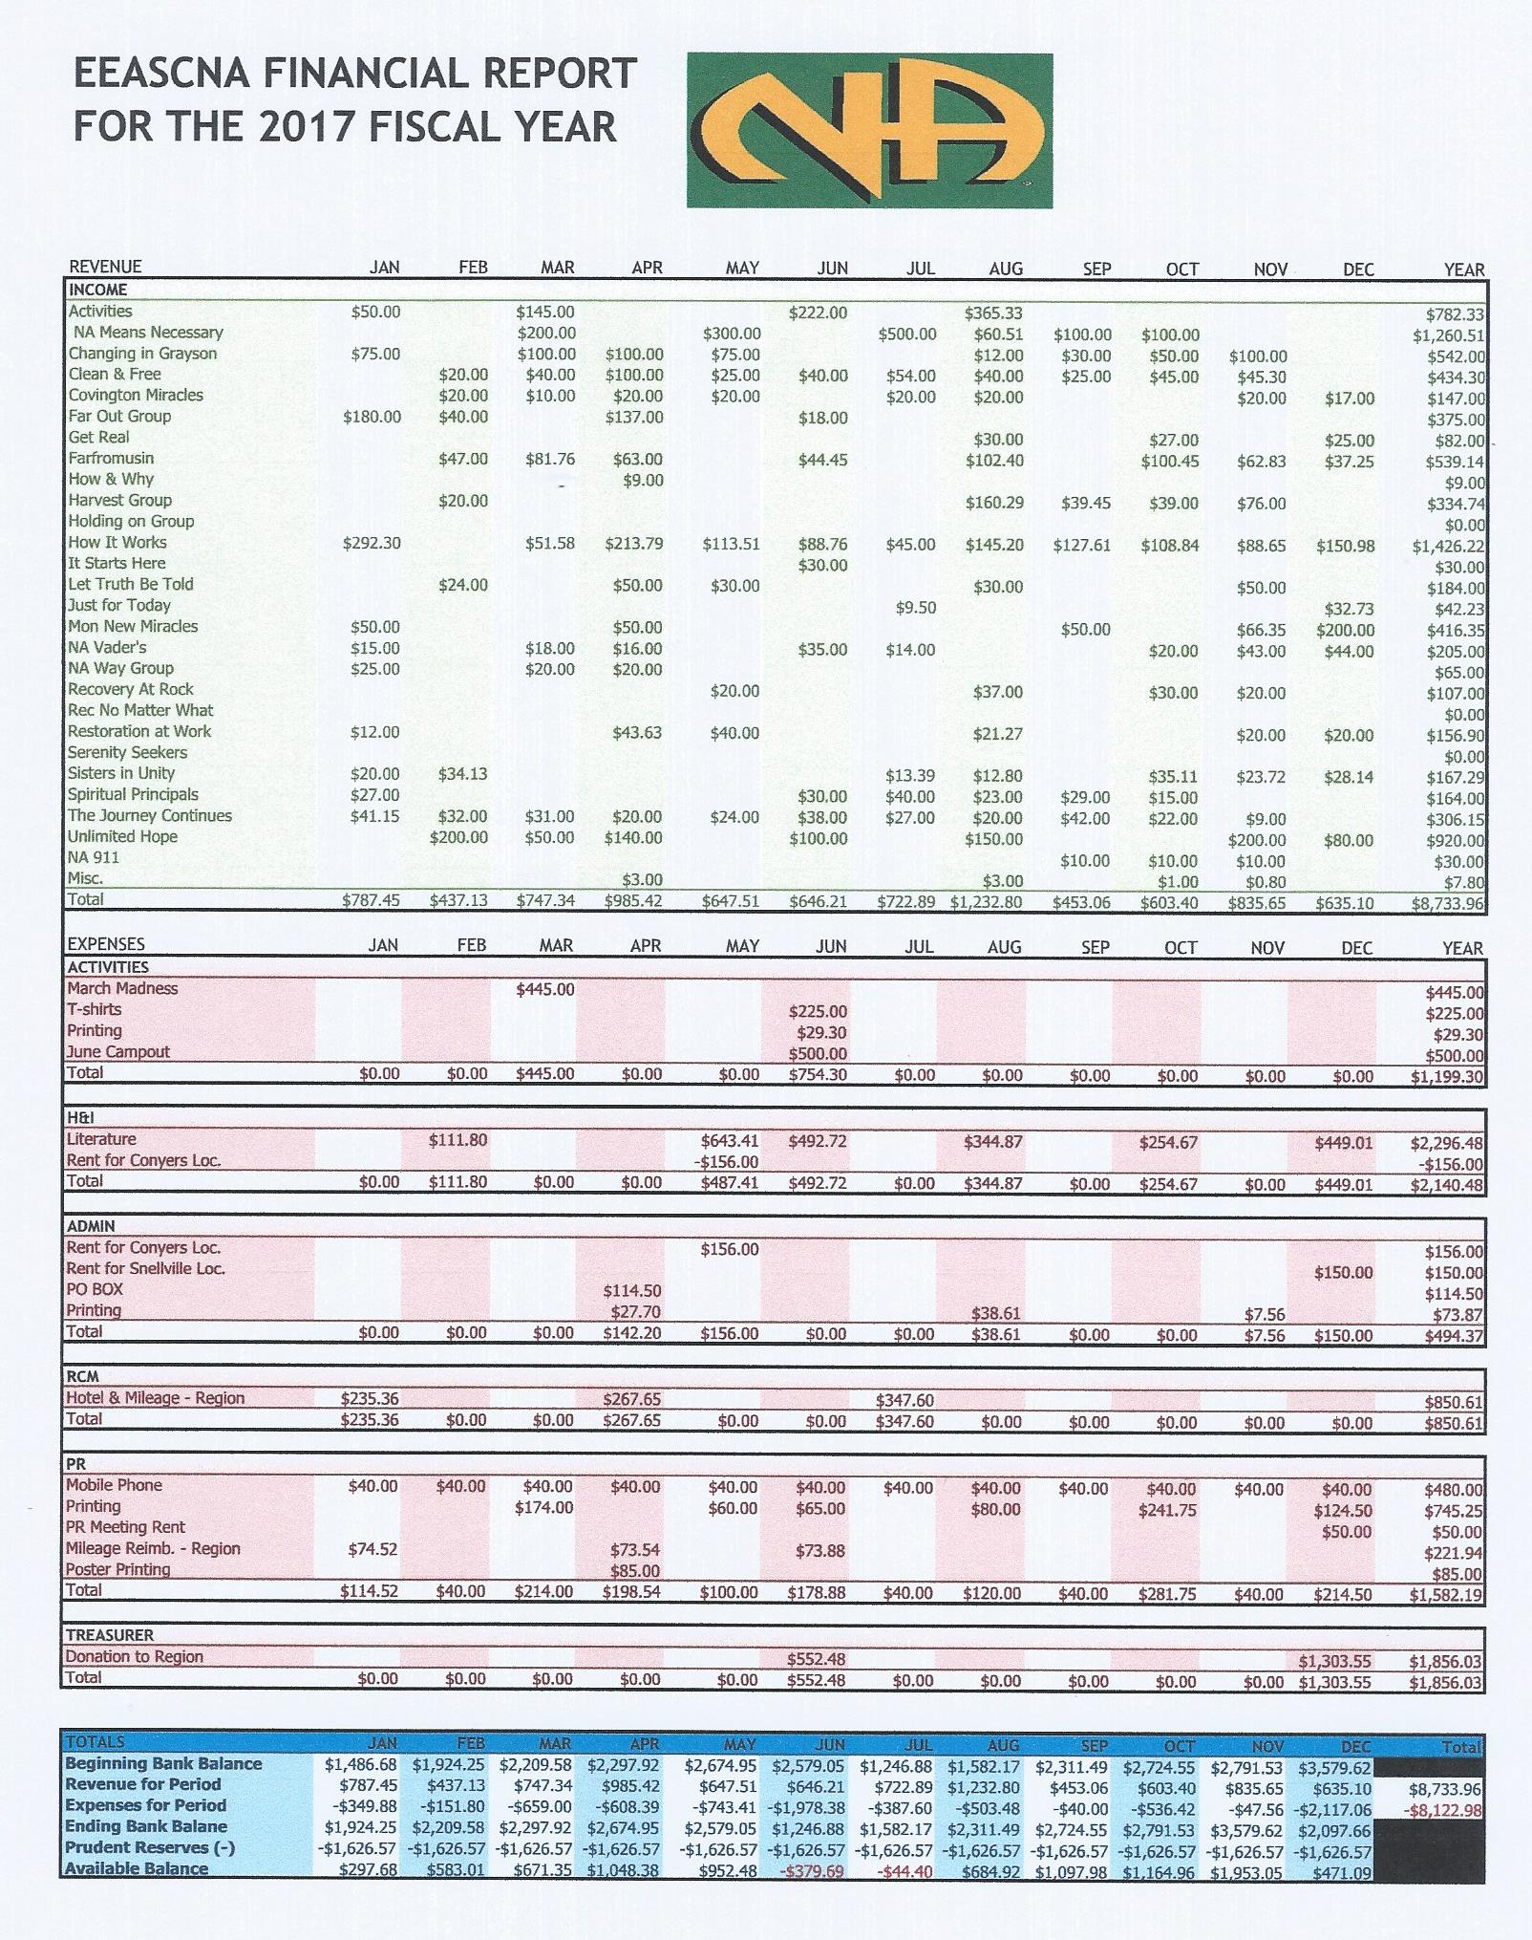
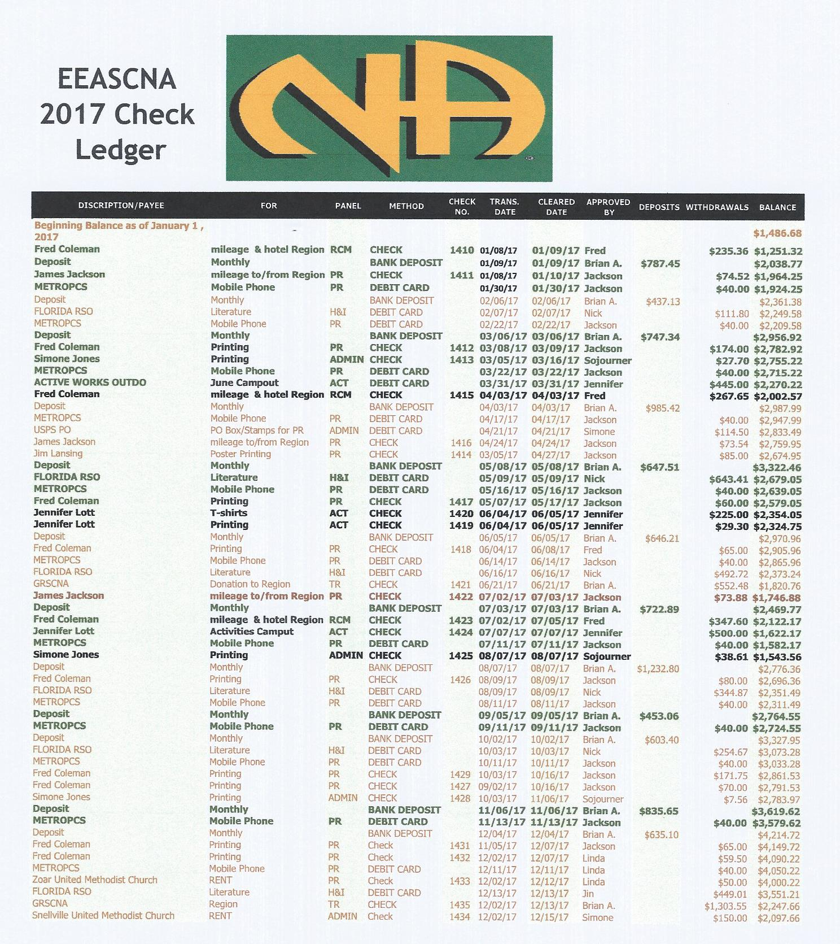

RCM Report
Next RSC will be March 10th & 11th
- Voted to have online meeting for CPP
- Kristin F elected Alternate Region Secretary
- CAR report available on GRCNA website, can be printed
- After February 4th area, Jeremy going to have CAR workshop - stay after to get clarification on CAR report
- Needs to be voted on by March Region meeting

***Full report will be emailed in separate email when finished***

H & I Report
- Going to every meeting in East End in next month to get volunteers to make a commitment schedule
- Budget went up a little from last year, new literature order for new meeting
- Twin Lakes in Monroe on Monday nights at 7 pm to be starting once PR goes in to do presentation - will need volunteers! At least 90 days clean time required - Twin Lakes 398 Highway 11, Monroe, GA 30655
- Please announce H&I needs in meetings, don’t wait until group conscious!!
Full report below:
H&I Report as of January 7, 2018

Support is up for meetings.
Chair is continuing to attend meetings in East End, asking for additional support.
Chair is in the process of compiling a commitment calendar for East End’s H&I meetings.

Report given by Jon C., your encrusted servant.

Public Relations Report
- New phone for phone line
- PR will be visiting groups that haven’t been active to see if meeting still there
- Regional calendar to possibly attend other area events/celebrations
- Facebook violating 12th Tradition? Read Social media guidelines pamphlet
- NA 911 group not meeting anymore

Full report below:

EAST END AREA of
Narcotics Anonymous
PUBLIC RELATIONS TASK PANEL
eastend@grscna.com Phone Helpline: 678 973-6798 http://eeascna.org/
In keeping with the spiritual nature of Narcotics Anonymous, our structure should always be one of service, never of government.
(12th Concept of NA Service)
DATE: December 16, 2017

DATE AND LOCATION OF NEXT PANEL MEETING:
 | January 20, 2018
 | Zoar United Methodist Church 3895 Zoar Church Road
CALL TO ORDER: | Snellville, GA 30039
ATTENDEES: | Joe, Jackson and David
READINGS | 12 Traditions and 12 Concepts

WHAT HAPPENING IN THE TASK PANEL?

BUDGET:

The Task Panel review 2017 budget and compile 2018 budget. Review budget and added expense of $100.00 for phone.

MISC.
- Poster Drive – Each Home Group will be given a poster to each GSR. This will help with the poster drive.
- East End PR Task Panel will be attending the Metro Atlanta PR Sub Committee meeting on January 14, 2018 at I-20 club. The Metro Atlanta Meeting list are out.
- For the month of January, the PR Task panel will review Core principle – Anonymity.
- PR Inventory – The committee compiled 10 questions.

  - How well is the Public Relations Task Panel served to the East End Area?
  - How well does the East End website communicate with local members?
  - How well does the Public Relations Task Panel the area phoneline?
  - How well is the Public Relations Task Panel attracted new members?
  - How well has the Public Relations Task Panel done this year in making NA’s message more wisely known in the larger community?
  - How completely does the hotline respond to the needs of the larger community?
  - How well is the Public Relations Task Panel participate in outreach events?
  - How effectively does the Public Relations Task Panel demonstrate responsibility and accountability? 9. How well is the Public Relations Task Panel using human and financial resources to carry NA’s message of recovery in an efficient and effective way?
10. How fully trained and supported are the trusted servants who interact with members of the community?

RSC

- I’d attended my first GA Regional Service Conference on December 9, 2017 at 400 Holiday Circle, Forsyth, GA. Most of the areas are going through the same issues of lack of service to carry the message, support groups and sponsorship. We should look at the regional calendar and attend each other area events for support. Learning day and workshops on IPs. The areas are interested in the PR inventory we are conducting and would like panel to forward information to them.
The following literatures are good tools to add to kit and learning.
Item #2306 – NA and Persons Receiving Medication-Assisted Treatment, Social Media and Our Guiding Principles and bookmarks. It was suggested each area could modify regional 1-800 phone number and use their area phone number on posters and/or bookmarks.

HELPLINE: Number of Helpline calls 57 for the month of December 2017.

WEBSITE: All is working well. www.eeascna.org The CAR PDF file is posted on the event and policy page. The GSR’s can download for their groups and members to read as well.
Please forward information that you would like posted to eastend@grscna.com

MEETNG LIST:

GSR’s Please record up-coming Events for the daily meeting announcements, help recruit New-Comers (ONE DAY clean-time is the only requirement). Please gather any information that has been added to the PRsign-up sheets and submit to any PR-committee member or you may contact Linda Z. at 443-631-0098..

Activities Report
- Speaker Jam in March
- Block Party in May at NA Way location
- Not going to sell food - possibly bring in food truck or food vendor
- Go to 2 meetings per month to let them know activities is here and to take suggestions
- 5-6 activities a year
- Activities sub-committee meeting meets the 3rd Saturday of every month at 11 am at Zoar church

Inventory Ad-hoc committee
- Committee head stepped down, still looking for someone to lead so we can move forward

Policy Ad-hoc committee
- Policy rough draft will be posted soon

Group Reports
SCANNED AND ATTACHED BELOW

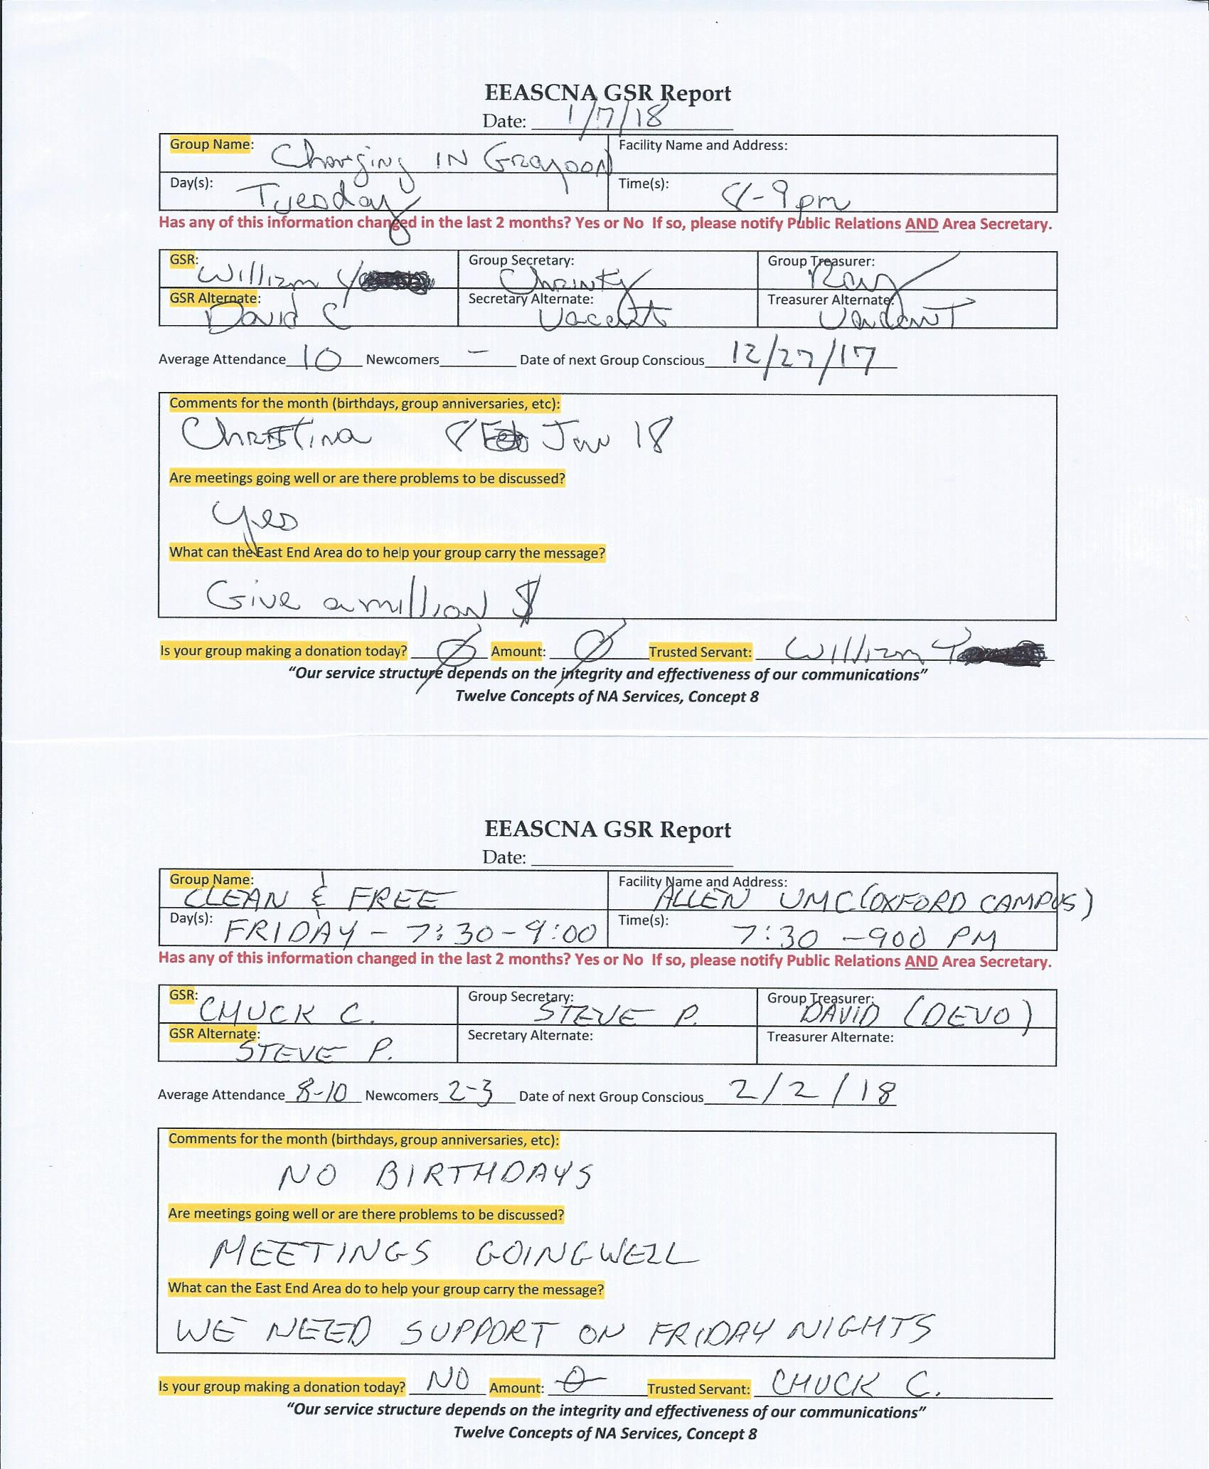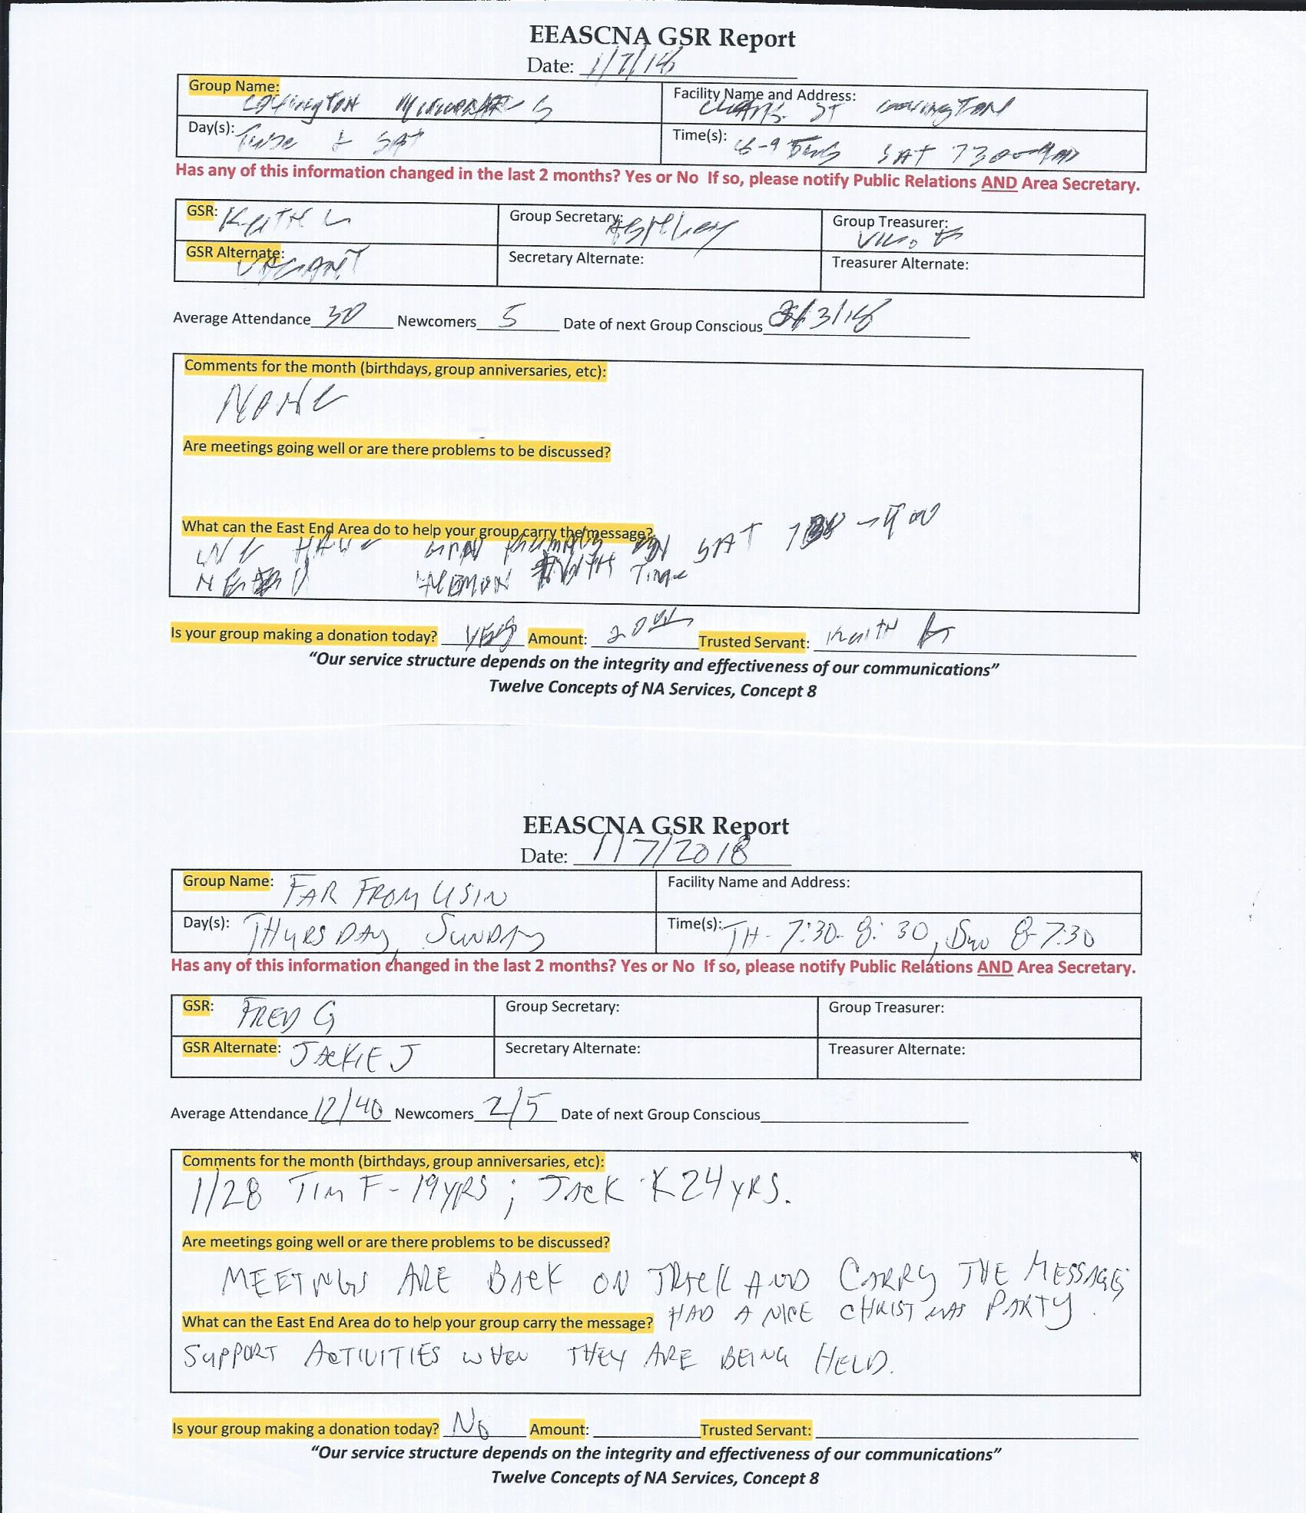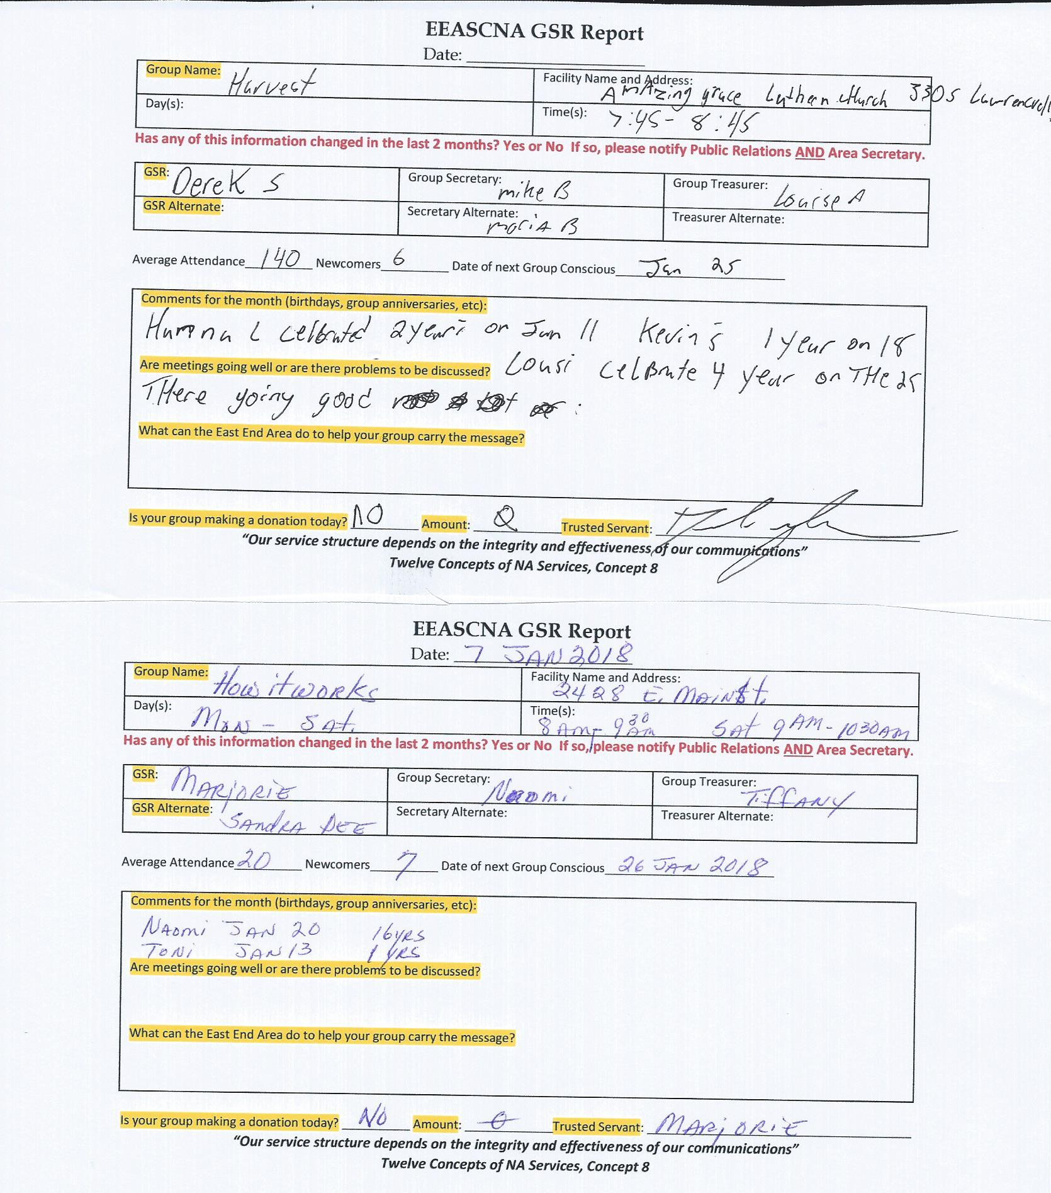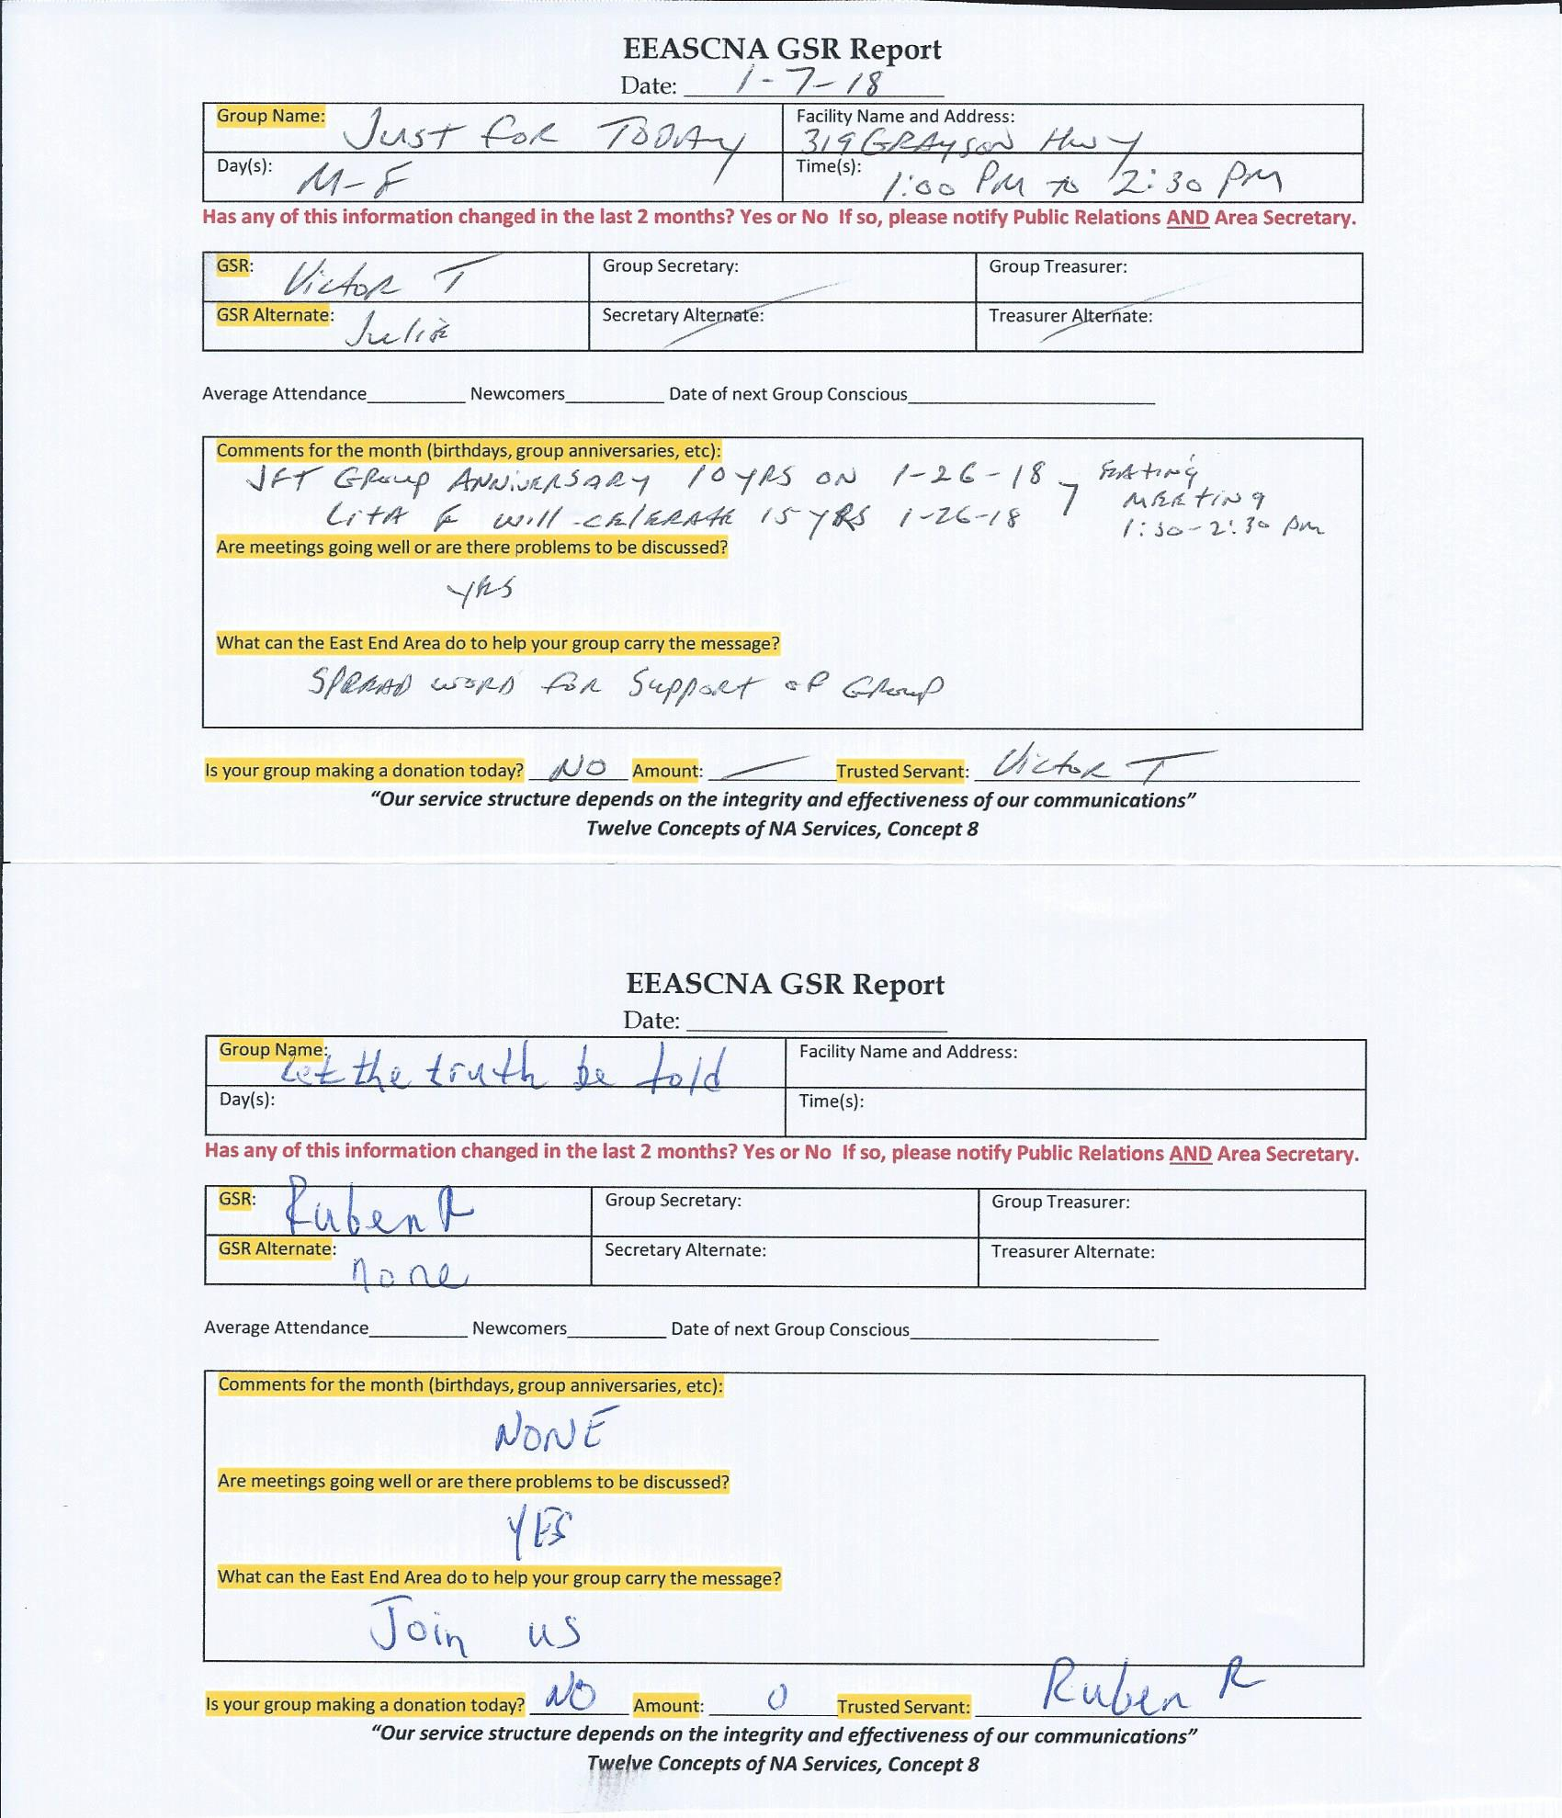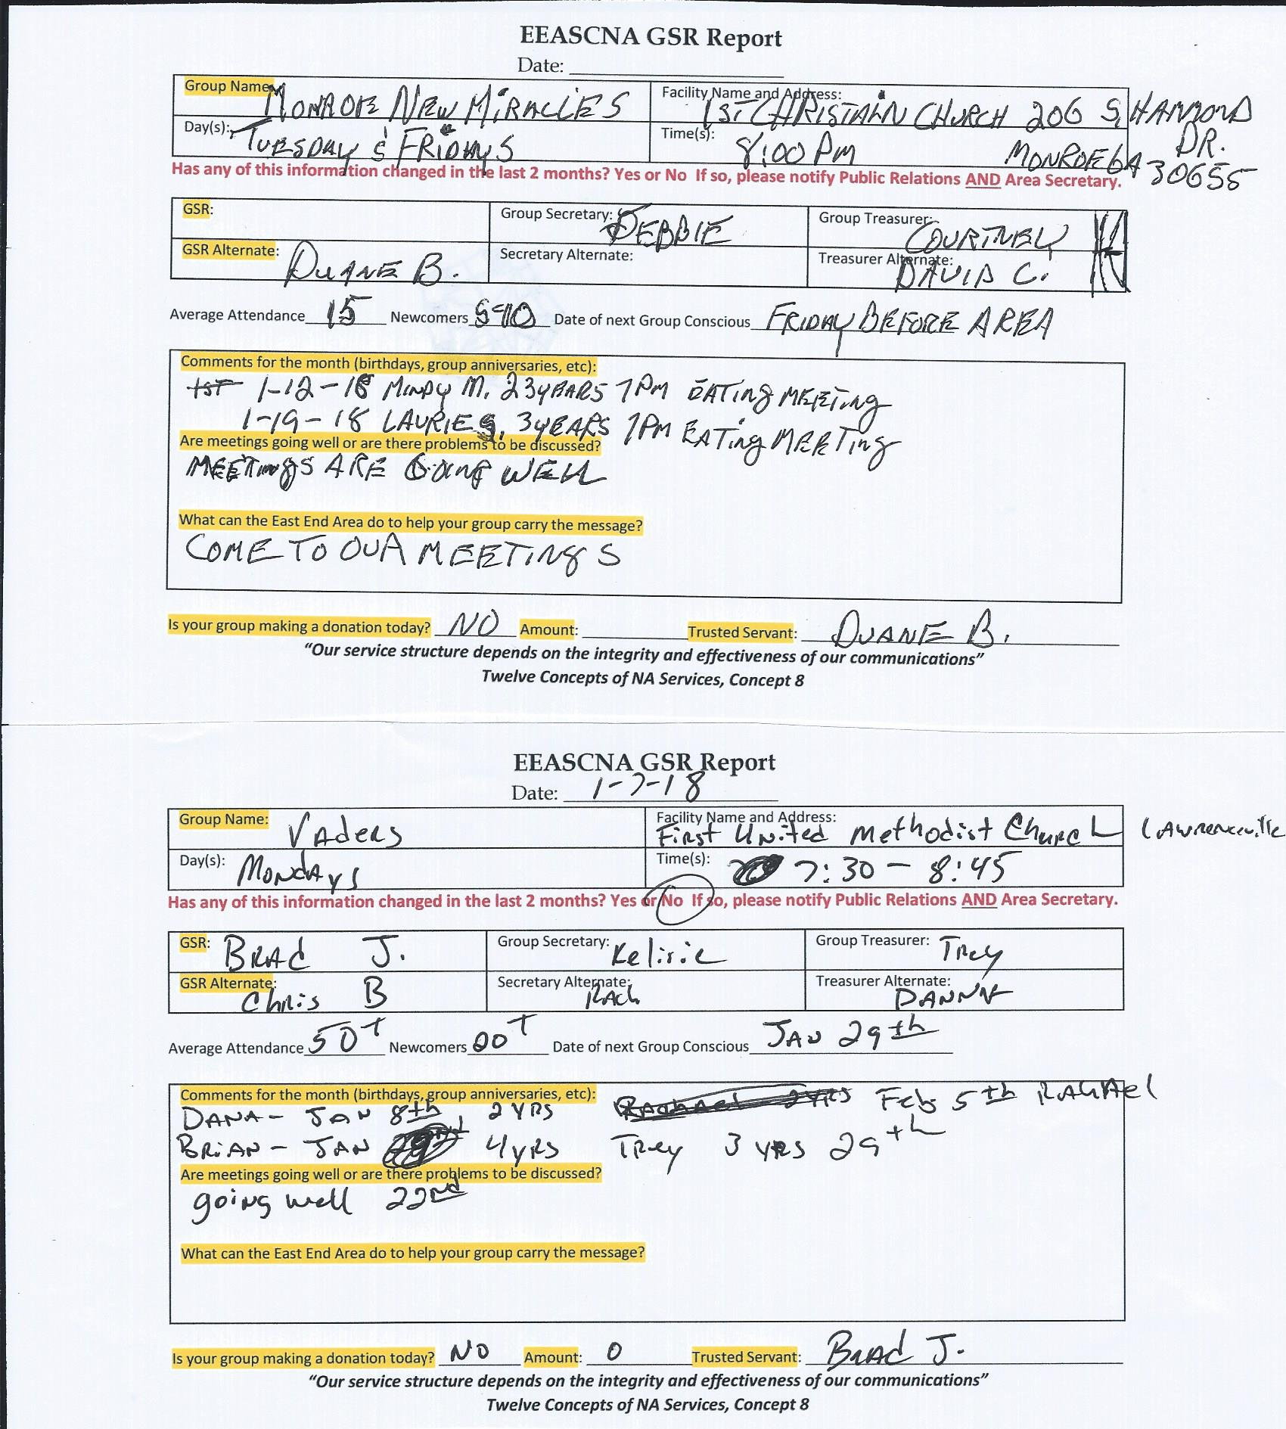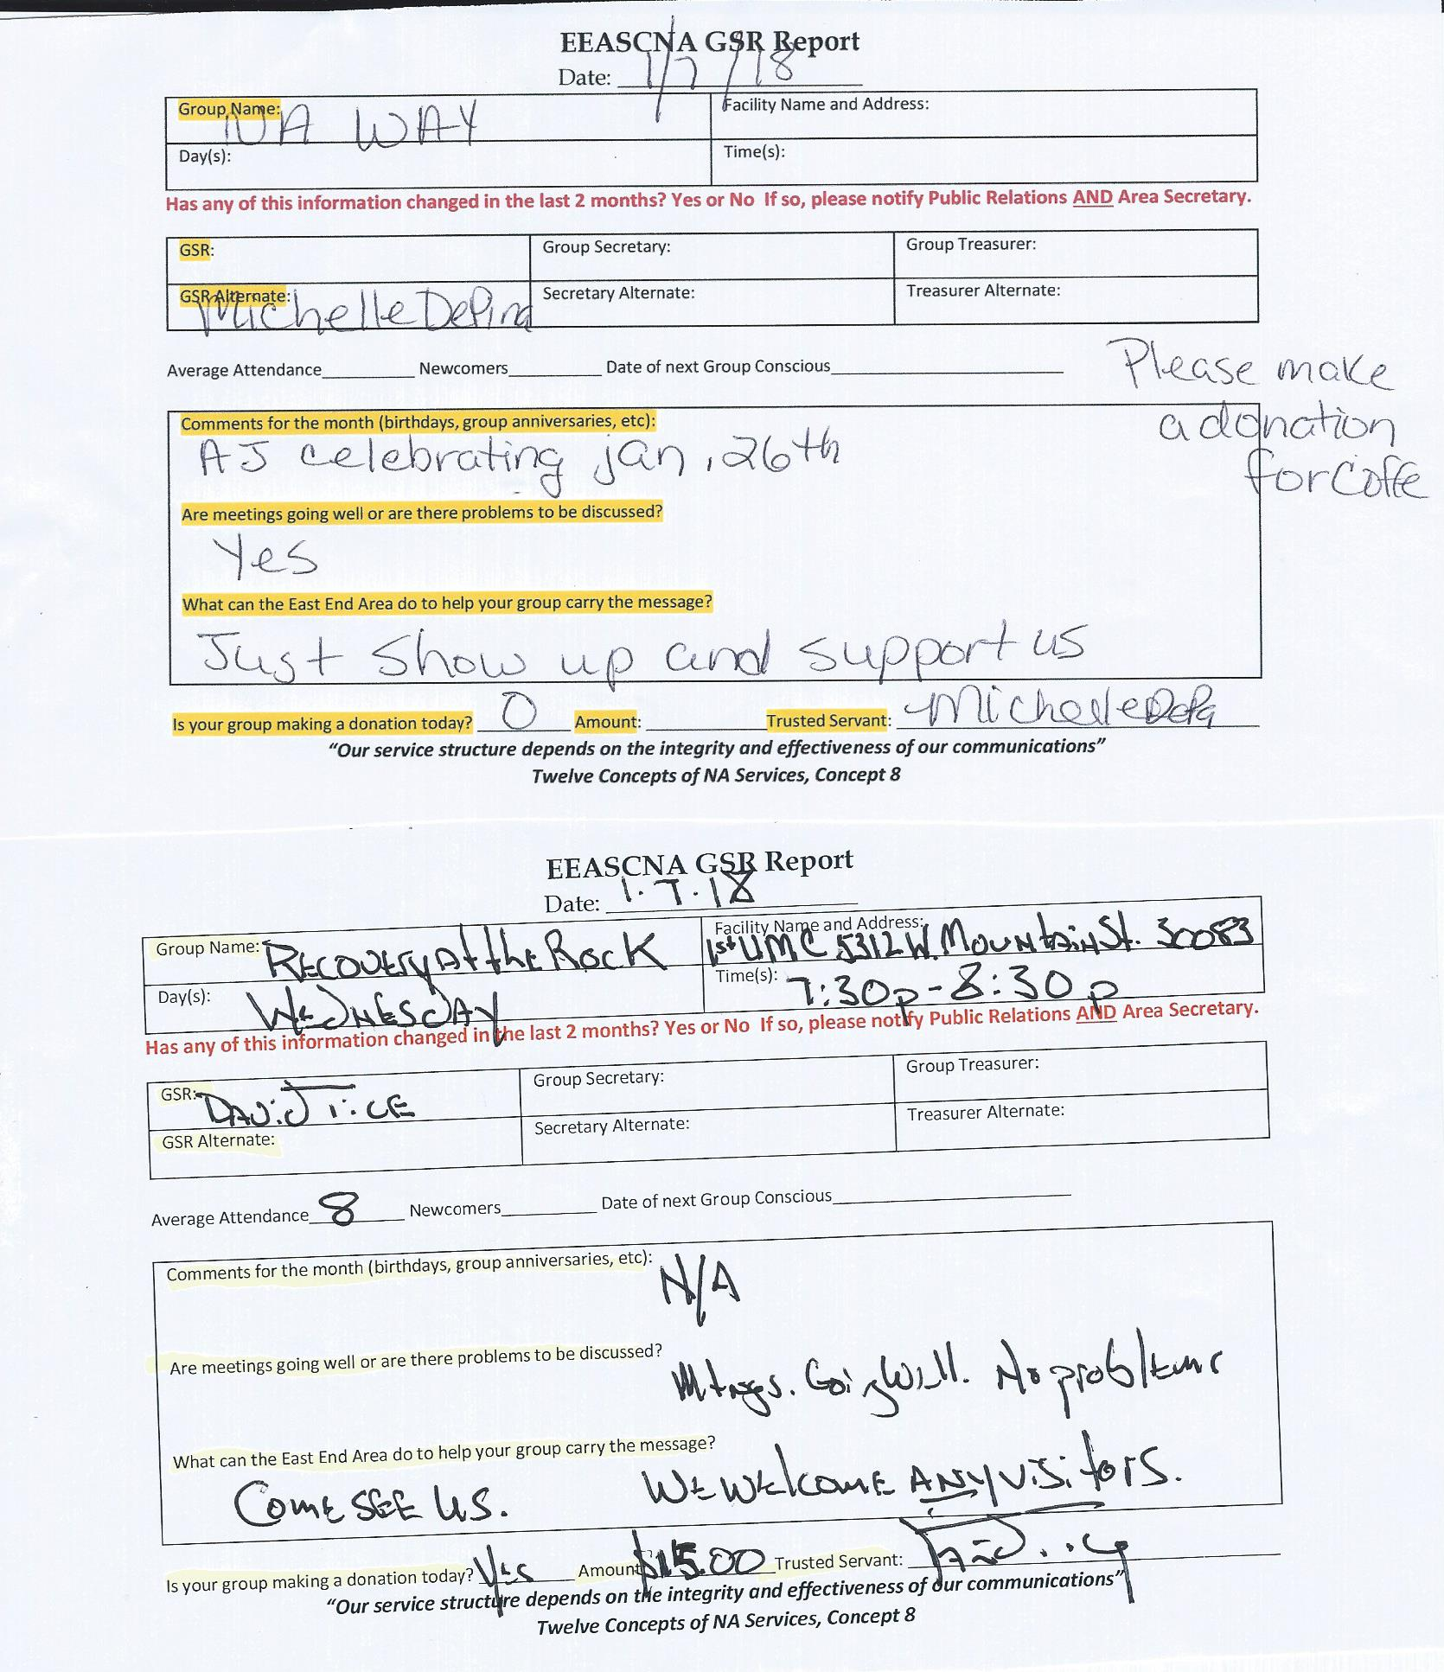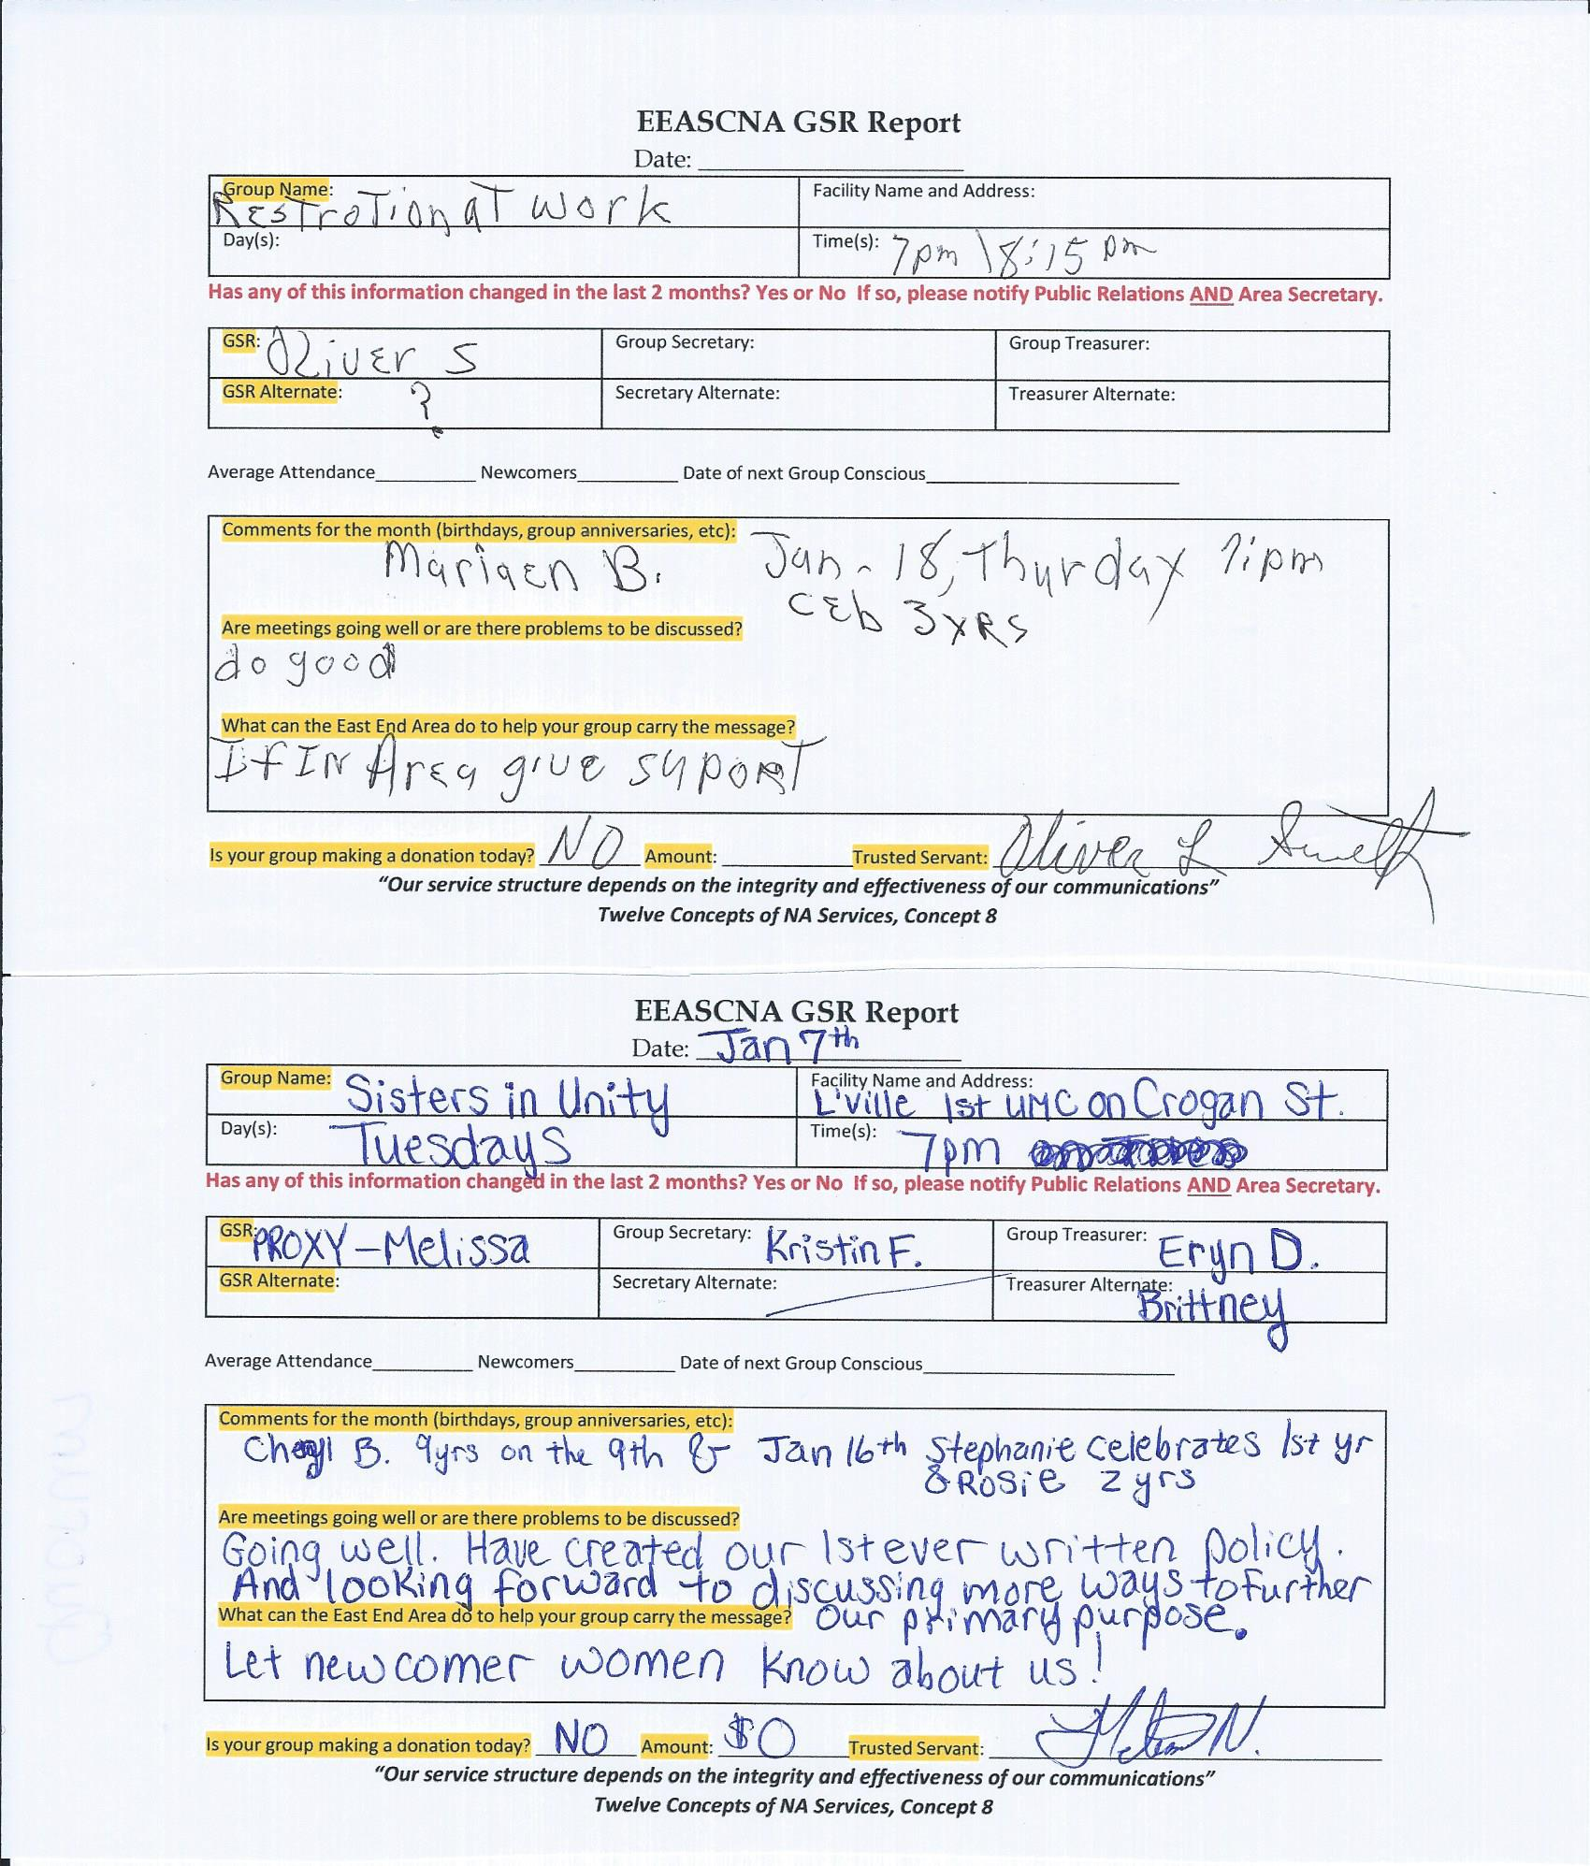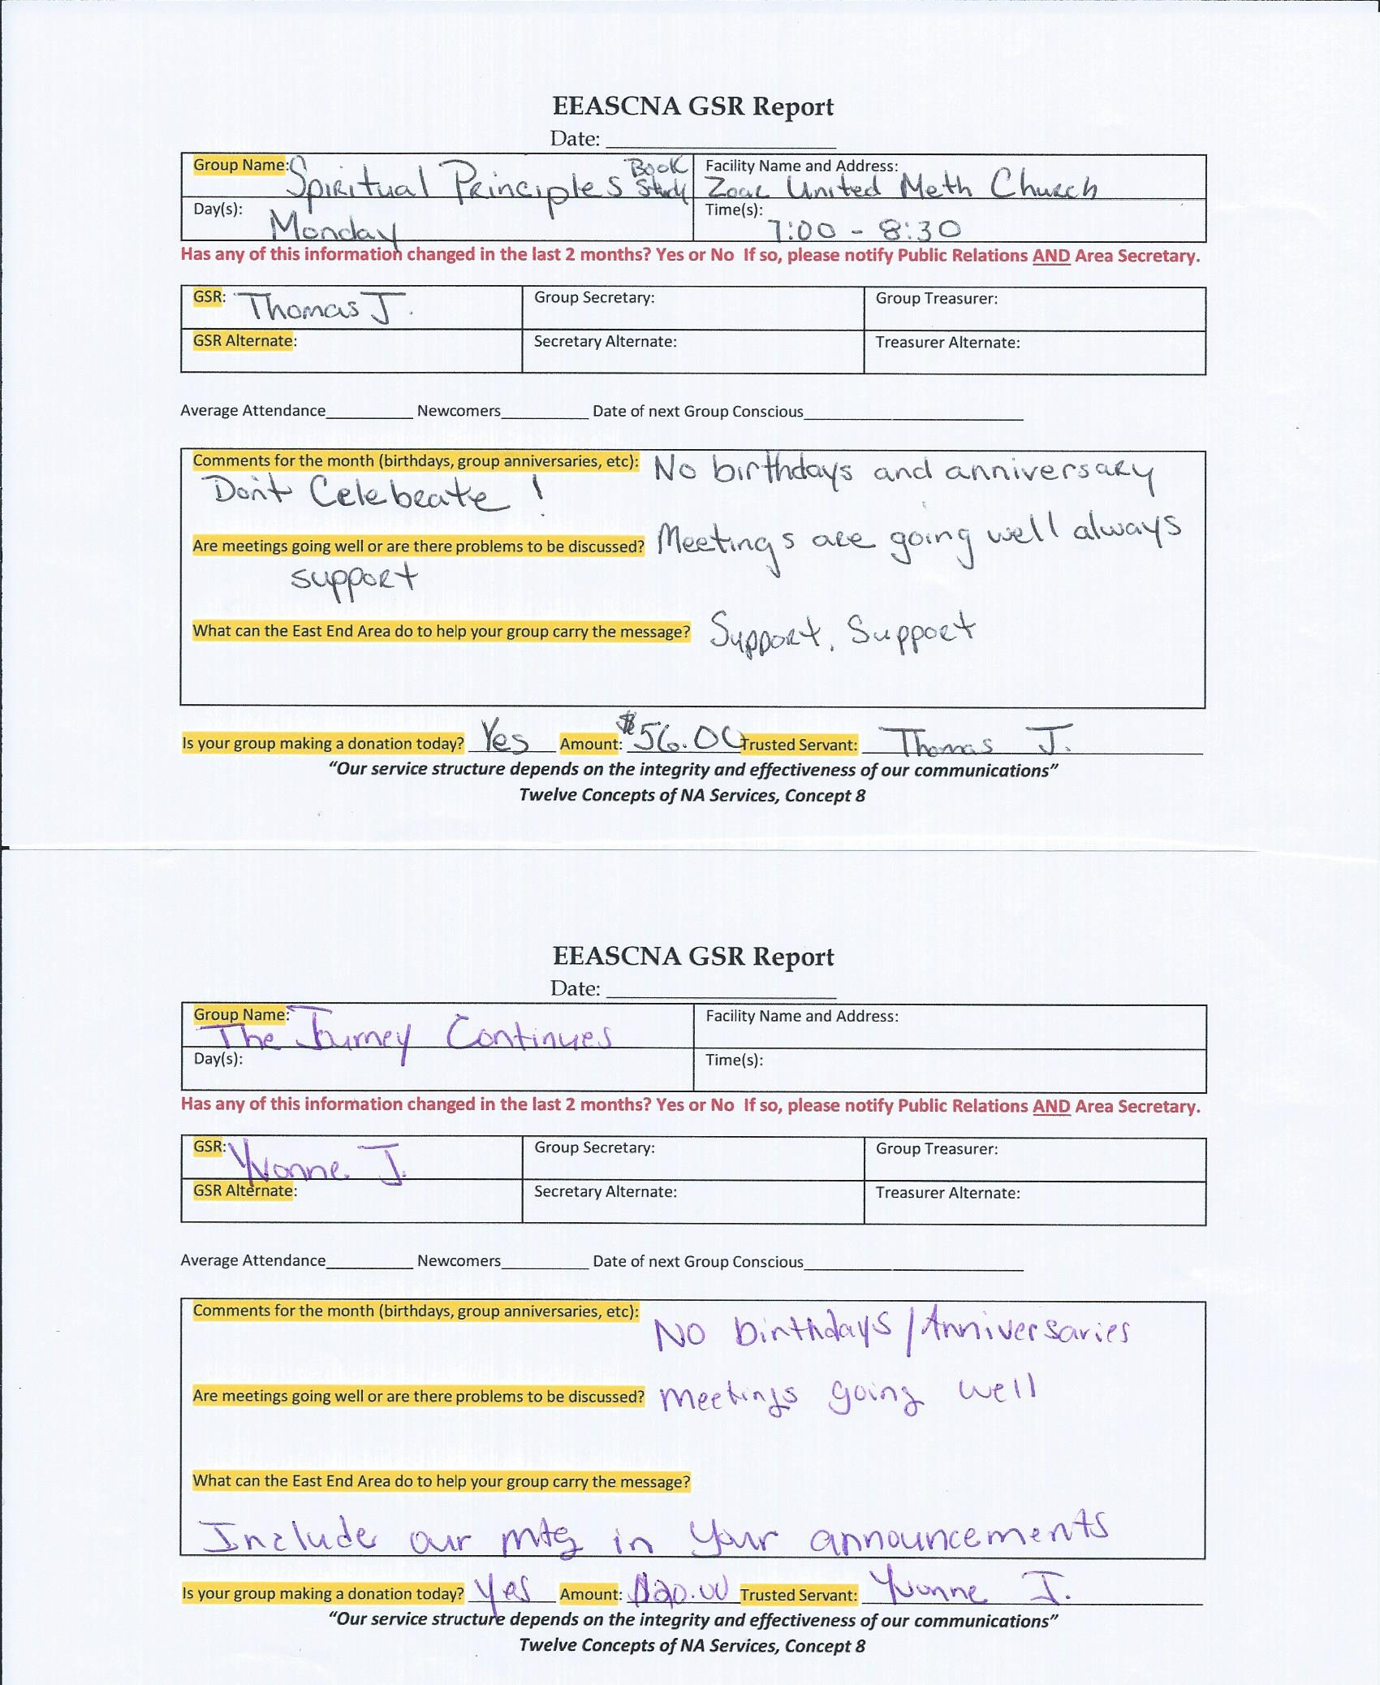

Old Business
None

Nominations/Elections

None

Positions Still Open
Treasurer
Alternate Treasurer
Alternate Secretary
H & I Vice Chair
Activities Vice Chair
Public Relations Vice Chair

Open Forum
- While finding new Treasurer, Co-Facilitator can act as Treasurer
- PO box key that was lost, need to get replacement made so that we have two keys
- When groups are having activities, please have them bring a flier to be passed out (has to have NA Logo, approved by PR) - Will send Guidelines for flyers to homegroups

New Business
2018-001 - To allow additional funds to cover printing costs of abbreviated CAR Reports to one representative per all good-standing groups in East End not to exceed $90
Assent - 14 Assent w/res. - 0 Stand Aside - 1
CONSENSUS REACHED
(Topic form below)

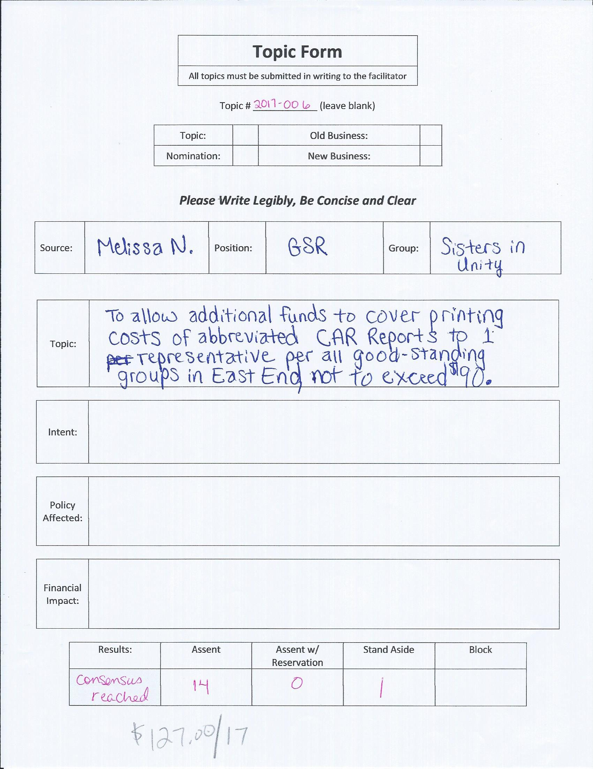

Plans for the next meeting
Next Area Service will be
Held at 3pm February 4th in Snellville
**ADMIN MEETS AT 2:00 PM**

(Other forms and flyers below)


