EEASCNA Minutes- February 2017
Sojourner opened ASC Meeting with moment of silence followed by the Serenity Prayer
Reading of Twelve Traditions - Yvonne
Reading of Twelve Concepts – Mary Ellen
Reading of Article II & III: Purpose of EEASCNA - Simone
Article II: Purpose The purpose of the East End Area Service Committee of Narcotics Anonymous (EEASCNA) shall be to respond to the needs and collective conscience of its member groups. EEASCNA supports and encourages the unity, welfare and growth of the East End Area as part of a worldwide Fellowship.
Article III: A. Definition and Function of the Area: The Area Service Conference (ASC) is the communicative channel for a unified Fellowship, a tie that binds us together. The ASC serves as a link in the flow of communication from the member to the worldwide Fellowship, establishes a structure in which services and education are provided, and functions as a vehicle through which our Area Fellowship and society can relate. The EEASC is a Committee made up of Group Service Representatives (GSRs), special purpose Task panels and an Administrative Body from Member Groups of the East End Area.
Administration Roll-Call
Key: 0= Not Present, 1= Present, (-) = Vacant, R= Report submitted only
ROLE | NAME | D | J | F | M | A | M | J | J | A | S | O | N | D
Facilitator | Sojourner B. | 1 | 1 | 1
Co-Facilitator | Simone J. | 1 | 1 | 1
Secretary | Kristin F. | 1 | 1 | 1
Alt-Secretary |  | 1 | - | -
Treasurer | Brian A. | 1 | 1 | 1
Alt-Treasurer | Cherri | 0 | 1 | 1
H&I Chair | Nick P. | 0 | 1 | 1
H&I Vice |  | - | - | -
PR Chair | Jackson J. | 1 | 1 | 1
PR Vice |  | - | - | -
Activities | Jennifer L. | 1 | 1 | 1
Activities Vice | Ashley | 0 | 0 | 0
RCM | Fred C. | 1 | 1 | 1
RCMA | Mike R. | 1 | 1 | 1
Group Voting Policy:
- To reach quorum, 50% + 1 of groups present must be in good-standing.
- A quorum must be reached by fifteen (15) minutes after roll call is completed and before any business can be conducted.
- In order for a topic to be enacted, 80% of the groups present must be in good standing.
- New groups must attend 3 consecutive Area Meetings to gain voting rights at the 3rd Area.
- If a group misses 2 consecutive Area Meetings to re-gain voting rights at the 2nd.
East End Area Groups Roll Call
Key: 0= Not Present, 1= Present, R= Report Submitted only, Blacked Out= Not G.S.
2015- 2016 | D | J | F | M | A | M | J | J | A | S | O | N | D
By NA Means Necessary | 0 | 0 | 0
Changing in Grayson | 1 | 1 | 1
Clean & Free | 1 | 1 | 1
Covington Miracles | 1 | 1 | 1
Fahrfromusin | 1 | 1 | 1
Far Out | 1 | 1 | 1
Get Real | 0 | 0 | 1
Harvest | 0 | 1 | 1
How It Works | 1 | 1 | 1
Just for Today | 1 | 1 | 1
Let the Truth Be Told | R | 1 | 1
Monroe New Miracles | 1 | 1 | 0
NA Vaders | 1 | 1 | 1
NA Way | 1 | 1 | 1
No Name Group | 0 | 0 | 0
Recovery at the Rock | 0 | 0 | 0
Restoration at work | 1 | 1 | 0
Set-Free | 0 | 0 | 0
Sisters in Unity | 1 | 1 | 1
Spiritual Principles | P | R | R
The Journey Continues | 1 | 1 | 1
Unlimited Hope | 1 | 0 | 1
Total of Groups in Area | 22 | 22 | 22
Total Groups Present | 14 | 16 | 15
Groups in Good Standing | 17 | 17 | 16
Groups Present & G.S. | 14 | 15 | 14
Number for Quorum (50% + 1)?  Is Quorum reached? | 12 Yes | 12 Yes | 12 Yes
Number for Consensus (80% present in G.S)?  Do we have Consensus? | 11 | 12 | 12

Subcommittee Reports
Admin- Workshop moved improperly, not with GSR approval. Addressed in admin meeting. PR stated that their poster drive had to be moved because workshop was bumped, but worked out in PR favor to be at this month’s area. Treasurer stated we will go over budget for admin today. Will need continuing resolution until budget is voted on. H & I have new sign up forms, asks that GSRs take them back to their homegroup and announce that they have them. Activities stated they have no money to move forward with any activities until April. Ad-hoc meeting went well. Will meet on Feb. 12th @ Panera in Snellville to move forward.

Treasurer Report
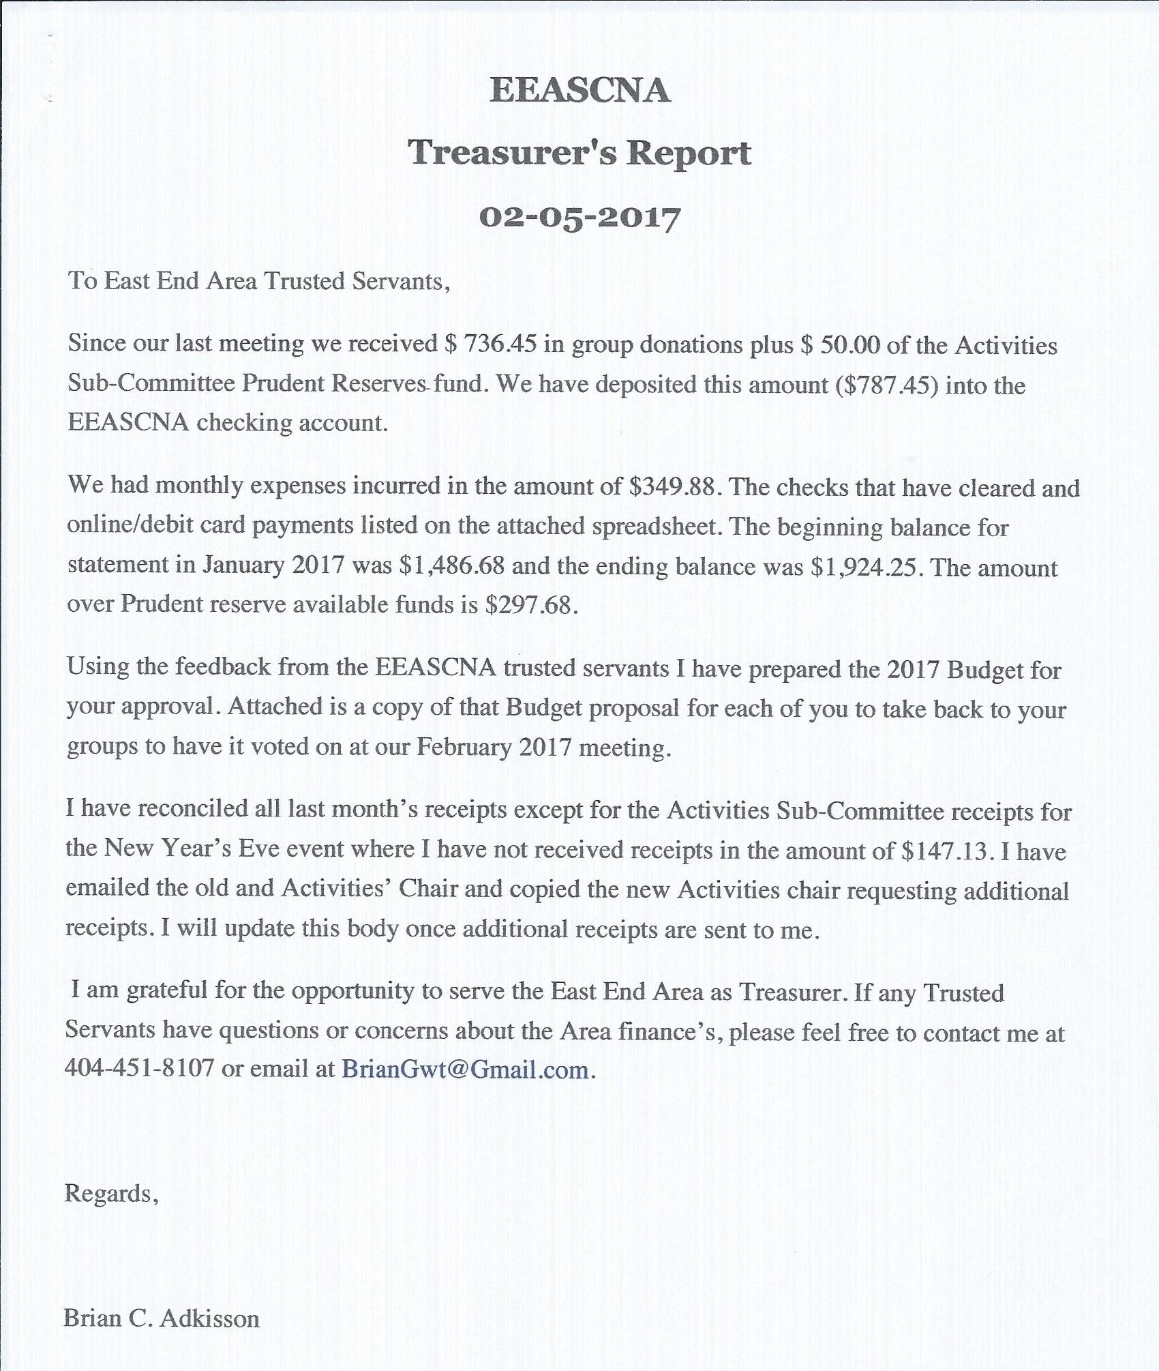
Mileage reimbursement questioned. Area rent needs to be added to budget. Full report below:
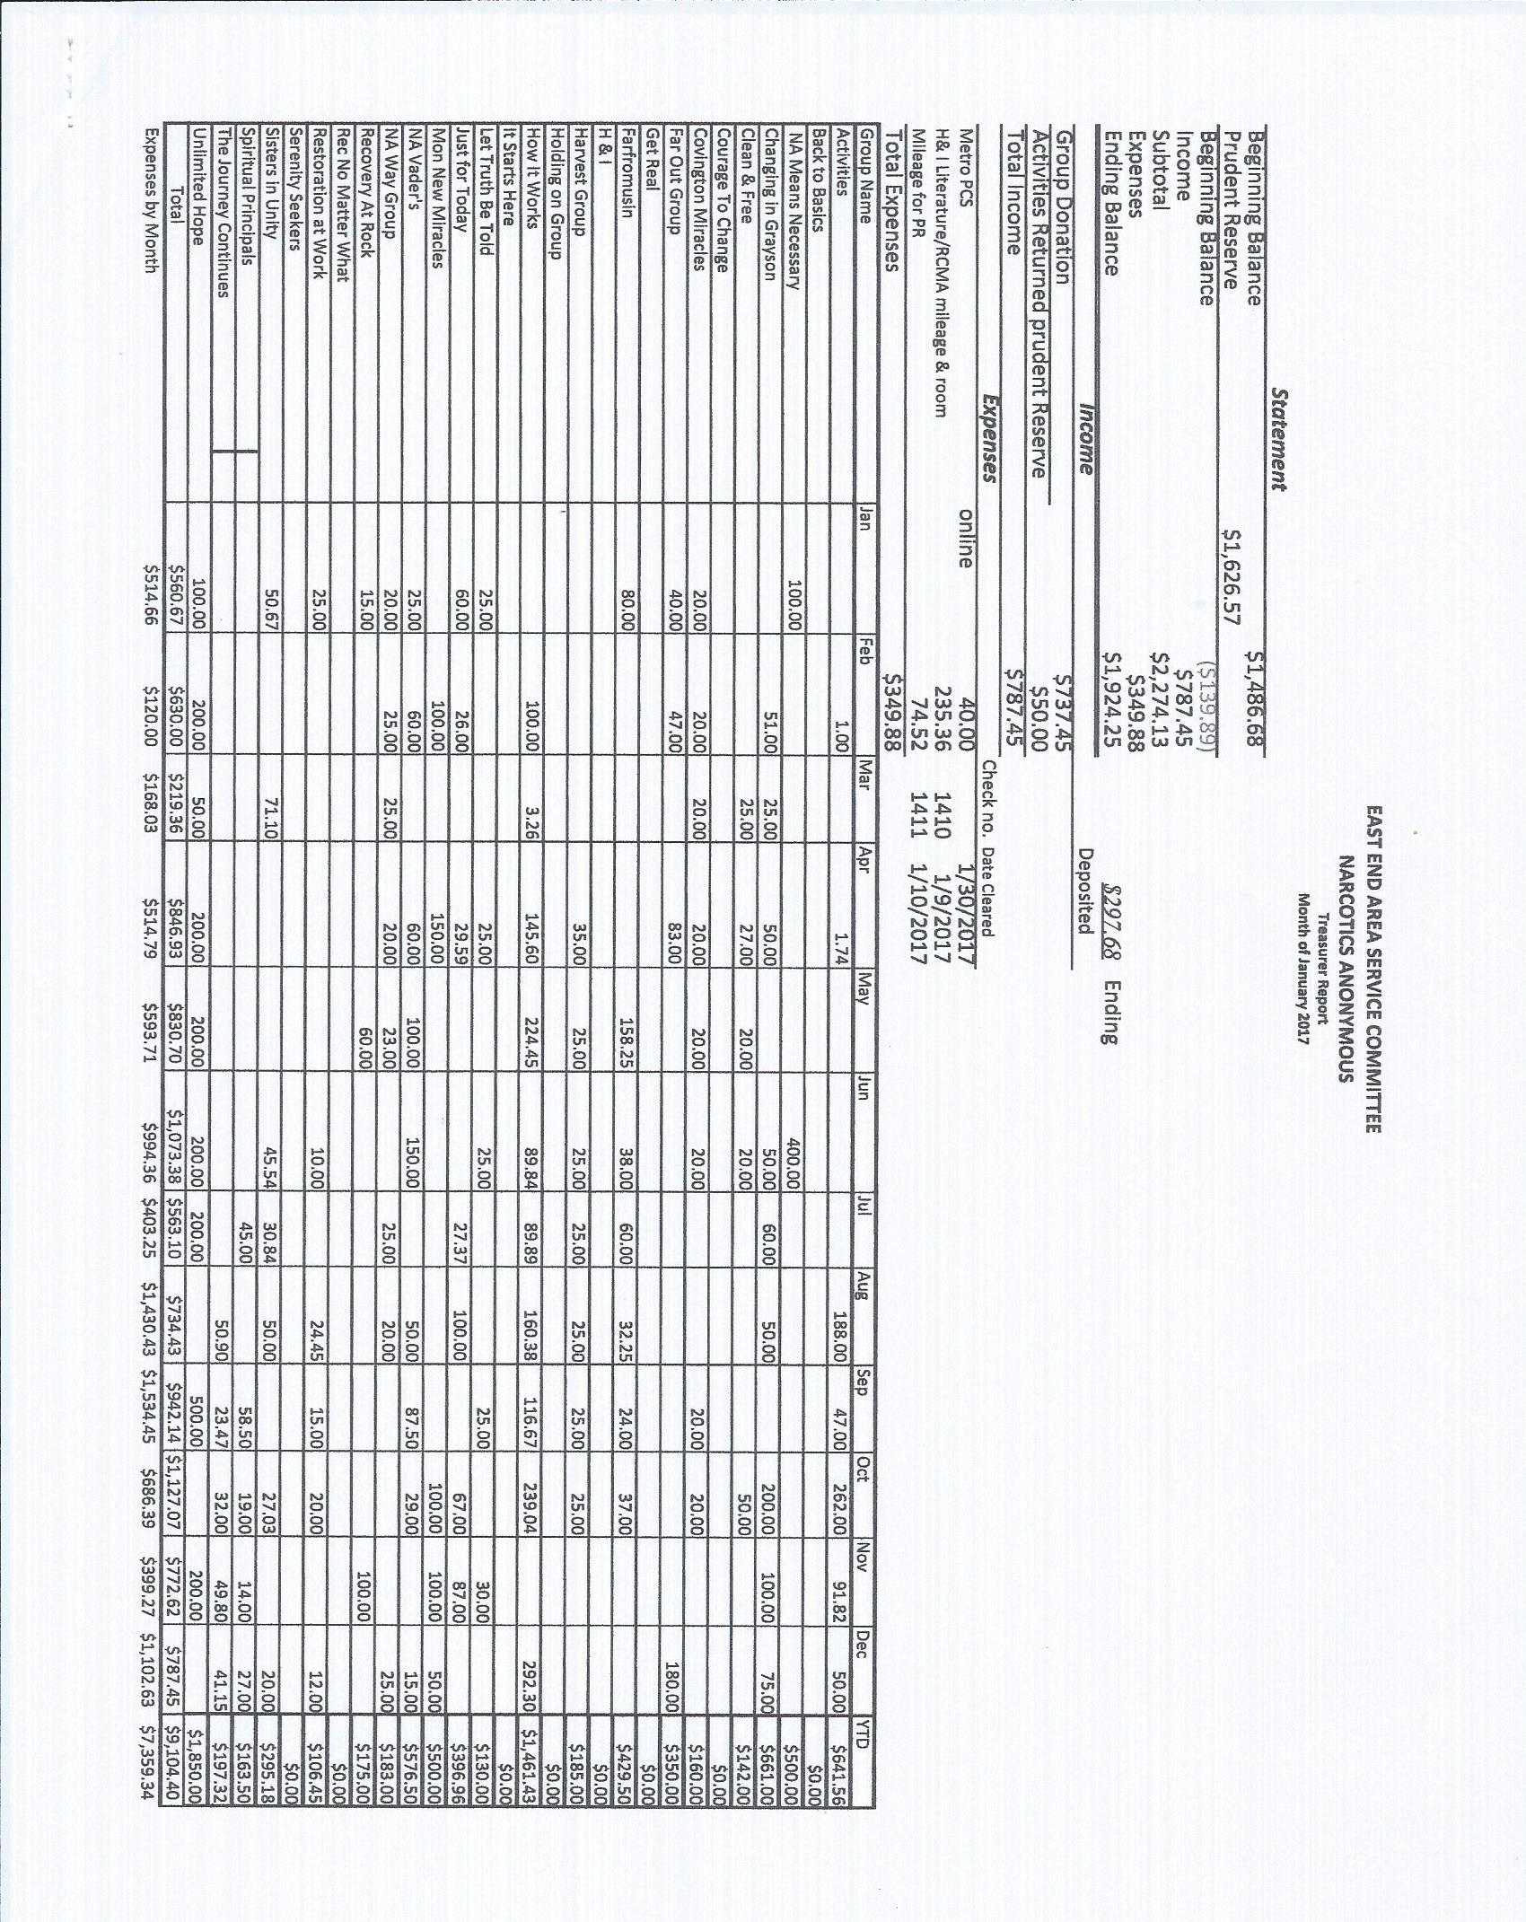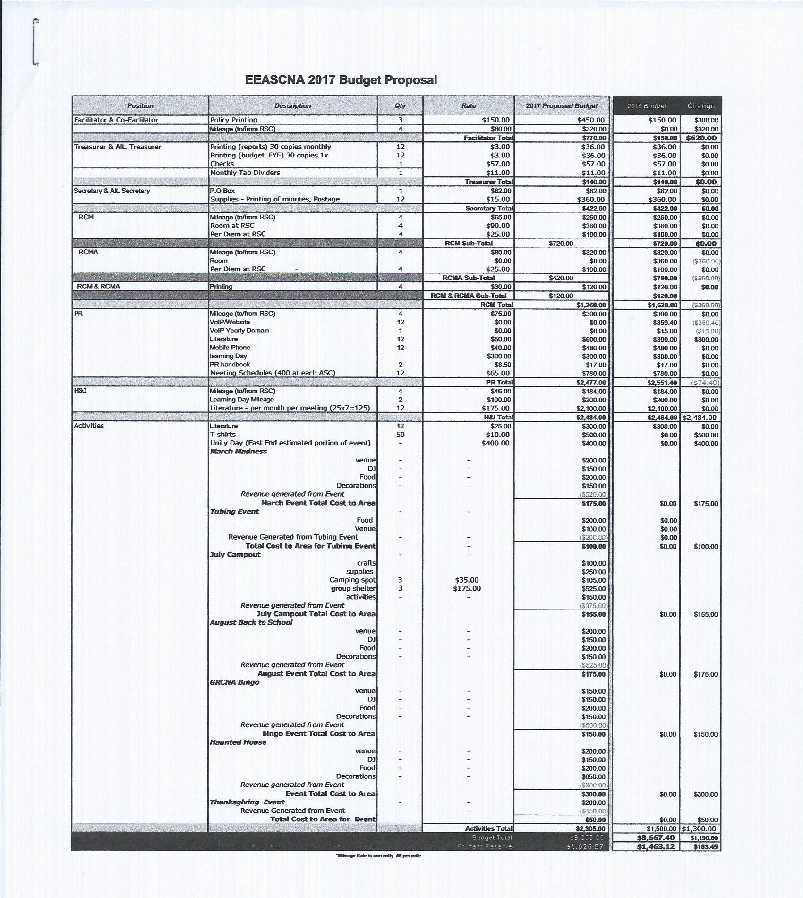

RCM Report
RCMA position will be open in March. Next RCM is March 11-12th. Consensus based workshop will be held after Area next month on March 5th. Positions from Region and Topic need to be voted on before March area.
Full report below:
The next RSC will be: March 11-12, 2017 Central Georgia Convention Complex, 400 Holiday Circle – Forsyth, GA. 31029
Old Business: None
New Business:
New Nominations:
Alt Treasurer- Tiffany L. straw poll can she be nominated without being present (since she was on-call at work, she submitted letter)? Straw poll: 12— will be in Minutes
[Original Topic submitted for 2016-16] Reimbursement of Room Rates for Regional Admin with intent to allow more members to serve without the financial hardship as deciding factor to serve.
Process of discussion and modification of Topic ensued: Current Policy: ½ cost of room not to exceed $50. One member will talk to management to see if hotels are talk to management willing to negotiate. Several straw polls taken to modify topic by using consensus on floor. 11 in favor of dropping the word “half” on article 13. Cap of $60 per night 9 in favor. And a suggestion of sharing a room 1 in favor. $320 financial impact of the 2016- 2017 Budget.
2016-16 [Back to groups] To remove the word “half” and to raise cap to $60.
New Policy would read:
Approval is granted to reimburse the Georgia Regional elected Trusted Servants the cost of one room night at the RSC meeting site, if requested. For those trusted servants who live 150 miles one way or greater from the meeting site, the cost of an additional room night may be requested. Reimbursement not to exceed $60.00 per position. BACK TO GROUP
Nomination- Tony Owens for CPP Chair GRCNA 37 Clean date: 06/07/1992 I have a NA home group: Clean in Clermont I have a working knowledge of the 12 steps, traditions and concepts. I have a NA sponsor I have served as a GSR, ASR, RCM, Area Policy chair, Area Chair, RDA, and RD. I am proficient at workshop facilitation. I have a working knowledge of CBDM I was program chair for GRCNA 35. I am currently Vice chair of GRCNA 36 The only commitment I have not fulfilled was as ASR for the northeast area in 1997. ILS Tony O
Nomination- Asa Beal for CPP Vice Chair GRCNA 37
Nomination- Jerry Evans for CPP Treasurer GRCNA 37 GOES BACK TO GROUPS
Nominations:
o Tiffany L. for Alternate Treasurer
o Tony Owens for CPP Chair GRCNA 37
o Asa Beal for CPP Vice Chair GRCNA 37
o Jerry Evans for CPP Treasurer GRCNA 37
Vacant Admin Position in great need:
o Alternate Secretary
For Further Review:
o Review for RD: The Environmental Scan from NAWS
o Distribute Group History Form for GA History Book
Topics:
o 2016-16
PLANS FOR THE NEXT MEETING
March 11-12
Trusting Servant Fred C

H & I Report
Need more people for subcommittee and to volunteer. Passed out volunteer forms for GSRs to take back to groups.

Public Relations Report
Asking for funds for posters and postage. Will have presentation for poster drive today. Poster drive April 1st. First of 4 events. Work in teams, Gwinnett, Conyers/Covington, Winder/Monroe. Looking for Co-chair for PR. Full report below:
East-End Area
Monthly Subcommittee Minutes for January 21 2017
12:00pm-2:00pm
Called to order at 12: noon with the N A service prayer
God, grant us the knowledge that we may act according to your divine precepts.
Instill in us a sense of your purpose, make us servants of your will and
grant us a bond of selflessness that this may truly be your work, not ours,
so, that no addict, anywhere, need not die from the horrors of addiction.
Attendees: Laurie, Joe B. Brian A., Yvonne J., Nick P. Jackson J., Mitch
Reading of the Twelve Concepts and observance of the 3rd and 11th Traditions.
Read and approve Minutes from last month’s meeting.
Chair Report
The committee met to discuss the April Poster Drive and the methods by which we can best execute the distribution of the project.
Draw up a letter to inform contacts
Get a $134.00 for N A Posters and postage stamps. 85.00 for posters and 49.00 for stamps.
Web-site
The web-site is functioning as planned, with
Meeting List
Make sure any needed changes are added to the Up-Date List that is going around
Help-Line
The help-line is working
Old Business
Regional Learning Day Planning for April 22. MORE TO BE REVEALED
- *15-minute PR-presentation at the February East End Area Service Committee Meeting (ACM), (performed by Regional Chair) on the April 1, Poster Drive
- *Mar 23-26 2017 Recruit for East-End Area Poster Drive at the Georgia Regional Convention

New Business for December
Get the information together to contact organizations about the Poster Drive
I was contacted by the north Atl. PR Chair about a united effort for Gwinnett County.
Open Forum Discussion for January

How can we better serve the community?
- GSR’s Please record up-coming PR-Events for the daily meeting announcements, help recruit New-Comers (ONE DAY clean-time is the only requirement). Please gather any information that has been added to the PR-sign-up sheets and submit to any PR-committee member or you may contact Jackson@ (786) 267-4751. Also, Please announce THE GRACNA Convention as the Georgia Regional Convention for clarity.

Closed @ 1:30 with the N A Service Prayer.
HONOR and SERVICE
P R Committee

Activities Report
Good turnout at subcommittee meeting. Discussed budget. Will need money up front for a lot of activities. Will be able to take credit card payments, online payments, and cash. Full report below:

NA Activities Sub Committee Meeting 1/19/17
Open position – treasurer
$50 prudent reserve went back to the area

New business
-Jennifer L introduced as new Chair
-need to discuss budget…new East End treasurer wants actual $ amount by line so that the money will be readily available when we need it. $300 literature, $500 t-shorts, $150 printing budget
-vote to move meetings to Sunday afternoons at 2pm at Panera Bread on 124..vote passed, committee meetings will be the 2nd Sunday of each month…next meeting is scheduled for Feb 12 @ 2pm at the Panera on 124
-we have approval from Treasurer to accept credit card payments, we will charge up front processing fee, East End is not approving this service, but it will be resolved at the area meeting

Activity List for Feb 2017 – October 2017
Feb – Main Event .. (Rick in charge of this event…needs to get pricing, structure and flyers)
March – March Madness …looking at the 1st weekend in March (everyone to research fun events)
April – Unity Event with H&I and PR (Jennifer to contact chairs PR, H&I, and Regional chair for availability..Elaine will be in charge of this event)
May – May 6th Braves kickoff (Rick to let us know pricing of tickets once they are posted)
June – tubing in Helen (Maggie to secure pricing and options)
July – Mac Daddy Camp Out …weekend before the 4th of July..create a way to register and pay $20-35 reg fee…some sleeping arrangements may be extra
August – back to school Jam (raffle, backpacks, karaoke)
September – GRCNA bingo
October – Haunted House (Hannah to research pricing and options for this event…possibly use the recovery not scary box to raise money for this event)
Group Reports
SCANNED AND ATTACHED BELOW
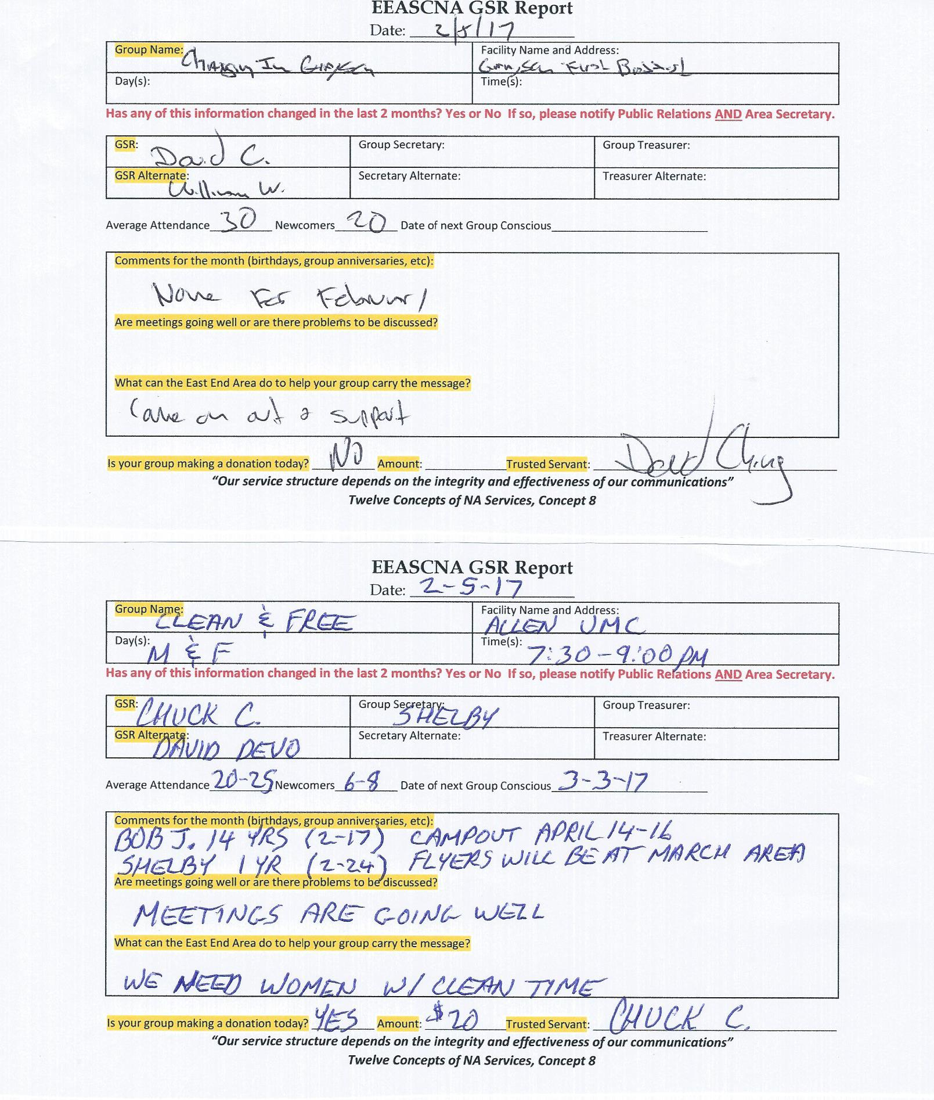
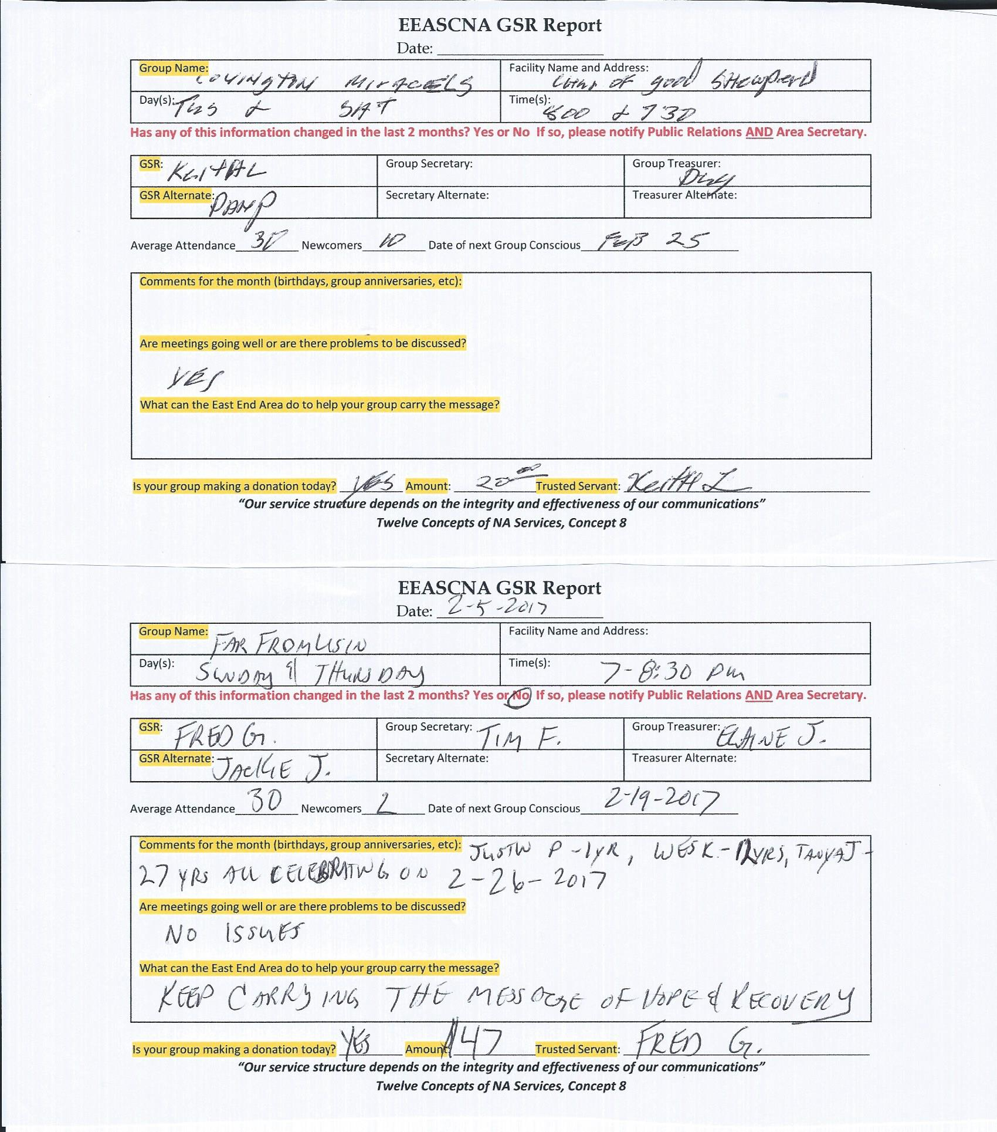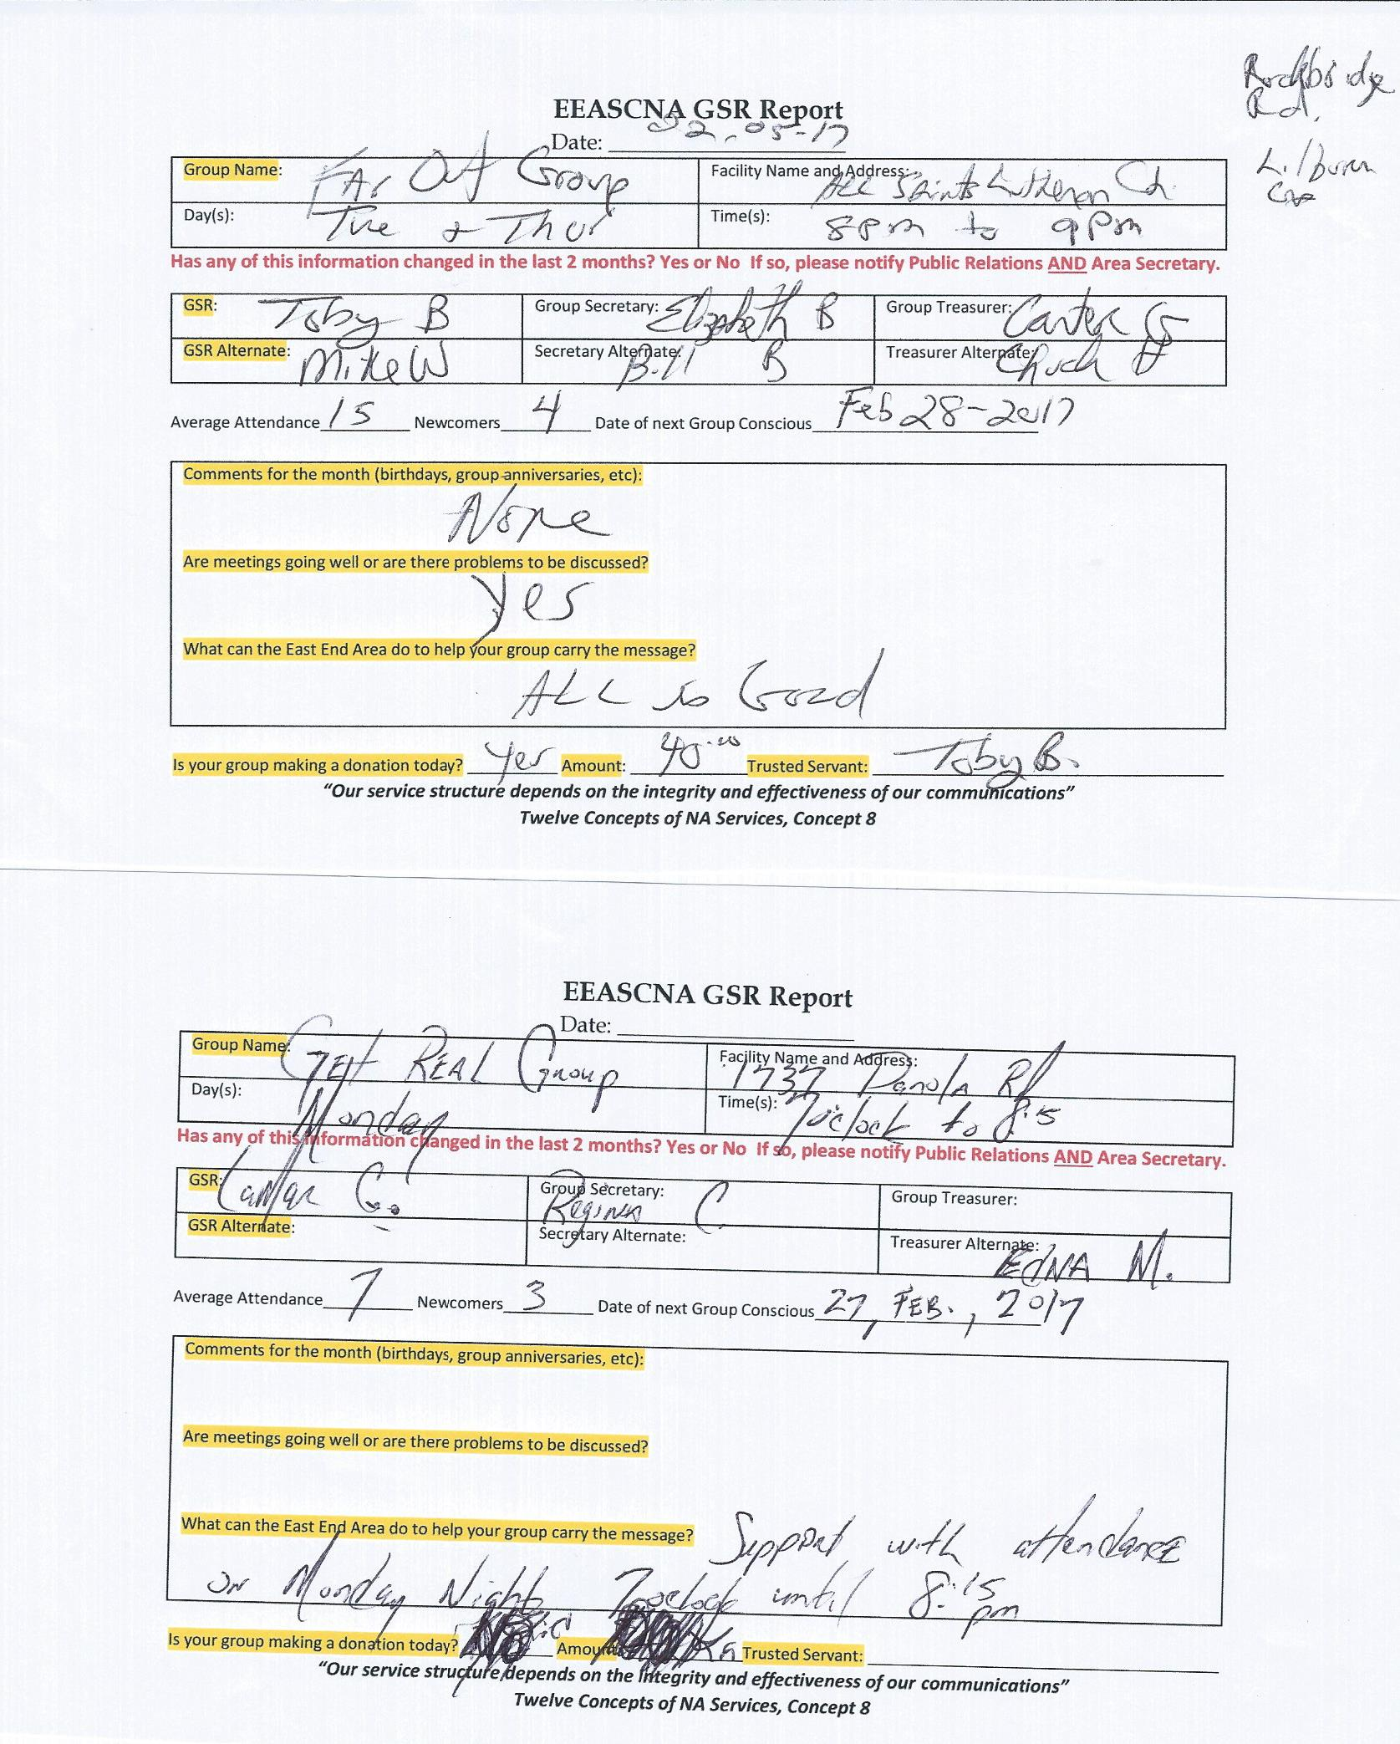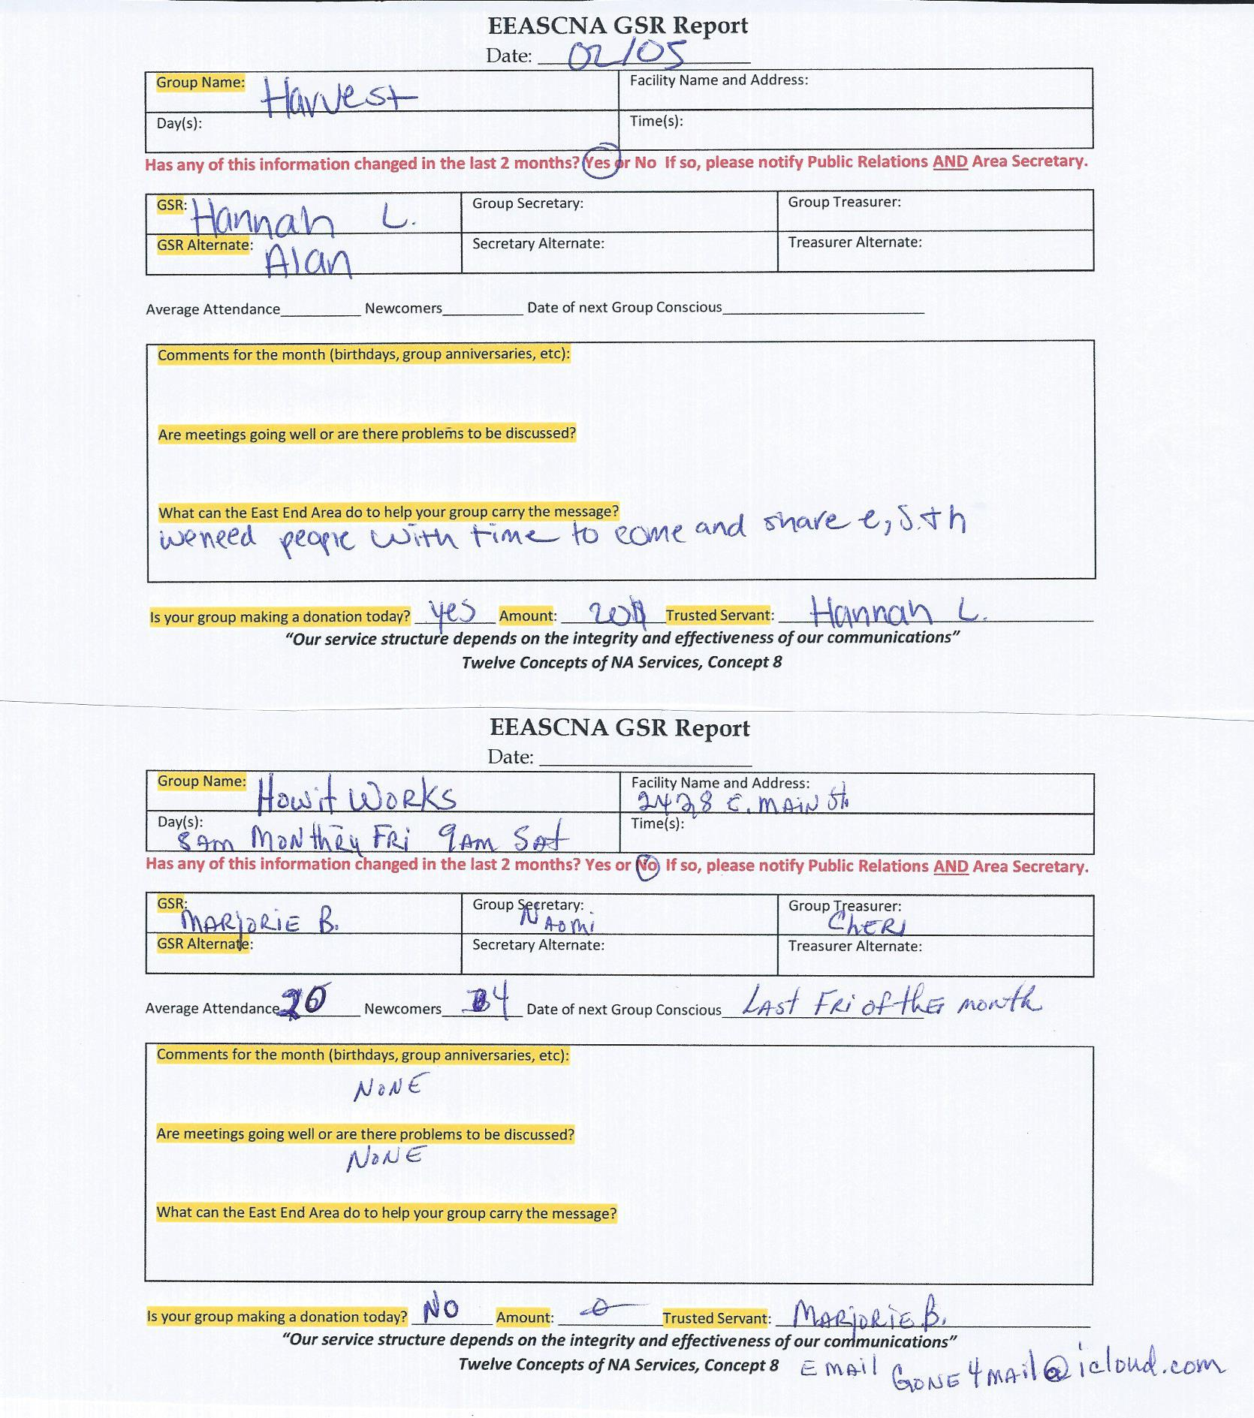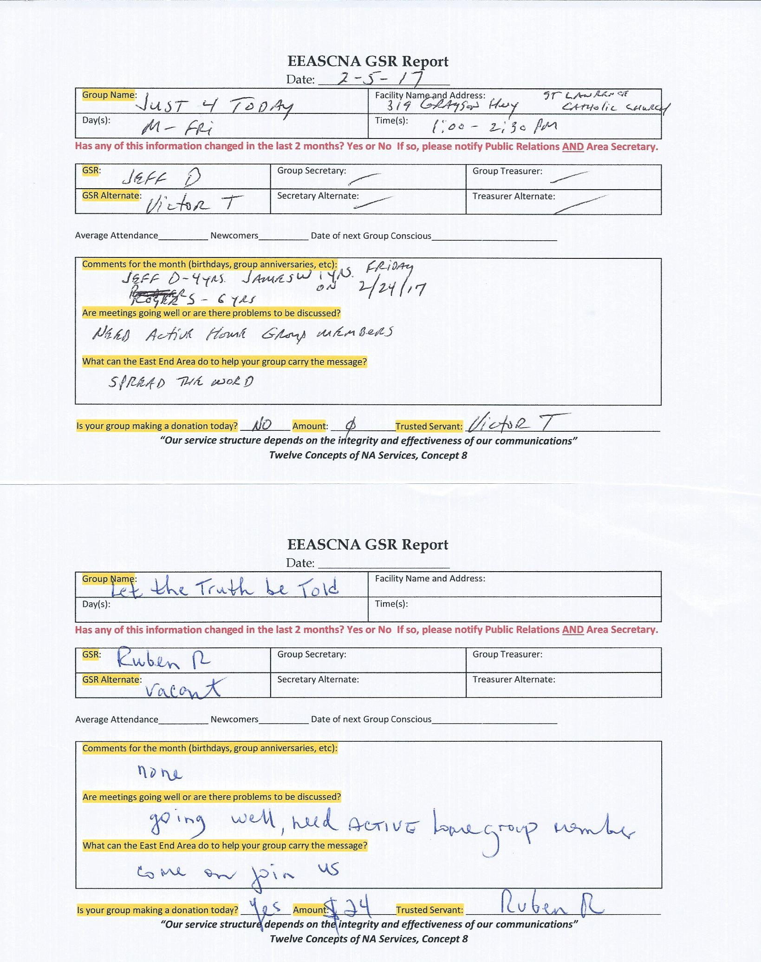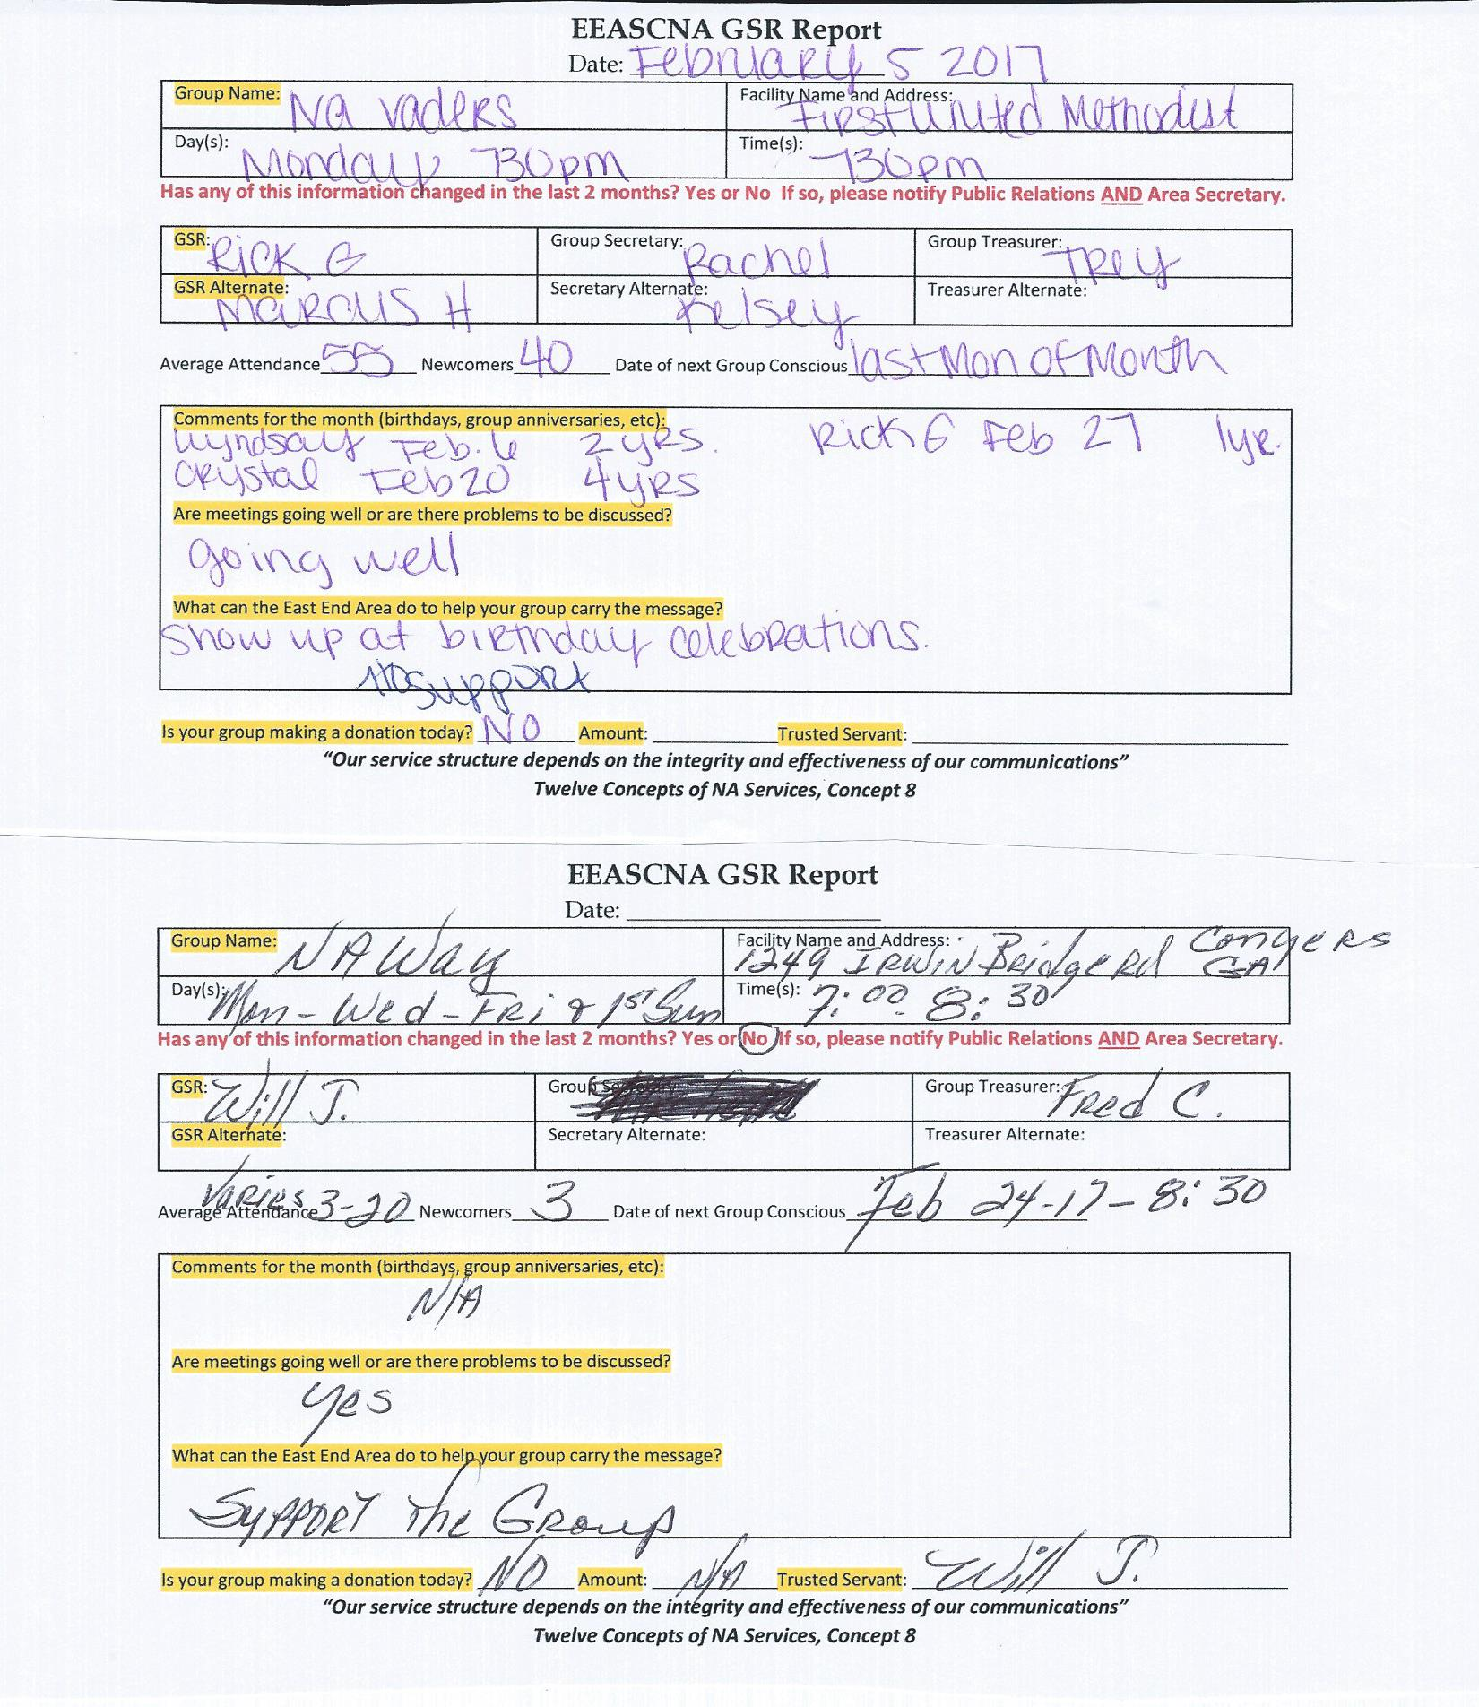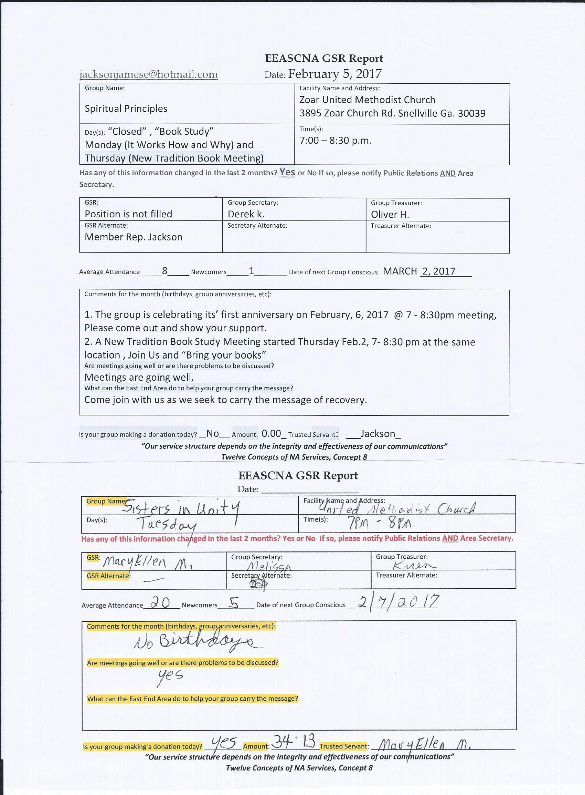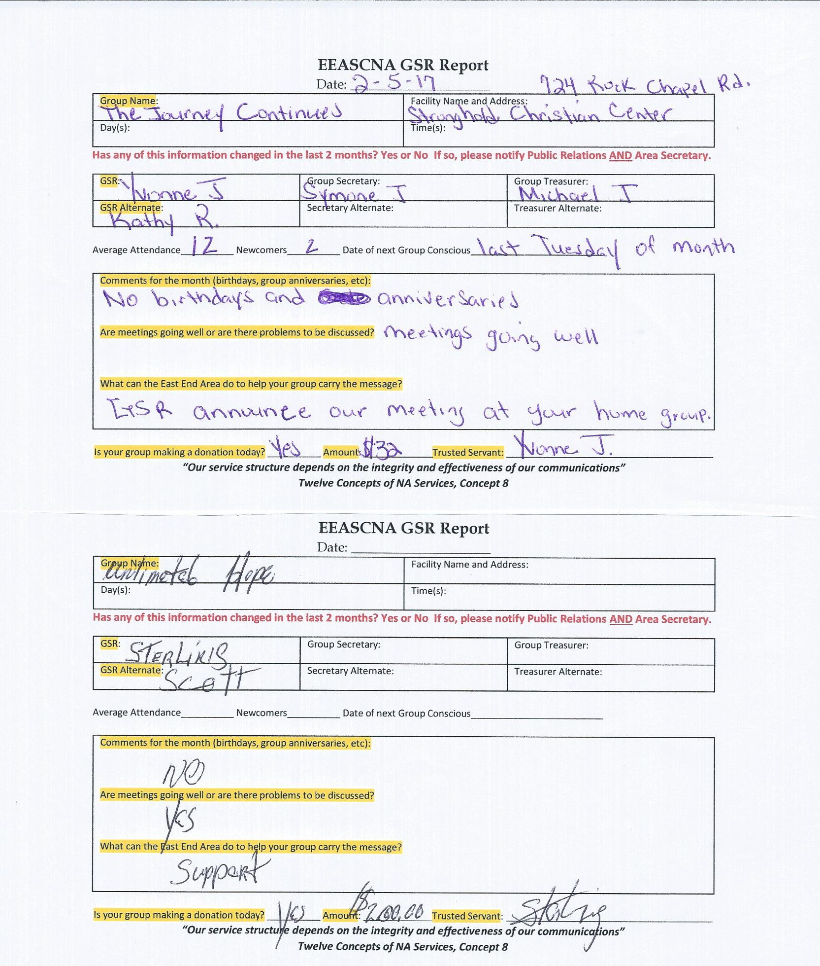

Old Business
- 2017-001 – Create a policy Ad-hoc committee budget for editing policy for 2017-2018

Nominations/Elections
none

Positions Still Open
Alternate Secretary
H & I Vice Chair
Public Relations Vice Chair

Open Forum
- Needing to adjust budget to accommodate for 10 cents below government mileage allotment. Currently 46 cents. Needs to change to 43 cents. Policy discrepancy, can we table this until policy reviewed? Will follow up with email and correct information

New Business
Enough GSRs left to where we could not vote on new business

Plans for the next meeting
Next Area Service will be
Held at 3pm March 5th in Conyers
**ADMIN MEETS AT 2:00 PM**

