**Notice: Meeting format has changed**
EEASCNA Minutes- October 2016
Sojourner opened ASC Meeting with moment of silence followed by the Serenity Prayer
Reading of Twelve Traditions – Yvonne
Reading of Twelve Concepts - Hannah
Reading of Article II & III: Purpose of EEASCNA - Victor
Article II: Purpose The purpose of the East End Area Service Committee of Narcotics Anonymous (EEASCNA) shall be to respond to the needs and collective conscience of its member groups. EEASCNA supports and encourages the unity, welfare and growth of the East End Area as part of a worldwide Fellowship.
Article III: A. Definition and Function of the Area: The Area Service Conference (ASC) is the communicative channel for a unified Fellowship, a tie that binds us together. The ASC serves as a link in the flow of communication from the member to the worldwide Fellowship, establishes a structure in which services and education are provided, and functions as a vehicle through which our Area Fellowship and society can relate. The EEASC is a Committee made up of Group Service Representatives (GSRs), special purpose Task panels and an Administrative Body from Member Groups of the East End Area.
Administration Roll-Call
Key: 0= Not Present, 1= Present, (-) = Vacant, R= Report submitted only
ROLE | NAME | D | J | F | M | A | M | J | J | A | S | O | N | D
Facilitator | Sojourner B. | i | i | i | i | i | 1 | 1 | 1 | 1 | 1 | 1
Co-Facilitator |  | - | - | - | 1 | 1 | - | - | - | - | 0 | 1
Secretary | Sara Y. | 1 | 1 | 1 | 1 | 1 | 1 | 1 | 0 | 1 | 1 | 0
Alt-Secretary | Kristin F. | - | - | - | - | - | - | - | 1 | 1 | 1 | 1
Treasurer | Susan W. | i | i | i | 1 | 1 | 1 | 1 | 1 | 1 | 1 | 1
Alt-Treasurer | Cheri H. | - | - | - | 0 | 0 | 1 | 1 | 1 | 1 | 1 | 1
H&I Chair | Tim F. | 1 | 1 | 1 | 1 | 1 | 1 | 1 | 1 | 1 | 1 | 1
H&I Vice |  | - | - | - | - | - | - | - | - | - | - | -
PR Chair |  | - | - | - | - | - | 1 | 0 | - | - | - | -
PR Vice |  | - | - | - | - | - | - | - | - | - | 1 | 1
Activities | Elaine J. | 1 | 1 | i | 1 | 1 | 0 | 1 | 1 | 1 | 1 | 1
Activities Vice | James J. | - | - | 1 | - | 1 | 1 | 1 | 0 | 1 | 0 | 1
RCM | Fred C. | 1 | 1 | 1 | 1 | 1 | 1 | 1 | 1 | 1 | 1 | 1
RCMA | Mike R. | - | 1 | 1 | 1 | 1 | 1 | 0 | 1 | 1 | 1 | 1
Group Voting Policy:
- To reach quorum, 50% + 1 of groups present must be in good-standing.
- A quorum must be reached by fifteen (15) minutes after roll call is completed and before any business can be conducted.
- In order for a topic to be enacted, 80% of the groups present must be in good standing.
- New groups must attend 3 consecutive Area Meetings to gain voting rights at the 3rd Area.
- If a group misses 2 consecutive Area Meetings to re-gain voting rights at the 2nd.
East End Area Groups Roll Call
Key: 0= Not Present, 1= Present, R= Report Submitted only, Blacked Out= Not G.S.
2015- 2016 | D | J | F | M | A | M | J | J | A | S | O | N | D
By NA Means Necessary | 1 | 1 | 0 | 1 | 0 | 0 | 1 | 0 | 0 | 0 | 0
Changing in Grayson | R | R | 1 | 1 | 1 | 1 | 1 | R | 1 | R | 1
Clean & Free | 1 | 1 | 1 | 1 | 1 | 1 | 1 | 1 | 1 | 0 | 1
Covington Miracles | 1 | 1 | 1 | 1 | R | 1 | 1 | 1 | 1 | 1 | 1
Fahrfromusin | 1 | 1 | 1 | R | 1 | 1 | 1 | R | 1 | 1 | 1
Far Out | 1 | 1 | 1 | 1 | 1 | 1 | 0 | 1 | 0 | 0 | 0
Get Real | 1 | 0 | 0 | 0 | 0 | 0 | 0 | 0 | 0 | 0 | 0
Harvest | 1 | 1 | 1 | 1 | 1 | 1 | 1 | 1 | 1 | 1 | 1
How It Works | 1 | 0 | 1 | 1 | 1 | 1 | 1 | 1 | 1 | 1 | 1
Just for Today | 1 | 1 | R | 0 | 1 | 1 | 1 | 1 | 1 | 1 | 1
Let the Truth Be Told | 0 | 1 | 1 | 0 | 1 | 0 | 1 | 1 | 1 | 1 | 1
Monroe New Miracles | 1 | 1 | 1 | 1 | 1 | 1 | 0 | 0 | 1 | 0 | 1
NA Vaders | 1 | 1 | 1 | 1 | 1 | 1 | 1 | 1 | 1 | 1 | 1
NA Way | 1 | 1 | 1 | 1 | 1 | 1 | 1 | 1 | 1 | 1 | 1
No Name Group | _ | _ | 1 | 0 | 1 | 1 | 1 | 1 | 1 | 0 | 1
Recovery at the Rock | 1 | 1 | 0 | 0 | 0 | 0 | 0 | 0 | 0 | 0 | 0
Restoration at work | 0 | 1 | 1 | 1 | 1 | 1 | 1 | 1 | 1 | 1 | 1
Set-Free | - | 1 | 1 | 0 | 0 | 0 | 0 | 0 | 0 | 0 | 0
Sisters in Unity | 1 | 1 | 1 | 1 | 1 | 1 | 1 | 1 | 1 | 1 | 1
Spiritual Principles | - | - | - | - | 1 | 1 | 1 | R | 1 | 0 | 1
The Journey Continues | - | - | - | - | - | - | - | - | 1 | 1 | 1
Unlimited Hope | 1 | 0 | 1 | R | 1 | 0 | 1 | 1 | 0 | 1 | 0
Total of Groups in Area | 19 | 19 | 20 | 20 | 21 | 21 | 21 | 21 | 21 | 22 | 22
Total Groups Present | 14 | 17 | 15 | 14 | 17 | 15 | 17 | 16 | 12 | 13 | 16
Groups in Good Standing | 16 | 16 | 17 | 17 | 16 | 16 | 17 | 18 | 18 | 17 | 17
Groups Present & G.S. | 13 | 16 | 14 | 14 | 15 | 13 | 15 | 16 | 13 | 12 | 16
Number for Quorum (50% + 1)?  Is Quorum reached? | 11 Yes | 10 Yes | 11 Yes | 11 Yes | 10 Yes | 12 Yes | 15 Yes | 12 Yes | 12 Yes | 12 Yes | 12 Yes
Number for Consensus (80% present in G.S)?  Do we have Consensus? | 14 Yes | 13 Yes | 12 Yes | 11 Yes | 10 Yes | 14 Yes | 10 Yes | 13 Yes | 13 Yes | 12 Yes | 13 Yes

Subcommittee Reports
Admin- Treasurer reviewed report; activities donated $262 ($240 shirts/$22 7th tradition at laser show). H&I meetings going well. Viewpoint meeting needs help, more details from Chair. PR Chair nomination today.
Treasurer- All expenses itemized on second page of report. Check policy to see if hand written checks can be given as donation to treasurer

EEASCNA Treasurer's Report
10-2-2016
To East End Area Trusted Servants,
Since our last meeting we received $ 942.14 in group donations which were deposited into the checking account. Monthly expenses were incurred in the amount of $ 1534.45. The checks that cleared and online/debit card payments are listed on page 2 of your report. The beginning balance for statement in Sept 2016 was $ 1686.79 and the ending balance was $1198.50. Prudent reserve is under $ 264.62 in the account. Prudent reserve will be replenished by the money from sales of T shirts that was paid up front for this purpose.
I am grateful for the opportunity to serve the East End Area as Treasurer. If any Trusted Servants have questions or concerns about the Area's finances please feel free to contact me at 678-658-7175 or email at info@eeascna.org. In Service, Susan W.

EAST END AREA SERVICE COMMITTEE
NARCOTICS ANONYMOUS
Treasurer Report
Month of Sept 2016
Statement
Beginning Balance |  |  | $1,686.79
Prudent Reserve |  | $1,463.12
Beginning Balance |  |  | $1,686.79
Income |  |  | $942.14
Subtotal |  |  | $2,628.93
Expenses |  |  | $1,534.45
Ending Balance |  |  | $1,198.50 |  | -$264.62 | prudent reserve
Income |  |  |  |  | Deposited
Group Donation |  |  | $942.14
Total Income |  |  | $942.14
Expenses |  |  |  | Check no. | Date Cleared
Metro PCS |  | online | 40.00 |  | 9/7/2016
Sec.
VOIP |  | online | 29.95 |  | 9 Sept
H & I Literature |  | online | 406.55 |  | 13 Sept
RCM Room/Mileage
PR Room/Mileage
Region Donation |  |  | 500.00
Treasurer Printing |  |  | 14.95 |  | 6 Sept
PR Printing |  |  | 68.00 | 1391 | 9 Sept
Activities |  |  | 475.00 | 1393/ 1394 | 6 Sept
rent fahrfrumusin
Total Expenses |  |  | $1,534.45
Group Name |  | Jan | Feb | Mar | Apr | May | Jun | Jul | Aug | Sep | Oct | Nov | Dec | YTD
Activities |  |  | 1.00 |  | 1.74 |  |  |  | 188.00 | 47.00 |  |  |  | $237.74
Back to Basics |  |  |  |  |  |  |  |  |  |  |  |  |  | $0.00
NA Means Necessary |  | 100.00 |  |  |  |  | 400.00 |  |  |  |  |  |  | $500.00
Changing in Grayson |  |  | 51.00 | 25.00 | 50.00 |  | 50.00 | 60.00 | 50.00 |  |  |  |  | $286.00
Clean & Free |  |  |  | 25.00 | 27.00 | 20.00 | 20.00 |  |  |  |  |  |  | $92.00
Courage To Change |  |  |  |  |  |  |  |  |  |  |  |  |  | $0.00
Covington Miracles |  | 20.00 | 20.00 | 20.00 | 20.00 | 20.00 | 20.00 |  |  | 20.00 |  |  |  | $140.00
Far Out Group |  | 40.00 | 47.00 |  | 83.00 |  |  |  |  |  |  |  |  | $170.00
Get Real |  |  |  |  |  |  |  |  |  |  |  |  |  | $0.00
Farfromusin |  | 80.00 |  |  |  | 158.25 | 38.00 | 60.00 | 32.25 | 24.00 |  |  |  | $392.50
H & I |  |  |  |  |  |  |  |  |  |  |  |  |  | $0.00
Harvest Group |  |  |  |  | 35.00 | 25.00 | 25.00 | 25.00 | 25.00 | 25.00 |  |  |  | $160.00
Holding on Group |  |  |  |  |  |  |  |  |  |  |  |  |  | $0.00
How It Works |  |  | 100.00 | 3.26 | 145.60 | 224.45 | 89.84 | 89.89 | 160.38 | 116.67 |  |  |  | $930.09
It Starts Here |  |  |  |  |  |  |  |  |  |  |  |  |  | $0.00
Let Truth Be Told |  | 25.00 |  |  | 25.00 |  | 25.00 |  |  | 25.00 |  |  |  | $100.00
Just for Today |  | 60.00 | 26.00 |  | 29.59 |  |  | 27.37 | 100.00 |  |  |  |  | $242.96
Mon New Miracles |  |  | 100.00 |  | 150.00 |  |  |  |  |  |  |  |  | $250.00
NA Vader's |  | 25.00 | 60.00 |  | 60.00 | 100.00 | 150.00 |  | 50.00 | 87.50 |  |  |  | $532.50
NA Way Group |  | 20.00 | 25.00 | 25.00 | 20.00 | 23.00 |  | 25.00 | 20.00 |  |  |  |  | $158.00
Recovery At Rock |  | 15.00 |  |  |  | 60.00 |  |  |  |  |  |  |  | $75.00
Rec No Matter What |  |  |  |  |  |  |  |  |  |  |  |  |  | $0.00
Restoration at Work |  | 25.00 |  |  |  |  | 10.00 |  | 24.45 | 15.00 |  |  |  | $74.45
Serenity Seekers |  |  |  |  |  |  |  |  |  |  |  |  |  | $0.00
Sisters in Unity |  | 50.67 |  | 71.10 |  |  | 45.54 | 30.84 | 50.00 |  |  |  |  | $248.15
Spiritual Principals |  |  |  |  |  |  |  | 45.00 |  | 58.50
The Journey Continues |  |  |  |  |  |  |  |  | 50.90 | 23.47
Unlimited Hope |  | 100.00 | 200.00 | 50.00 | 200.00 | 200.00 | 200.00 | 200.00 |  | 500.00 |  |  |  | $1,650.00
Total |  | $560.67 | $630.00 | $219.36 | $846.93 | $830.70 | $1,073. | $563.10 | $734.43 | $942.14 | $0.00 | $0.00 | $0.00 | $6,239.39
Expenses by Month |  | $514.66 | $120.00 | $168.03 | $514.79 | $593.71 | $994.3 | 6$403.25 | $1,430.4 | 3$1,534.4 |  |  |  | $6,273.68

RCM- Topics and info to go back to groups included in report below. December 10th-11th next Region. Power point from facilitator training at Region included in minutes as well. Traditions workbook $11 available in October, limited edition approx. $30. Consensus workshop can be scheduled – motion made to have one, seconded.
Region positions still needed – Alternate Secretary and Alternate Treasurer
RCM Report
The RSC was attended by myself and Mike R RCMA on Sept. 10thand 11th after the meeting Saturday, we attended the campout event. We are pleased to announce the East End Area was well represented at the event. I have included in the report the topics that were discussed. The topics to go back to group are highlighted in red. The topics need be talk about at the group by GSR’s and a vote is needed at the next ASC.
The next RSC will be, December 10th and 11th 400 Holiday Circle, Forsyth GA.
OLD BUSINESS Old Topics:
2016-10: Submitted by RDA to move requirement for budget submission to June and vote September (policy change) see topic form for details. Intent: admin believes this will allow the new admin panel to set the new budget to allow for a clean slate
Ascent: 10 Ascent w/Reservations: 2 Stand Aside: 1 Block: 0
Consensus reached
2016-11: Submitted by Big Bob of Marietta and rewritten with help from Lynda B. Intent was to make more efficient use of time at Region. To submit RCM reports without reading them on the Region Floor. Ascent: 3 Ascent w/Reservations: 1 Stand Aside: 8 Block: 0
Consensus Not Reached
2016-13: CPP Treasurer needs to be present at Saturday. George, said a representative for CPP should be able to give report without the Treasurer needing to stay. Due to policy changes and treasurer removal from roll call, must go back to groups. Please see revised forms. Effects Article 6, Section E, Item 1 (task panel, region) (6, E-1).
Ascent: 9 Ascent w/Reservations: 2 Stand Aside: 2 Block: 0 Consensus Reached
2016-14: Topic to accept the updated policy guidelines 2016-2017.
Ascent: 11 Ascent w/Reservations: 1 Stand Aside: 1 Block: 0
Consensus Reached
Nominations: NONE
NEW BUSINESS
2016-15 Purchase Microsoft Office 1 Year Subscription to be installed only on Regional computers (ie. Secretary and Treasurer)
Ascent: 10 Ascent w/Reservations: 3 Stand Aside: 0 Block: 0
Consensus Reached
2016-16 Accept New Form created specifically for Nominations.
Ascent: 13 Ascent w/Reservations: 0 Stand Aside: 0 Block: 0
Consensus Reached

GOES BACK TO GROUPS Vacant Admin Positions: o Alternate Secretary o Alternate Treasurer
For Further Review:
- Does your Area need (and want) a Consensus Workshop?
- How can Admin help?
Topics:
NONE Thanks for allowing us to serve Trusted Servant:
Fred C and Mike R
H & I- Report attached – Sherriff meeting going well 7:30-8:30. Rockdale men’s meeting 1st & 3rd Thursday meeting not getting enough support, going to try changing back to every Thursday. Gwinnett Co jail meeting Friday GRN meeting needs more support on Wednesday from 8-9 pm contact Debbie or Larissa.
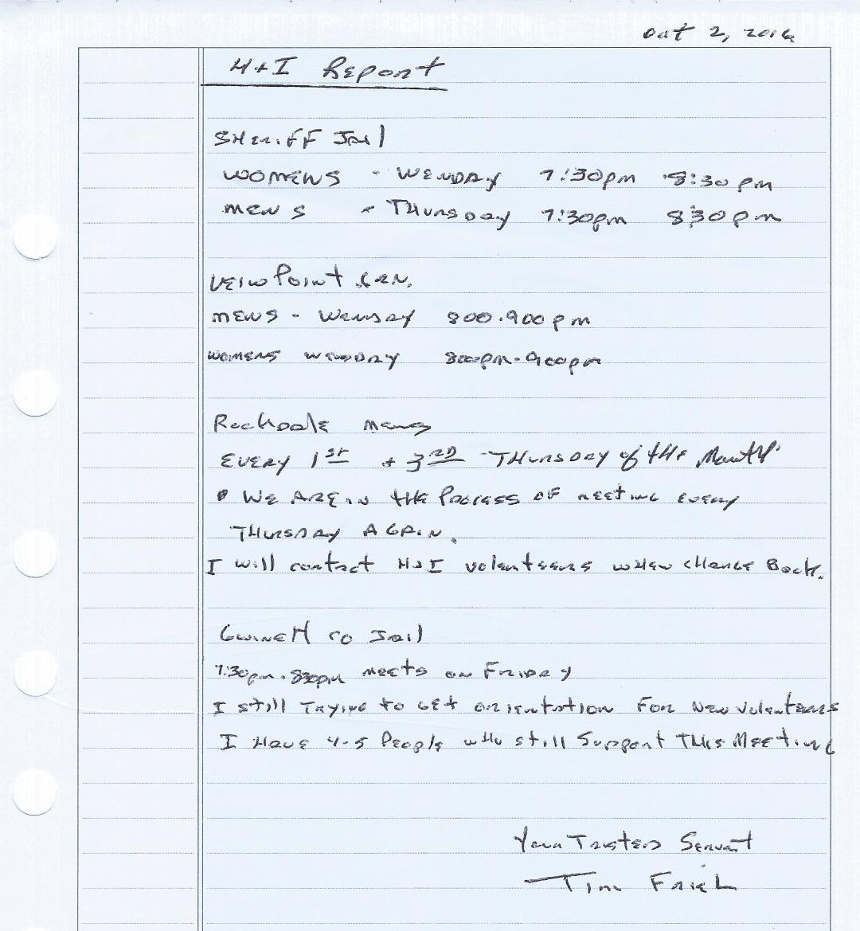

PR- [VERBAL REPORT] At Gwinnett county fair, 42 people from multiple areas came to volunteer. One hiccup but due to improper structure and training on how to interact. Drug court event gave presentation. Reestablishing drug court orientation – twice a month give new people in drug court an idea of what to expect at a meeting. Training sessions later this month for new committee members. Voice over IP cost to absorbed by Region for all areas. Multi-area H&I and PR day, end of Jan/beginning of Feb. Pushing use of Google calendar on website to ease confusion over events throughout areas (Susan suggested a volunteer to help her with inputting calendar events). Information database, emails and numbers from GRCNA to send out flyers etc. PR – 42 people at fair booth. One hiccup, attributed to poor committee and orientation.
Activities- Next meeting October. Area t-shirts still available $15. Multi-Metro Unity Day raffle tickets available for $1 put name and phone number on back, don’t have to be present to win – flyer included at bottom of minutes. October 28th spooky dance - flyer included at bottom of minutes. Annual talent show November 19th at Farhfromusin meeting place with East End and North Atlanta Area $5 suggested donation price GRCNA 36 fundraiser Nov 19th @ Farhfromusin meeting place – North Atlanta and East End. GSR workshop after area meeting today. Atlanta Multi-Metro Area Unity Day 2 has raffle tickets for sale - $1.00 each (1st prize GRCNA 36 reg. 2nd prize WEANA 30 reg. 3rd prize NA clock.
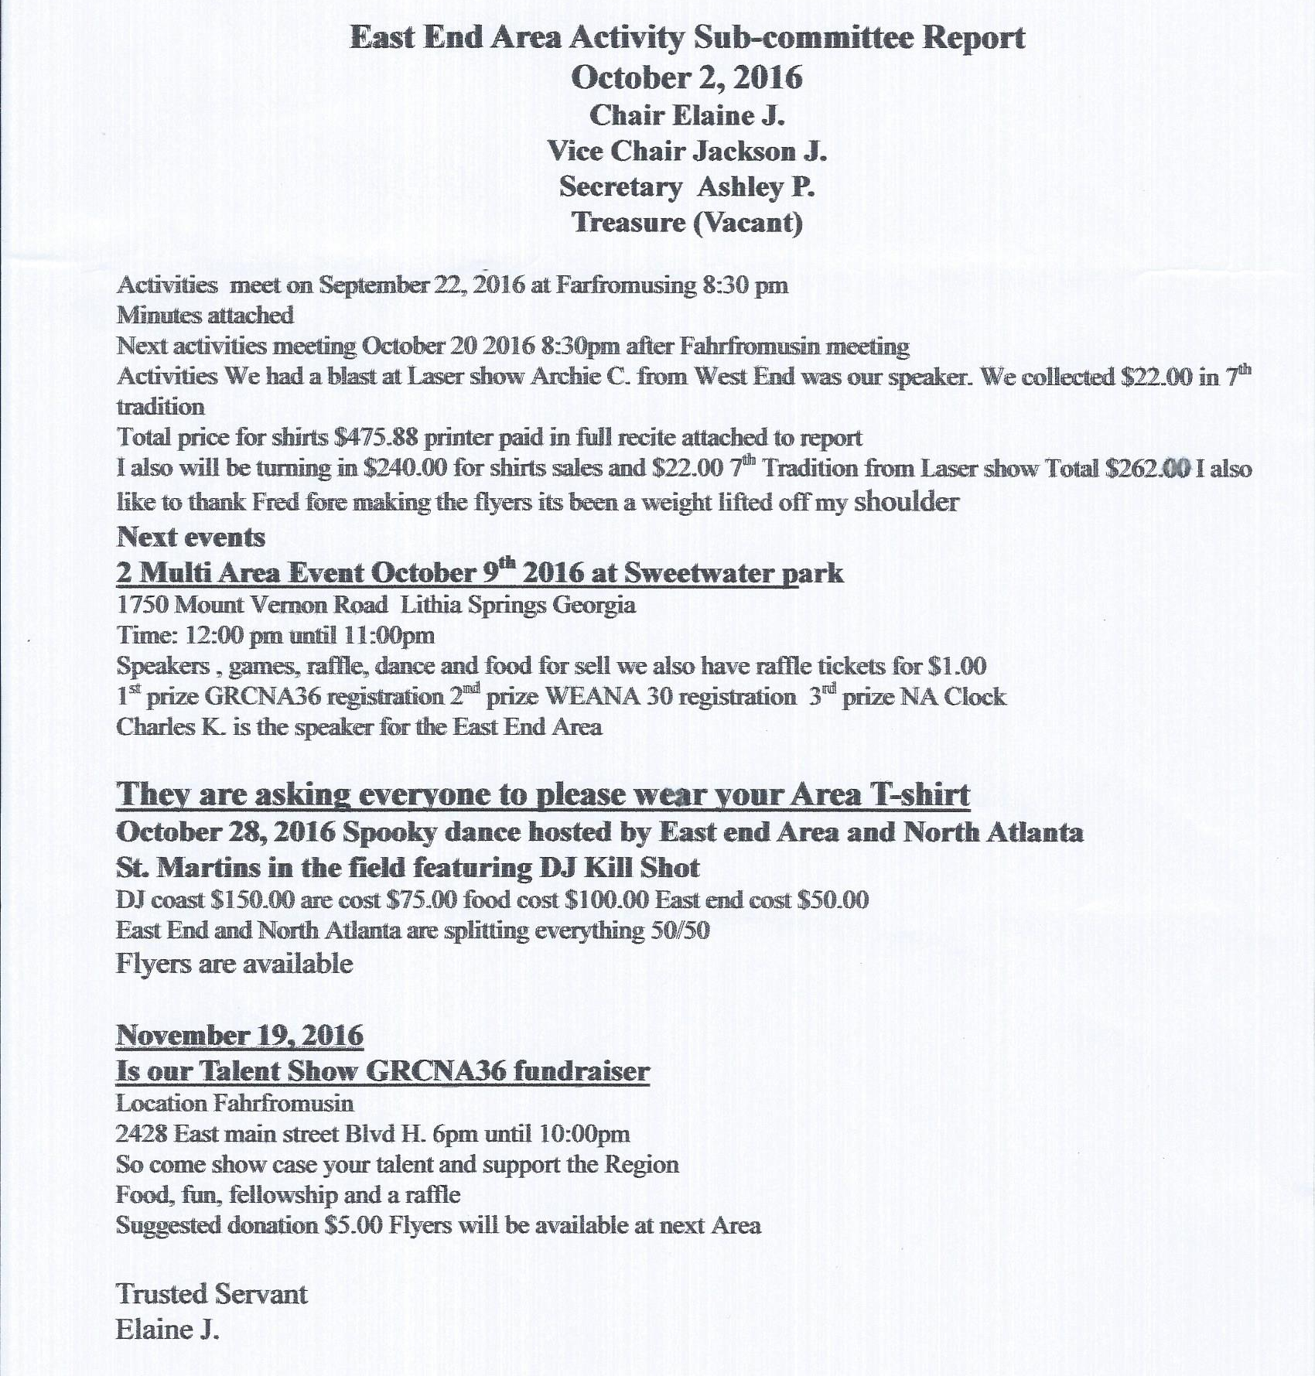

Group Reports
SCANNED AND ATTACHED BELOW
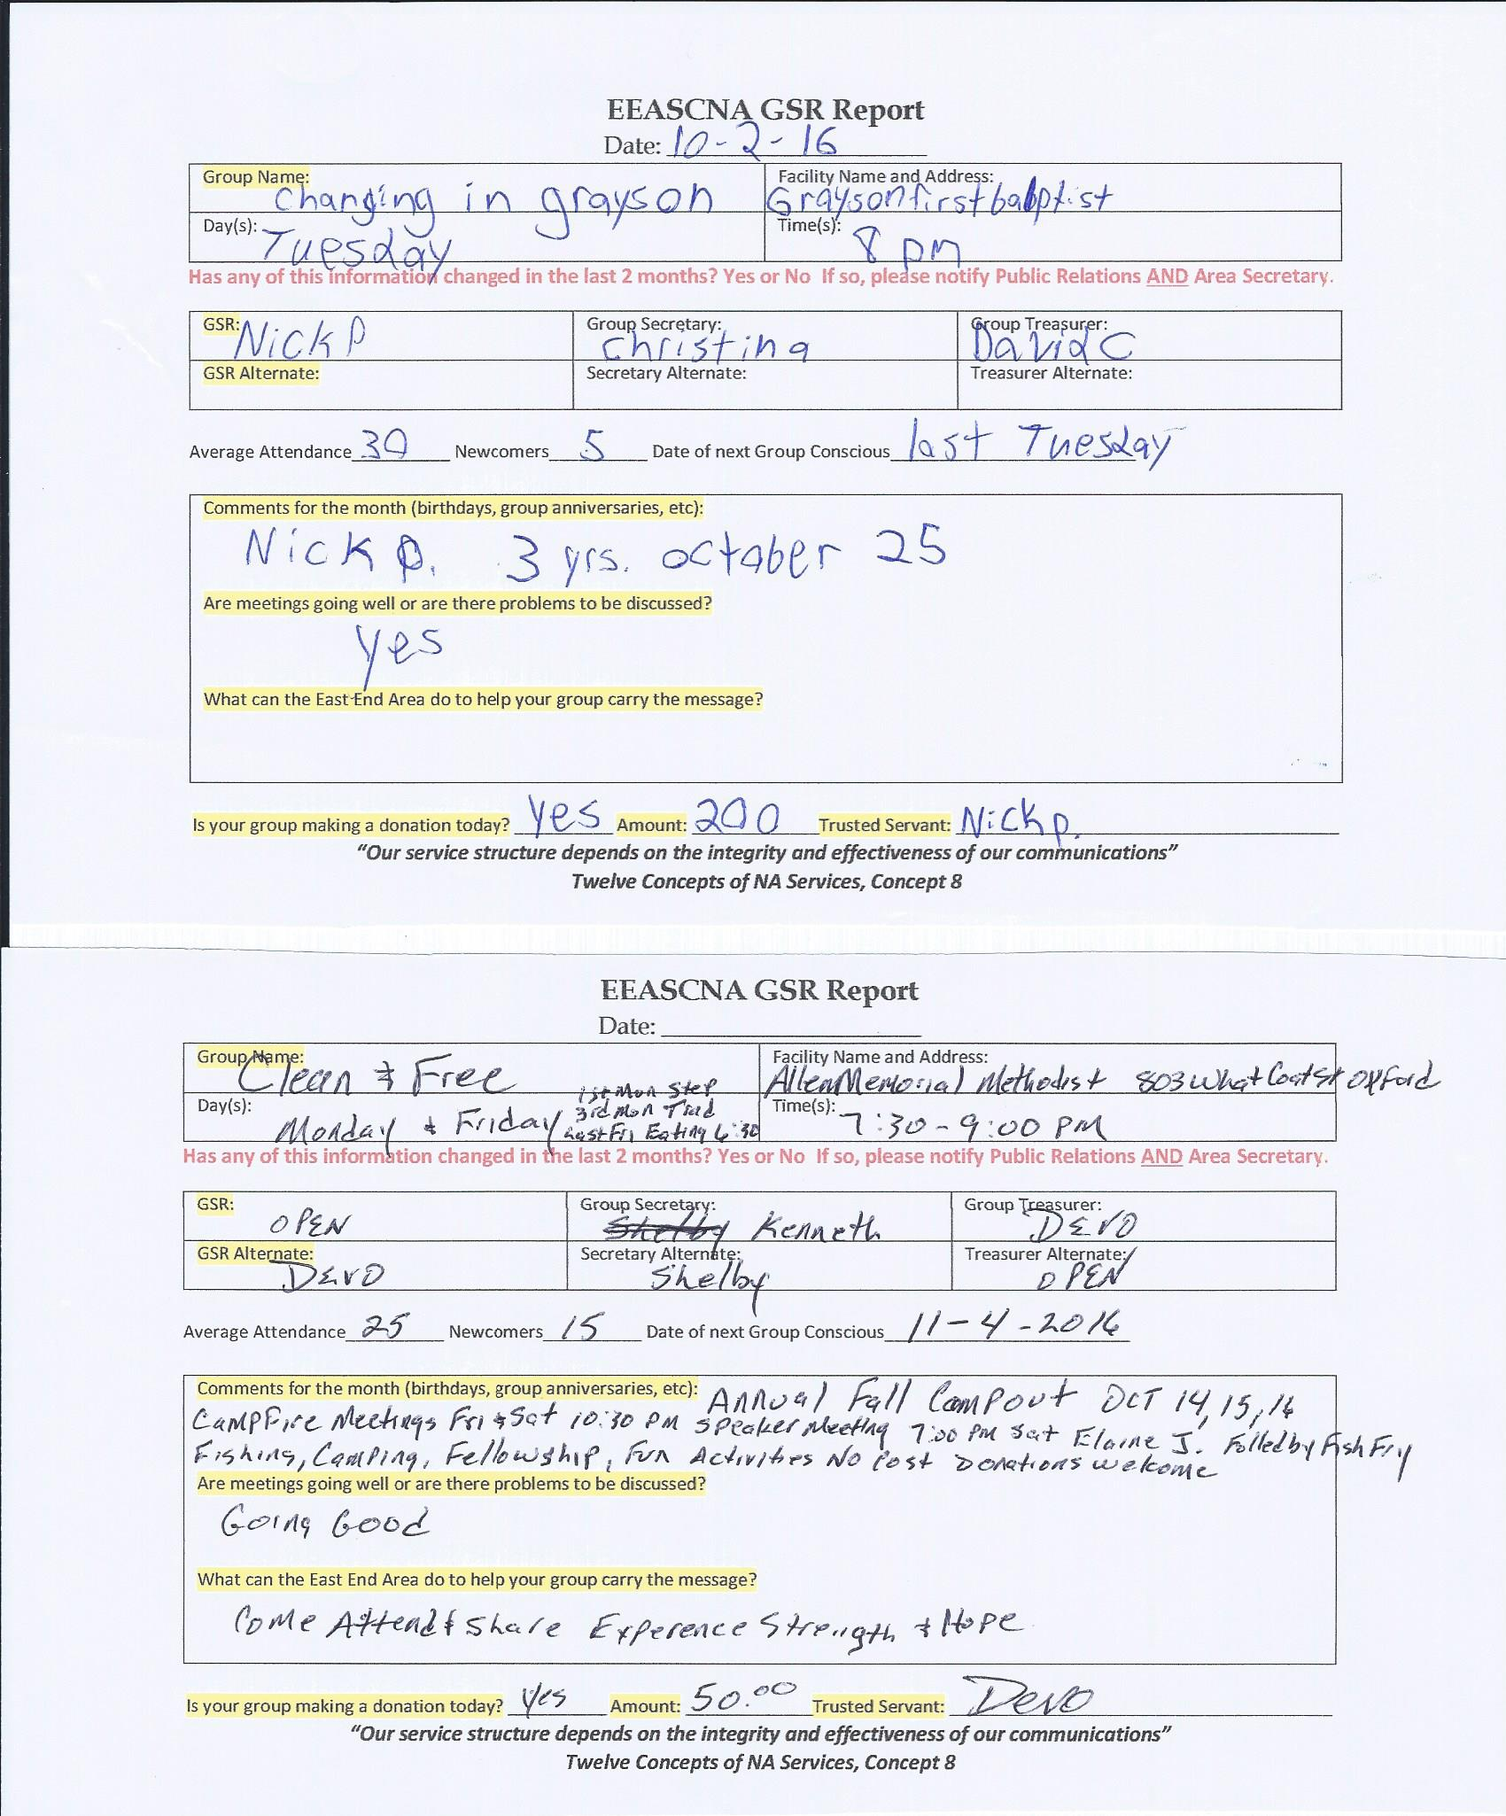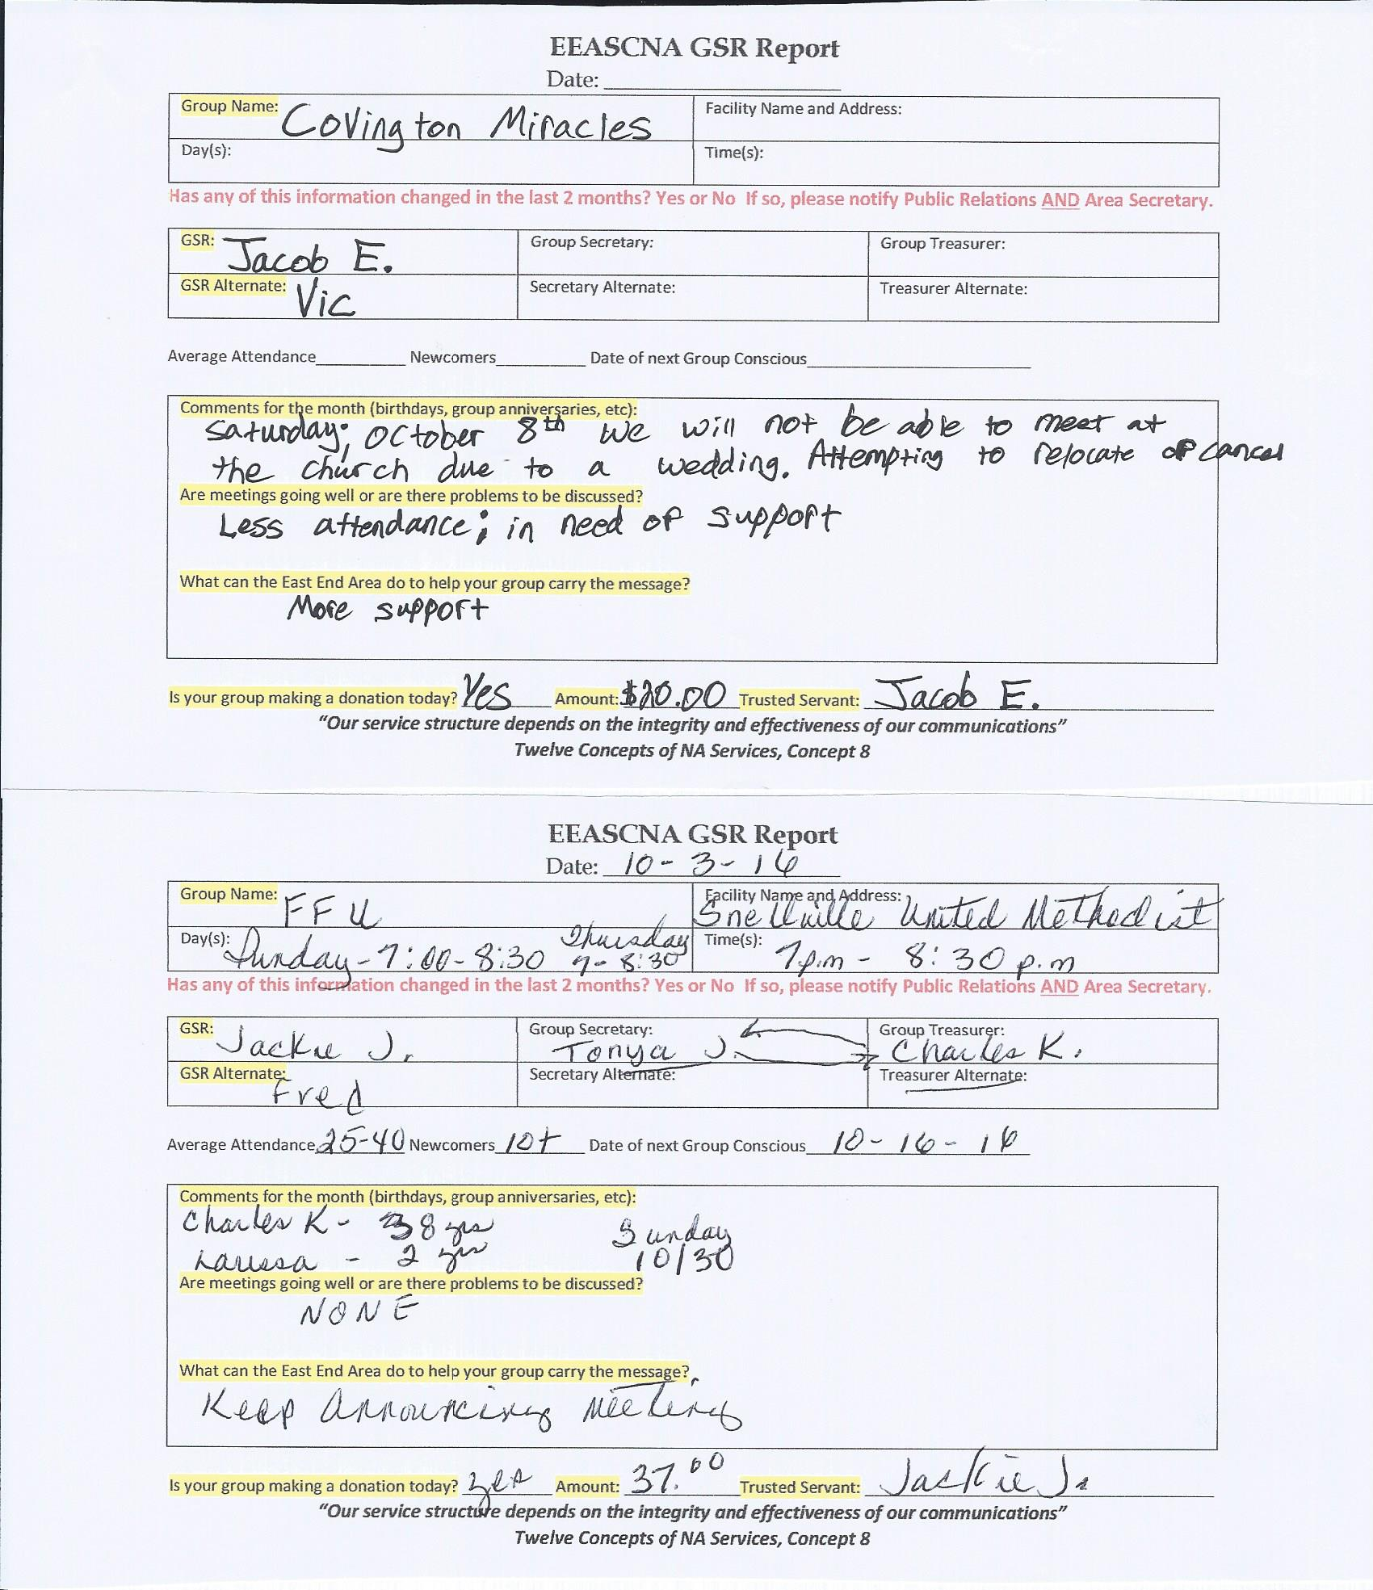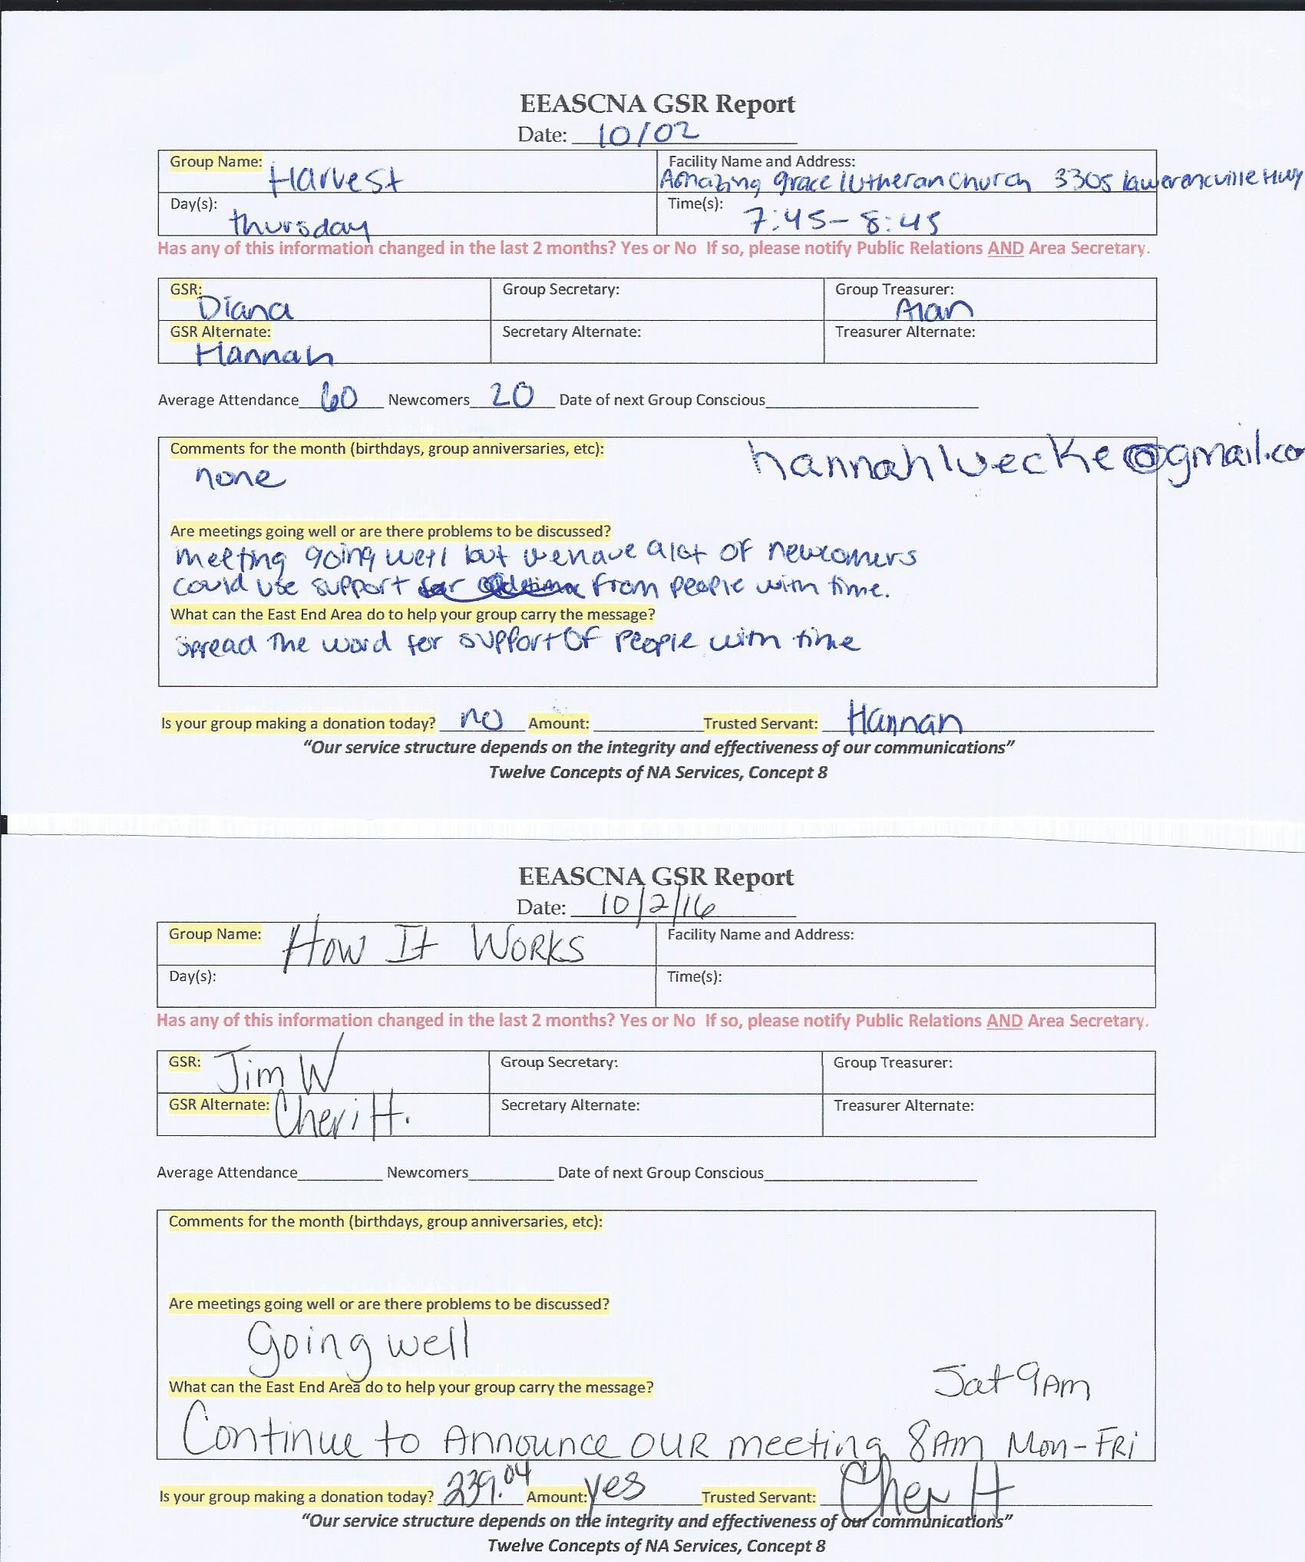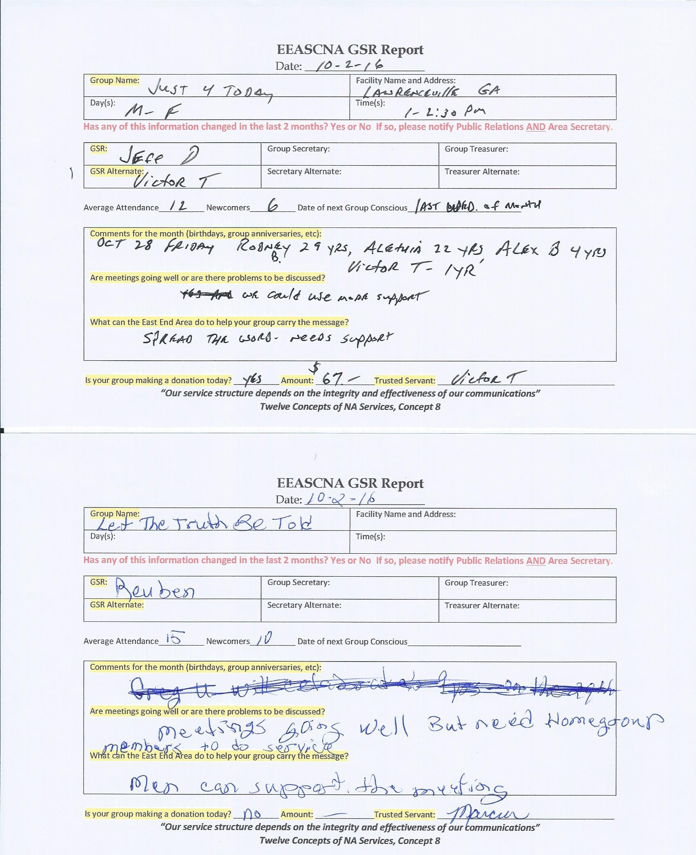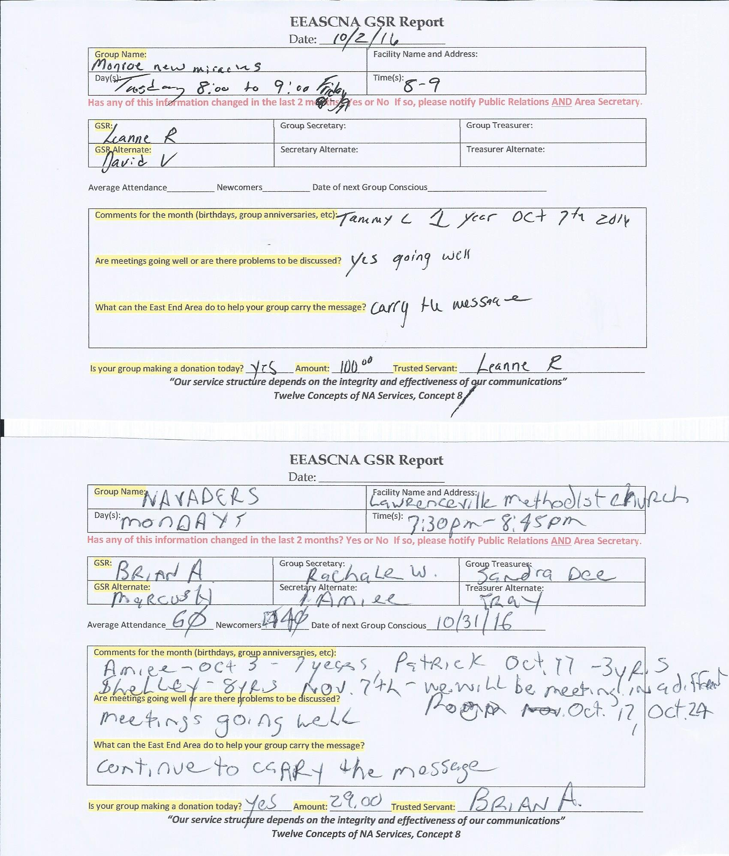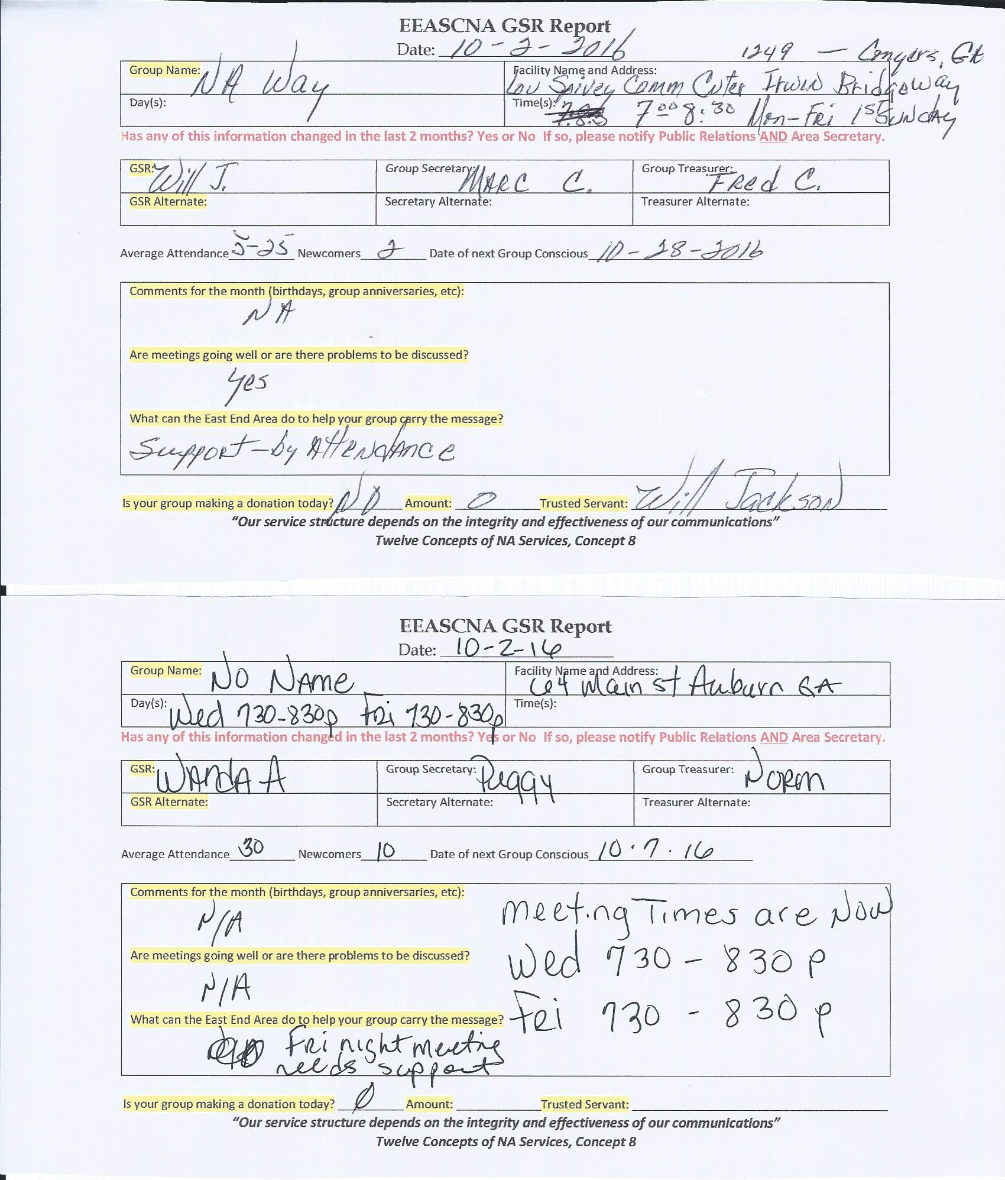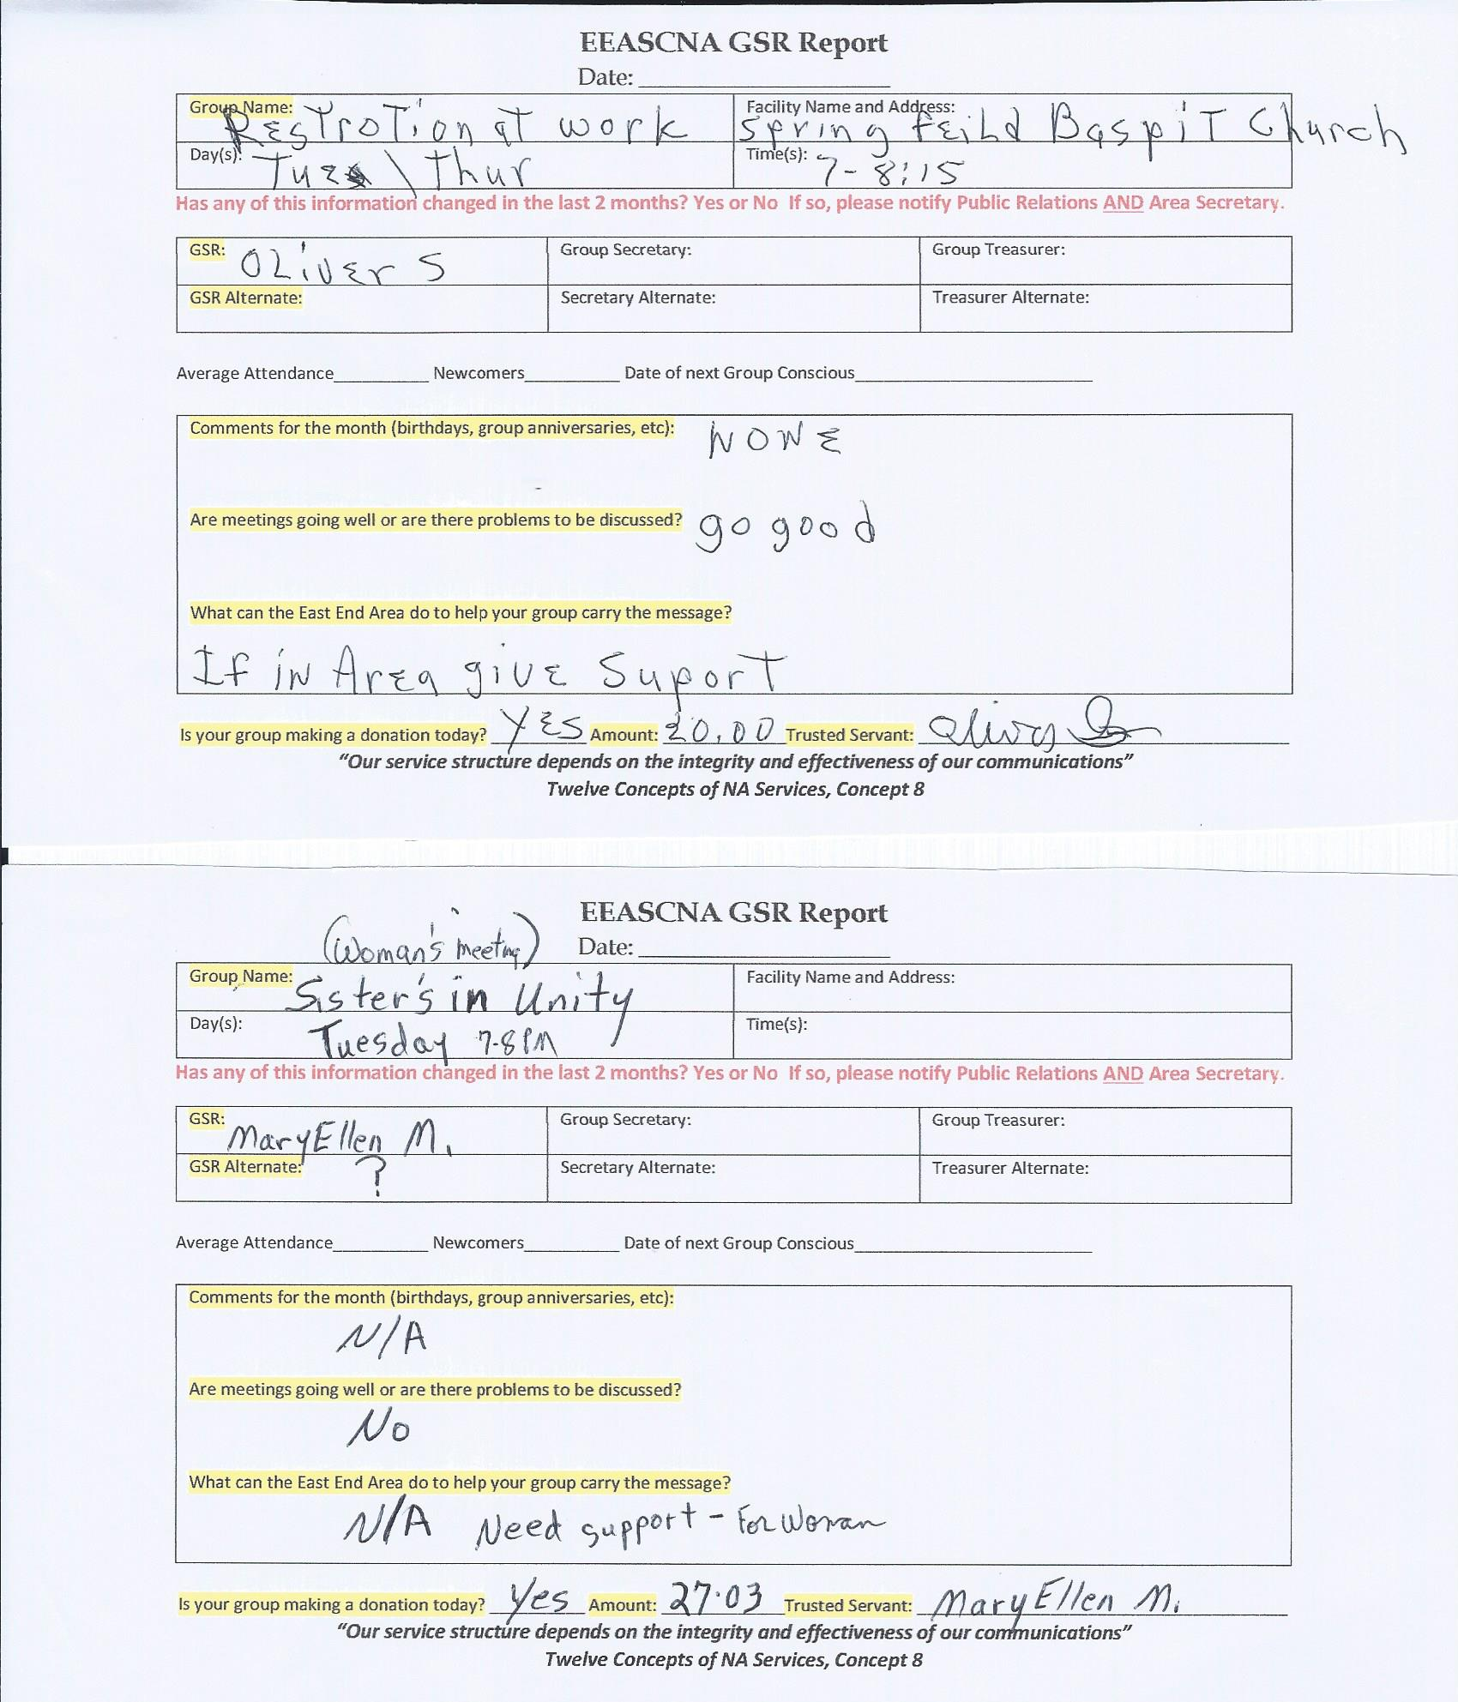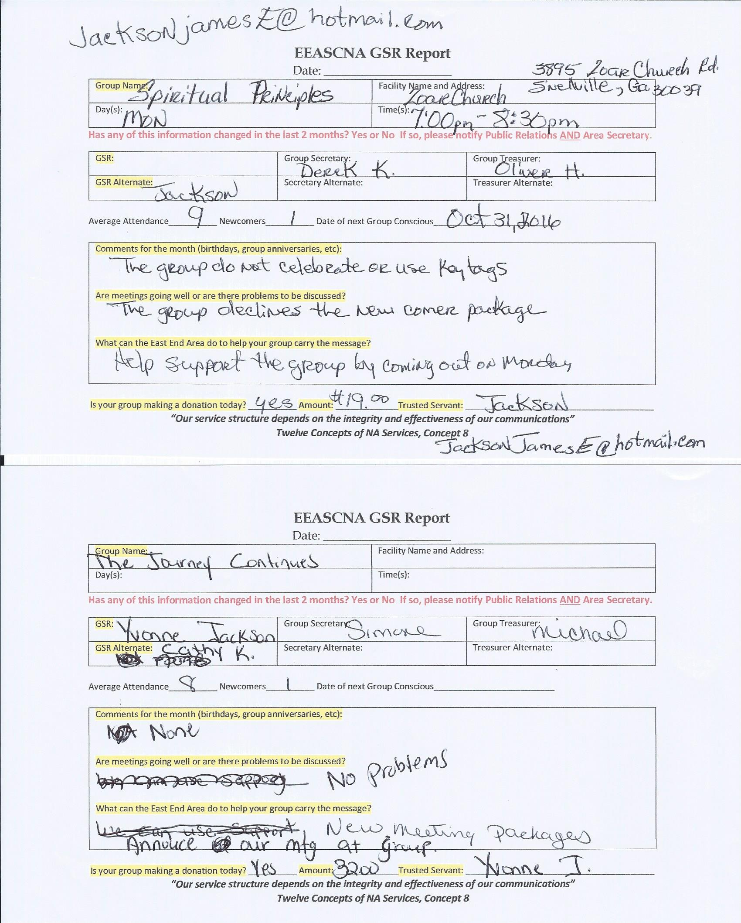

Old Business
None

Nominations/Elections
PR Chair – Jackson 11-0-0 Pass

Open Forum
VOTING IS NOT MADE IN OPEN FORUM
- Three options for collecting money that’s not cash
  - Online payments like PayPal (no device)
  - Device from bank, has fee and fee per transaction
  - PayPal scanner or Square
- GSR workshop after area meeting today. Wasn’t held at laser show
- Make it known to volunteers about tickets when going to Fair for PR booth
- PO Box?
- Riding the river of change limited t-shirt idea needed by October 7th – contact Asa B. with submissions
- Consensus workshop to be scheduled at next Region meeting for our area

New Business
- PO Box to be obtained in Snellville post office - $36 per 6 months. Update address on pamphlets to correct PO box – voted and passed
- Consensus workshop to be scheduled at next Region meeting for our area

AREA POSITIONS STILL OPEN: H&I VICE

Plans for the next meeting
Next Area Service will be
Held at 3pm November 6th in Conyers
**ADMIN MEETS AT 2:30 PM**

