EEASCNA Minutes- August 2016
Sojourner opened ASC Meeting with moment of silence followed by the Serenity Prayer
Reading of Twelve Traditions – Simone
Reading of Twelve Concepts - Yvonne
Reading of Article II & III: Purpose of EEASCNA - Mike
Article II: Purpose The purpose of the East End Area Service Committee of Narcotics Anonymous (EEASCNA) shall be to respond to the needs and collective conscience of its member groups. EEASCNA supports and encourages the unity, welfare and growth of the East End Area as part of a worldwide Fellowship.
Article III: A. Definition and Function of the Area: The Area Service Conference (ASC) is the communicative channel for a unified Fellowship, a tie that binds us together. The ASC serves as a link in the flow of communication from the member to the worldwide Fellowship, establishes a structure in which services and education are provided, and functions as a vehicle through which our Area Fellowship and society can relate. The EEASC is a Committee made up of Group Service Representatives (GSRs), special purpose Task panels and an Administrative Body from Member Groups of the East End Area.
Administration Roll-Call
Key: 0= Not Present, 1= Present, (-) = Vacant, R= Report submitted only
ROLE | NAME | D | J | F | M | A | M | J | J | A | S | O | N | D
Facilitator | Sojourner B. | i | i | i | i | i | 1 | 1 | 1 | 1
Co-Facilitator |  | - | - | - | 1 | 1 | - | - | - | -
Secretary | Sara Y. | 1 | 1 | 1 | 1 | 1 | 1 | 1 | 0 | 1
Alt-Secretary | Kristin F. | - | - | - | - | - | - | - | 1 | 1
Treasurer | Susan W. | i | i | i | 1 | 1 | 1 | 1 | 1 | 1
Alt-Treasurer | Cheri H. | - | - | - | 0 | 0 | 1 | 1 | 1 | 1
H&I Chair | Tim F. | 1 | 1 | 1 | 1 | 1 | 1 | 1 | 1 | 1
H&I Vice |  | - | - | - | - | - | - | - | - | -
PR Chair |  | - | - | - | - | - | 1 | 0 | - | -
PR Vice |  | - | - | - | - | - | - | - | - | -
Activities | Elaine J. | 1 | 1 | i | 1 | 1 | 0 | 1 | 1 | 1
Activities Vice | David F. | - | - | 1 | - | 1 | 1 | 1 | 0 | 1
RCM | Fred C. | 1 | 1 | 1 | 1 | 1 | 1 | 1 | 1 | 1
RCMA | Mike R. | - | 1 | 1 | 1 | 1 | 1 | 0 | 1 | 1
Group Voting Policy:
- To reach quorum, 50% + 1 of groups present must be in good-standing.
- A quorum must be reached by fifteen (15) minutes after roll call is completed and before any business can be conducted.
- In order for a topic to be enacted, 80% of the groups present must be in good standing.
- New groups must attend 3 consecutive Area Meetings to gain voting rights at the 3rd Area.
- If a group misses 2 consecutive Area Meetings to re-gain voting rights at the 2nd.
East End Area Groups Roll Call
Key: 0= Not Present, 1= Present, R= Report Submitted only, Blacked Out= Not G.S.
2015- 2016 | D | J | F | M | A | M | J | J | A | S | O | N | D
By NA Means Necessary | 1 | 1 | 0 | 1 | 0 | 0 | 1 | 0 | 0
Changing in Grayson | R | R | 1 | 1 | 1 | 1 | 1 | R | 1
Clean & Free | 1 | 1 | 1 | 1 | 1 | 1 | 1 | 1 | 1
Covington Miracles | 1 | 1 | 1 | 1 | R | 1 | 1 | 1 | 1
Fahrfromusin | 1 | 1 | 1 | R | 1 | 1 | 1 | R | 1
Far Out | 1 | 1 | 1 | 1 | 1 | 1 | 0 | 1 | 0
Get Real | 1 | 0 | 0 | 0 | 0 | 0 | 0 | 0 | 0
Harvest | 1 | 1 | 1 | 1 | 1 | 1 | 1 | 1 | 1
How It Works | 1 | 0 | 1 | 1 | 1 | 1 | 1 | 1 | 1
Just For Today | 1 | 1 | R | 0 | 1 | 1 | 1 | 1 | 1
Let the Truth Be Told | 0 | 1 | 1 | 0 | 1 | 0 | 1 | 1 | 1
Monroe New Miracles | 1 | 1 | 1 | 1 | 1 | 1 | 0 | 0 | 1
NA Vaders | 1 | 1 | 1 | 1 | 1 | 1 | 1 | 1 | 1
NA Way | 1 | 1 | 1 | 1 | 1 | 1 | 1 | 1 | 1
No Name Group | _ | _ | 1 | 0 | 1 | 1 | 1 | 1 | 1
Recovery at the Rock | 1 | 1 | 0 | 0 | 0 | 0 | 0 | 0 | 0
Restoration at work | 0 | 1 | 1 | 1 | 1 | 1 | 1 | 1 | 1
Set-Free | - | 1 | 1 | 0 | 0 | 0 | 0 | 0 | 0
Sisters in Unity | 1 | 1 | 1 | 1 | 1 | 1 | 1 | 1 | 1
Spiritual Principles | - | - | - | - | 1 | 1 | 1 | R | 1
The Journey Continues | - | - | - | - | - | - | - | - | 1
Unlimited Hope | 1 | 0 | 1 | R | 1 | 0 | 1 | 1 | 0
Total of Groups in Area | 19 | 19 | 20 | 20 | 21 | 21 | 21 | 21 | 21
Total Groups Present | 14 | 17 | 15 | 14 | 17 | 15 | 17 | 16 | 12
Groups in Good Standing | 16 | 16 | 17 | 17 | 16 | 16 | 17 | 18 | 18
Groups Present & G.S. | 13 | 16 | 14 | 14 | 15 | 13 | 15 | 16 | 13
Number for Quorum (50% + 1)?  Is Quorum reached? | 11 Yes | 10 Yes | 11 Yes | 11 Yes | 10 Yes | 12 Yes | 15 Yes | 12 Yes | 12 Yes
Number for Consensus (80% present in G.S)?  Do we have Consensus? | 14 Yes | 13 Yes | 12 Yes | 11 Yes | 10 Yes | 14 Yes | 10 Yes | 13 Yes | 13 Yes

Subcommittee Reports
Treasurer – Report attached
RCM – Report attached - Next region meeting September 10th – 11th
H & I – Report attached - GRN needs support. Both jail meetings need support. Women’s jail meeting moved to the chapel. Taking literature to women’s meeting in jails
PR— Position vacant again. Gwinnett county fair coming up. (Sept 17th-27th) Each homegroup pick a day to come? 4 hour block weekdays, 8 hour block weekend. 2-3 people to volunteer? PR will come to business meetings to talk about it if we so wish. Can have training days; will have set dates at next area meeting. Call Joe 770-364-7867 or Fred 770-377-8292. Possibly making a calendar showing time slots.
Activities – Report attached - Met July 28th at 8:30 pm. Unity learning day Sunday August 21st 12-5 in Briscoe Park, flyer attached. $188.00 from luau and dance. September 24th laser show.

Group Reports
SCANNED AND ATTACHED

Old Business
- Newcomers day (flyer attached)
- Home groups each come up with a design for the East End shirt
- Area service workshop can be included in Unity day
- Susan W. will have a policy workshop after August area meeting

Nominations/Elections
Co-Facilitator Simone F. 13 votes
PR-Vice Chair David F.

Open Forum/New Business
- T-Shirts $15/shirt how many large, medium, small
- Sign up for fair
- Region looking for web facilitator

Take Back to Groups

- Homegroup members needed to sign up for spots at the September fair
- Region is looking for a web facilitator

Positions still open:

PR chair
H&I Vice

Plans for the next meeting
NEXT AREA SERVICE WILL BE
HELD AT 3PM SEPTEMBER 4th IN CONYERS
**ADMIN MEETS AT 2:30PM**

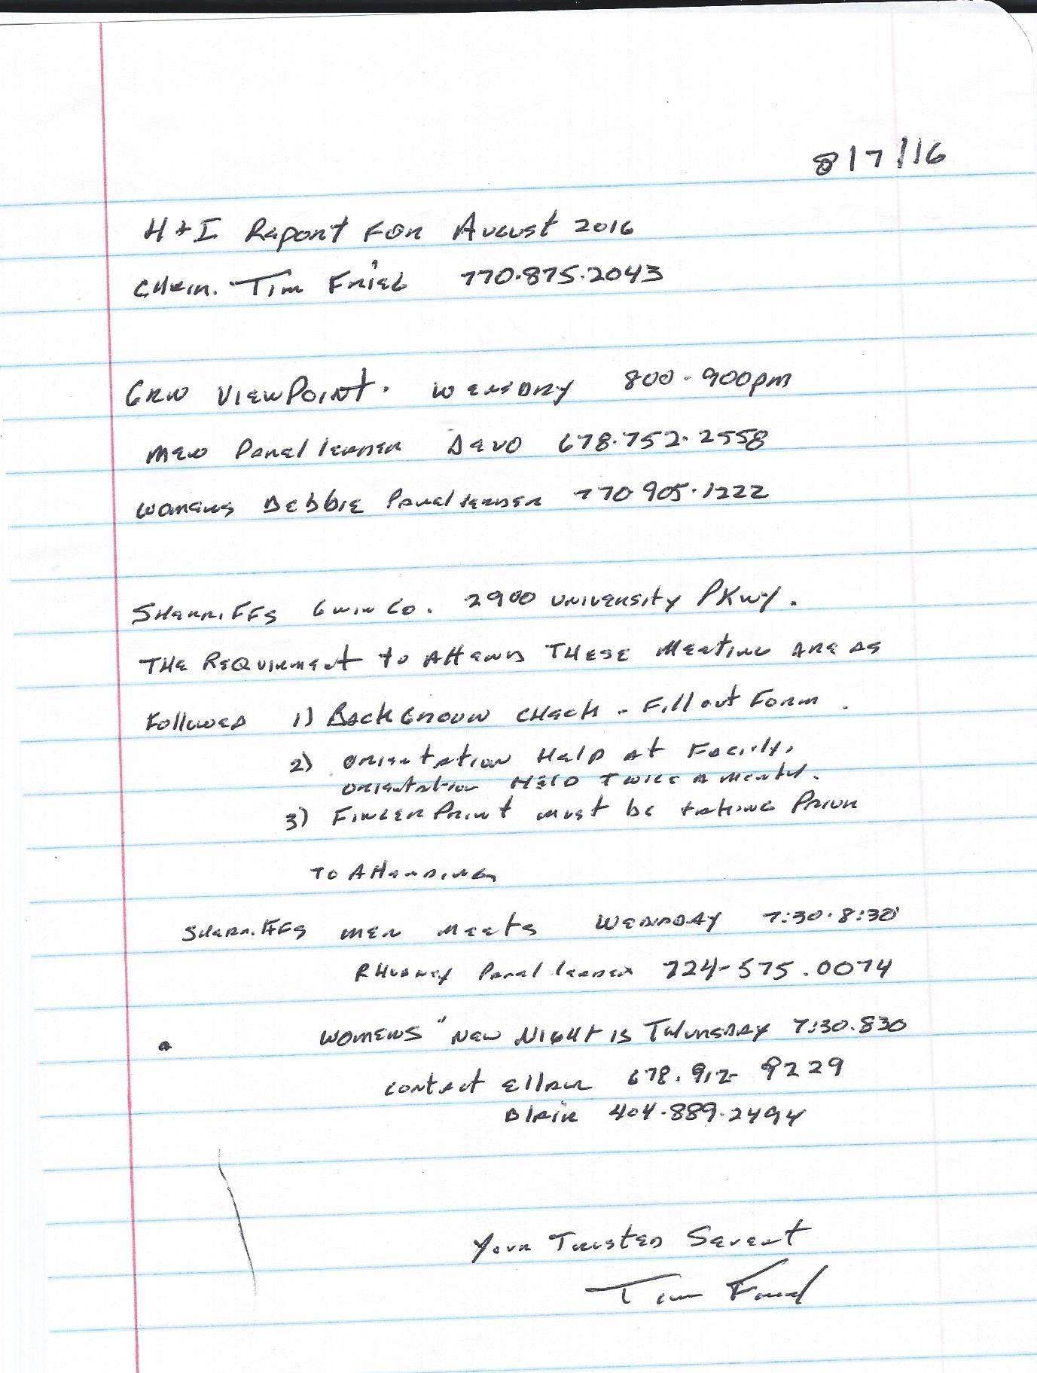
HI PR Unity learning day before fair August 21 12-5
Waiting on joe, we are wanting to do it in dekalb but if we don't hear from joe we will hold it at Briscoe Park
This is for Fair preparedness
As the date for the fair quickly approaches we must have informed members to carry the message , No clean time required
park via dinky
Free food
Drinks $1
Chicken bbq
Hot dogs
Baked beans
Cole slaw
180.00 to area from luau and dance
50 prudent reserve
Jackson voted into vice chair
Thank you David for his service he is moving up to PR
East end t shirt 10.00
2 vendors best price wins out
Sept 24 laser show 